CN LAB WEEK 3
SHREYA SRIKRISHNA
ROLL NUMBER 1

Part 1: Study of Application Layer Protocols using Wireshark

Q 3.1. Retrieve web pages using HTTP. Use Wireshark to capture packets for analysis. Learn
about most common HTTP messages. Also capture response messages and analyze them.
During the lab session, also examine and analyze some HTTP headers.

Http request and response packets are as shown below:
The website accessed is http://info.cern.ch/ and the GET and response (OK message) can be seen below
First we send a GET message from source(172.16.58.134) to the destination server (188.184.21.108) which sends us a 200 OK response.

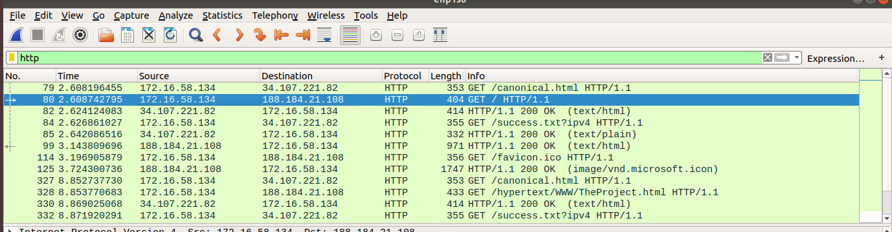

Next, we send a GET message for the favicon and receive the corresponding OK message for the same.
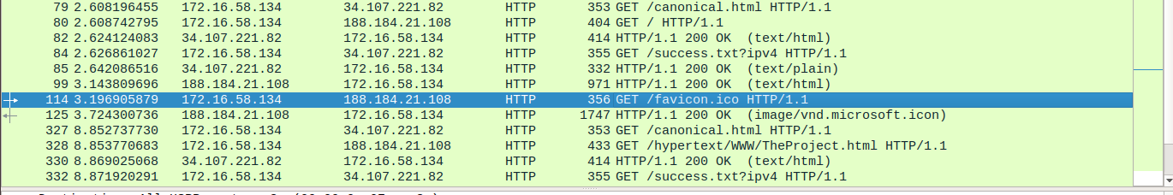
Below is the header for the GET request that we sent.
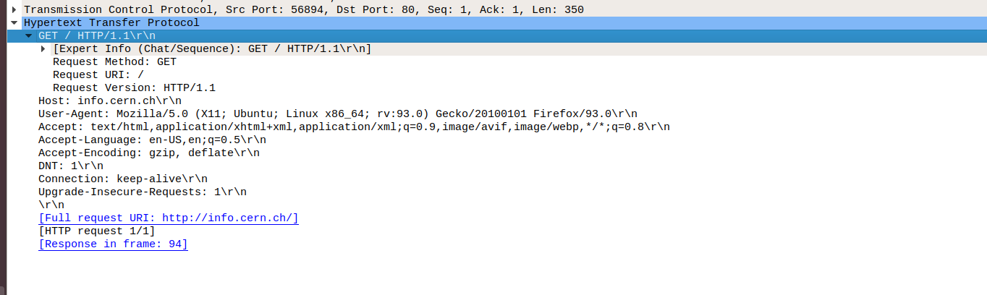

Below is the information of the html code that the server sends back.
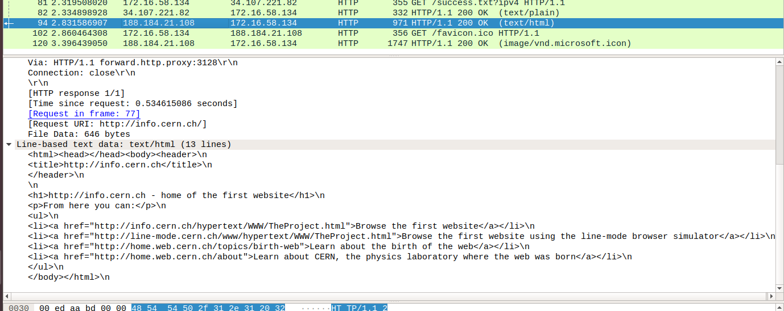

Q 3.2. Use FTP to transfer some files, Use Wireshark to capture some packets. Show that FTP
uses two separate connections: a control connection and a data-transfer connection. The data
connection is opened and closed for each file transfer activity. Also show that FTP is an
insecure file transfer protocol because the transaction is done in plaintext.

We access ftp using the terminal by connecting to the local server 172.16.57.143. We issue an ‘”ls” command next and observe the response the server gives.

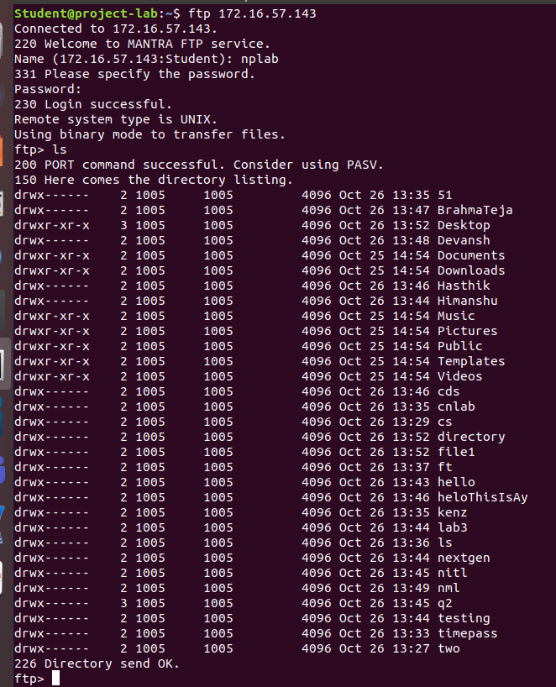

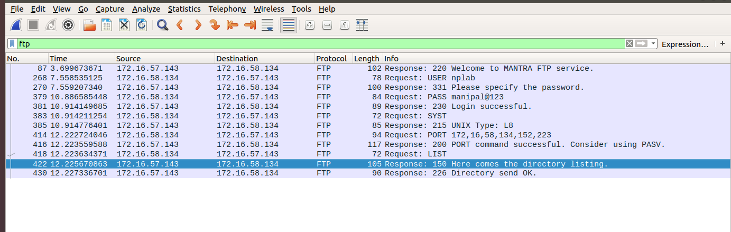
In the screenshots we observe that the we are asked for the username and password which we provide in a series of request and reponse messages.
The initial welcome message, the username and the password sent is all in plaintext, not hashed or hidden in any way. Thus this can be easily found by a packet sniffer. Hence ftp is not a secure transfer protocol.

Q 3.3. Analyze the behavior of the DNS protocol. In addition to Wireshark [Several network
utilities are available for finding some information stored in the DNS servers. Eg.dig utilities
(which has replaced nslookup). Set Wireshark to capture the packets sent by this utility.]

Analyzing the DNS protocol when a request for www.google.com is made. DNS uses the UDP protocol in the transport layer. The source port for the UDP protocol is
48285 and the destination port is 53. The request is sent from source address 172.16.58.134 to
destination address 172.16.19.203.

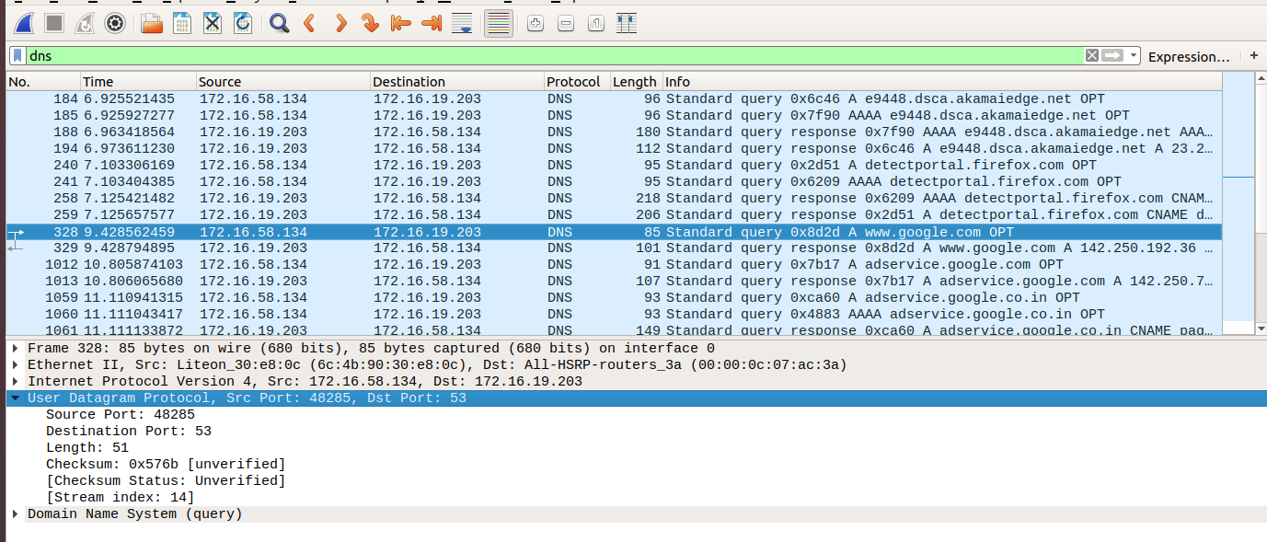
On doing a lookup with nslookup we see that the same ip address is returned.

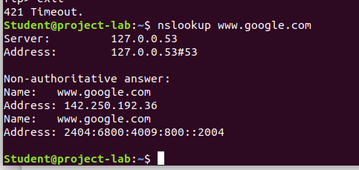

Part 2: Study of Network Devices in GNS3
Q 4.1 (a,b,c,d,e) and Q 4.3
Design network configuration shown in Figure 4.1 for all parts. Connect all four VMs to a
single Ethernet segment via a single hub as shown in Figure 4.1. Configure the IP addresses
for the PCs as shown in Table 4.1.
a. On PC1, view the ARP cache with showarp
b. Start Wireshark on PC1-Hub1 link with a capture filter set to the IP address ofPC2.
c. Issue a ping command from PC1toPC2:
PC1% ping 10.0.1.13 –c3
Observe the ARP packets in the Wireshark window. Explore the MAC addresses in the
Ethernet headers of the captured packets.
Direct our attention to the following fields:
• The destination MAC address of the ARP Request packets.
• The Type Field in the Ethernet headers of ARP packets.
d. View the ARP cache again with the command arp -a. Note that ARP cache
entries can get refreshed/deleted fairly quickly (~2minutes).
show arp
e. Save the results of Wireshark.

The network configuration is as shown below
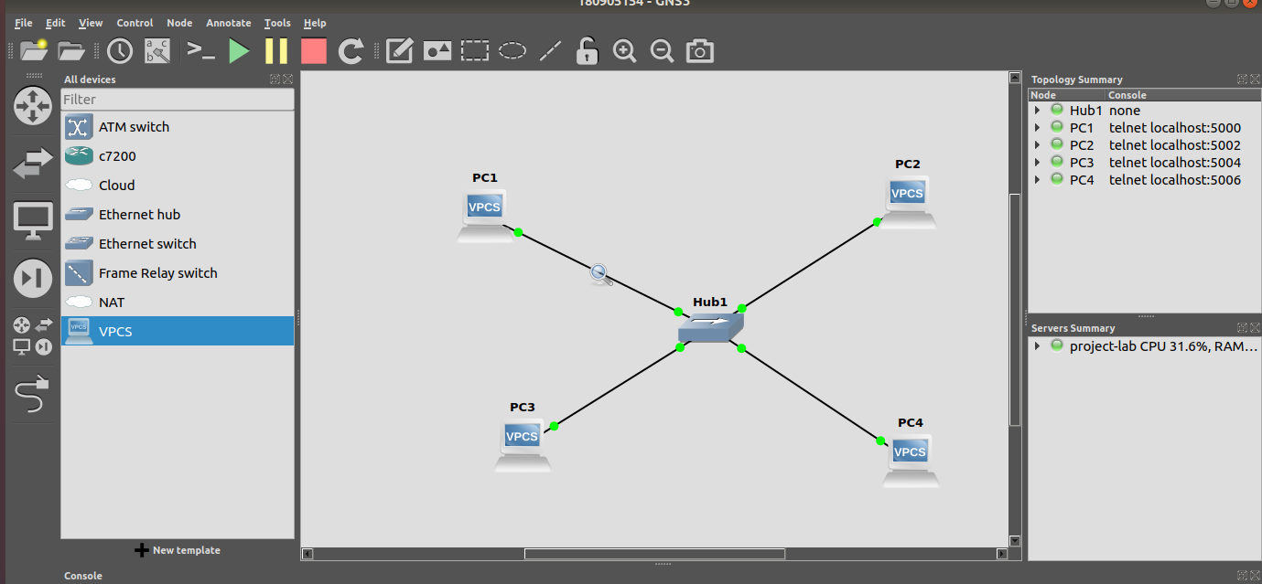

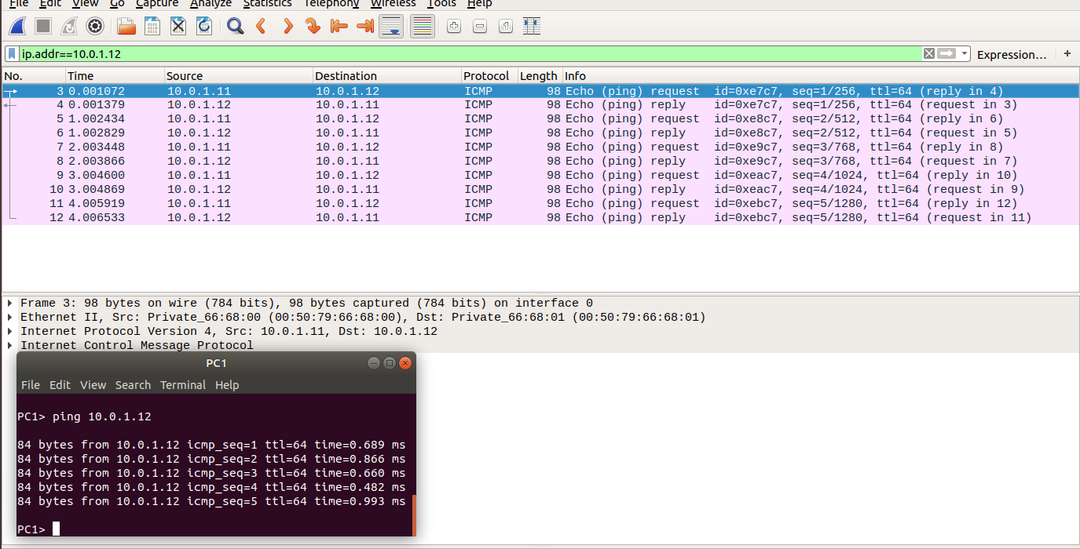
We make a ping from PC1 to PC2 while capturing packets from the PC1-Hub1 link with a capture filter set to the IP address of PC2.

We execute the show arp command for pc1

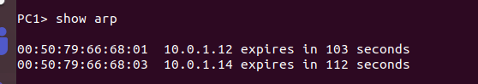

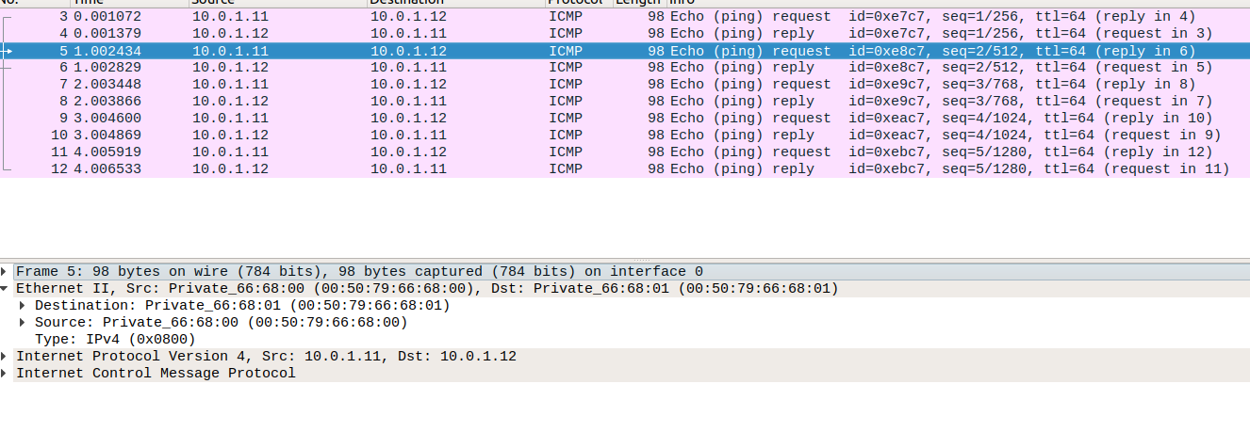
The destination MAC address of the ARP Request packets is 00:50:79:66:68:01
The type is ipv4.

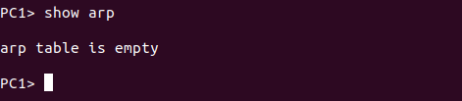

We see that ARP cache entries can get refreshed/deleted fairly quickly (~2minutes)which is why the arp table is empty.

