Rhea Adhikari
190905156
Roll No 23
Lab3 – DSL

Exercises(ONLY IN PDF)

Solved Examples (IN OBSERVATION)

1)

import numpy as np
A=np.array([2,5,10])
print(A.dtype)
B=np.array([2,4,6,5.3])
print(B.dtype)

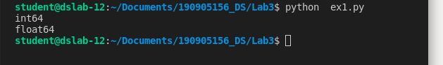

2)
import numpy as np
A=np.array([(3,4,5),(12,6,1)])
Z=np.ones((3,3))
print(A)
print(Z)

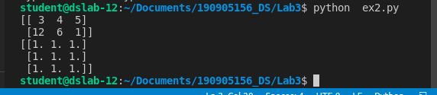
3)

import numpy as np
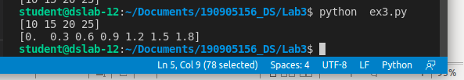
S=np.arange(10,30,5)
print(S)
S=np.arange(0,2,0.3)
print(S)

4)
import numpy as np
S1=np.linspace(0,2,9)
print(S1)

5)
import random

print(random.choice([1,2,3,4,5]))
print(random.choice('python'))
print(random.randrange(25,50))
print(random.random())
print(random.uniform(5,10))
print(random.shuffle([1,2,3,4,5]))
print(random.seed(10))
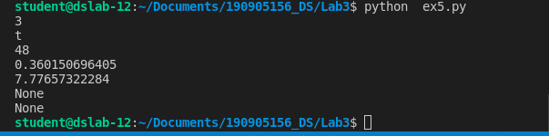
6)
import numpy as np
a=np.arange(15).reshape(3,5)
print(a)
print(a.shape)
print(a.size)
print(a.T)

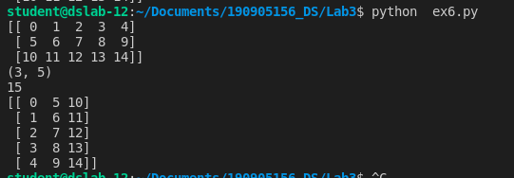

7)
import numpy as np
c = np.arange(24).reshape(2,3,4)
print(c)
print(c.shape)

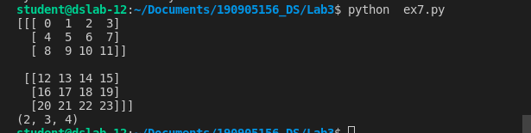
8)
import numpy as np
a=np.array([20,30,40,50])
b=np.arange(4)
print(b)
c=a-b
print(c)
print(b**2)
print(10*np.sin(a))
print(a<35)

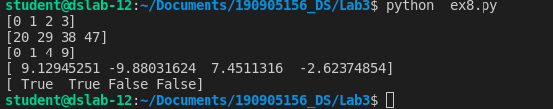

9)

import numpy as np
A=np.array([[1,1],[0,1]])
B=np.array([[2,0],[3,4]])
print(A*B)
print(np.dot(A,B))
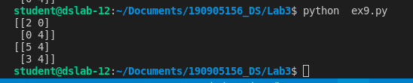
10)
import numpy as np
b=np.arange(12).reshape(3,4)
print(b)
print("sum of each col")
print(b.sum(axis=0))
print("sum of each row")
print(b.sum(axis=1))

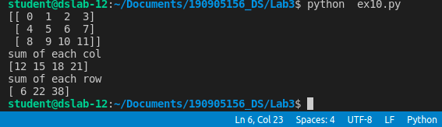
11)
import numpy as np
a=np.arange(10)**3
print("a=")
print(a)
print("--")
print(a[2:5])
print(a[0:6:2])
b=np.arange(20).reshape(5,4)
print("b=")
print(b)
print("--")
print(b[2,3])
print(b[0:5,1])
print(b[-1,:])
print(b[:,-1])
print("-row-")
for row in b:
print(row,sep='')
print("-flat-")
for ele in b.flat:
print(ele,end=' ')
print("-ravel-")
print(b.ravel())
B1=b.reshape(4,5)
print("B1=")
print(B1)
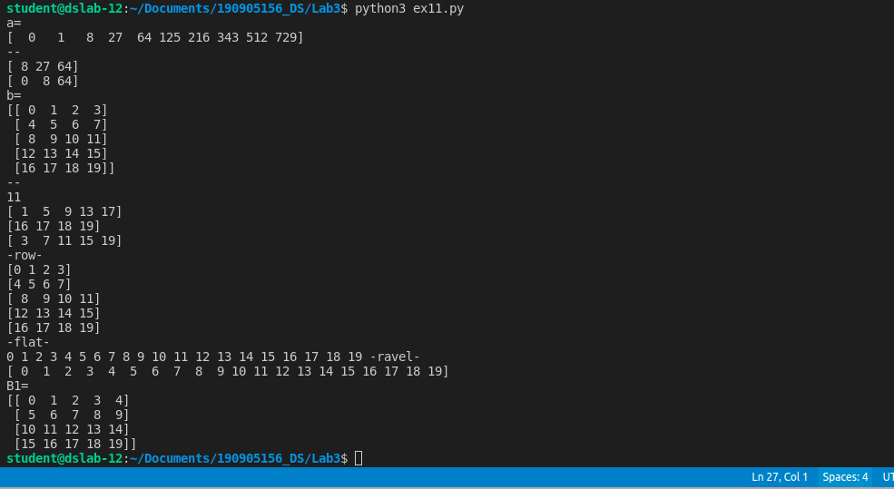
12)
import numpy as np
A1=np.array([(3,4,5),(12,6,1)])
A2=np.array([(1,2,6),(-4,3,8)])
print(A1)
print(A2)
D1=np.vstack((A1,A2))
D2=np.hstack((A1,A2))
print(D1)
print(D2)

a=np.array([4.0,2.0])
b=np.array([3.0,8.0])
np.column_stack((a,b))
D3=np.hstack((a,b))
print(D3)

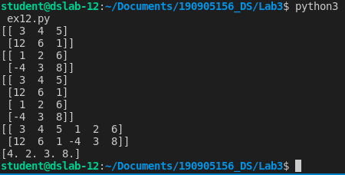

13)
import numpy as np
a=np.arange(12)**2
i=np.array([1,2,11,8,5])
print(a[i])
j=np.array([[3,4],[9,7]])
print(a[j])

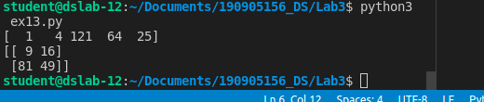
14)
import numpy as np
a=np.array([(3,2,9),(1,6,7)])
s=0
for i in range(a.shape[0]):
for j in range(a.shape[1]):
s+=a[i,j]
print(s)

