190905156
Rhea Adhikari
Roll No:23
Lab 4

1. Write a UDP time server to display the current time and day.

Client.py
import socket
import time
localIP = "127.0.0.1"
localPort = 20001
bufferSize = 1024
currentTime = time.ctime(time.time()) + "\r\n"
bytesToSend = str.encode(currentTime)
# Create a datagram socket
UDPServerSocket = socket.socket(family=socket.AF_INET, type=socket.SOCK_DGRAM)
# Bind to address and ip
UDPServerSocket.bind((localIP, localPort))
print("UDP server up and listening")
# Listen for incoming datagrams
while(True):
bytesAddressPair = UDPServerSocket.recvfrom(bufferSize)
message = bytesAddressPair[0]
address = bytesAddressPair[1]
clientMsg = "Message from Client:{}".format(message)
clientIP = "Client IP Address:{}".format(address)
print(clientMsg)
print(clientIP)
# Sending a reply to client
UDPServerSocket.sendto(bytesToSend, address)

Server.py
import socket
msgFromClient = "Hello UDP Server"
bytesToSend = str.encode(msgFromClient)
serverAddressPort = ("127.0.0.1", 20001)
bufferSize = 1024
# Create a UDP socket at client side
UDPClientSocket = socket.socket(family=socket.AF_INET, type=socket.SOCK_DGRAM)
# Send to server using created UDP socket
UDPClientSocket.sendto(bytesToSend, serverAddressPort)
msgFromServer = UDPClientSocket.recvfrom(bufferSize)
msg = "Message from Server {}".format(msgFromServer[0])
print(msg)

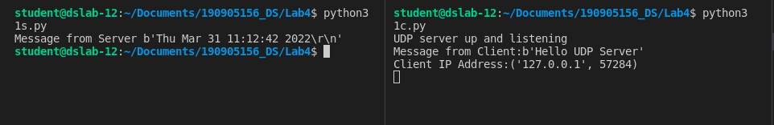

2. Write a UDP simple chat program for message send and receive.

Client.py
import socket
sock = socket.socket(socket.AF_INET,socket.SOCK_DGRAM)
udp_host = socket.gethostname()
udp_port = 12345
name = input(str("\nEnter your name: "))
sock.sendto(name.encode(), (udp_host,udp_port));
s_name,addr = sock.recvfrom(1024)
s_name = s_name.decode()
print(s_name, "has joined the chat room\nEnter ctrl+c to exit chat room\n")
while True:
message,addr = sock.recvfrom(1024)
message = message.decode()
print(s_name, ":", message)
message = input(str("Me : "))
sock.sendto(message.encode(),addr)

Server.py
import socket
import datetime
sock = socket.socket(socket.AF_INET,socket.SOCK_DGRAM)
udp_host = socket.gethostname()
udp_port = 12345
listeningAddress = (udp_host, udp_port)
sock.bind((udp_host, udp_port))
s_name,addr = sock.recvfrom(1024)
s_name = s_name.decode()
print(s_name, "has connected to the chat room\nEnter ctrl+c to exit chat room\n")
name = input(str("Enter your name: "))
sock.sendto(name.encode(),addr)
while True:
message = input(str("Me : "))
sock.sendto(message.encode(),addr)
message,addr = sock.recvfrom(1024)
message = message.decode()
print(s_name, ":", message)
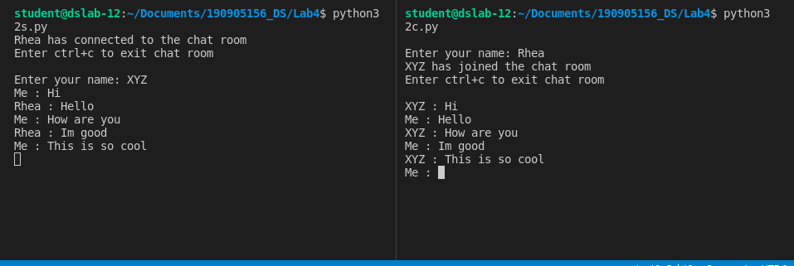

3. Write a TCP/UDP peer to peer chat system between two different machines.

Client.py
import socket
sock = socket.socket(socket.AF_INET,socket.SOCK_DGRAM)
udp_host = '172.16.58.157'
udp_port = 12345
name = input(str("\nEnter your name: "))
sock.sendto(name.encode(), (udp_host,udp_port));
s_name,addr = sock.recvfrom(1024)
s_name = s_name.decode()
print(s_name, "has joined the chat room\nEnter ctrl+c to exit chat room\n")
while True:
message,addr = sock.recvfrom(1024)
message = message.decode()
print(s_name, ":", message)
message = input(str("Me : "))
sock.sendto(message.encode(),addr)

Server.py
import socket
sock = socket.socket(socket.AF_INET,socket.SOCK_DGRAM)
udp_host = socket.gethostname()
udp_port = 12345
listeningAddress = (udp_host, udp_port)
sock.bind((udp_host, udp_port))
s_name,addr = sock.recvfrom(1024)
s_name = s_name.decode()
print(s_name, "has connected to the chat room\nEnter ctrl+c to exit chat room\n")
name = input(str("Enter your name: "))
sock.sendto(name.encode(),addr)
while True:
message = input(str("Me : "))
sock.sendto(message.encode(),addr)
message,addr = sock.recvfrom(1024)
message = message.decode()
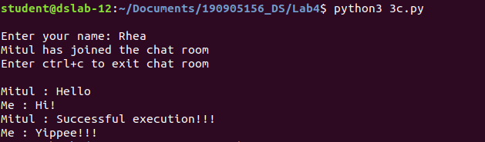
print(s_name, ":", message)

4. Debug Code

Client.py
import socket

serverIP = 'localhost'
serverPort = 16008

clientSock = socket.socket(socket.AF_INET, socket.SOCK_STREAM)
clientSock.connect((serverIP, serverPort))

message = input("Input integers with space in between: ")
message2 = input("Enter the length of the set: ")

clientSock.send(message.encode())
clientSock.send(message2.encode())

data = clientSock.recv(1024)

temp = [float(x) for x in data.split()]

print("The total of all numbers is: " + str(temp[0]))
print("The lowest number is: " + str(temp[1]))
print("The highest number is: " + str(temp[2]))
print("The mean is: " + str(temp[3]))

clientSock.close()

Server.py
import socket
serverIP = 'localhost'
serverPort = 16008

serverSock = socket.socket(socket.AF_INET, socket.SOCK_STREAM)
serverSock.bind((serverIP, serverPort))
serverSock.listen(1)

print("TCP server has started and is ready to receive")

while 1:
connection, addr = serverSock.accept()
data = connection.recv(1024)
if not data: break

temp = [float(x) for x in data.split()]
print("Received data:", temp)

length = len(temp)
maximum = max(temp)
minimum = min(temp)
total = sum(temp)
mean = total/length

msg = str(total) + " " + str(minimum) + " " + str(maximum) + " " + str(mean)

connection.send(str(msg).encode())
