**SWACHH SMART TOILET**

Submitted in partial fulfillment of the requirements

of the degree of

**B. E. Information Technology**

By

**Shruti Muralidas 67**

**Rhea Dsouza 68**

**Rachel Mascarenhas 69**

Supervisor(s):

**Ms. Grinal Tuscano**

Assistant Professor



Department of Information Technology

St. Francis Institute of Technology

(Engineering College)

University of Mumbai

2019-2020

**CERTIFICATE**

This is to certify that the project entitled **Swachh Smart Toilet** is a bonafide work of **Shruti Muralidas (67), Rhea D’souza (68), Rachel Mascarenhas (69)** submitted to the University of Mumbai in partial fulfillment of the requirement for the award of the degree of B.E. in Information Technology

**(Name and sign)**

**Supervisor/Guide**

**(Name and sign) (Name and sign)**

**Head of Department Principal**



**Project Report Approval for B.E.**

This project report entitled **Swachh Smart Toilet** by **Shruti Muralidas, Rhea D’souza, Rachel Mascarenhas** is approved for the degree of ***B.E. in Information Technology.***

Examiners

1.---------------------------------------------

2.---------------------------------------------

Date:

Place:



Declaration

I declare that this written submission represents my ideas in my own words and where others' ideas or words have been included, I have adequately cited and referenced the original sources. I also declare that I have adhered to all principles of academic honesty and integrity and have not misrepresented or fabricated or falsified any idea/data/fact/source in my submission. I understand that any violation of the above will be cause for disciplinary action by the Institute and can also evoke penal action from the sources which have thus not been properly cited or from whom proper permission has not been taken when needed.

-----------------------------------------

(Signature)

-----------------------------------------

(Name of student and Roll No.)

Date:



**Abstract**

In India, almost 60% of its population prefer open defecation over hygiene hence public toilets play a vital role.Although in recent times public toilets built by government help in reducing open defecation but the maintenance of these toilets in hygienic manner is still an issue.Due to the foul smell and improper maintenance the usage of these toilets are less preferred.Open defecation leads to multiple diseases and health problems such as diarrhea.Hence, the issue of open defecation and the hygiene and maintenance of public toilets needs a solution.Government of India has also introduced “Swachh Bharat” (Clean India). Providing uncontaminated toilets is the main objective of “Swachh Bharat” scheme.This paper could be fruitful in order to encourage the clean Bharat scheme.In this paper, we address the above mentioned issues and propose the implementation of public toilets using modern technologies to deliver clean and hygiene toilets, thereby reducing diseases and health problems and improving efficient usage of water and electricity resources.





**Contents**

|  |  |  |
| --- | --- | --- |
| **Chapter** | **Contents** | **Page No.** |
| **1** | **INTRODUCTION:** Give at least two to three sentences about your project. |  |
|  | **1.1 Description *(Brief description of project)*** The main functionality of the project should be explained in brief |  |
|  | **1.2 Problem Formulation *(Explain the problem)*** |  |
|  | **1.3 Motivation *(need of the project)***: List the various approaches along with its drawbacks for solving the problem and briefly explain the approach used for your project. |  |
|  | **1.3 Proposed Solution:** Explain the method/technique used for solving the problem and how it overcomes the drawbacks mentioned under heading 1.3. Also explain how the project is going to help end users. |  |
|  | **1.4 Scope of the project *(scale/range of your project)*:** Extent of how far your project can be completed. This can be in terms of domain or application related constraints/limitations. |  |
| **2** | **REVIEW OF LITERATURE *(include at least 3IEEE or similar reputed technical papers as reference*)** Should be atleast 2 pages which gives the ideas referenced by the reference papers. Mark the references wherever appropriate. (Note: - Please don’t write the paper titles and the abstract of papers.) |  |
| **3** | **SYSTEM ANALYSIS** |  |
|  | **3.1 Functional Requirements *( write requirements of the project)*** Should follow the IEEE SRS format |  |
|  | **3.2 Non Functional Requirements** Should follow the IEEE SRS format |  |
|  | **3.3 Specific Requirements *(Hardware and software requirements)*** |  |
|  | **3.4 Use-Case Diagrams and description**  (Application development projects use-case is mandatory) |  |
| **4** | **ANALYSIS MODELING** |  |
|  | **4.1 Data Modeling *(E-R Model if any with its associated Data dictionary****)* Applicable for those applications which are dependent on data storage and retrieval. ER Diagram normalized till the third normal form accompanied by the respective data dictionary table should be included |  |
|  | **4.2 Activity Diagrams / Class Diagram** Depending on the type of your project you may include any of the diagrams**.** |  |
|  | **4.3 Functional Modeling (DFDs *with specifications)****mandatory for all projects* |  |
|  | **4.4 TimeLine Chart *(For the entire year)*** |  |
| **5** | **DESIGN** |  |
|  | **5.1 Architectural Design (*Project Flow /architecture* *with description)*** |  |
|  | **5.2 User Interface Design** GUI for your project |  |
| **6** | **IMPLEMENTATION** |  |
|  | **6.1 Algorithms / Methods Used**  Mention your algorithms if any or any methodology used. |  |
|  | **6.2 Working of the project *(code for mentioned algorithms)*** |  |
| **7** | **TESTING *(white box /black-box / any testing algorithm used)*** |  |
|  | **7.1 Test cases *(conditions on which testing is done)*** |  |
|  | **7.2 Type of Testing used *(explanation and reason of testing method used)*** |  |
| **8** | **RESULTS AND DISCUSSIONS *(final results or outputs)*** |  |
| **9** | **CONCLUSIONS & FUTURE SCOPE** |  |

Appendix

Literature Cited

Publications by your group (if any)

Acknowledgements



**List of Figures**

|  |  |  |
| --- | --- | --- |
| **Fig. No.** | **Figure Caption** | **Page No.** |
| 1. | Timeline 1 |  |
| 2. | Timeline 2 |  |
| 3. | Door Module |  |
| 4. | Water Management Module |  |
| 5. | Water Level Monitoring Module |  |
|  |  |  |
| 6.  7. | Garbage Monitoring Module  Serial monitor indicating the total number of users and the total time of usage |  |
| 8. | Low water level notification is sent via a SMS |  |
| 9. | Notification is sent when the garbage bin is full |  |



**List of Tables**

|  |  |  |
| --- | --- | --- |
| **Table No.** | **Table Title** | **Page No.** |
|  |  |  |
|  |  |  |
|  |  |  |
|  |  |  |
|  |  |  |
|  |  |  |
|  |  |  |



**INTRODUCTION**

Toilets are a basic necessity but often taken for granted by those who have regular access.Poor public and community toilet services are one of the most visible symptoms of inadequate urban sanitation services in India.Even after implementing various techniques India has failed for providing and maintaining proper sanitation. One major challenge faced by India is Open defecation.Large number of diseases can be transmitted between individuals through contact with contaminated surfaces.In our project, we address several such issues and provide various techniques that can be used for maintaining the sanitation and to increase the usage of the public toilets using Internet of Things(IoT).

**1.1 Description**

Sanitation plays a vital role in our country’s development and needs to be taken seriously as it may affect future growth. Even after implementing various techniques India has failed for providing and maintaining proper sanitation. One major challenge faced by India is Open defecation. Open defecation is the exercise of removal of human waste (stools and urine) in public without accessing the toilets[11]. The important problem with open defecation is, the E.Coli present in the human stool may enter the digestive tract of the human that may lead to diarrhea [11].According to the recent survey by the World Health Organization (WHO), 58% of the Indian population are habituated to Open defecation.

According to the latest Census data reveals that the percentage of houses that have access to television and telephones in rural India exceeds the percentage of those that have access to basic toilet facilities [13]. In countries like India, any health problem has to be dealt with seriousness as this may affect the future growth of the country. In the survey made by the United Nations, Millennium Development Goals Report 2014, 66% of the Indian population in rural areas prefer open defecation [13]. To help make India open defecation free, the defence ministry has taken steps to make each and every state open defecation free. In 2014, when the Swachh Bharat Abhiyan was planned and launched,the call to get rid of open defecation gained quite an approval from the nation. India, which had a sanitation coverage of mere 41.92 per cent in 2014 has increased its coverage to 63.94 per cent, and this improvement is being viewed as a major success of the Swachh Bharat Abhiyan campaign. India’s sanitation coverage has increased to 63.96 per cent from 41.92 per cent in 2014[13].Although many states claim them as Open defecation free, really that is not a fact.

In order to be Open defecation free it needs to concentrate on the development, maintenance and hygiene of the public toilets. These public toilets are utilized not only by the visitors from various places but also used by people who don’t have access to washrooms at home. In this regard, hygiene of the public toilets is very important as the usage of these toilets can be improved only if it is maintained properly. In addition to this, there are times the toilets cannot be used due to water shortage or no water present in tanks. Often the foul smell present in the toilet as the garbage bins have not been emptied after appropriate time intervals.In literature, various methods and technologies are proposed for maintaining the hygiene and sanitation of these public toilets in an efficient manner. In this paper, we address all of the above issues and provide various techniques that can be used for maintaining sanitation and to increase the usage of public toilets.

**1.2 Problem Formulation**

* Toilets are a basic necessity and considered an essential part of every individual life.Poor public and community toilet services are one of the most visible symptoms of inadequate urban sanitation services in India.
* There is a growing body of research that shows that many microbes are commonly found in public washrooms and are easily transmitted between individuals through contact with contaminated surfaces.
* Since India is densely overpopulated it is a task to maintain cleanliness and sanitation. These are considered one of India’s biggest and most visible problems.
* Even those with toilets or access to toilets do not keep their toilets clean.Public toilets in most places are unusable except in exigent circumstances.Sometimes people have access to a toilet, but the toilet might be broken, or of poor quality. The typical “signed sheets” on the toilet wall that indicate when they were last cleaned is a relatively routine approach to maintenance, but the process often ignores actual usage leaving the toilets unhygienic.
* Other factors that further degrade the sanitation and cleanliness of public washrooms are the less or no supply of clean water,unpleasant odor due to the filled garbage bins that have not been collected.
* And due to this a majority of people prefer Open defecation.The important problem with open defecation is, the E.Coli present in the human stool may enter the digestive tract of the human that may lead to diarrhea.
* Hence to ensure that such diseases do not spread further open defecation needs to be eradicated by maintaining the sanitation and cleanliness of public toilets.

**1.3 Motivation *(need of the project)***

* India leads the world in this crisis.Cleanliness and sanitation are some of India’s biggest and most visible problems.
* Even those with toilets or access to toilets do not keep their toilets clean.
* Public toilets in most places are unusable except in exigent circumstances.Sometimes people have access to a toilet, but the toilet might be broken, or of poor quality.
* Absence of supply of water inside or next to toilets cause people to get water from a distance before using the toilet.
* Most of the time people do not flush after using the washroom which causes unpleasant odor.
* Sometimes the water in the tank is over and no more water is left for use.
* If too many people want to use a toilet at the same time, then some people may go outside to defecate instead of waiting.
* Often the garbage from the bins are not collected and keep overflowing, making the washroom smelly and unhygienic.

**1.4 Proposed Solution:**

The proposed solution solves the problems discussed in the above section 1.3.

The features of the proposed system include-

* Touch-free smart toilet.
* Availability of washroom indicated by LEDs.
* Automatic light switch ON/OFF.
* Touch-free sensor-based flushing mechanism
* Likewise touch-free sensor-based washbasin.
* Sensor-based Hand dryer

Door opening and closing controlled by a servo motor and the entering and exiting motion of user captured by IR sensor.Automatic switching on and off of the lights as well as the door once the person is detected entering/exiting the washroom via the IR sensor.This helps provide a touch-free toilet and conservation of electricity.

Continuous monitoring of water level with the functionality to notify via SMS.Sensor based flushing mechanism using Ultrasonic sensor as well as reusing the water from the wash basin for flushing.This ensures touchless and sanitized flushing and reusing of water.

Continuous monitoring of garbage level with the functionality to notify via SMS. Inorder to ensure the washrooms remain odorless it is essential to clear the garbage bins.

Sensor-based Touch-free Hand dryer using IR Sensor. The hand dryer switches on automatically once the user places hand near the sensor and the sensor detects the users hand and it switches off when the user removes the hand placed.

**1.5 Scope of the project**

The following are the scope of our proposed system

* To avoid the health issues created by open defecation.
* To provide a touch-free toilet to avoid transmission of diseases
* To maintain the hygiene of public toilets.
* To reduce the consumption of electricity.
* To reduce the consumption of water.
* To count the total number of users and total time of usage.

**REVIEW OF LITERATURE**

V. Sudha et. al.[1] summarizes the techniques used for maintaining the public toilets and technologies used for facilitating the physically challenged peoples. It concludes that one of the best and possible methods to avoid open defecation is first to provide the infrastructure facilities where ever necessary. It discusses the various technologies used for reducing the water used for flushing the toilet. It also sheds light on the different systems such as the light weight glass system with audio aid that was introduced for the visually impared people as well as the system that with the help of smart toilet’s equipment measured the parameters that were needed to identify any health issues of the user.

D. Katariya et. al.[2] proposed a system to maintain hygienic levels of Railway toilets through automation with the help of IoT. The proposed system automatically cleans the squat pan toilet with the help of a robotic arm. The robotic arm has a brush attached to its end effector which is used for the cleaning purpose. In this system there is minimum usage of water and electricity.Auto door locking system is also provided during the working of this system to avoid human interference. A database is maintained which gives all the notifications to authorities of the cleaning department of railway on a web page and an android application by using Wi-Fi.

K. Osathanunkul et. al. [3] proposed a smart automatic urinal flushing system . It is designed and implemented to provide the entire usage information to a caretaker. It is developed using an ESP8266 chip connected with an ultrasonic sensor. Once the sensor detects an object, it controls a solenoid to flush water. This sensor and solenoid activation data is sent from ESP chip to a Raspberry Pi board via MQTT protocol. Once the data has been received, it is saved into a database inside the Raspberry Pi. This system has validated its functionality by testing under different scenarios.

K.Elavarasi et. al. [4] proposed a system which concentrated on keeping clean toilets and monitoring the sweepers working activities. This system is to use safe and hygienic toilets. It is based on IOT and image-processing concepts using different sensors like smell sensor, IR sensor,sonic sensor, RFID reader. The RFID reader (Radio Frequency Identification) is used to observe the sweepers activities (absence and presence in the toilet cleaning).

N.Muntashar et. al. [5] proposed an idea of a smart mech automatic flush system. This device helps to control the amount of clean water running in urinals in the toilets while ensuring that the urinals are always flushed after it has been used. It also prevents the chances of any infection from pushing the flushing button. And if there is a no water the system will send message to the caretaker and with the help of a message the caretaker can refill the water to the storage tank from time to time.It is implemented using Arduino Uno, water level sensor, ultrasonic sensor and odor sensor, relay,submersible water pump and GSM module.

S Mohamed Ashiq et al. [6] have designed and fabricated the semi autonomous flushing system.Their main objectives were to clean the train toilet basin automatically with more pressure than head pressure of the normal toilet flushing and with less quantity of water, reducing water wastage, making efficient cleaning of toilet basin since water should be consumed efficiently in trains.the proposed system uses the force exerted on the door that is used for opening and closing the door to compress the water in a cylinder arrangement so that high pressure has been created, it opens a valve and water is pushed forcefully with high pressure into the basin.

R Kanesaraj Ramasamy et al. [7] have presented an architecture of Smart Toilet (ST) which does not focus only on a bowl or the wash basin but entire toilet cleaning frequency.They have proposed an architecture which is able to optimize the resources usage.They have even developed a mobile application that the manager will be able to view the status of the toilet and instruct the janitors to clean the toilet along with ability to view the average toilet usage on a monthly basis.

Priti Falke et al. [8] have proposed a system for cleaning the washroom.The proposed system makes use of a Node MCU and a variety of other sensors to provide different functionalities such as the use of PIR sensor to detect the motion of person when they enter in the washroom and switch the lights ON/OFF.The system detects the odour level present in the washroom with the help of ammonia sensor.The system is capable of tracking how frequently restroom are used with the help of SMS alert.

Mithya V et al. [9] have proposed a smart toilet using a turbidity sensor.The turbidity sensor detects water quality by measuring the level of turbidity in the water. It is able to detect suspended particles in water.An IR sensor is used to discover the dirt present in the toilet.If the dirt present, it gives the beep sound alerting the user to flush.They have used a gas sensor to detect the unwanted gases present in the toilet.

Madhurima Santra et al. [10] have proposed a Smart Wireless water level Monitoring & Pump controlling System.This project is designed to build to master a water level in a tank, and controlling the water pump by without human interfacing.They have used Arduino R3 as a microcontroller.Also,an ultrasonic sensor is used to detect the level of water in the water tank.

**SYSTEM ANALYSIS**

**3.1 Functional Requirements**

1. The door must automatically open when a user stands in front of the door.

2. The door must remain closed when the toilet is already occupied.

3. The water should be pumped immediately when the user hovers over the flush button.

4. The water should be pumped immediately when the user puts his hand below the hand wash

basin.

5. The hand dryer should start as soon as it sensors a hand under it.

6. The system should check the water levels in the two tanks regularly and sent a message once

the level goes below the threshold value.

7. The system should immediately send a message when the garbage can becomes full.

8. The lights in the washroom should automatically switch on when a user enters and switch

off when the user exits the washroom.

**3.2 Non Functional Requirements**

**3.3 Specific Requirements**

**3.3.1 Hardware Requirements**

**Arduino Uno** **:** It is a microcontroller board based on ATmega328P. It has an Operating voltage of 5 volts,14 digital input/output pins (out of which 6 can be used as PWM outputs), 6 analog inputs, a 16 MHz quartz crystal, a USB connection, reset button and power jack.

**Global system for mobile (GSM) communication :** is a device which modulates and demodulates signals as required to meet the communication requirements.Used to send a message to the admin when the water level in the tank drops below a certain threshold value.

**Ultrasonic Sensors** : Ultrasonic Distance Sensor provides very short (2cm) to long-range (4m) detection and ranging.

**Moisture Sensor:** Used to measure the water level in the water tank.

**IR sensor:**Used in the door module to detect the presence of a user.

**Servo motor:**It is an electrical device used which can push or rotate an object with great precision.

**Relay:**A relay is an electrically operated switch.

**Submersible Water Pump:** A submersible pump is a device which has a [hermetically sealed](https://en.wikipedia.org/wiki/Hermetic_seal) [motor](https://en.wikipedia.org/wiki/Electric_motor) close-coupled to the pump body. The whole assembly is submerged in the fluid to be pumped.

**3.3.2 Software Requirements**

1. Arduino IDE

**ANALYSIS MODELING**

**4.1 Timeline Chart**

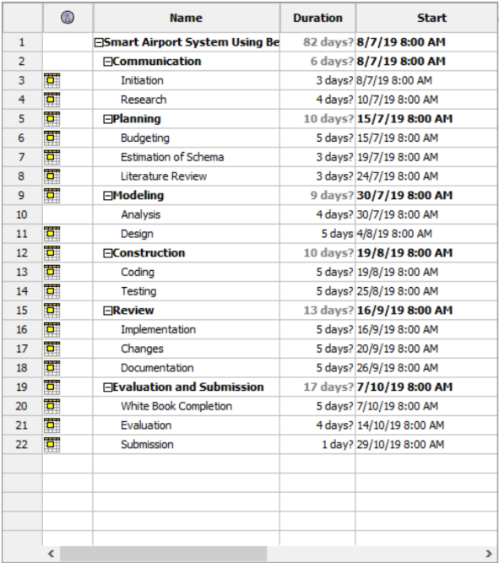

**Figure 4.1: Timeline 1**

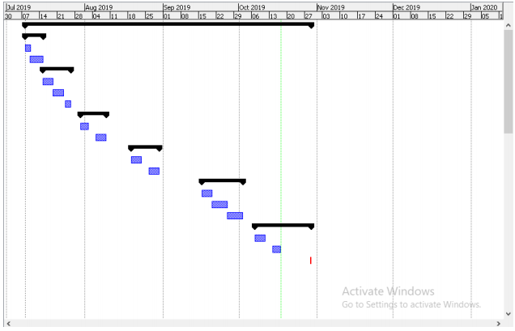

**Figure 4.2: Timeline 2**

**DESIGN**

**5.1 Architectural Design (Project flow/ architecture with description)**

# 

Fig. 5.1. System Design

1. **Door Management Module**

The door module has the functionality of counting the total number of users along with the

usage time per user and the total time of usage.

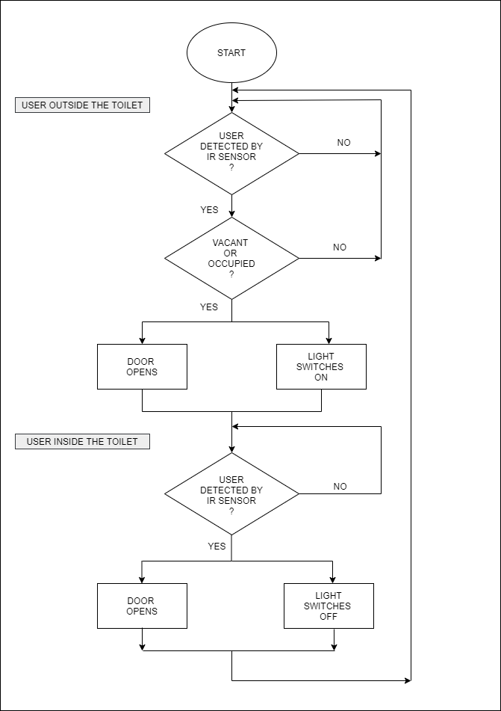

Fig. 5.2. Door Module

***B.) Water Management Module***

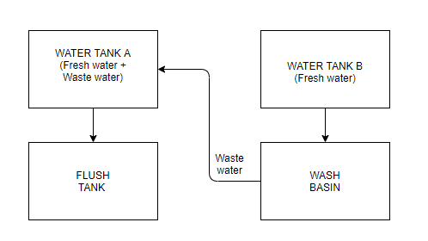

Fig. 5.3. Water Management Module

***C.) Water Level Monitoring Module***

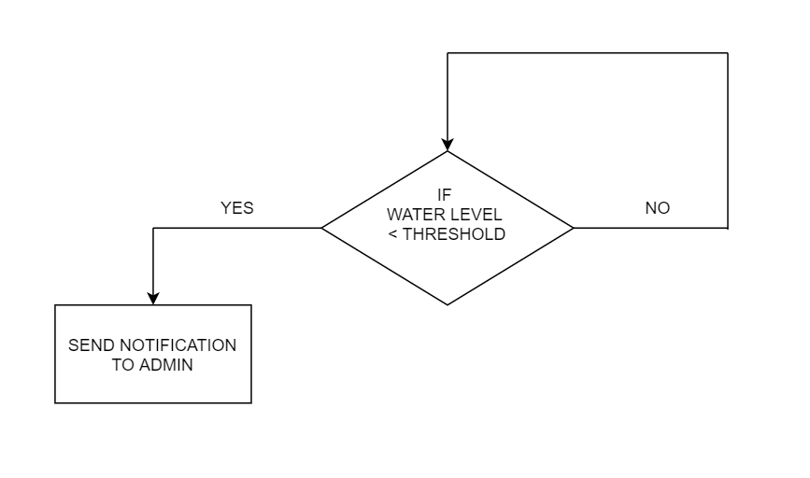

Fig. 5.4.. Water Level Monitoring Module

***D.)Garbage Monitoring Module***

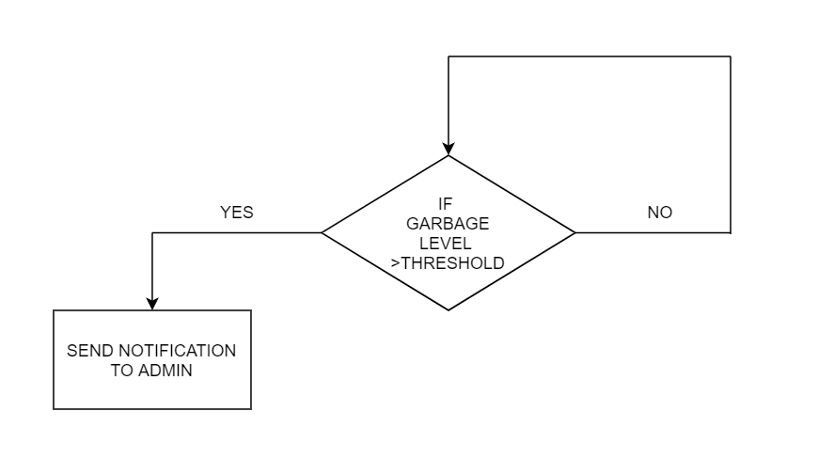

Fig. 5.5. Garbage Monitoring Module

**IMPLEMENTATION**

**6.1 Methods Used**

WORKING

The programming of the system is done using Arduino IDE and uploaded in Arduino UNO.

***A.)Door Module***

*1. Door Opening Mechanism*

In our proposed toilet system, there is an IR sensor outside the washroom which detects the user waiting outside and if the washroom is vacant, it sends a signal to start the servo motor to unlatch the door and also the system will automatically switch ON the light in the washroom. Then the servo motor again latches the door once the user enters the washroom.

*2. Door closing mechanism:*

When the user wants to exit the washroom, the system has an IR sensor inside the washroom that senses the user standing near the door and sends a signal to start the servo motor to unlatch the door and also the system will automatically switch OFF the light inside the washroom. Then the servo motor again latches the door once the user exits the washroom.

***B.) Water Management Module***

*1. Flushing Mechanism*

When the user is done using the toilet, he has to just hover over the Ultrasonic sensor to flush. In the flushing mechanism, once the ultrasonic sensor detects the presence of an object, it starts the servo motor which pulls the lever of the flush tank.

*2. Hand wash Mechanism*

In this part, when the user places his hand under the tap, the sensor senses it and starts pumping water from the water tank B using a submersible water pump. The dirty water from the basin is then pumped back to water tank A using another submersible water pump. This water is later reused for flushing.

*3. Water Level Monitoring Module*

The entire system has two tanks, water tank A for flushing and Water tank B for hand wash. Both these tanks have moisture sensors immersed in them which are used to monitor the water level inside the tanks. If the water level falls below a set value then it will notify the person- in-charge via a text message sent with the help of a GSM Module.

***C.)Garbage Monitoring Module***

In this part, the lid of the garbage can has an ultrasonic sensor attached to it. This sensor senses the depth uptil which the garbage can is full. If the garbage can gets filled higher than the set depth then the system will notify the person-in-charge via a text message with the help of a GSM Module.

***D.)Hand dryer Module***

Here, when the user places his hand under the hand dryer, the IR sensor inside the hand dryer senses it and switches on the 12 V cooling fan that is attached. However, with the use of nichrome wire, the hand dryer.

**6.2 Working of the project (code for the mentioned system)**

*A.) Door Management and Garbage Monitoring Module*

//for door mechanism

#include <Servo.h>

Servo myservo; // create servo object to control a servo

boolean toDisable1 = false;// to enable the outside IR sensor (irPin1) in the start

boolean toDisable2 = true;//to disable the inside IR sensor (irPin2) in the start

int irPin1=2;

int irPin2=4;

int count=0;//to count the number of people using the toilet

unsigned long startTime = 0;

unsigned long perUserTime = 0;

unsigned long totalUsageTime = 0;

//for garbage can

const int trigPin = 6;

const int echoPin = 7;

long duration;

int distanceCm;

void setup() {

Serial.begin(9600);

//for door mechanism

myservo.attach(5); // attaches the servo on pin 9 to the servo object

myservo.write(0);// send servo to the middle at 90 degrees

pinMode(irPin1, INPUT);// assign pin 2 as input for first IR sensor

pinMode(irPin2, INPUT);// assign pin 4 as input for second IR sensor

pinMode(9, OUTPUT);// defind pin 10 as output

digitalWrite(9, HIGH);// turn the pin 10 LOW i.e. LED outside the toilet for VACANT

pinMode(10, OUTPUT);// defind pin 10 as output

digitalWrite(10, LOW);// turn the pin 10 LOW i.e. LED outside the toilet for OCCUPIED

pinMode(11, OUTPUT);// defind pin 10 as output

digitalWrite(11, LOW);// turn the pin 10 LOW i.e. LED inside the toilet foe indicating light bulb

//for garbage can

pinMode(trigPin, OUTPUT);

pinMode(echoPin, INPUT);

}

void loop() {

//door mechanism

while(digitalRead(irPin1) == LOW && toDisable1 == false){ // to open and close the door for coming inside the toilet

Serial.println("Entering the toilet");

startTime = millis();

digitalWrite(11, HIGH);// turn the pin 11 HIGH (give it 5v)i.e. bulb LED

myservo.write(90); //servo position 90 degree

delay(4000);

myservo.write(0); //servo position 0 defree

delay(1000);

digitalWrite(9, LOW);// turn the pin 9 LOW (give it 0v)i.e. vacant LED

digitalWrite(10, HIGH);// turn the pin 10 HIGH (give it 5v)i.e. occupied LED

toDisable1 = true;// to disable the outside IR sensor

delay(5000);//keeping a five second delay before enabling the inside IR sensor

toDisable2 = false;//to enable the inside IR sensor

}

while(digitalRead(irPin2) == LOW && toDisable2 == false){ // to open and close the door for coming out of thr toilet

count= count+1;

Serial.println("Exiting the toilet");

myservo.write(90); //servo position 90 degree

delay(4000);

myservo.write(0); //servo position 0 defree

delay(1000);

digitalWrite(9, HIGH);// turn the pin 9 HIGH (give it 5v)i.e. vacant LED

digitalWrite(10, LOW);// turn th pin 10 Low (give it 0v)i.e. occupied LED

digitalWrite(11, LOW);// turn th pin 11 Low (give it 0v)i.e. bulb LED

delay(5000);//keeping a five second delay before enalbing the outside IR sensor

toDisable1 = false;// to again enable the IR sensor outside the washroom

toDisable2 = true;//to again disable the IR sensor inside the washroom

Serial.print("Number of people that have used the toilet:");

Serial.println(count);

perUserTime = (millis() - startTime)/1000;

Serial.print("User ");

Serial.print(count);

Serial.print(" usage time in seconds: ");

Serial.println(perUserTime);

totalUsageTime = totalUsageTime + perUserTime;

Serial.print("Total Usage Time in seconds: ");

Serial.println(totalUsageTime);

}

//for garbage can

digitalWrite(trigPin, LOW);

delayMicroseconds(2);

digitalWrite(trigPin, HIGH);

delayMicroseconds(10);

digitalWrite(trigPin, LOW);

duration = pulseIn(echoPin, HIGH);

distanceCm= duration*0.034/2;

delay(100);

if(distanceCm<=4){

Serial.println("Garbage can is full");

SendSMS();

}

}

void SendSMS()

{

Serial.println("AT+CMGF=1"); //To send SMS in Text Mode

delay(1000);

Serial.println("AT+CMGS=\"+917972576561\"\r"); //Change to destination phone number

delay(1000);

Serial.println("Garbage can is full");//the content of the message

delay(200);

Serial.println((char)26); //the stopping character Ctrl+Z

delay(10000);

}

*B.) Water Management Module*

//for flushing mechanism

#include <Servo.h>

Servo myservo;

int flush_trig = 7;

int flush_echo = 8;

int servo = 11;

long flush_duration, flush_distance;

long a[3];

//for hand wash mechanism

const int handwash_trigPin = 9;

const int handwash_echoPin = 10;

const int handwash_relay = 5;

const int dirtywater_relay = 6;

long handwash_duration;

int handwash_distanceCm;

//for water level monitoring

int state = 0;

const int flush_tank_moisture_sensor = A2;

const int handwash_tank_moisture_sensor = A1;

void setup() {

//for flushing mechanism

myservo.attach(servo);

pinMode(flush_trig, OUTPUT);

pinMode(flush_echo, INPUT);

myservo.write(0); // servo position 0 degree

delay(1000);

myservo.detach();

//for handwash mechanism

pinMode(handwash_trigPin, OUTPUT);

pinMode(handwash_echoPin, INPUT);

pinMode(handwash_relay, OUTPUT);

pinMode(dirtywater_relay, OUTPUT);

digitalWrite(handwash_relay, LOW);

digitalWrite(dirtywater_relay, LOW);

Serial.begin(9600);

}

void measure()

{

digitalWrite(flush_trig, LOW);

delayMicroseconds(6);

digitalWrite(flush_trig, HIGH);

delayMicroseconds(15);

digitalWrite(flush_trig, LOW);

pinMode(flush_echo, INPUT);

flush_duration = pulseIn(flush_echo, HIGH);

flush_distance = (flush_duration/2) / 29.1;

}

void SendSMS()

{

Serial.println("AT+CMGF=1"); //To send SMS in Text Mode

delay(1000);

Serial.println("AT+CMGS=\"+919422667850\"\r"); //Change to destination phone number

delay(1000);

Serial.println("Low Water Level in Tank");//the content of the message

delay(200);

Serial.println((char)26); //the stopping character Ctrl+Z

delay(10000);

}

void loop() {

//the flushing mechanism

for (int i=0;i<=2;i++) {

measure();

a[i]=flush_distance;

delay(50);

}

flush_distance=(a[0]+a[1]+a[2])/3;

Serial.print("Flush distance= ");

Serial.println(flush_distance);

if ( flush_distance<10 ) // change this value to increase or decrease detection range.

{

myservo.attach(servo);

delay(1);

myservo.write(90); //servo position 90 degree

delay(2000);

myservo.write(0); //servo position 0 degree

delay(1000);

myservo.detach();

}

//the hand wash mechanism

digitalWrite(handwash_trigPin, LOW);

delayMicroseconds(2);

digitalWrite(handwash_trigPin, HIGH);

delayMicroseconds(10);

digitalWrite(handwash_trigPin, LOW);

handwash_duration = pulseIn(handwash_echoPin, HIGH);

handwash_distanceCm= handwash_duration*0.034/2;

delay(100);

//Serial.println(handwash_distanceCm);

if(handwash_distanceCm<=10){

Serial.println("RELAY 1 has started");

digitalWrite(handwash_relay, LOW);

delay(1000);

Serial.println("RELAY 2 has started");

digitalWrite(dirtywater_relay, LOW);

delay(100);

}

else{

digitalWrite(handwash_relay, HIGH);

delay(1000);

digitalWrite(dirtywater_relay, HIGH);

delay(100);

//for water level monitoring

float moisture_percentage_1;

int sensor_analog_1;

sensor_analog_1 = analogRead(flush_tank_moisture_sensor);

moisture_percentage_1 = ( 100 - ( (sensor_analog_1/1023.00) * 100 ) );

Serial.print("Moisture Percentage in Tank A= ");

Serial.print(moisture_percentage_1);

Serial.println("%");

delay(1000);

if(moisture_percentage_1 < 10)

SendSMS();

float moisture_percentage_2;

int sensor_analog_2;

sensor_analog_2 = analogRead(handwash_tank_moisture_sensor);

moisture_percentage_2 = ( 100 - ( (sensor_analog_2/1023.00) * 100 ) );

Serial.print("Moisture Percentage in Tank B= ");

Serial.print(moisture_percentage_2);

Serial.println("%");

delay(1000);

if(moisture_percentage_2 < 10)

SendSMS();

}

}

**RESULTS AND DISCUSSIONS**

In the below figure,the total number of people using the toilet is counted along with the usage time per user and the total time of usage.

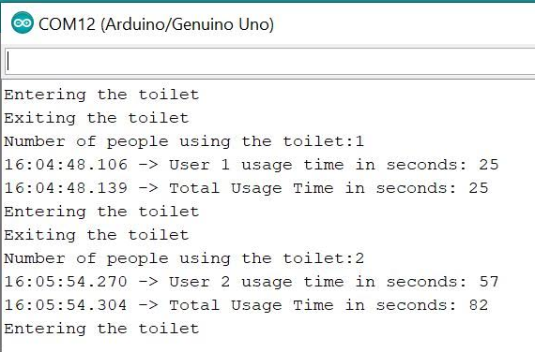

Fig. 8.1. Serial monitor indicating the total number of users and the total time of usage

As shown in Fig.7, a message indicating a low water level in the water tank is sent to the person-in- charge via a GSM module.

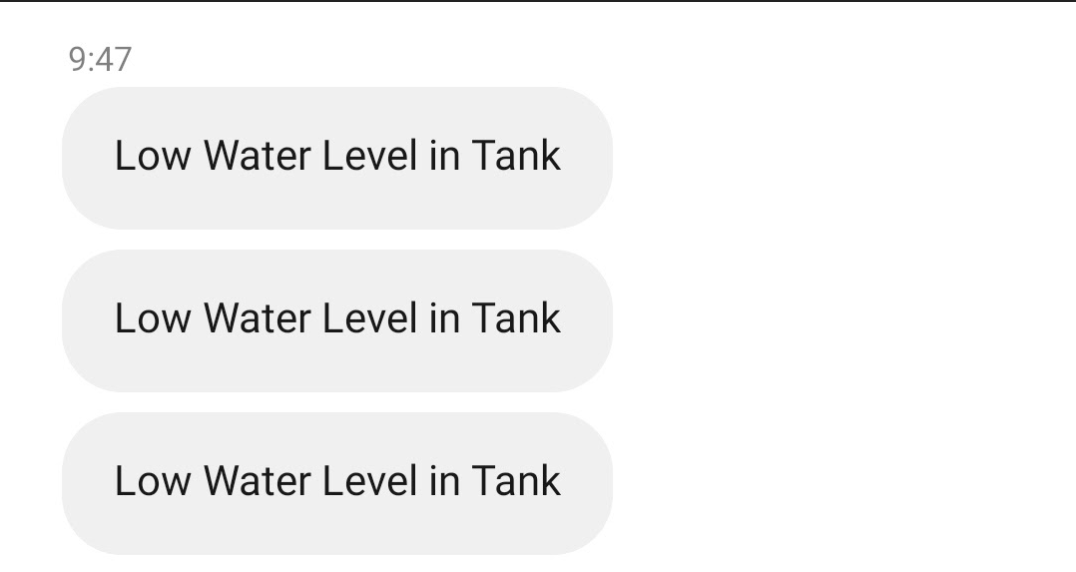

Fig. 8.2. Low water level notification is sent via a SMS

As shown in the below figure, a message is sent to the person-in-charge when the garbage bin is full.

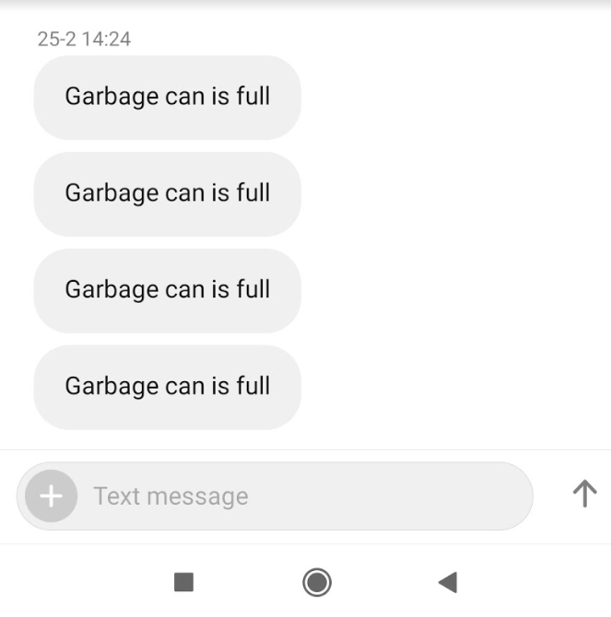

Fig. 8.3. Notification is sent when the garbage bin is full

**CONCLUSIONS & FUTURE SCOPE**

##### Hence, the system provides for a Swachh, Hygienic Smart Toilet. Our proposed project helps to avoid health issues created by open defecation and will create awareness among the people about proper sanitation. .It makes use of IOT, which is a rapidly growing technology. Our system maintains hygiene along with conservation of electricity and water .Thus by using technologies in a smarter way, we can maintain cleanliness which is next to godliness.

##### The proposed model further would have advancements in terms of design and functionality. Therefore for the future work an odor sensor for smell detection along with an automatic deodorizer can be a part of the system. Specifications for the gases to be detected can be made more

**LITERATURE CITED**

[1] V.Sudha, N.Jeba, R.Akiladevi, ”A Survey on the Modern Technologies used in Public Toilets”, International Journal of Recent Technology and Engineering (IJRTE), vol. 7, November 2018.

[2] K.Dharmesh, P.Pratik,P.Akshay,L.Gauri,B.Aita ”SMART TOILET” , International Journal of Electrical, Electronics and Data Communication, vol. 6, no. 5,pp. 71-74, May-2018.

[3] K.Osathanunkul,K.Hantarkul,P.Pramokchon,P.Khoenkaw and N. Tantitharanukul, ”Design and implementation of an automatic smart urinal flusher”,International Computer Sci-

ence and Engineering Conference (ICSEC), Chiang Mai, pp. 1-4, 2016.

[4] K.Elavarasi, V.Suganthi and J.Jayachitra, ”Developing smart toilets using Iot” , International Journal of Pure and Applied Mathematics, vol. 119, no.14, pp. 611-618, 2018.

[5]Nafeesa Muntashar, Sahana KN, Saniya Shilledar, ”Smart urinal mech-automatic flush”,Journal of Emerging Technologies and Innovative Research (JETIR), vol. 5, no.

6,June 2018.

[6] S Mohamed Ashiq,K Karthikeyan,S Karthikeyan,”Fabrication of Semi Automated Pressurized Flushing System in Indian Railway Toilet”,International Journal of Engineering and Advanced Technology (IJEAT), ISSN: 2249 – 8958, Volume-2, Issue-3,pp. 240-244, February 2013.

[7] R Kanesaraj Ramasamy, Venushini Rajendran, Sevangthi Murthy,”SMART TOILET: An IoT Implementation for Optimization of Resources”,Knowledge Management

International Conference (KMICe),pp. 111-116, 25 –27 July 2018, Miri Sarawak, Malaysia.

[8]Priti Falke, Pooja Hunge, Kisan Manmothe,”Smarter Restroom for Visitors Using IOT”,International Journal for Research in Applied Science & Engineering Technology (IJRASET),ISSN: 2321-9653,Volume 7 Issue V,May 2019.

[9]Mithya V, Divya Prabha.N, Sisma Samlein S, Madhumitha M,” Smart Toilets using Turbidity Sensor”,International Journal of Innovative Technology and Exploring Engineering (IJITEE),ISSN: 2278-3075, Volume-8 Issue-5S,pp. 413-417, March 2019.

[10] Madhurima Santra, Sanjoy Biswas, Sibasis Bandhapadhyay, Kaushik Palit,” Smart Wireless water level Monitoring & Pump controlling System”,International Journal of Advances in Scientific Research and Engineering (ijasre),ISSN: 2454-8006,Vol. 03, Issue 4,pp. 186-196,May -2017.

[11] F.Lan, G.Zhai, W.Lin,”Lightweight smart glass system

with audio aid for visually impaired people”, TENCON 2015, January.

[12] .P.Panek, G.Edelmayer, Christian Daye and W.L.Zagler, “Concept and Evaluation Methodology of Adjustable Toilets for Old Persons and People with Disabilities”, The 3rd European Medical and Biological Engineering Conference, EMBEC’05, Pg. 20-25, November 2005.

[13] [Saptarshi Dutta](https://swachhindia.ndtv.com/author/saptarshidutta/) ,Swachh Bharat Abhiyan: Can India Become Open Defecation Free By 2019?,May 30, 2017.Accessed on: February 4, 2020. [Online].

Available:<https://swachhindia.ndtv.com/swachh-bharat-abhiyan-can-india-become-open-defecation-free-by-2019-7566>

**ACKNOWLEDGEMENTS**

We would like to thank our respected teachers, especially our project guide Prof. Grinal Tuscano, for the time-to-time guidance, encouragement, valuable suggestions, insights, and new ideas