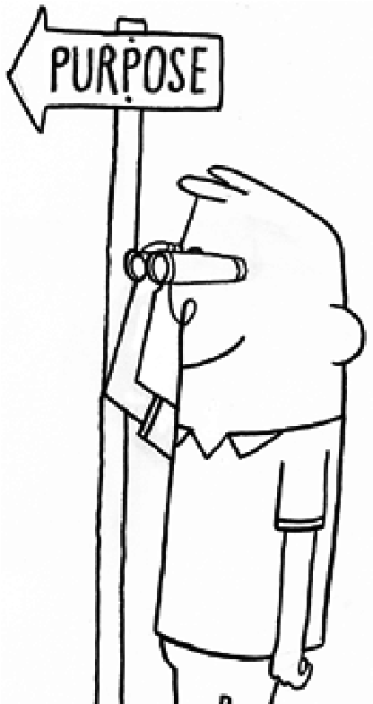

WWW.UNSTUCK.COM/PURPOSE

_

PRACTICE

2

.

CONSIDER YOUR OPTIONS

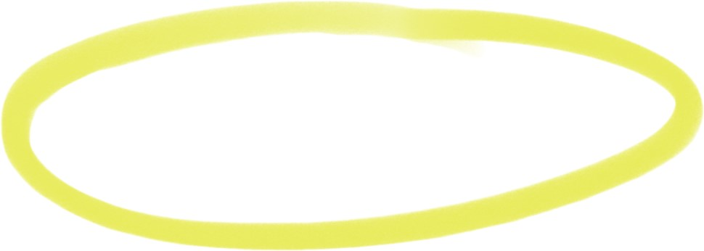

WHAT HAVE YOU DECIDED

IS YOUR PURPOSE?

Now, connect each possibility with as many or few core values as apply.

You’re looking for the opportunity that best matches your values.

1.

2.

3.

4.

5.

List your core values based

on your answers to #1

Core values are your foundational beliefs,

ways to think and act that are more important

to you than anything else.

List your opportunities

Think small as well as big or medium,

personal as well as professional,

dreams as well as realities.

1.

2.

3.

4.

5.

PURPOSE PRACTICE SHEET

*1.*

*What motivates me to get up*

*in the morning?* My alarm clock.

*2.*

*What keeps me up at night?* Anxiety.

*3.*

*What am I doing when I’m*

*at my best?* When I’m competing in games.

*4.*

*Why am I bothered by what*

*bothers me?* The oligarchy.

*5.*

*Why do I do the work I do?* To eat.

*6.*

*Why do I live where I live?* No therapy.

*7.*

*Why do I buy what I buy?* To eat.

*8.*

*Why do I long for what I long for?* Joy.

*9.*

*Why do I read and watch what I do?* Curiosity.

*10.*

*Why do I admire whom I admire?* Beauty.

*11.*

*When am I happy?* When I forget.

*12.*

*Why do I have the relationships*

*that I have?* Coincidence.

.

1

PINPOINT YOUR VALUES

To investigate what’s truly important

to you, answer the questions below

(

expanded from a set in

*Life Reimagined*

,

Berrett-Koehler, 2013). Take your time.

Go from your gut. And write them down

on the back.

.

3

MAKE ROOM FOR WHAT YOU LOVE

Think about your purpose. What do you need more or less of to achieve it?

Refer to your answers in #1 for guidance.

Maximize

Minimize

2.

3.

1.

2.

3.

**Live better every day**

4

.

FILTER BY PURPOSE

When you’re feeling out of sorts about

what’s going on in your life, or if you’re

trying to decide if a new opportunity

fits your purpose, use these questions

to filter through to an answer.

• What core value does this fit with?

• What level of excitement do I have

about this?

• Will/does this distract from something

else that is very important to me?

• How might this play out in the future?