Task- 3
Hacker Rank
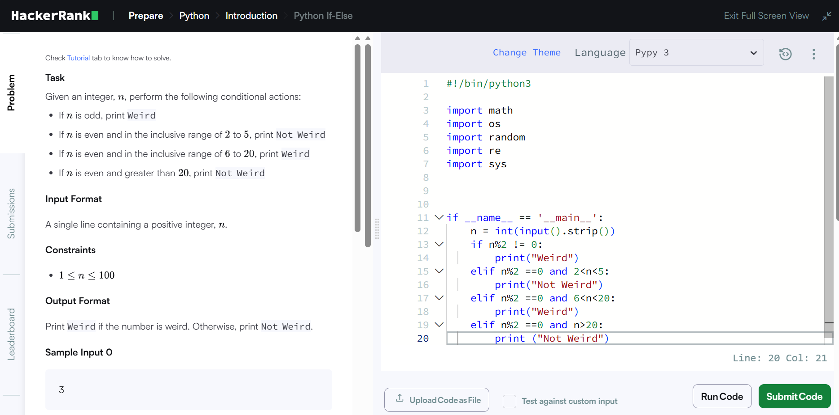

Google Form
https://docs.google.com/forms/d/e/1FAIpQLSfNj8dxjgwvr8HdBcT3ckS0cM6Nk_L3I1jRh2YTfwrITeBqFQ/viewform?usp=header
