# Hands on Assignment PowerBI

SQL Database Created

Relationship Diagram

1.

Merged

Data Loaded

Hierarchy

Filter

Calculated Columns

3. Avg Price by Category

6th. Percentage of products

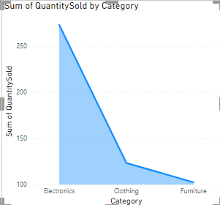

9th.

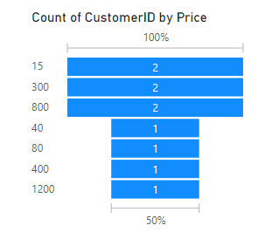

10th.

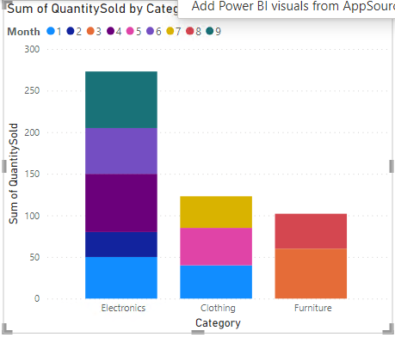

5th

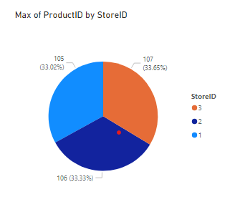

8th

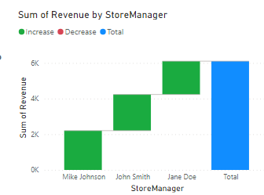

2nd

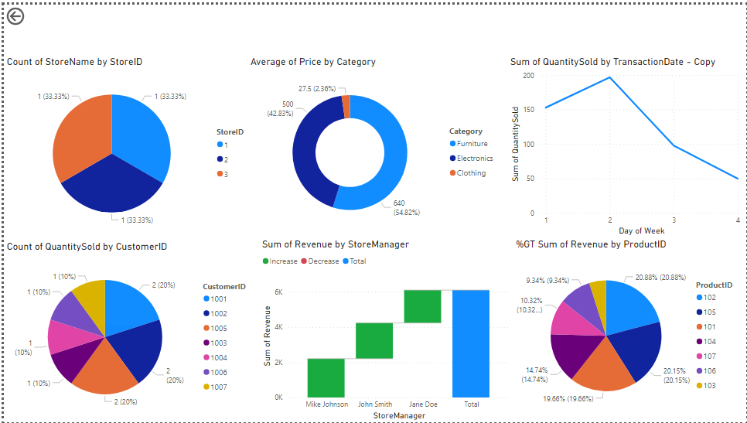

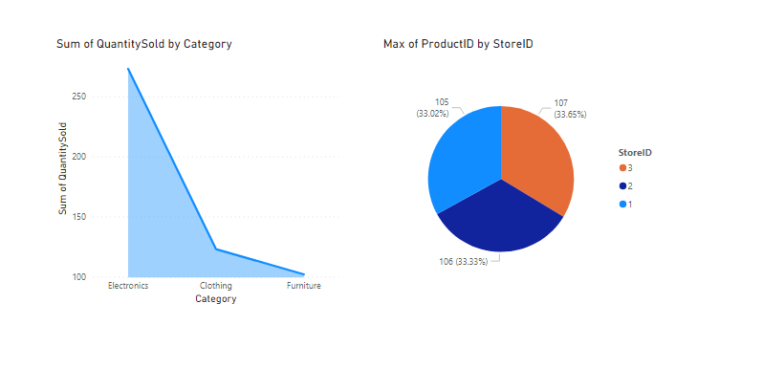



Create Visual Stories: Total Visualization

Analyze Patterns: Tuesday has the highest sale

Generate Insights: As the sales of electronics good are the highest, and customer buy the most between price ranges 15-800, the company should release more electronics products in that range.

There should be more sales on Tuesday and on the months when sales are the highest i.e. 4th and 9th months.