Activity 19

NAME : Rhema Daphne E G COURSE : Mobile Computing
Reg No : 192321097 COURSE CODE: ITA0301

Develop a user interface prototype for an Android application using Figma.

Aim:
To Develop a user interface prototype for an Android application using Figma. Procedure:
- Create a file
- Add The First Frame
- Add Shapes
- Add Text
- Create The Second Frame
- Add Prototyping

Step By Step Procedure : Interface Of Experiment:
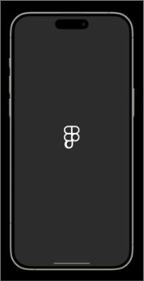

Next Page:

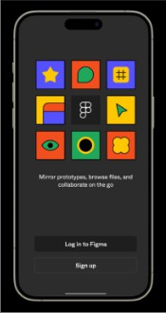

Login And Signup Page:
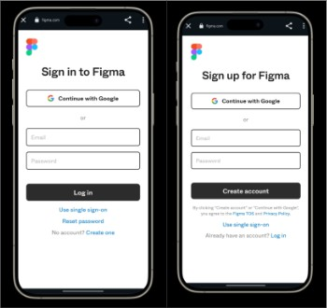

Final Step:

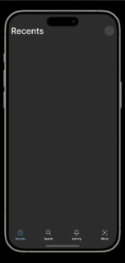

Prototype:
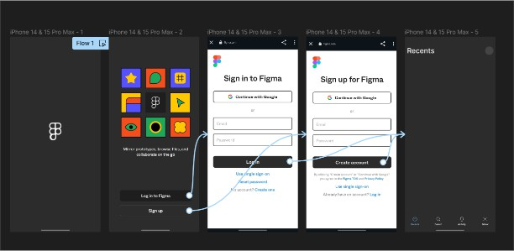

Result:
Hence the Develop a user interface prototype for an Android application created and executed successfully

