**How To Craft Your Company Vision**

Great companies have a clear and distinct DNA that pervades their culture, their brand, their marketing, and the very fabric of the organisation. They stand for something, have personality, achieve great things, and have fun along the way.

**In order to define and amplify your company DNA, you need to first develop your Vision.**

This is arguably the most powerful and important foundational principle for you to get right in your business. Why?

As entrepreneurs and business owners, our #1 role is to provide leadership to everyone around us - great leaders, not just in business but in life, lead people to some place. But you cannot lead someone somewhere unless you know where you are going.

Crafting a Vision is about knowing where you are going, getting everyone on the same page, and inspiring them towards one common purpose. And when you get this right, you will start to tap into an essence that is far more powerful than just business. It is about finding a purpose that is bigger than you, and enlisting others to go on the journey with you.

Throughout this eBook, we’ll share with you the core principles, frameworks and questions you need to ask yourself, so you can develop a Vision that stands for something which matters, and that resonates with your audience. You’ll also discover how to become a Vision-driven leader, and lead from a place of inspiration, confidence and empowerment.

JOHN DYER:Increased His Revenue By $1 Million

Managing Director, Air Adventure Australia

| In just 12 months with The Entourage, John:  Increased the business’ annual revenue by an extra **$1 Million**  **Doubled** the size of his team  Achieved an incredible **NPS of 83**  Established a **Marketing and Sales process** to accelerate profitable growth for his business  Got crystal clear clarity on his **Vision, Mission and Values**, and now has **confidence and clarity** to lead his team |
| --- |

“Before I joined The Entourage, we were ticking along ok. We were growing - slowly. We had no strategy. We were blissfully ignorant to a lot of deficiencies within our business, and when it came to our Marketing and Sales, we were Australia’s best-kept secret.

Since joining The Entourage, **we’ve increased our revenue by an extra $1 Million**. **We’ve also doubled our team**, and they’re all tied into the vision of transforming the way our clients experience remote Australia. **Another exceptional result was that we achieved an NPS of 83**.

I think I was on auto-pilot. The Entourage flicked the switch for me - they’ve given me the tools and confidence to take control of my business.”

# **Table Of Contents**

Table Of Contents

About The Entourage

What Is Vision?

Examples Of Captivating Visions

The Entourage

Samsung

Ikea

Instagram

Amazon

5 Keys To Crafting A Captivating Vision

5 Questions To Answer To Develop A Captivating Vision

Question 1

Question 2

Question 3

Question 4

Question 5

How Your Vision Will Impact Your Business

# **About The Entourage**

* 3,500+ businesses transformed
* More than $2 billion generated for Australian businesses
* Across 150+ industries
* Online and worldwide community of 500,000+
* 40,000 attendees at our events
* Driven by Australia’s most passionate minds in business education

Since 2010, The Entourage has been Australia’s leading specialist business education institution for entrepreneurs, having transformed over 3,500 businesses and hosted more than 40,000 attendees at our suite of business events.

With a worldwide community of 500,000 and a growing list of Members and Alumni who pepper the list of Australia’s fastest-growing companies, including the **Deloitte Fast 50, BRW Fast Starters, Telstra Business Awards** and more, The Entourage has empowered thousands of entrepreneurs to build the business of the dreams and make their mark on the world.

At our core, The Entourage believes that entrepreneurs are the creators, innovators and dreamers that shape the very world we live in.

But we also believe that the traditional education system doesn’t empower or equip entrepreneurs with the tangible business skills it takes to drive growth or provide access to a like-minded community who truly gets what you’re going through each step of the way.

The Entourage is changing that through a new kind of business education. One that provides a personalised experience that builds both the entrepreneur AND their business by connecting them with elite entrepreneurs and industry experts with proven processes that achieve serious results.

As seen on:

*[list of business and media icons]*

“If you are working on something exciting that you really care about, you don’t have to be pushed.

The vision pulls you.”

Steve Jobs

Co-Founder of Apple

# **What Is Vision?**

Your Vision is your picture of the future and the **impact** your business will make on it.

The **contribution-centric purpose** the business has for existing.

The **difference** your business can make to the world.

The **North Star** you’re constantly steering towards.

# 

# **Examples Of Captivating Visions**

## The Entourage

To move the world forward through entrepreneurship.

## Samsung

Inspire the world. Create the future.

## Ikea

To create a better everyday life for the many.

## Instagram

Capture and share the world’s moments.

## Amazon

To be the world’s most customer-centric company, where customers can find and discover anything they might want to buy online.

# **5 Keys To Crafting A Captivating Vision**

1. **Your Vision needs to define and communicate the business’ highest purpose**  
     
   When we can do this, it means that we’re able to tap into something far more powerful than KPIs or any management metric. Instead, we start to tap into why each of us are here . When we do this, we reach a level of leadership that gets missed when we only speak quarter-by-quarter or year-by-year. Your Vision should be grand.
2. **You Vision needs to touch the hearts and minds of those who come into contact with it**  
     
   It doesn’t matter who you communicate it to, your Vision needs to inspire that person. If our #1 job as entrepreneurs is to lead and make decisions as to where we are going, then our #2 job is to be inspired, and to inspire. The extent to which you fulfill your Vision is the extent to which you can mobilise others towards it.
3. **Your Vision must inspire you personally**  
     
   You are the first person who needs to be inspired and excited by the Vision. When you can tap into a higher purpose, and your team can see you really mean what you talk about, they will be inspired - and that will ultimately enable you to achieve your success as a changemaker and as an entrepreneur.
4. **Your Vision must be contribution-centric**  
     
   This needs to make a difference, not to the world at large however. It could make a difference to your consumers or your community. Come at it from a scale that works for you and your business - but make sure that it focuses on other people and contribution.
5. **Your Vision does not necessarily need to be measurable**  
   What matters is that it inspires you, touches the hearts and minds of others, and that it is contribution-centric.

# ROBBIE & TAMARA TURNER: “Our business now operates when we’re not there”

Co-Founders, Axon Property Group

| Since joining The Entourage and implementing everything they have learnt, Robbie & Tamara:  Have **10Xed their business’ monthly revenue**  Grew their team from 4 people to **14 people**  Implemented **systems, structure and strategies** so the business can grow sustainably, and **without their direct involvement**  Can **take time away from the business**, and their team can still bring in revenue  Stepped up to be the **high-performance leaders** they knew they needed to be |
| --- |

“Before we joined The Entourage, we didn’t know what we were doing in our business. We weren’t operating within any lanes, we didn’t know who was doing what, we didn’t have an organisational chart or a budget. **We were flying by the seat of our pants and stepping on each other’s toes.**

We were scared of risk and of growing the business because **we didn’t know how to do it with processes, structures and strategy behind it.**

Once we started working with The Entourage, we immediately got the clarity and space we needed to work together on the growth of our business. We got out of each other’s ways and hired some incredible people to join our team.

**We’ve since 10Xed our monthly revenue.** The business isn’t just doing good in the here and now; we know it has longevity, sustainability, and we have a team of superstars around us so it can continue to grow and operate even if we’re not there.

The community of other 6, 7, and 8-figure business owners and experts that The Entourage has created has been **just the thing we needed to take our business to the next level.**”

# **5 Questions To Answer To Develop A Captivating Vision**

Buy yourself the space and the time to reflect on the following 5 questions. Start with just 30 minutes, and write freely on whatever comes to mind for you.

Remember, purpose comes from heart, not head. Go deep on these questions, get emotive on them, and understand that it may take you several attempts to craft your Vision.

## **Question 1**

**What are the emotional benefits your product or service provides to your consumer?**

## **Question 2**

**How does what you do in your business affect and improve people’s lives?**

## **Question 3**

**Why is this important to you?**

## **Question 4**

**What difference can your business make? What will it contribute to the world?**

## **Question 5**

**How can you summarise this into a succinct, powerful and inspiring sentence?**

“The extent to which you fulfill your vision is the extent to which you can mobilise other people towards it.”

Jack Delosa

Founder of The Entourage

# **How Your Vision Will Impact Your Business**

Those who are able to achieve great things are those who have developed the ability to touch the hearts and minds of people everywhere. **Vision** is just the first ingredient to bottle that magic within your organisation. **Mission** and **Values** are the second and third.

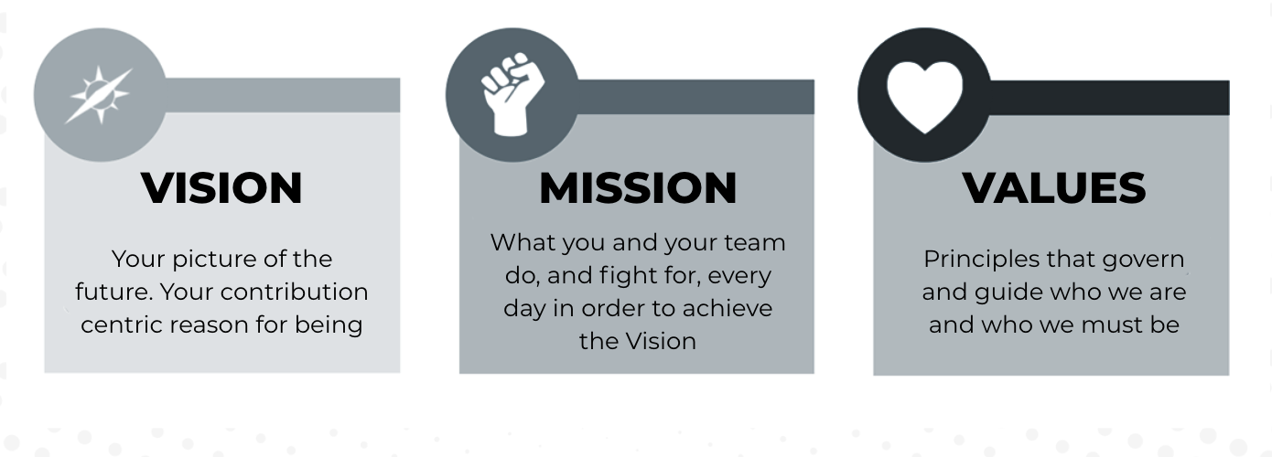

Get them right, and they will have a far-reaching impact on so many areas of your business, including:

1. Direction and strategy of the business
2. Branding and positioning
3. Marketing and messaging
4. Sales process and style
5. Product development and delivery
6. Customer service
7. Financial management and decisions
8. Recruitment process and selection
9. Induction and training
10. Ongoing management and leadership

While conversations around targets, deadlines and KPIs are necessary and important, if they aren’t underpinned by a greater sense of purpose, then your people will simply be doing tasks according to what you give direction on.

There is no power or magic in that, and there is certainly very little influence in that.

When you can show people the path forward, and the role they will play in the actualisation of it, **they move**.

SUNIL KUMAR:From $1 Million Annual Revenue To Over $16 Million In 3 Years

Founder & CEO, Reliance Real Estate

| With the help of The Entourage, Sunil’s business became one of the fastest-growing real estate agencies in Australia:  Annual revenue grew **from $1 Million to $16 Million in just 3 years**  Increased the **annual number of sales from 200 to over 1000** in that same time period  Grew his team **from 15 people in 1 office to over 100 people in 7 Reliance Real Estate offices**  Named **AFR’s #1 Fastest Growing Real Estate Company**  Named **AFR’s #8 Fastest Growing Company in Australia** |
| --- |

“The first few years of business at Reliance Real Estate were incredibly difficult.

I started the business in 2011, with one other partner, and when the industry was in decline. It was a struggle to pay the bills. I even considered going back to a safe and steady job.

And even when the business did experience periods of growth, I didn’t have all the answers I needed to take it to another level.

With the help of The Entourage, **the business became the fastest-growing real estate agency in Australia.**

The Entourage provided me with the structure and clarity I needed to grow the business, and my leadership, exponentially.

The main result has been in me. **I’ve changed as a leader** - I’m leading from the front, and providing my team with the right opportunities for growth.”