**Sales Psychology Guide**

How Tapping Into Emotions Will Move Your Prospects To Paying Customers

**No one likes to be sold to.**

(In fact, “sales” died in the eighties). We all want to buy a car and own a car, but no one wants to be *sold* a car. We’d love to buy and own a home, but we don’t want to be *sold* a home.

And while you might have the best product or service to offer your prospective customers, confidently demonstrating its value can be challenging, and at times, uncomfortable.

As a result, too many business owners let the prospect dictate the sales conversation. This doesn’t serve the potential customer, because it means that the business that can supply the help they need is providing very little leadership in the decision-making process. And it doesn’t serve the business itself because it creates an unpredictable sales cycle, which means that the sales conversation might go on for an hour, a week, or in some cases even months.

The good news is that anybody can learn how to be influential in sales and provide leadership to their prospects, simply by using the right strategies.

Rather than focusing on “selling” or pushing your product or service to your ideal customer, you need to create an attraction model that will drive people to you.

**The key here is tapping into your prospect’s emotions.**

This isn’t about being salesy or pushy - quite the opposite. It’s about communicating with people in a way they like to be communicated with, so that you can inspire and lead the way. We’ve shared our most successful models in this eBook to help you do exactly that.

KATE PRIOR:Increased Her Profit From $100K to $600K

Owner and Managing Director, Face2Face Recruitment

| With the help of The Entourage, Kate:  Increased her annual profit from **$100,000 to $600,000 in just 6 months**  Won the **Australian Small Business Champion Award** for Recruitment Services  Was named a finalist in the **Telstra Business Awards**  And **2Xed her team** from 11 to 22 (which included hiring an Operations Manager to free up Kate’s time) |
| --- |

“I’ve been running my business for 13 years, and there were a series of events in 2011 that almost took me down. I didn’t know if I could keep going with the business, and I had to see my financial advisor every day to see if we could keep operating.

For me, The Entourage gave me the tools I needed to reinvent myself and be the person I needed to be to elevate the company to new levels.

When I first spoke with The Entourage team, I told them I wanted to increase the profit from $100,000 to $500,000. **We’re on track to make a profit of over $600,000. I’ve increased my team from 11 to 22, freeing up my time.** We’ve also won the Australian Small Business Champion Award for Recruitment Services, and a Telstra Business Award.

# We’re now playing a bigger game. The business is bigger than ever. **I’ve had to rewrite every process because the growth of the business is just so monumental.**”

# **Table Of Contents**

Table Of Contents

About The Entourage

Understanding The Human Brain And Using That To Your Advantage

Green Brain Vs. Red Brain

Green Brain Modelling: View This From The Eyes Of Your Audience

The Four Forces To Attraction

Putting This Into Practice

# 

# **About The Entourage**

* 3,500+ businesses transformed
* More than $2 billion generated for Australian businesses
* Across 150+ industries
* Online and worldwide community of 500,000+
* 40,000 attendees at our events
* Driven by Australia’s most passionate minds in business education

Since 2010, The Entourage has been Australia’s leading specialist business education institution for entrepreneurs, having transformed over 3,500 businesses and hosted more than 40,000 attendees at our suite of business events.

With a worldwide community of 500,000 and a growing list of Members and Alumni who pepper the list of Australia’s fastest-growing companies, including the **Deloitte Fast 50, BRW Fast Starters, Telstra Business Awards** and more, The Entourage has empowered thousands of entrepreneurs to build the business of the dreams and make their mark on the world.

At our core, The Entourage believes that entrepreneurs are the creators, innovators and dreamers that shape the very world we live in.

But we also believe that the traditional education system doesn’t empower or equip entrepreneurs with the tangible business skills it takes to drive growth or provide access to a like-minded community who truly gets what you’re going through each step of the way.

The Entourage is changing that through a new kind of business education. One that provides a personalised experience that builds both the entrepreneur AND their business by connecting them with elite entrepreneurs and industry experts with proven processes that achieve serious results.

As seen on:

*[list of business and media icons]*

# **Understanding The Human Brain And Using That To Your Advantage**

Entrepreneurs don’t get into business to become great at sales. And yet, sales is the #1 skill you need to start, grow and scale your business.

Simply put, sales is finding out how someone likes to receive information, and giving it to them in such a way that they can make a decision. In doing so, you position yourself and your business as the “go-to” leader in your industry, and build up an audience who feels compelled to engage with you.

The first step in this process is to create an emotional connection with the person you’re speaking with. Here are some ways you can do that.

## 

# **Green Brain Vs. Red Brain**

The human brain can be divided into two parts or sides.

The left part is the “logical” or “analytical” side. At The Entourage, we call this the **Red Brain**. Why? Because, when we see a red light, we stop and look for warning signs and reasons to not proceed.

When the language (verbal or written) or imagery you use in your sales process locks your prospect into the logical side of the brain, it slows down their ability to make buying decisions, and increases procrastination.

In essence, “Red Braining” is when you talk to the part of the brain that makes a prospect analyse the details, facts and figures about your products and/or services. It prompts them to start thinking of reasons why your product or service can’t or won’t work for them, as opposed to reasons why it would.

Engage someone in the right, or the creative and emotional side of the brain, and the opposite happens. We call this the **Green Brain**, because when you appeal to your prospect’s emotions, there are no warning signs to slow down their decision-making.

Their response to the emotional connection you’re creating with them is action - they want to fulfil the emotional desire that your product or service has created for them.



| Logical | Emotional |
| --- | --- |
| Analytical | Creative |
| Increases procrastination | Faster decision-making |
| Processes specific features, timeframes, detail, methods, the ins and outs of your product or service | Emotionally wired to act based on feelings. Fills the emotional desire that has been created. |
| Comprehends the facts, figures and data | Needs-based questions that focus on emotions |
| Slows down the ability to make timely decisions, buy into concepts, and the pace of becoming engaged | Gives permission to go. They buy in, want it, understand why they need it, and the conversation becomes “let’s do it now.” |

DANIELLA DIONYSSIOU and NATALIA SUESSKOW: From 7 To 8 Figures In 6 Months

Co-Founders, Verge Girl

| Within 6 months of joining The Entourage, Daniela and Natalia:  Grew their business **from 7 to 8 figures** in revenue and experienced **100% year-on-year growth**  Began to work as a **true team and leaders**, by focussing on developing their complementary strengths  Have developed a **Marketing Strategy**, with structure for the growth of their business  Now have **confidence in their decision-making** at the scale stage |
| --- |

“In the last six months since working with The Entourage, **we’ve already gone from a 7-figure business, to an 8-figure business.**

Within the first week with the Entourage, we did a full business analysis. We looked at where we are, and where we want to be.

Ultimately, the biggest change for us since joining The Entourage has been around confidence; **we’re all feeling confident** and are super excited for the future.

We always knew that there was potential, but **we didn’t know how to unlock it.** But now, with the help of The Entourage, we feel like **we’ve got the keys and we know what to do.**

**There is nothing that The Entourage can’t help you with.**”

# **Green Brain Modelling: View This From The Eyes Of Your Audience**

**Remember, people make decisions emotionally and justify them logically.**

You need to engage both parts of the brain to help your prospects reach a decision.

Start by looking at the language you’re already using (whether that’s verbal, in conversations with your prospects, or written on your website), and ask yourself the following 3 questions:

1. What do you do?
2. What is the outcome of what you do in the eyes of your customer?
3. And what effect does that outcome have?

You want to make sure you’re **focussing on communicating the effect** of the outcome to your prospective customers.

Start with this and lace everything you do with as much Green Brain language as you can - that way, you’ll position yourself and your business in a way that attracts people *to* you.

**Red Brain / Green Brain** can be used as a foundation for everything you do in your business. From your marketing copy to your sales scripts, product names and descriptions, this is a model that will strongly serve you in building relationships with your prospects.

Here’s an example or some common Red Brain words and language that businesses typically use, plus a suggestion for how you can Green Brain one of them.

Review the language you’re using to connect with your prospects, and take note of what you might be able to Green Brain in your own business and communications.

| **Red Brain Words & Language** | **Green Brain Words & Language** |
| --- | --- |
| Pay | Look after / Take care of / Fix up |
| Direct debit |  |
| Appointment |  |
| Contract |  |
| Proposal |  |
|  |  |
|  |  |
|  |  |
|  |  |
|  |  |
|  |  |
|  |  |
|  |  |
|  |  |
|  |  |
|  |  |
|  |  |

SUNIL KUMAR:From $1 Million Annual Revenue To Over $16 Million In 3 Years

Founder & CEO, Reliance Real Estate

| With the help of The Entourage, Sunil’s business became one of the fastest-growing real estate agencies in Australia:  Annual revenue grew **from $1 Million to $16 Million in just 3 years**  Increased the **annual number of sales from 200 to over 1000** in that same time period  Grew his team **from 15 people in 1 office to over 100 people in 7 Reliance Real Estate offices**  Named **AFR’s #1 Fastest Growing Real Estate Company**  Named **AFR’s #8 Fastest Growing Company in Australia** |
| --- |

“The first few years of business at Reliance Real Estate were incredibly difficult.

I started the business in 2011, with one other partner, and when the industry was in decline. It was a struggle to pay the bills. I even considered going back to a safe and steady job.

And even when the business did experience periods of growth, I didn’t have all the answers I needed to take it to another level.

With the help of The Entourage, **the business became the fastest-growing real estate agency in Australia.**

The Entourage provided me with the structure and clarity I needed to grow the business, and my leadership, exponentially.

The main result has been in me. **I’ve changed as a leader** - I’m leading from the front, and providing my team with the right opportunities for growth.”

# **The Four Forces To Attraction**

Once you’ve locked your prospect into the Green Brain, you’ll want to know how to best communicate with them to progress the sales conversation.

To simplify this, we organise how and what should be communicated into four quadrants. We call this **The Four Forces To Attraction.**

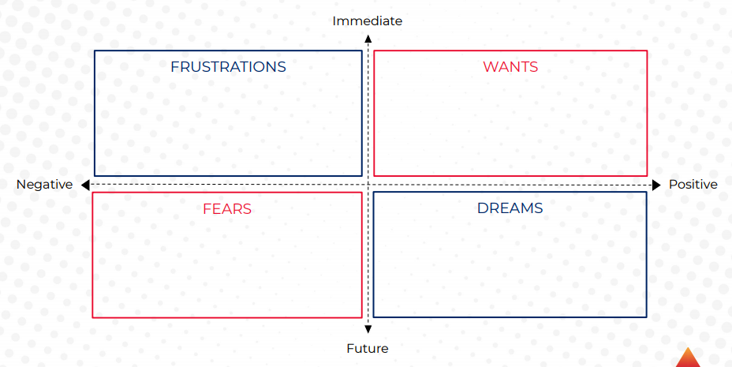

In the vertical axis, you have the **Immediate** and the **Future**, followed by **Negative** and **Positive** on the horizontal axis. These axes represent the feelings and emotions of your prospects.

To best communicate with your audience and articulate your offerings, start in the top-left quadrant (between Negative and Immediate). This top left quadrant symbolises the understanding of your customers’ **Frustrations** - what are the immediate frustrations your customers have? Talk with them about those first.

Next, you next want to discuss any future **Fears** they have (the lower left quadrant, between Negative and Future). Why? If you don’t eliminate their immediate frustrations, these future fears will be created.

Moving to the top right-hand quadrant, what you want to do next is understand what your prospect’s immediate **Wants** are (between Immediate and Positive). Nobody wants frustrations, so you need to uncover what their immediate wants and motivators are.

Finally underneath that is **Desires** (between Positive and Future); what future desires are there following the attainment of their immediate wants?

Communicate with your prospects in this order - Frustrations, Wants, Fears and Desires - and you’ll create an attraction model where people will want to work with you and respond to anything that you do.

# 

# 

# **Putting This Into Practice**

Your goal is to create a buying mindset in your prospects, instead of a selling mindset in you and your sales team.

How you position yourself throughout the sales process is critical to achieving this. If you don’t create an emotional connection with them from the outset, you will turn them away before you get the chance to present your product or service, lose deals and leave money on the table.

Understanding the psychology of your consumer is a critical first step. Build Green Braining language and follow the Four Forces To Attraction model into your sales process, and you’ll be able to help them buy more, without you having to “sell.”

JOHN DYER:Increased His Revenue By $1 Million

Managing Director, Air Adventure Australia

| In just 12 months with The Entourage, John:  Increased the business’ annual revenue by an extra **$1 Million**  **Doubled** the size of his team  Achieved an incredible **NPS of 83**  Established a **Marketing and Sales process** to accelerate profitable growth for his business  Gained the **confidence and clarity** to lead his team |
| --- |

“Before I joined The Entourage, we were ticking along ok. We were growing - slowly. We had no strategy. We were blissfully ignorant to a lot of deficiencies within our business, and when it came to our Marketing and Sales, we were Australia’s best-kept secret.

Since joining The Entourage, **we’ve increased our revenue by an extra $1 Million**. **We’ve also doubled our team**, and they’re all tied into the vision of transforming the way our clients experience remote Australia. **Another exceptional result was that we achieved an NPS of 83**.

I think I was on auto-pilot. The Entourage flicked the switch for me - they’ve given me the tools and confidence to take control of my business.”