Rheno Rayhan F.D.P.

2I-TI / 22 / 2141720157

**Kuis 2**

**Statistic Computation**

1. Standard normal distribution

X = 290

μ= 281.67

σ = 323.07

Z-Score

Z= $\frac{(x- μ)}{σ}$

Z= $\frac{(290-281.67 )}{323.07}$

Z = 0.0257839

Cumulative probabilty = 0.5091

P = 0.5091100

Or approximately equal to **1.033 x 10-11**

1. Confidence interval

x̄ = 53.56

n = 25

σ2 = 1948.24

Standard deviation = $\sqrt{1948.24}$ ≈ 44.15

Confidence interval = 53.56 ± 2.064 x $\frac{44.15}{\sqrt{25}}$

Standard error = $\frac{44.15}{\sqrt{25}}$ = 8.83

Confidencce Interval = 53.56 ± 2.064 x 8.83

= 53.56 ± 18.20

= **35.36 v 71.76**

1. Total Pokemon Who have been caught = 698

Total Pokemon Who have Fled = 17

Caught standard deviation = 0

Fled standard deviation = 0

Harley testing = Biggest variance / smallest variance

**There are no variance on the dataset because the dataset only consists of each ‘1’ (caught) and ‘0’ (flee) which makes it impossible to prove the Harley test result.**

1. Test value = 0.0973

p-value = 0.05

Confidence coefficient = 0.08

**p-value < Confidence coefficient**, which means that **the sample is not normally distributed**

1. 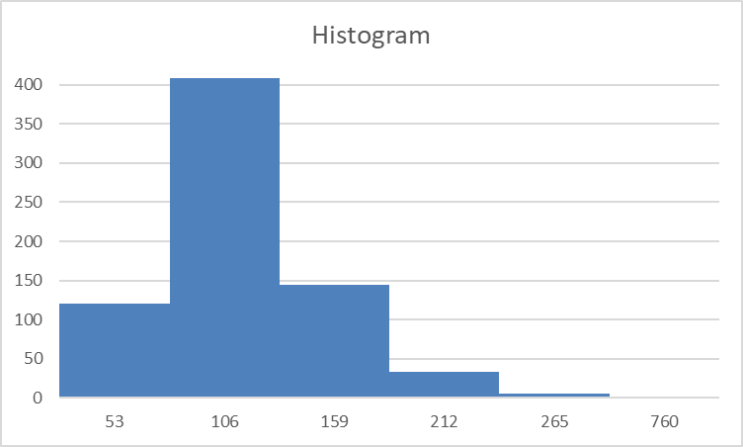

266-760

213-265

160-212

107-159

54-106

0-53

1. Test value = 0.0825

p-value = 0.0009

Confidence level = 99%

Confidence coefficient = 99/100 = 0.99

**p-value < Confidence coefficient**, which means that **the sample is not normally distributed**

1. 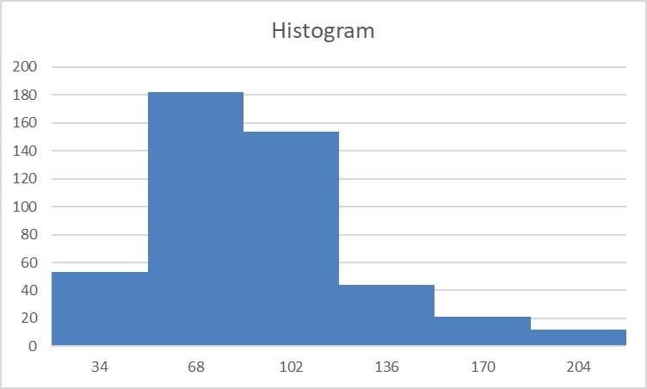

0-34

35-68

69-102

103-136

137-170

171-204