**COMP SCI 4HC3**

**DESIGN Project Milestone #1**

**Proposal and Software Survey**

Marek Ceglowski - 1150038

David Elsonbaty - 1141043

Mathew Wood - 1138343

Rhett Amin - 1060085

For our final project we would like to design a user interface for a wallpaper database for desktop and mobile devices. Such a database would hold a very large amount of images that users can access to use as backgrounds on various devices. In the optimum case, these images would need to be stored in various sizes to account for several different aspect ratios. Tags should be attached to these images in order to categorize and to aid users in searching for similar images.

The reason why we would like to design the UI for a wallpaper database is because a very popular website used for this was recently shut down due to the costs of hosting the server became too much for the developer. When we searched for alternative websites for the same task, we found websites that didn’t quite meet our standards.

We are hoping to build a platform where the user can easily find a wallpaper that they like and that does not require a lot of time in order to do so. In order to make the user’s search fast and reliable, we will narrow down as many options the average user would be required to take. Our platform will eliminate the need of selecting your device’s resolution by only providing wallpapers of your current device’s resolution, this will also eliminate the frustration of not finding your device’s resolution for the images you like, as they will not be displayed. This feature will be used primarily for mobile devices, and will allow the user to find a desired wallpaper without searching for their device’s resolution.

Another feature that our front-end database application will have will be searching with keywords. Different keywords will point the user to a subset of wallpapers related to what they typed using tags attached to each image. Each search will provide other suggested search keywords to the user so that they can explore similar subsets of wallpapers that they may be interested in. This helps the user find more wallpapers without actually having to think of proper search keywords. These suggested search results can help fix a problem that other wallpaper databases have, which is not being able to find any results when the user’s search can not be found.

Another feature will be liking and flagging Images. With the ability to flag, and like your favourite wallpapers, our project will be able to provide the best suggestions for users by creating an algorithm that matches your taste in wallpapers with others and suggesting other wallpapers they have liked.

In Conclusion, we feel like this project will showcase the design principles learned in class, and will create an effective user interface that is better than current wallpaper database websites. With this project we hope to find a UI that will help users find wallpapers for their devices easily, and quickly, without any hassles.

**VladStudio**

Vladstudio is the personal website for Vlad Gerasimov. On his site he has games, merchandise, and what most people visit his site for desktop wallpapers. Each of the 100+ wallpapers are drawn and designed by the artist himself. The website itself is clean and easy-to-use, and is very consistent in terms of layout and functionality. Visibility is very high on this website. Navigating to the wallpaper section, and then to the desired style of wallpaper (Desktop, 2 monitors, 3 monitors, mobile devices) is easy, and clearly displayed. Feedback is also very high on this site, as shown when selecting different styles of wallpapers. When switching between styles the website displays each wallpaper in the resolution it would be in those styles but on a smaller scale. The website is really well done and is easy to find a wallpaper that you would like, though since each wallpaper is made by the artist, you can only download a certain style of wallpaper. It is only possible to download what the artist has created, and there are no categories to separate the different wallpapers, so finding the one you want, if you wanted to find a specific one is hard. Overall this website is good if you were looking for a certain style of wallpaper with time on your hands.

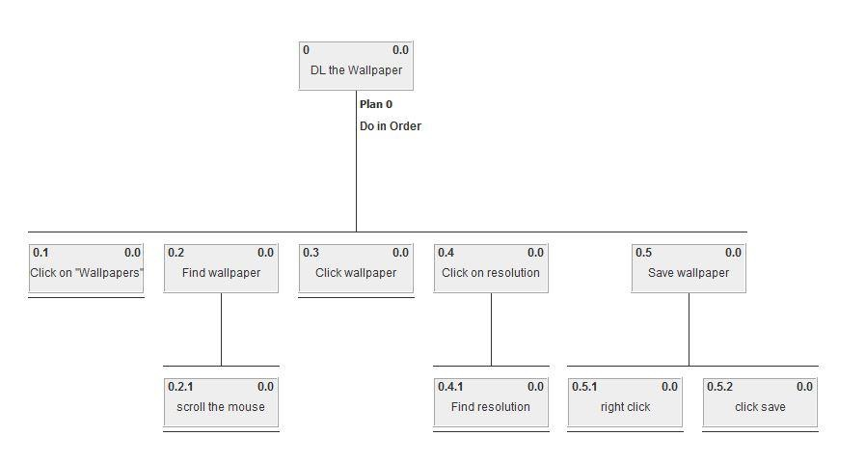

Figure 1 - Downloading a wallpaper

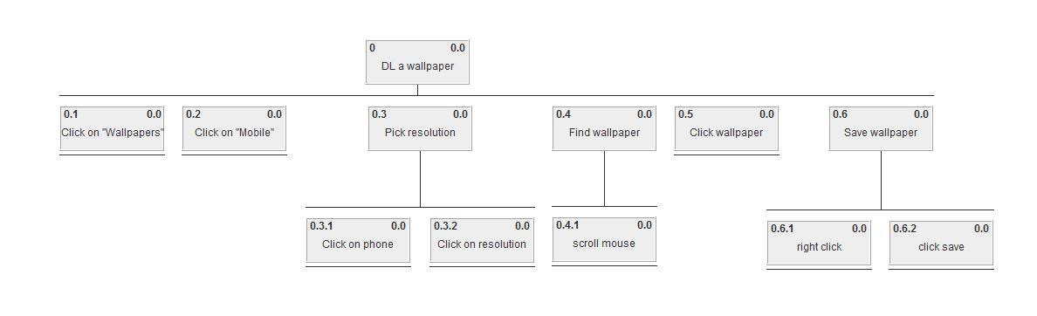

Figure 2 - Downloading a wallpaper for mobile devices

**SocWall**

In regards to the visual presentation of SocWall, the website is generally well laid out. The amount of columns of images shown on a single page is dependent on the width of the user’s browser window (to a minimum of 1 column). The total amount of wallpaper images on any one page remains constant. Copyright and contact information of the developers are shown at the bottom of every page. A consistent toolbar with the title and several useful buttons are presented in a header. When a user tries to use the website to search for an image they are able to type in a few keywords into a search bar or sort images by categories. Anyone can upload an image to contribute to the database. When uploading images there aren’t any constraints to prevent people from uploading inappropriate images or images that don’t have suiting titles. There also isn’t a way for the uploader to attach tags to their own images, making it harder on the administrator of the database, leaving that task up to them. Many of the images are title: “...” with the artist “Unknown Artist”. This leaves room for a desired constraint that should be reinforced when uploading an image. Upon further investigation, the title field is now required when uploading, but “...” can still be entered. Perhaps the developer should consider limiting what can be accepted as a title. There is a rating system where users can vote up or vote down a particular image. However it is not possible to sort wallpapers by these ratings which seems like a lot of wasted potential. There are no affordances that lead the user to believe that the “Browse” button is infact a drop-down menu containing a list of categories that the images can be sorted by.

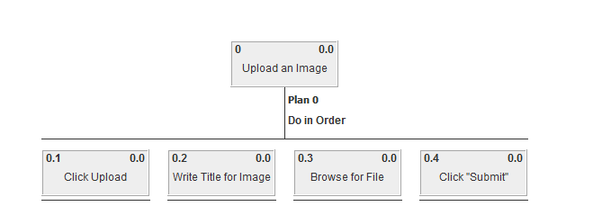

Figure 1 - Uploading an Image

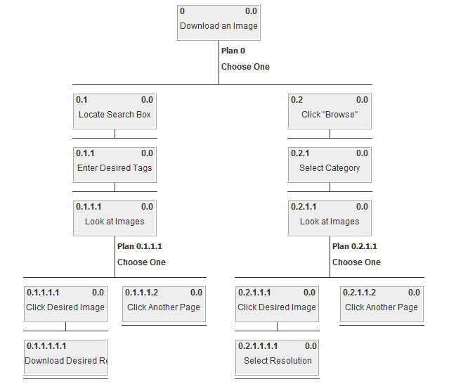

Figure 2 - Downloading an Image

**InterfaceLift**

InterfaceLift is a wallpaper, theme and icon website designed for free public use. It includes a variety of tags that direct the user to different pages. These tags are organized into tag types allowing the user to find tags based on a style of wallpaper they want. The users can submit their own wallpapers and vote on other submissions. The layout is minimal and functional, but is not especially eye catching. Visibility is pretty good as you can clearly see different sections, various sizes for wallpapers, tags, and more. There are very few items that are not visible right away, however one of these includes searching of wallpapers because the search bar is really small and off to the side where the user doesn't usually look. Feedback is good but minimal as most elements on screen stays static. There are a few things that change with user input such as the current chosen resolution of a wallpaper and the search bar on the side. You must download the wallpaper directly in order to view it in its full resolution. The website is well down, however its selection in wallpapers is limited as compared to other wallpaper services and it is missing a few functions that would be useful for users. One such function is an advanced search that allows users to find wallpapers based on various types of criteria (such as searching all wallpapers with a specific tag attached, or wallpapers uploaded after a specific date). Their search function makes it easy to find general wallpapers but finding a specific wallpaper is difficult because the search is not refined.

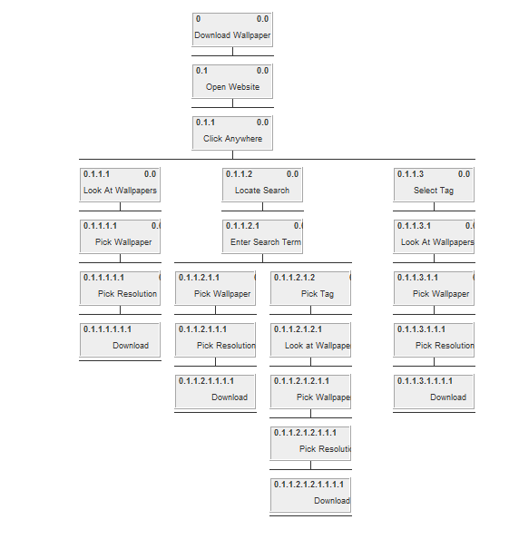

Figure 1 - Downloading a Wallpaper

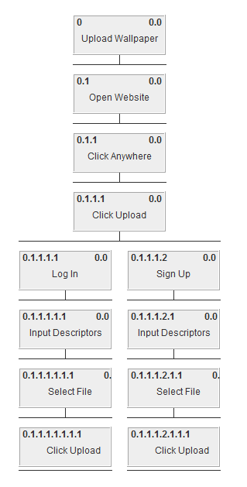

Figure 2 - Uploading Wallpaper

**WallDB**

WallDB is a simple wallpapers hub with an aim to share HD wallpapers. It is currently very early stage and has a few features down the roadmap. The website has a much simpler look and feel than its competitors but unfortunately, the website lacks many crucial features such as photo categories and its current searching ability is not functional. The website is heading in the right direction, some feature which it offers and does well is having the user select their desired wallpaper resolution ahead of choosing wallpapers which eliminates the frustration of not finding the right screen resolution most of the time users find a wallpaper they like. Although the website offers users to favourite their likings, the only way for users to find wallpapers is to scroll through the random home screen wallpapers which is very inefficient.

