**DESIGN Project Milestone #3 Report**

|  |  |  |  |
| --- | --- | --- | --- |
| David Elsonbaty  Student # 1141043  Mac ID: elsonbd  [elsonbd@mcmaster.ca](mailto:elsonbd@mcmaster.ca) | Rhett Amin  Student # 1060085  Mac ID: aminr4  [aminr4@mcmaster.ca](mailto:aminr4@mcmaster.ca) | Marek Ceglowski  Student # 1150038  Mac ID: ceglowm  [ceglowm@mcmaster.ca](mailto:ceglowm@mcmaster.ca) | Mathew Wood  Student # 1138343  Mac ID: woodmjm  [woodmjm@mcmaster.ca](mailto:woodmjm@mcmaster.ca) |

# ABSTRACT

We have created a new wallpaper website based on Norman's principles in order to provide computer-users with a quick and easy way to download wallpapers for use on their computers. We then let participants try out an early development version of the website and surveyed their opinions on what its like to use our wallpaper site. We have outlined results and discuss the impact of our results in comparison to the webpage. In this document we also discuss related works and describe what a wallpaper website entails.

## Author Keywords

Wallpaper, website, categories, search, layout, menu, page, user-friendly, resolution, visibility, feedback, constraints, mapping, consistency, affordance.

# INTRODUCTION

With the recent closure of “wallbase.cc”, a popular image gallery database, the market for websites that serve the same function in a similar effective way is limited. Most similar websites have clunky, cluttered, and unappealing layouts and navigating to what you want or finding what you want is sometimes a challenge. This is something we wanted to solve with “Walleee”. We wanted to solve the issue, by creating a cleaner, more user-friendly, interface that helps the user quickly find the image they wa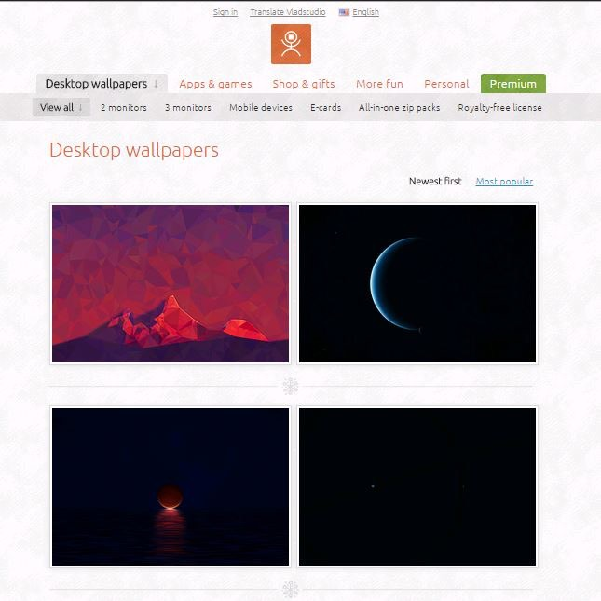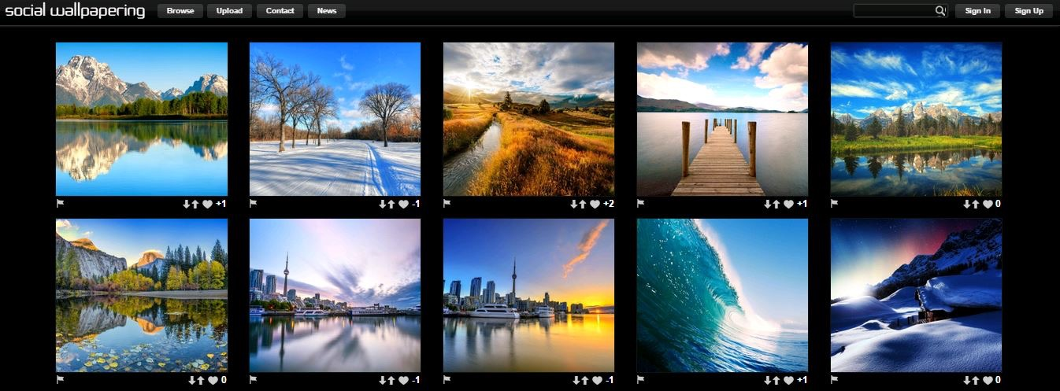nt, in the desired resolution, and to create a more enjoyable fluid experience.

**Figure 1. *VladStudio (***[**http://www.vladstudio.com/home/**](http://www.vladstudio.com/home/)***)***

**Figure 2. *SocialWallpapering (***[**http://www.socwall.com/**](http://www.socwall.com/)***)***

This document will go over the design and reasoning in regards to the creation and implementation of the website, its contents, functions, and layout. It will also showcase related websites to the project and show how the layouts and/or functionality for the websites are not efficient and require a better iteration. The document will also go over the results of our survey targeted at determining the usability of our layout, a discussion on the project, and our final conclusion.

# Related works

When determining the layout and functionality for Walleee, several similar websites were observed to assess their work, and to formulate a better more efficient format throughout the designing process. Four websites in particular were observed more so than the other others, these websites were: Vladstudio (Figure 1), Social Wallpapering (Figure 2), InterfaceLift (Figure 3), and WallDB (Figure 4).

Vladstudio is the personal website for Vlad Gerasimov. Each of the 100+ wallpapers are drawn and designed by the artist himself, and the website itself is clean and easy-to-use, and is very consistent in terms of layout and functionality. The website is really well done, it’s clean and provides the necessary functionality. Even with its clean interface and easy to navigate menus the website lacks categories for the images, and the only images to be found are the ones done by the artist himself. Our interface took a note from this site, in terms of how clean the interface is. In regards to the visual presentation of Social Wallpapering, the website is generally well laid out. A consistent toolbar with the title and several useful buttons are presented in a header. When a user tries to use the website to search for an image they are able to type in a few keywords into a search bar or sort images by categories. This website offers some good design choices except for the buttons, as 4 of the 6 are dropdown menus and the other 2 take you to another section of the website. The website also has a dull feeling to it. Apart from these issues, the website helped us with our design process, in terms of layout and design choices.

InterfaceLift is a wallpaper, theme and icon website designed for free public use. The layout is minimal and functional, but is not especially eye catching. There are very few items that are not visible right away, however one of these includes searching of wallpapers because the search bar is really small and off to the side where the user doesn't usually look. There are a few things that change with user input such as the current chosen resolution of a wallpaper and the search bar on the side. You must download the wallpaper directly in order to view it in its full resolution. The website is well done, however its selection in wallpapers is limited as compared to other wallpaper databases and it is missing a few functions that would be useful for users. One such function is an advanced search that allows users to find wallpapers based on various types of criteria. Their search function makes it easy to find general wallpapers but finding a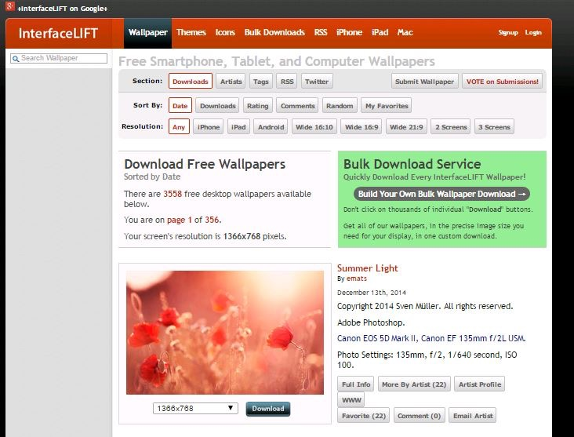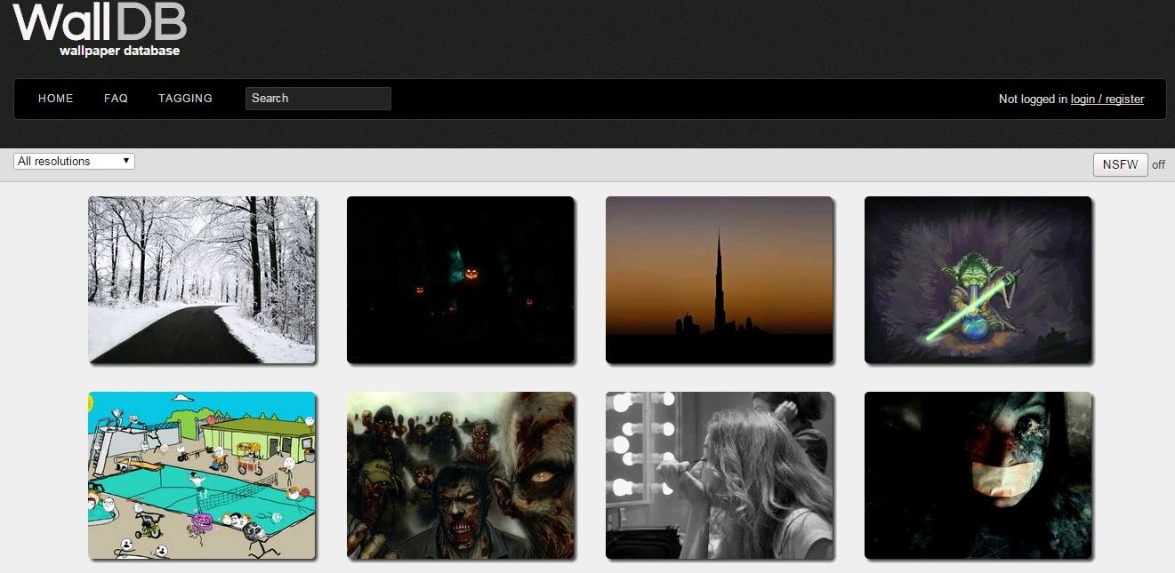 specific wallpaper is difficult because the search is not refined. In terms of functions we pulled some ideas from this website, but in terms of everything we didn’t refer to it, except in the case of “What not to do”.

**Figure 4. WallDB (**[**http://walldb.net/wallpapers/**](http://walldb.net/wallpapers/)**)**

**Figure 1. Results of the usability testing question “I was never confused on the function of the controls.”**

**Figure 3. Interfacelift (**<https://interfacelift.com/>**)**

WallDB is a simple wallpapers hub with an aim to share HD wallpapers. It is currently very early stage and has a few features down the roadmap. The website has a much simpler look and feel than its competitors but unfortunately, the website lacks many crucial features such as photo categories and its current searching ability is not functional. The website is heading in the right direction, some feature which it offers and does well is having the user select their desired wallpaper resolution ahead of choosing wallpapers which eliminates the frustration of not finding the right screen resolution most of the time users find a wallpaper they like. Although the website offers users to favourite their likings, the only way for users to find wallpapers is to scroll through the random home screen wallpapers which is very inefficient. This website is the closest design to our current iteration, though they are vastly different. Our design takes it a step further and creates a more unique layout, with similar functionality.

# Results

Unlike other wallpaper websites, our website’s simplicity and clarity resulted having the users find the functions of the controls to be very clear, this eliminated all ambiguity and confusion of the functionality of all unclear controls (see Figure 1). Our testers did not however find all the functionality desired from a wallpaper website in ours. Many found the need to filter images by resolution which was not implemented at the time. Although prohibition of some desired tasks were found, our design successfully eliminated prohibition from performing an invalid task. Our website’s simplicity has completely eliminated the introduction of invalid entries and tasks. Our testers found the placement of the controls to be ideal and make sense which has verified our design’s placement of controls and interface. The feedback of all inputs were obvious to our testers, with a 100% agreement on the statement “I was always aware of when my input was accepted or declined.” Although the testers found some commands to be missing, they have found the commands available to be easy to find and visible as opposed to hidden and misplaced. Our design has been found to be very consistent throughout the different pages from our testers. They have also found the website to be very intuitive, easy to navigate and use for the first time in a quick fashion. Lastly, the testers have moderately agreed that the layout of the wallpaper images and controls are setup in a way that is useful and intuitive.

# Discussion

Some of the elements of this website turned out very well and functioned the way that was intended. However, from the results, it seems clear that a few aspects of the website went wrong. Beginning from the top of the page, the website title is visible from every page and acts as a clickable button that will always return the user to the first page. This turned out as intended and provides a level of consistency that most websites similar to this one offer.

The profile button works for demonstration purposes. It brings the user to a page that shows all of their uploads, which can then be filtered by images uploaded more recently and images that have received more likes. The next step here would be to add a member database and a login system. The like button is completely broken. There is no way to tell as to what exactly is being liked or if anything actually happens when the button is clicked. A popup that appears on button click that lets the user know exactly what happened, or for the time being just letting the user know that the website acknowledged the button being clicked, is essential here. Although it contains a nice heart which is a good affordance as to what it does, it would still do well to put in a tooltip that appears on mouse hover or something similar that affirms the function of the button. The search bar has some pretty serious known bugs but provides enough feedback to let the user know that it is attempting to do something. Aside from the functional aspect of the search bar, the search button and like button appear to be attached. This looks good until the user attempts to resize the window. When the window gets too small, these three elements break apart and appear in a column. A good modification here would be to wrap the three elements together and prevent them from separating on screen resize.

The category buttons worked well functionally. Aesthetically speaking, the buttons do well until the user tries to resize the screen which results in the buttons becoming off centred. When the window gets too small the buttons print on separate lines, which is good, but the new line of buttons should also be centred. It would do well to have the buttons in a separate tool bar that is visible at all times either at the top or the side of the window. This improves the visibility of the controls so that the user does not have to scroll all the way back to the top of the page to browse a different category.

As for the images themselves, they appear off centred. It seems as though the images are organized in such a way to account for an extra column of images. Adding this last column would solve this problem. The function of reducing the number of visible columns upon screen resize was intended at works as planned. When an image is selected it comes up in a nice viewer, but effectively only zooms the image. Users aren’t able to save the image from this expanded view. It would do well to add a download button and options for which resolution to download the image in.

Lastly, there is a button that appears in the bottom right corner of the screen when the user’s view is below the search bar. This button returns the view to the top of the page in an effort to provide the user an easier way to return to the main controls of the website. The affordances for this button perform well as most people will understand the function of this button from the word “top” written inside of it. In terms of Norman’s principles of UI design, the website covers the affordances, constraints, and mappings aspects quite well. The main things that would be best to improve are the feedback, especially on the “like” button, and the visibility of controls. Other than that and a few problems with aesthetics, the website works as intended.

# Conclusion

We have taken a group of wallpaper websites and created one that follows Don Norman's principles of Human-Computer Interaction in order to make it easier for the average computer user to find a wallpaper for their desktop of choice. Our work is different from previous works because it specifically pays attention to Norman's principles when designing the website in order to ensure that users have a great experience when using the site. Other websites do not appear to follow all of Norman's principles in their design. What our website contributes to the field is a well-designed site that others can use as a guide when designing other websites that require similar layouts. In conclusion, our usability has enlightened us of the missing features which some potential users look for. It has also confirmed our website’s simplicity and consistency.