SIGCHI Conference Proceedings Format
Rhett Amin  Developer  23 Cline Ave South  rhettamin@gmail.com  (647)838-0043 | David Elsonbaty  Developer  Address  davidelsonbaty@gmail.com  Optional phone number | Mathew Wood  Developer  Address  e-mail address  Optional phone number | Marek Ceglowski  Developer  Address  Email  Phone numner

ABSTRACT
Updated 7/30/2014. In this sample paper, Sheridan Printing Co., Inc. describes the formatting requirements for SIGCHI Conference Proceedings, and this sample file offers recommendations on writing for the worldwide SIGCHI readership. Please review this document even if you have submitted to SIGCHI conferences before, some format details have changed relative to previous years.

Author Keywords
Guides; instructions; author’s kit; conference publication; keywords should be separated by a semi-colon.
Optional section to be included in your final version, but strongly encouraged.

ACM Classification Keywords
H.5.m. Information interfaces and presentation (e.g., HCI): Miscellaneous. See: http://www.acm.org/about/class/1998/ for more information and the full list of ACM classifiers and descriptors. Optional section to be included in your final version, but strongly encouraged. On the submission page only the classifiers’ letter-number combination will need to be entered.

INTRODUCTION
With the recent closure of “wallbase.cc”, a popular image gallery database, the market for websites that serve the same function in a similar effective way is limited. Most similar websites have clunky, cluttered, and unappealing layouts and navigating to what you want or finding what you want is sometimes a challenge. This is something we wanted to solve with “Walleee”. We wanted to solve the issue, by creating a cleaner, more user-friendly, interface that helps the user quickly find the image they want, in the desired resolution, and to create a more enjoyable fluid experience.
This document will go over the design and reasoning in regards to the creation and implementation of the website, its contents, functions, and layout. It will also showcase related websites to the project and show how the layouts and/or functionality for the websites are not efficient and require a better iteration. The document will also go over the results of our survey targeted at determining the usability of our layout, a discussion on the project, and our final conclusion.

Related works
When determining the layout and functionality for Walleee, several similar websites were observed to assess their work, and to formulate a better more efficient format throughout the designing process. Four websites in particular were observed more so than the other others, these websites were: Vladstudio, Social Wallpapering, InterfaceLift, and WallDB.
VladStudio—(http://www.vladstudio.com/home/)
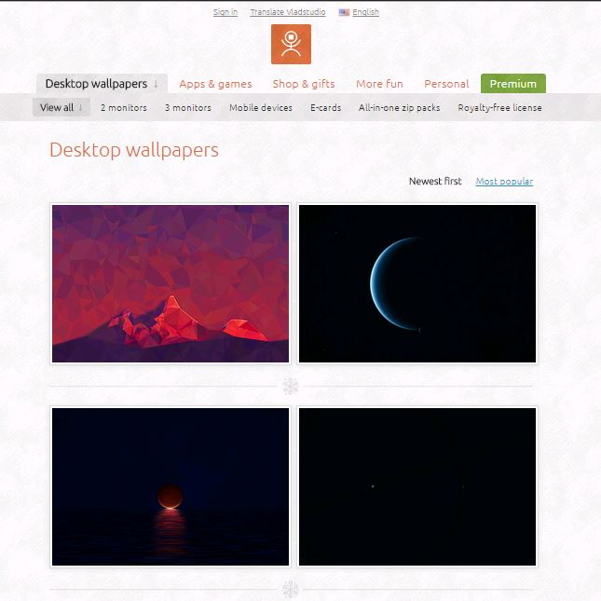
Vladstudio is the personal website for Vlad Gerasimov. Each of the 100+ wallpapers are drawn and designed by the artist himself, and the website itself is clean and easy-to-use, and is very consistent in terms of layout and functionality. The website is really well done, it’s clean and provides the necessary functionality. Even with its clean interface and easy to navigate menus the website lacks categories for the images, and the only images to be found are the ones done by the artist himself. Our interface took a note from this site, in terms of how clean the interface is.

SocialWallpapering—(http://www.socwall.com/)
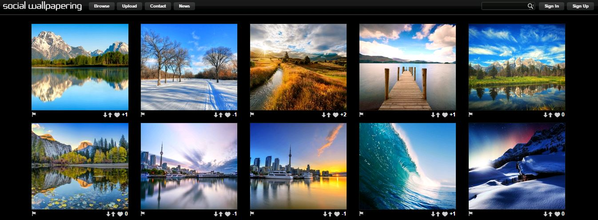
In regards to the visual presentation of Social Wallpapering, the website is generally well laid out. A consistent toolbar with the title and several useful buttons are presented in a header. When a user tries to use the website to search for an image they are able to type in a few keywords into a search bar or sort images by categories. This website offers some good design choices except for the buttons, as 4 of the 6 are dropdown menus and the other 2 take you to another section of the website. The website also has a dull feeling to it. Apart from these issues, the website helped us with our design process, in terms of layout and design choices.

Interfacelift—(https://interfacelift.com/)
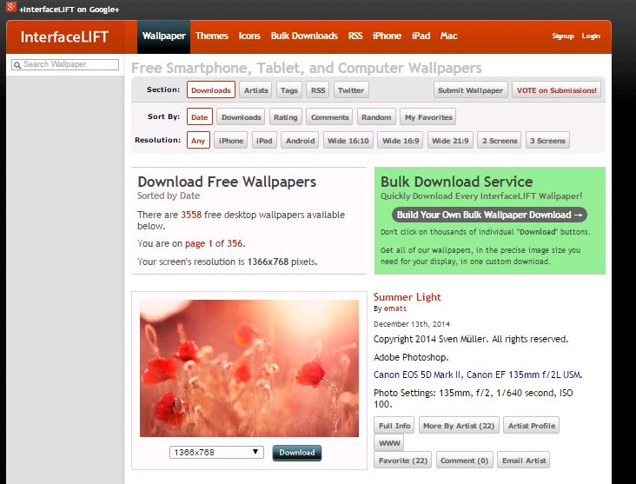
InterfaceLift is a wallpaper, theme and icon website designed for free public use. The layout is minimal and functional, but is not especially eye catching. There are very few items that are not visible right away, however one of these includes searching of wallpapers because the search bar is really small and off to the side where the user doesn't usually look. There are a few things that change with user input such as the current chosen resolution of a wallpaper and the search bar on the side. You must download the wallpaper directly in order to view it in its full resolution. The website is well done, however its selection in wallpapers is limited as compared to other wallpaper databases and it is missing a few functions that would be useful for users. One such function is an advanced search that allows users to find wallpapers based on various types of criteria. Their search function makes it easy to find general wallpapers but finding a specific wallpaper is difficult because the search is not refined. In terms of functions we pulled some ideas from this website, but in terms of everything we didn’t refer to it, except in the case of “What not to do”.

WallDB—(http://walldb.net/wallpapers/)
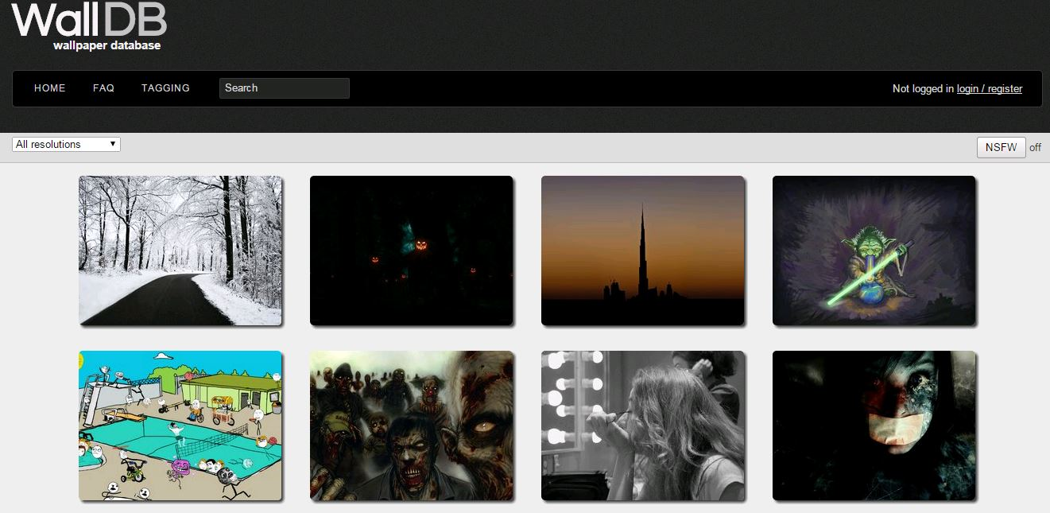
WallDB is a simple wallpapers hub with an aim to share HD wallpapers. It is currently very early stage and has a few features down the roadmap. The website has a much simpler look and feel than its competitors but unfortunately, the website lacks many crucial features such as photo categories and its current searching ability is not functional. The website is heading in the right direction, some feature which it offers and does well is having the user select their desired wallpaper resolution ahead of choosing wallpapers which eliminates the frustration of not finding the right screen resolution most of the time users find a wallpaper they like. Although the website offers users to favourite their likings, the only way for users to find wallpapers is to scroll through the random home screen wallpapers which is very inefficient. This website is the closest design to our current iteration, though they are vastly different. Our design takes it a step further and creates a more unique layout, with similar functionality.

TYPESET TEXT
Prepare your submissions using Microsoft Word on a PC or Mac.

Title and Authors
Your paper’s title, authors and affiliations should run across the full width of the page in a single column 17.8 cm (7 in.) wide. The title should be in Helvetica 18-point bold; use Arial if Helvetica is not available. Authors’ names should be in Times Roman 12-point bold, and affiliations in Times Roman 12-point (not bold, nor italic).
To position names and addresses, use a single-row table with invisible borders, as in this document. Alternatively, if only one address is needed, use a centered tab stop to center all name and address text on the page; for two addresses, use two centered tab stops, and so on. For more than three authors, you may have to place some address information in a footnote, or in a named section at the end of your paper. Please use full international addresses and telephone dialing prefixes. Leave one 10-pt line of white space below the last line of affiliations.
Adding & Removing Author Fields Above
If you need a 4th block for an additional author with a different affiliation. Go to the Table Tab, drag down to “Insert,” then drag down to “Column to the Right” OR “Column to the Left.” Then highlight the whole table, right click, go to “Table Properties” and within the Table Tab, click the tab box for “Preferred Width” enter 7.0 inches. Choose center alignment, then click OK.
If you need remove author blocks for only 1 or 2 authors. Click in the unwanted cell, right click, drag down to “Delete Cell,” then click “Delete entire column,” then click OK. Repeat if necessary.

Abstract and Keywords
Every submission should begin with an abstract of about 150 words, followed by a set of keywords. The abstract and keywords should be placed in the left column of the first page under the left half of the title. The abstract should be a concise statement of the problem, approach and conclusions of the work described. It should clearly state the paper's contribution to the field of HCI.
The first set of keywords will be used to index the paper in the proceedings. The second set are used to catalogue the paper in the ACM Digital Library. The latter are entries from the ACM Classification System [3].

Normal or Body Text
Please use a 10-point Times Roman font or, if this is unavailable, another proportional font with serifs, as close as possible in appearance to Times Roman 10-point. The Press 10-point font available to users of Script is a good substitute for Times Roman. On a Macintosh, use the font named Times and not Times New Roman. Please use sans-serif or non-proportional fonts only for special purposes, such as headings or source code text.

First Page Copyright Notice
This sample word document has the correct ACM SIGCHI copyright notice in place (see page 1, bottom of column 1) Copyright will be held by ACM. Accepted extended abstracts and papers will be distributed in the Conference Publications. They will also be placed in the ACM Digital Library, where they will remain accessible to thousands
of researchers and practitioners worldwide. To view
ACM’s copyright and permissions policy, click this link: http://www.acm.org/publications/policies/copyright_policy

Subsequent Pages
On pages beyond the first, start at the top of the page and continue in double-column format. The two columns on the last page should be of equal length.
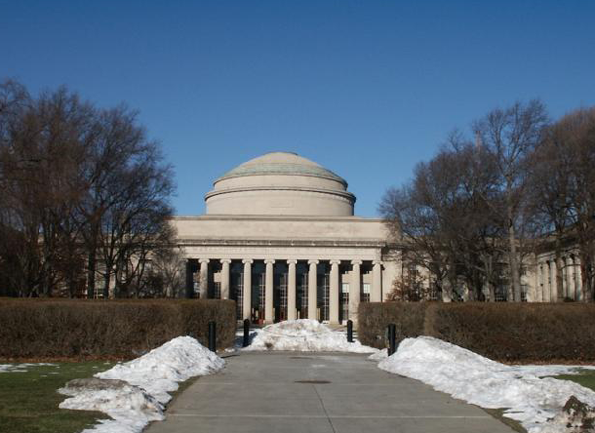
Figure 1. With Caption Below, be sure to have a good resolution image (see item D within the preparation instructions).

References and Citations
Use a numbered list of references at the end of the article, ordered alphabetically by first author, and referenced by numbers in brackets [2, 4, 5, 7]. Kindly make the text of this section ragged-right, so that the increasing number of references/citations with web addresses/urls do not have large word and letter spacing. For papers from conference proceedings, include the title of the paper and an abbreviated name of the conference (e.g., for Interact 2003 proceedings, use Proc. Interact 2003). Do not include the location of the conference or the exact date; do include the page numbers if available. See the examples of citations at the end of this document.
Objects | Caption – pre-2002 | Caption – 2003 and afterwards
Tables | Above | Below
Figures | Below | Below
Table 1. Table captions should be placed below the table.
 | Anyone | SN | Specific | No one
Flight | 45% | 34% | 18% | 3%
City | 47% | 35% | 14% | 3%
Table 2: Sharing travel plans
Your references should be published materials accessible to the public. Internal technical reports may be cited only if they are easily accessible (i.e., you provide the address for obtaining the report within your citation) and may be obtained by any reader for a nominal fee. Proprietary information may not be cited. Private communications should be acknowledged in the main text, not referenced (e.g., “[Robertson, personal communication]”).

SECTIONS
The heading of a section should be in Helvetica 9-point bold, all in capitals (Heading 1 Style in this template file). Use Arial if Helvetica is not available. Sections should not be numbered.

Subsections
Headings of subsections should be in Helvetica 9-point bold with initial letters capitalized (Heading 2). (Note: For sub-sections and sub-subsections, a word like the or of is not capitalized unless it is the first word of the heading.)

Sub-subsections
Headings for sub-subsections should be in Helvetica 9-point italic with initial letters capitalized (Heading 3).

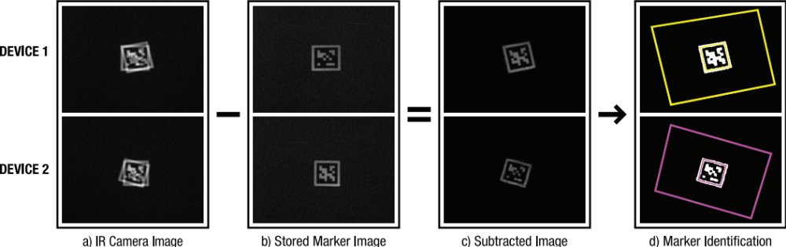
Figure 2: Sample of a wide figure. Be sure to place at the top of the page or bottom of the page.

FIGURES/CAPTIONS
Place figures and tables at the top or bottom of the appropriate column or columns, on the same page as the relevant text (see Figure 1).
A figure or table may extend across both columns to a maximum width of 17.78 cm (7 in.).
Captions should be Times New Roman 9-point bold (Caption Style in this template file). They should be numbered (e.g., “Table 1” or “Figure 2”), centered and placed beneath the figure or table. Please note that the words “Figure” and “Table” should be spelled out (e.g., “Figure” rather than “Fig.”) wherever they occur.
All figures should also include alt text for improved accessibility. In Word, right click the figure, and select Format Picture | Alt Text).
Papers and notes may use color figures, which are included in the page limit; the figures must be usable when printed in black and white in the proceedings.
The paper may be accompanied by a short video figure up to five minutes in length. However, the paper should stand on its own without the video figure, as the video may not be available to everyone who reads the paper.

Inserting Images
Occasionally MS Word generates larger-than-necessary PDF files when images inserted into the document are manipulated in MS Word. To minimize this problem, use an image editing tool to resize the image at the appropriate printing resolution (usually 300 dpi), and then insert the image into Word using Insert | Picture | From File...

Table Style
The text of tables will format better if you use the special Table Text style (in this template file). If you do not use this style, then you may want to adjust the vertical spacing of the text in the tables. (In Word, use Format | Paragraph… and then the Line and Page Breaks tab. Generally, text in each field of a table will look better if it has equal amounts of spacing above and below it, as in Table 1.)
For improved accessibility, header rows of tables should be marked. In Word, right click a header row, and select Table Properties | Row | Repeat as header at the top of each page.

LANGUAGE, STYLE AND CONTENT
The written and spoken language of SIGCHI is English. Spelling and punctuation may use any dialect of English (e.g., British, Canadian, US, etc.) provided this is done consistently. Hyphenation is optional. To ensure suitability for an international audience, please pay attention to the following:
- Write in a straightforward style.
- Try to avoid long or complex sentence structures.
- Briefly define or explain all technical terms that may be unfamiliar to readers.
- Explain all acronyms the first time they are used in your text – e.g., “Digital Signal Processing (DSP)”.
- Explain local references (e.g., not everyone knows all city names in a particular country).
- Explain “insider” comments. Ensure that your whole audience understands any reference whose meaning you do not describe (e.g., do not assume that everyone has used a Macintosh or a particular application).
- Explain colloquial language and puns. Understanding phrases like “red herring” may require a local knowledge of English. Humor and irony are difficult to translate.
- Use unambiguous forms for culturally localized concepts, such as times, dates, currencies and numbers (e.g., “1-5- 97” or “5/1/97” may mean 5 January or 1 May, and “seven o’clock” may mean 7:00 am or 19:00). For currencies, indicate equivalences – e.g., “Participants were paid 10,000 lire, or roughly $5.”
- Be careful with the use of gender-specific pronouns (he, she) and other gendered words (chairman, manpower, man-months). Use inclusive language that is gender-neutral (e.g., she or he, they, s/he, chair, staff, staff-hours, person-years). See [6] for further advice and examples regarding gender and other personal attributes.
- If possible, use the full (extended) alphabetic character set for names of persons, institutions, and places (e.g., Grønbæk, Lafreniére, Sánchez, Universität, Weißenbach, Züllighoven, Århus, etc.). These characters are already included in most versions of Times, Helvetica, and Arial fonts.

Accessibility
The Executive Council of SIGCHI has committed to making SIGCHI conferences more inclusive for researchers, practitioners, and educators with disabilities. As a part of this goal, the all authors are asked to work on improving the accessibility of their submissions. Specifically, we encourage authors to carry out the following five steps:
- Add alternative text to all figures
- Mark table headings
- Generate a tagged PDF
- Verify the default language
- Set the tab order to “Use Document Structure”
For more information and links to instructions and resources, please see:
http://chi2014.acm.org/authors/guide-to-an-accessible-submission

Page Numbering, Headers and Footers
Your final submission SHOULD NOT contain any footer or header string information at the top or bottom of each page. The submissions will be paginated in a determined order by the chairs and page numbers added to the pdf during the compiling, indexing, and pagination processes.

Producing and testing PDF files
We recommend that you produce a PDF version of your submission well before the final deadline. Your PDF file must be ACM DL Compliant. The requirements for an ACM Compliant PDF are available at:
http://www.sheridanprinting.com/typedept/ACM-distilling-settings.htm
When creating your PDF from Word, ensure that you generate a tagged PDF from improved accessibility. This can be done by using the Adobe Add-in, also called PDFMaker. In Word, select Preferences from the Acrobat ribbon and ensure that “Enable Accessibility and Reflow with tagged Adobe PDF” is selected. You can then generate a tagged PDF by selecting “Create PDF” from the Acrobat ribbon.
Test your PDF file by viewing or printing it with the same software we will use when we receive it, Adobe Acrobat Reader Version 7. This is widely available at no cost from [1]. Note that most reviewers will use a North American/European version of Acrobat reader, which cannot handle documents containing non-North American or non-European fonts (e.g. Asian fonts). Please therefore do not use Asian fonts, and verify this by testing with a North American/European Acrobat reader (obtainable as above). Something as minor as including a space or punctuation character in a two-byte font can render a file unreadable.

Conclusion
It is important that you write for the SIGCHI audience. Please read previous years’ Proceedings to understand the writing style and conventions that successful authors have used. It is particularly important that you state clearly what you have done, not merely what you plan to do, and explain how your work is different from previously published work, i.e., what is the unique contribution that your work makes to the field? Please consider what the reader will learn from your submission, and how they will find your work useful. If you write with these questions in mind, your work is more likely to be successful, both in being accepted into the Conference, and in influencing the work of our field.

ACKNOWLEDGMENTS
Sample Text: We thank all the volunteers, and all publications support and staff, who wrote and provided helpful comments on previous versions of this document. As well authors 1, 2, & 3 gratefully acknowledge the grant fron NSF (#1234-2012-ABC). This whole paragraph is just for example … Some of the references cited in this paper are included for illustrative purposes only.

References format
References must be the same font size as other body text.

REFERENCES
- Adobe Acrobat Reader 7, Be sure that the references sections text is Ragged Right, Not Justified. http://www.adobe.com/products/acrobat/.
- Anderson, R.E. Social impacts of computing:
Codes of professional ethics. Social Science Computing Review 10, 2 (1992), 453-469.
- How to Classify Works Using ACM’s Computing Classification System.
http://www.acm.org/class/how_to_use.html.
- Klemmer, R.S., Thomsen, M., Phelps-Goodman, E., Lee, R. and Landay, J.A. Where do web sites come from? Capturing and interacting with design history.
In Proc. CHI 2002, ACM Press (2002), 1-8.
- Mather, B.D. Making up titles for conference papers. Ext. Abstracts CHI 2000, ACM Press (2000), 1-2.
- Schwartz, M. Guidelines for Bias-Free Writing.
Indiana University Press, Bloomington, IN, USA, 1995.
- Zellweger, P.T., Bouvin, N.O., Jehøj, H., and Mackinlay, J.D. Fluid Annotations in an Open World. Proc. Hypertext 2001, ACM Press (2001), 9-18.

The columns on the last page should be of approximately equal length.
Remove these two lines from your final version.

Note that the items in this bulleted list were formatted using the Bullet Style (in this template file). Numbered lists are allowed.

