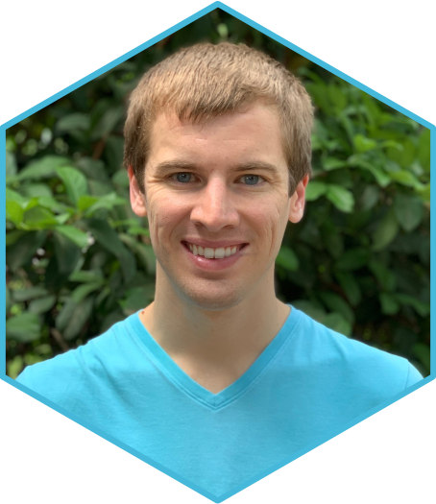
Rhett M. Rautsaw, PhD

Postdoctoral Research Associate

Washington State University & University of South Florida • +1 (937) 417-5334 • rautsaw@usf.edu
Websites: RhettRautsaw.com • RhettRautsaw.app • Twitter: @ReptileRhett • GitHub: RhettRautsaw • Full CV

Summary

Evolutionary/Computational biologist with >8 years of experience in bioinformatics, statistics, scripting/programming, software engineering, pipeline development, application development, next-generation sequencing data analysis, and scientific communication. I am primarily interested in using/developing tools that transform complex genomic data into biological knowledge. I currently study snake venom evolution and wildlife disease and am in search for a remote bioinformatics position in customer support, research, and/or software development. I have had many positive interactions with PacBio and am excited by the opportunity to join your team.

Skills
- NGS Experience: Whole-Genome Sequencing (Illumina, PacBio CLR & HiFi), DNA-Seq, RNA-Seq, ATAC-Seq, Bisulfite Sequencing (WGBS), Omni-C Seq, snRNA-Seq, Bionano Optical Mapping.
- Programming & Software Development: Python, R, Unix, Shiny, version control (git, GitHub), PBS, SLURM.
- Bioinformatics: NGS data analysis (QC, read filtering, etc.), de novo genome/transcriptome assembly (including hybrid & long-read assemblies such as MaSuRCA and hifiasm), genome/transcriptome annotation (funannotate, MAKER, etc.), alignment (bwa, minimap, etc.) and variant calling (GATK, deepvariant, etc.), pipeline development, population genomics, and phylogenomics.
- Statistics: Hypothesis testing, model comparison/selection, maximum likelihood, Bayesian inference.
- Writing & Documentation: markdown/Rmarkdown, LaTeX/Overleaf, Microsoft Office, Adobe Acrobat.
- Leadership/Training: Mentored & trained 4 graduate students & 6 undergraduate students on using R, Unix, and Python. Worked closely with Clemson University Genomics & Bioinformatics Facility to provide additional assistance to customers when needed.

Education
PhD 2017 – 2022 Clemson University, Department of Biological Sciences, Clemson, SC USA
MS 2014 – 2017 University of Central Florida, Department of Biology, Orlando, FL USA
BS 2012 – 2014 Wright State University, Dayton, OH USA (Cum Laude, Biological Sciences)

Professional Experience
Postdoctoral Research Associate | Washington State University | University of South Florida | Tampa, FL 2022 – current
- Tasmanian Devil Facial Tumor Disease Genomics
- Research: Assembling, annotating, and calculating differential methylation of Tasmanian Devil tumor genomes using PacBio SMRT HiFi sequencing to identify the mechanisms responsible for oncogenesis and transmissibility. Also performing snRNA-Seq and testing for coevolution between devils and tumors. Analyses are performed on Mac and Linux HPC (SLURM) operating systems using pre-existing and custom-developed software in R and Python.

NSF Graduate Research Assistant | Clemson University | Clemson, SC 2017 – 2022
- Phylogenomics of Vipers and the Role of Competition on Venom Evolution
- Project Management: Simultaneously managed 18 projects including my dissertation research. Fifteen projects have been published (5 first author). Won 15 competitive graduate student research grants, fellowships, and awards totaling $31,460 including the “Outstanding Graduate in Discovery Award” by the College of Science and Department of Biological Sciences. Many of these projects were the result of extensive teamwork with lab mates and collaborators in Brazil, Mexico, Texas, & more.
- NGS & Bioinformatics: Performed WGS, ATAC-Seq, WGBS, and RNA-Seq on Illumina and PacBio SMRT HiFi sequencing platforms including tissue preparation, DNA/RNA extraction, and library preparation. Once sequenced, data management, filtering, and analysis was performed on Mac and Linux HPC (PBS) operating systems using pre-existing and custom-developed software in R and Python.
- Leadership & Teaching: Mentored and trained 4 incoming graduate students and 2 undergraduate researchers including design and implementation of independent research projects, particularly next-generation sequencing lab work and bioinformatics. I was also responsible for supply ordering, environmental health and safety, and IACUC management for our lab. Also aided Clemson University Genomics and Bioinformatics Facility (CUGBF) with customer support when needed.
- Scientific Communication: Designed artwork depicting the underlying research published in Molecular Biology and Evolution which was subsequently chosen as the journal cover. Invited to give 7 presentations at international, national, and regional conferences and departmental seminars; including the 2022 PacBio Discoveries Roadshow in Research Triangle. Won several presentation awards due to my ability to clearly explain my research.
Graduate Teaching Assistant & Researcher | University of Central Florida | Orlando, FL 2014 – 2017
- Movement of Gopher Tortoises (Gopherus polyphemus) along roads and railways
- Project Management: Simultaneously managed 6 different projects including my thesis research which I designed, executed, and led. Five projects have been published (2 first author). I was responsible for managing a team of 5-8 people performing intensive field work including getting access to the site (Kennedy Space Center) and emergency management, writing grant reports, ordering supplies, and performing data analyses in a variety of programs including R and ArcGIS.
- Leadership & Teaching: Mentored and trained 4 undergraduate researchers, including field work, lab work, and data analysis in R. Two became coauthors on subsequent publications. In addition, I taught several classes including Ecology lab where I was instructor of record and designed a lesson to teach students the basics of data analysis in R.
- Scientific Communication: Created an animation (YouTube) depicting the results from a thesis projects. This video aided my nomination for the BioOne Ambassador Award by Copeia which I subsequently won along with Copeia’s 2019 Best Student Paper. The BioOne Ambassador award recognizes impactful work by early career authors whom are dedicated to communicating the importance and impact of their research to the public. Paper published in Copeia | Award Announcement.
Select Publications (5 of 20) [† equal contribution]
My full publication record can be found on Google Scholar citations: 183, h-index: 8, i10-index: 7
- Rautsaw RM, et al. 2022. VenomMaps: Updated distribution maps and niche models for New World pitvipers (Viperdae: Crotalinae). Scientific Data 9(232). DOI: ﻿10.1038/s41597-022-01323-4
- Rautsaw RM†, Nachtigall PG†, et al. 2021. ToxCodAn: a new toxin annotator and guide to venom gland transcriptomics. Briefings in Bioinformatics. DOI: ﻿10.1093/bib/bbab095
- Margres MJ, Rautsaw RM, et al. 2021. The Tiger Rattlesnake genome reveals a complex genotype underlying a simple venom phenotype. PNAS 118(4): e2014634118. DOI: ﻿10.1073/pnas.2014634118
- Rautsaw RM, et al. 2021. Genomic adaptations to salinity resist gene flow in the evolution of Floridian watersnakes. Molecular Biology and Evolution 38(3): 745–760. DOI: 10.1093/molbev/msaa266
- Rautsaw RM, et al. 2018. Stopped dead in their tracks: The impact of railways on Gopher Tortoise (Gopherus polyphemus) movement and behavior. Copeia 106(1): 135–143. DOI: 10.1643/CE-17-635

Select Open-Source Code, Applications, and Tutorials


All code and applications can be found on github.com/RhettRautsaw and on RhettRautsaw.app

- Walter: A modified version of PacBio’s pb-CpG-tools addressing Issue #26 script regarding parallelization. Walter makes use of GNU-Parallel rather than concurrent.futures to address this issue. [Python, Unix]
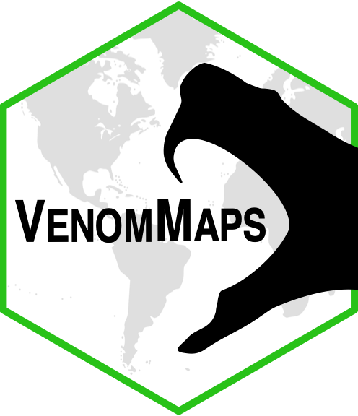
- ToxCodAn: A computational tool designed to detect and annotate toxin genes in transcriptome assemblies and a guide for venom-gland transcriptomics. Published in Briefings in Bioinformatics. [Python]
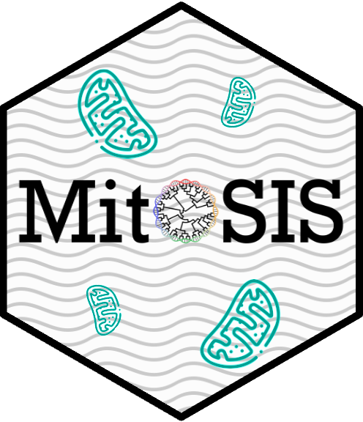
- VenomMaps: Shiny app designed to display the distributions, niche models, and occurrence records of vipers for use by researchers and medical aid from snakebite. Published in Scientific Data. [R, Shiny, Leaflet]
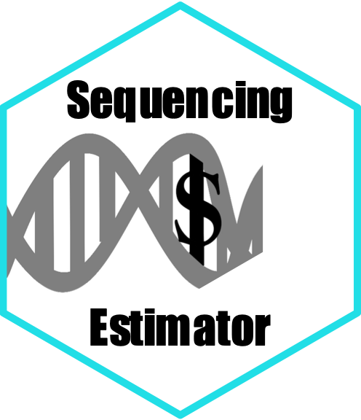
- MitoSIS: Mitochondrial Species Identification System. A wrapper for mitochondrial genome assembly and identification of sample contamination or mislabeling. Draft prepared. [Python]
- Sequencing Estimator: Shiny app designed to aid in choosing a NGS platform and estimate costs given the estimated size of the genome, read length, number of samples, etc. [R, Shiny]
- pyVAE: A modified version of popVAE designed to fit a variational autoencoder (VAE) to generalized multi-dimensional data (e.g., transcriptome expression data) and output the latent space. Publication in prep. [Python].
- GIS Workshop: Workshop to teach users the basics of Geographic Information Systems and using open-source QGIS and R. Invited to give at BCEENET 2021. [markdown]
- PacBio HiFi Genome Assembly & Annotation Tutorial: Documentation for assembly and annotation of PacBio HiFi data. The base repository – “Bioinformatics” – also contains several useful training resources for bioinformatics and HPC. [markdown]
Select Presentations (4 of 25) 9 invited talks & 3 first place awards
- [Invitation] 2022. Snakes and Ladders: Elevating snake genome assembly and evolutionary biology with HiFi genomics. PacBio Discoveries Roadshow, North Carolina Biotechnology Center, Research Triangle Park, NC, USA.
- [Invitation] 2022. Testing the influence of competition on venom evolution. Departmental Seminar. Clemson University.
- [Invitation] 2020. Genomic adaptations to salinity resist gene flow in the evolution of Floridian watersnakes. Departmental Seminar. Instituto Butantan, São Paulo, Brazil.
- [Invitation] 2020. On the right track: Understanding and reducing the impact of railways on Gopherus. 45th Annual Desert Tortoise Council Meeting. Las Vegas, NV USA.

