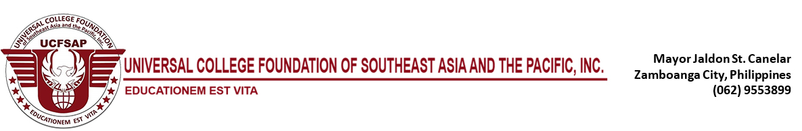

Semester Adopted: Sem: 2nd Academic Year: 2018-2019

Revision Status: 1st Draft

Revision Date: November 14, 2018

Recommending Approval: Department Chair

Concurred: Dean

Approved: VPAA

**OUTCOME-BASED EDUCATION (OBE) SYLLABUS / INTRUCTOR’S GUIDE**

**1st Semester Academic Year 2020-2021**

**(ND 121 or Basic Food II)**

BACHELOR OF SCIENCE IN PHARMACY

|  |  |  |  |  |  |
| --- | --- | --- | --- | --- | --- |
| **VISION** | A | | | | |
| **MISSION** |  | | | | |
| **INSTITUTIONAL OUTCOME** |  | | | | |
| **GOALS** |  | | | | |
| **DAPARTMENT OBJECTIVES** |  | | | | |
| **PROGRAM OUTCOMES** |  | College Objectives | | | |
|  | A | B | C | D |
|  | [✓](http://www.i2symbol.com/symbols/check) | ✓ | ✓ | ✓ |
|  | ✓ | ✓ | ✓ | ✓ |
|  |  |  |  |  |
|  |  |  |  |  |
|  |  |  |  |  |  |