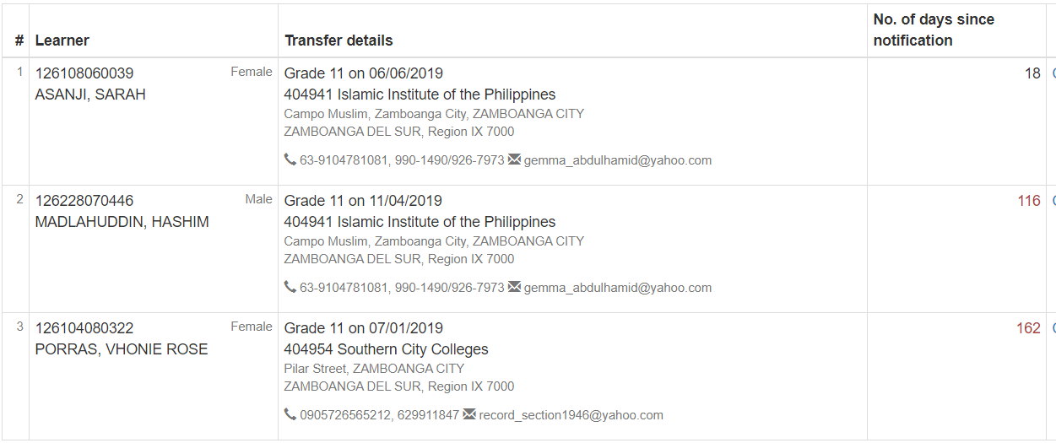

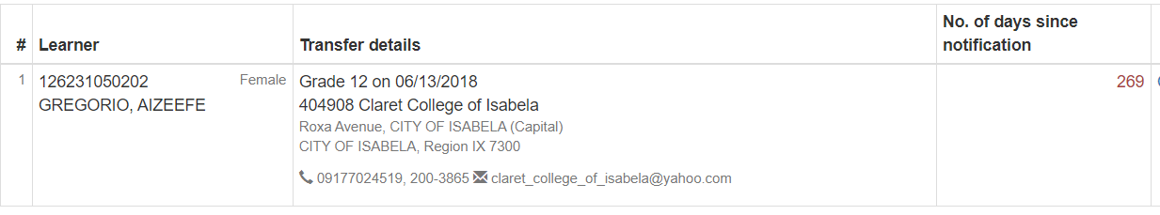

|  |  |  |  |  |  |  |  |
| --- | --- | --- | --- | --- | --- | --- | --- |
| 99 | 126228070446 | MADLAHUDDIN, HASHIM  pending transfer | M | Front Office Services (NC II) 1 | Grade 11 G11-CANARY (AMS) | No status | 06/10/2019 |
| 116 | 126104080322 | PORRAS, VHONIE ROSE  pending transfer | F | General Academic Strand 1 | Grade 11 G11-APRICOT (GAS) | No status | 06/10/2019 pending transfer |
| 125 | ●198001120187 | SADALANI, FRANCIS JOHN  pending enrolment | M | Bread and Pastry Production (NC II) 1 | Grade 11 G11-EMERALD (CULINARY) | Pending request | 06/10/2019 |
| 79 | 126261120298 | JIKIRI, ADJIMAR  pending transfer | M | Computer System Servicing (NC II) 1 | Grade 12 G12-LILIUM (CNE) | Pending transfer | 06/10/2019 |

|  |  |  |  |  |  |
| --- | --- | --- | --- | --- | --- |
| 11 | 126262060014 | ALIH, FARRAH | F | Humanities and Social Sciences 1 | Grade 11 HUMMS 11-A |
| 36 | 126113120325 | IKKAO, JULIANA KHAIRA | F | Accountancy, Business, and Management 1 | Grade 11 ABM 11-A |
| 44 | 126112050125 | JARALVE, ROSETTE JOY | F | Humanities and Social Sciences 1 | Grade 11 HUMMS 11-B |
| 46 | 303914140039 | JAYYARI, SHERIDA | F | Caregiving (NC II) 1 | Grade 11 CAREGIVING 11-A |
| 47 | 126221060307 | JUMAWID, KAYE | F | General Academic Strand 1 | Grade 11 GAS 11-A |
| 52 | 124814070057 | MATO, CYNTHIA | F | Humanities and Social Sciences 1 | Grade 11 HUMMS 11-B |
| 53 | 126177070067 | MORENO, JEMAICA | F | Housekeeping (NC II) 1 | Grade 11 HRM 11-A |
| 56 | 126260070166 | PAMARAN, MARK | M | Computer System Servicing (NC II) 1 | Grade 11 CNE 11-A |
| 59 | 134612120448 | PEDRING, ALLINDA | F | Bread and Pastry Production (NC II) 1 | Grade 11 CULINARY 11-A |
| 63 | 127966070207 | RAMOS, HAIDEE | F | Humanities and Social Sciences 1 | Grade 11 HUMMS 11-B |
| 70 | 303923130359 | TENEBROSO, KYNIE | M | Accountancy, Business, and Management 1 | Grade 11 ABM 11-A |
| 78 | 126262050240 | WEE, STEFANE VIANESE | F | Humanities and Social Sciences 1 | Grade 11 HUMMS 11-A |