ASEAN REGISTRATION
Link of the Registration Site: https://asean.chedro12.com
OPTION 1: WITH ISSUANCE OF PHYSICAL ID
System Requirements:
- Sub-domain: https://asean.ched.gov.ph
- Server and Hosting
- Semaphore Subscription (for SMS sending) – 5000 credits (estimated PhP 2,800.00 with VAT)
- For Email Sending Subscription (if Mailchimp around $175-$350/month, already with Email and SMS subscription)
- PVC IDs
- PVC ID Printer
- PVC ID Cutter (rounded corners)
- Lanyard (optional) + puncher
- QR scanner
- Tablet (to display the attendance after scanning)
- TVs for other promotional materials and other infographics

OPTION 2: WITHOUT ISSUANCE OF PHYSICAL ID
- Sub-domain: https://asean.ched.gov.ph
- Server and Hosting
- Semaphore Subscription (for SMS sending) – 5000 credits (estimated PhP 2,800.00 with VAT)
- For Email Sending Subscription (if Mailchimp around $175-$350/month, already with Email and SMS subscription)
- QR scanner
- Tablet (to display the attendance after scanning)
- TVs for other promotional materials and other infographics

Other Attached Materials:
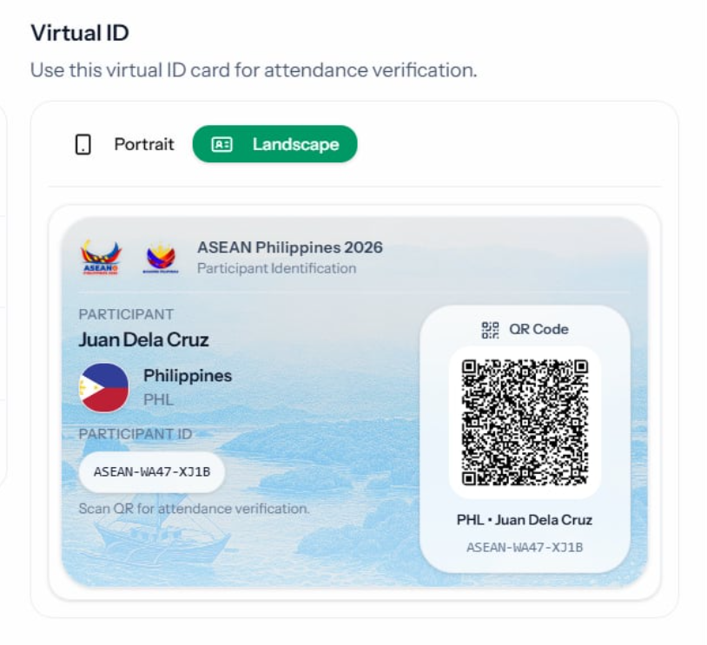
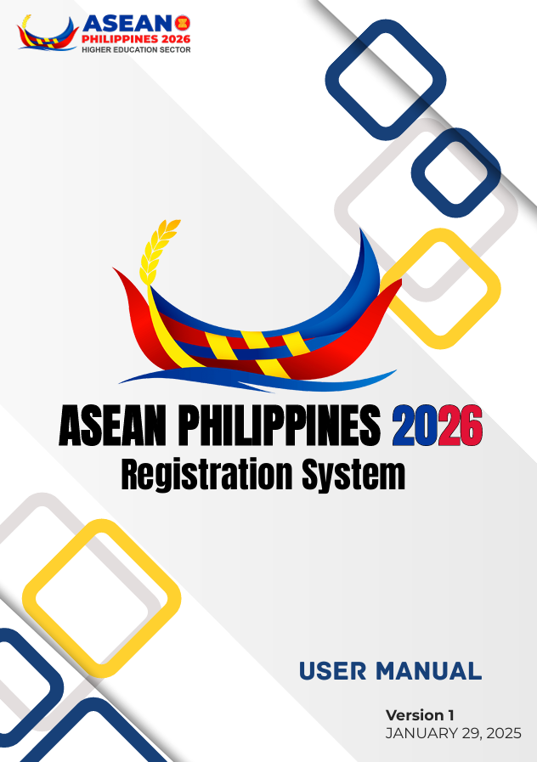
Sample ID and User Manual: https://tinyurl.com/36924uz7

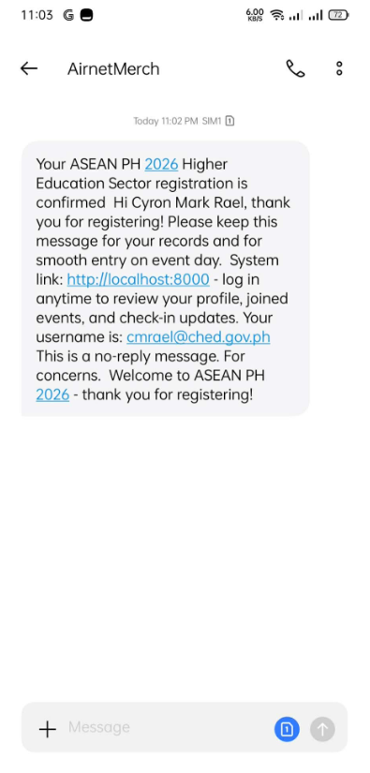
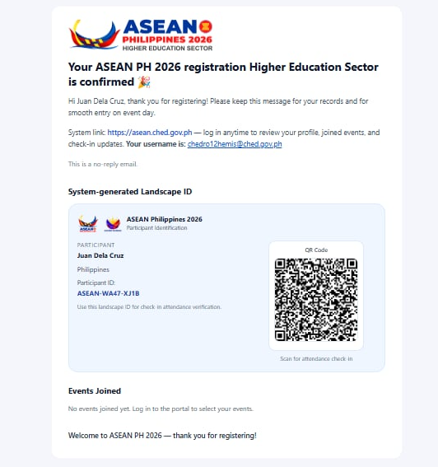
Sample Email and SMS:

