Asymptotic Forms: The following gives both the formal “c and n0” definitions and an equivalent limit
definition for the standard asymptotic forms. Assume that f and g are nonnegative functions.
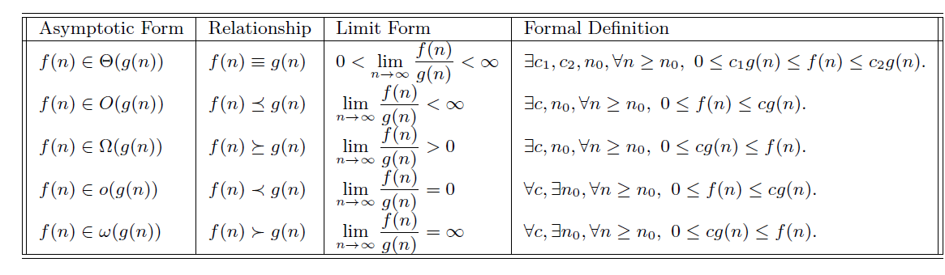
Recurrences (Decreasing Functions)

Given
T(n)=aT(n−b)+f(n), a> 0, b > 0, f(n) = O(n^{k}), k >= 0
Rule#1
- If a == 1, then O(n*f(n)) that is O(n^{k+1})
Rule#2
- If a > 1, then O(a^{n/b} * f(n)) that is O(a^{n/b} n^{k} )
Rule#3
- If a < 1, then O(f(n)) that is O(n^{k})

Recurrences (Dividing Functions)

Given
T(n)=aT(n/b)+f(n), a>= 1, b > 1, f(n) = O(n^{k}log^{p}n)

Answer depends on 2 values
- log_{b}(a)
- k
Case#1
- If log_{b}(a) > k O(n^{log}_{b}^{(a)})
Case#2
- If log_{b}(a) = k 3 subcases
  - If (p > -1) O(n^{k}log^{p+1}n)
  - If (p == -1) O(n^{k}log(log(n)))
  - If (p < -1) O(n^{k})
Case #3
- If log_{b}(a) < k 2 subcases
  - If (p >= 0) O(n^{k}log^{p}n)
  - If (p < 0) O(n^{k})

Remarks For Common Summations: Let c be any constant, c != 1, and n ≥ 0.
