**Encryption**

To encrypt a file, click on the “Encrypt File” button in the “Main” sheet.

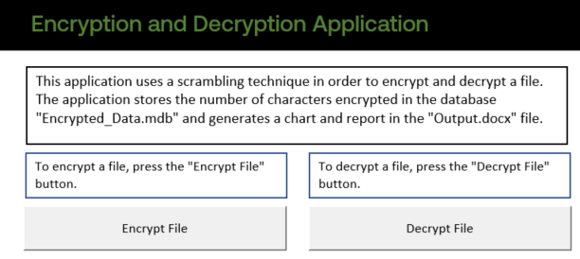

You will then be prompted with this window:

The default Excel file to encrypt is the Encryption and Decryption Application. To change this, click the top “Browse” button and select an Excel file.

The default location to save the encrypted files is the folder that contains the Excel file. To change the location, click on the bottom “Browse” button and select a folder to store the .crzy files.

Once the file to be encrypted and location for the encrypted files has been selected, click on the “Encrypt” button. A message will appear at the bottom saying if the encryption was successful or if there was an error.

Once done, click on the “Close” button to exit the new window.

**Decryption**

To decrypt a file, click on the “Decrypt File” button in the “Main” sheet.



You will then be prompted with this window:

Click on the “Browse” button and select a .crzy file. Then type in a name for the decrypted sheet. Note that the decrypted sheet name cannot already exist in the workbook. Once that is done click on the “Decrypt” button. A message will appear at the bottom to show if the decryption was successful or if there was an error.

Once done, click on the “Close” button to close the window.