**Convert Collections to Empty Objects**

# Installing the addon

Open blender.

At the top: “**Edit**” > “**Preferences**”

In the “**Add-ons**” tab. Click on “**Install…**”

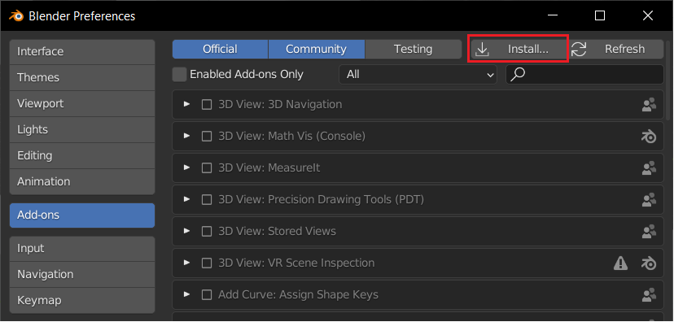

Navigate to the location of where you download the “CollectionToEmpty.py” add-on.

Select it and press “Install Add-on”

The following should show up.

Finally, click on the check box next to the add-on name to enable it.

# How to use the addon

Right click anywhere in the 3D view and get the “Object Context Menu”.

Select the option “Convert to Empties”.

# Additional

TIP:  
In the blender Viewport Shading UI. Select the option “Solid”. This will ease the processing load of blender make the addon run faster on more complex/larger scenes.

