Joshua R. Carlo
Mobile Application Development
COM-437-OL01

Android App: Studyfi Outline

Summary: Mobile-Application-Development-StudyFi is a mobile & web-based studying application to engage users throughout their study session. It features interactive studying tools such as personalized study plans, gamification, collaborative study rooms, and study progress tracking to help students stay focused, motivated, organized, and on track. It does so with innovative tools to make studying effective and fun.

Problem: Students often face distractions, motivation issues, and ineffective study habits. Many study apps lack engagement features, leading to poor retention and drop-off.
How StudyFi Addresses It: Offers engaging features (gamification, rewards, timers). Allows users to study together with shared sessions and group chats. Provides personalized study plans tailored to subjects and goals. Includes focus tools (Pomodoro timer, ambient sounds, progress tracking).

Initial Application Layout: Search bar in top for locating study topics. A home/dashboard button for easy navigation back to home page. Progress tracker tab which displays all current study topics and progress as far as games/quizzes, etc. Most importantly a “Go Study!” button which initiates the user into the different studying modes (quiz mode, flashcard mode, and other various gamified study options). A study-based games tab specifically for game modes, and lastly a recommended topics which use analytics to recommend study topics that suit your degree or learning needs. Also, will feature a clock in the bottom right for timekeeping.

Initial Design Phase 1:
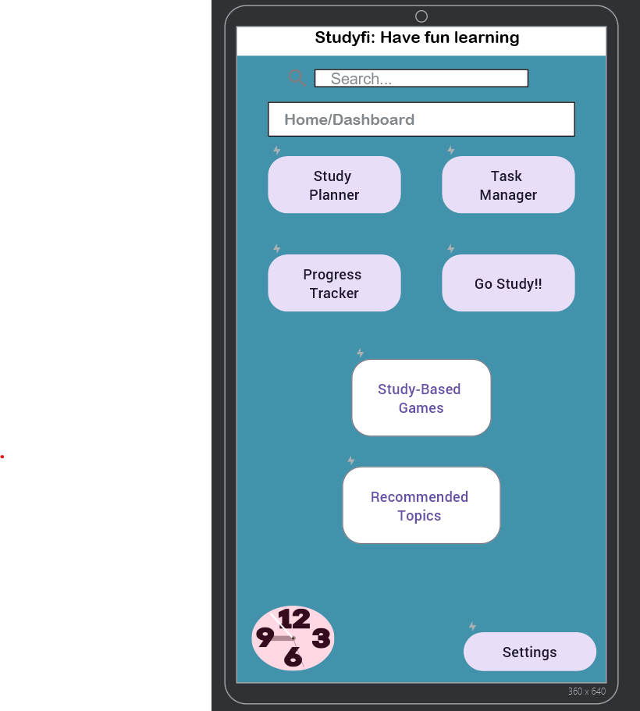

Application Layout change notes V.2: Removing clock as most phones have one built in. Generalizing the “Go-Study” button and Study-based games into a singular tab. Recommended tips will show when using the search bar instead of its own tab. The Home/Dashboard button will be more centralized and specific to the users’ navigational needs. App color will change to be a little livelier as blue is associated with more negative emotions/use cases.
Design Phase 2: 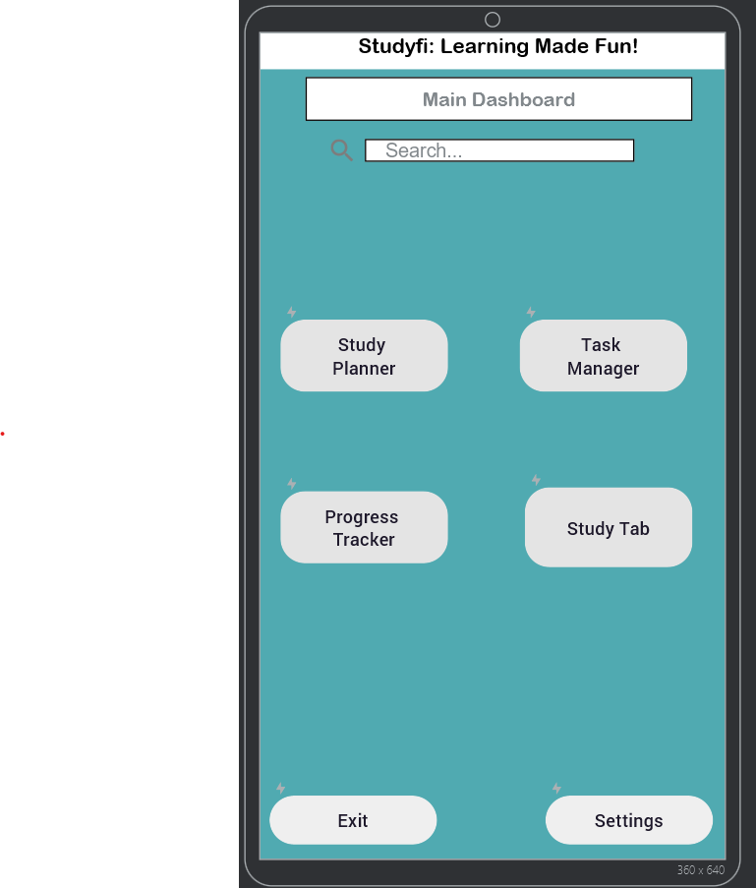

Application Layout (addition of study planner and task manager screens):
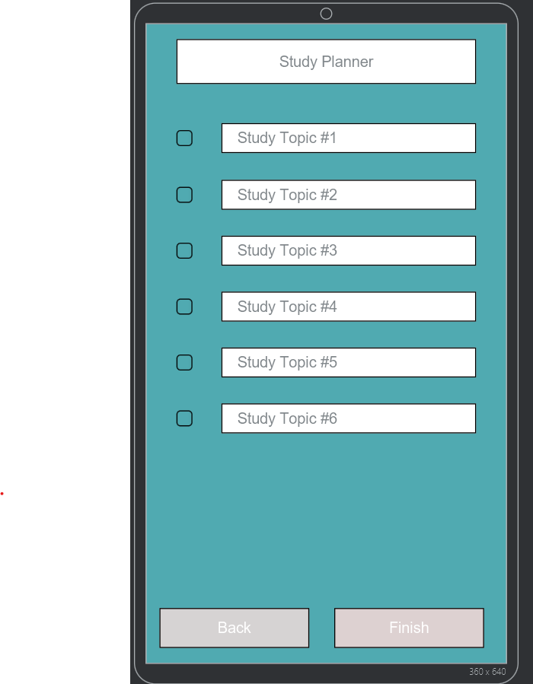

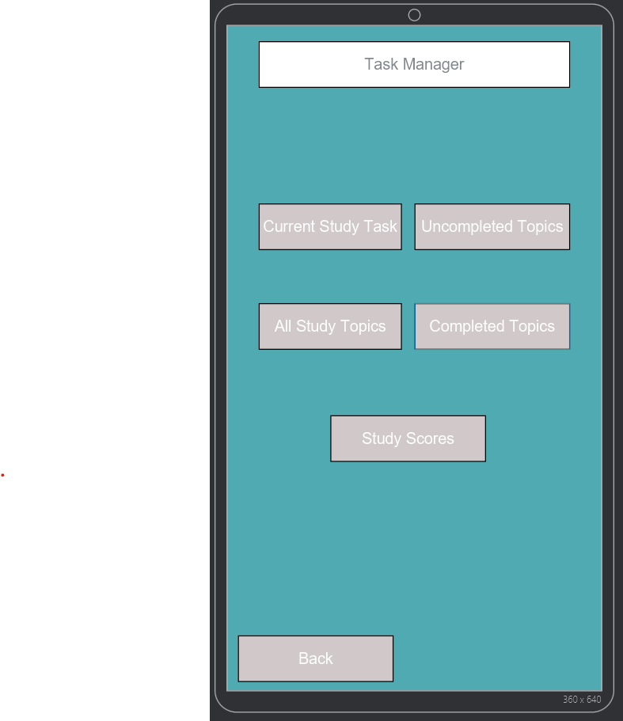

Future Change Notes: Addition of study tab, progress tracker, as well as a settings tab for any app specific needs. Also a new design as well as additional features and graphics will be added once app layout and screens are set.

