NETWORK ANALYSIS ASSIGNMENT
Rhithick Murali – 108119093 ECE

DESCRIPTION:

The Program does 3 tasks:
- Conversion of T to Pi and Pi to T:
- Conversion of one parameter to all other parameters (ABCD, Z, Y, S, h)
- Series RLC Circuit Solver.

Normally one can convert from one parameter to any other parameter provided if they know inter-relationship formula. Otherwise one should derive using the equations and then convert. Instead of going through such tedious works and keeping the fact of doing calculation mistake aside this CAD reduces the users effort. It uses the inter-relationship formula to convert from one parameter to all other parameters. The 5 parameters that is used are Impedence(Z), Admittance(Y), transmission line(ABCD), hybrid parameters(h) and Scattering Paramters(S). This program also analyzes series RLC circuit. The operations that can be done using this CAD are as follows:

Network Conversion:
- Convert PI – network → T – network.
- Convert T – network → PI – network.

Port Conversion:
- Convert Z parameter → Y , ABCD, h, S parameters.
- Convert Y parameter → Z , ABCD, h, S parameters.
- Convert ABCD parameter → Z , Y, h, S parameters.
- Convert h parameter → Z , Y, ABCD, S parameters.
- Convert S parameter → Z, Y, ABCD, h paramters.

Circuit:
- Series RLC Circuit Analysis.
Given R, L, C and f it would output:
    - Inductive Reactance.
    - Capacitive Reactance.
    - Impedance of the circuit.
    - Phase angle.
    - Resonant frequency
    - Q factor
    - Bandwidth
    - Graph of Impedance vs Frequency.

PREVIEW:

1) Main Page:



2) Port Conversion:

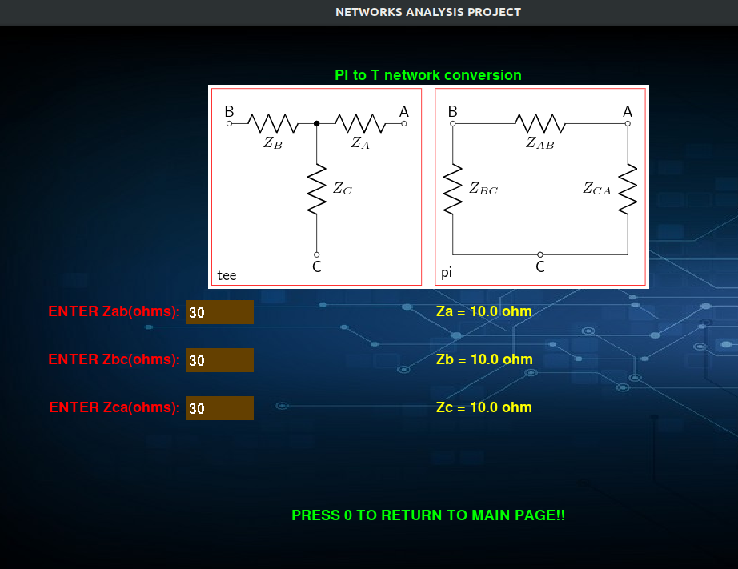

3) Parameter Conversion:

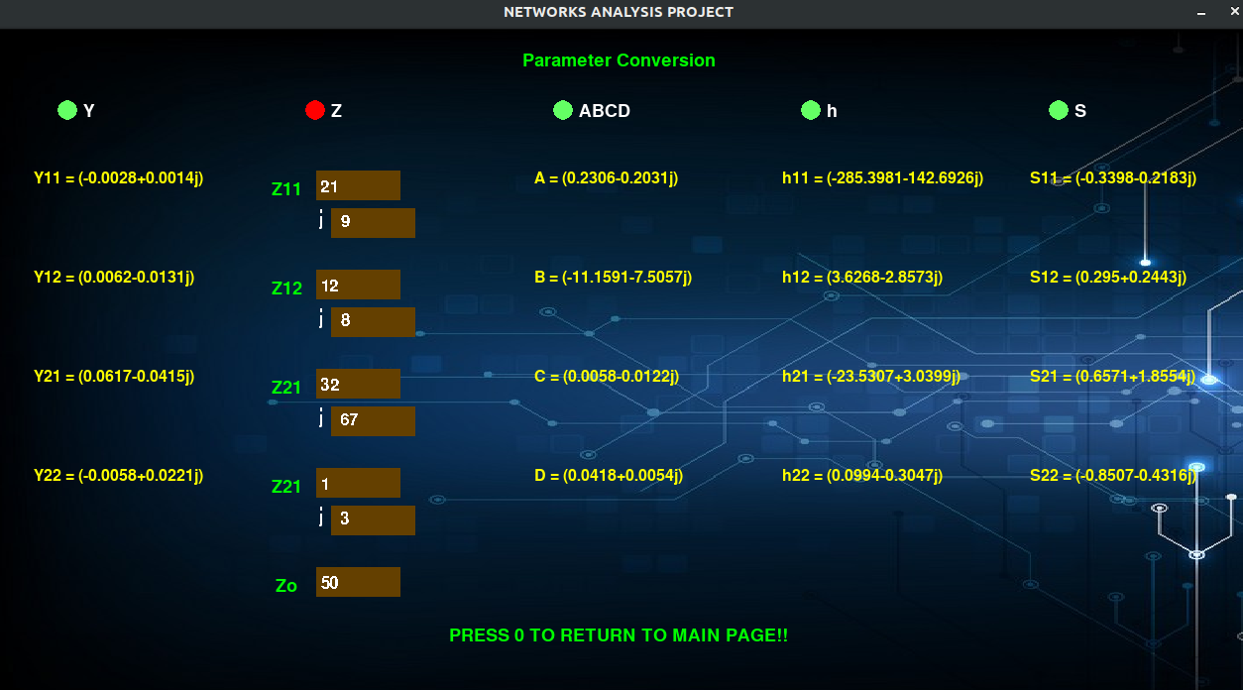

4) Series RLC Circuit Solver:
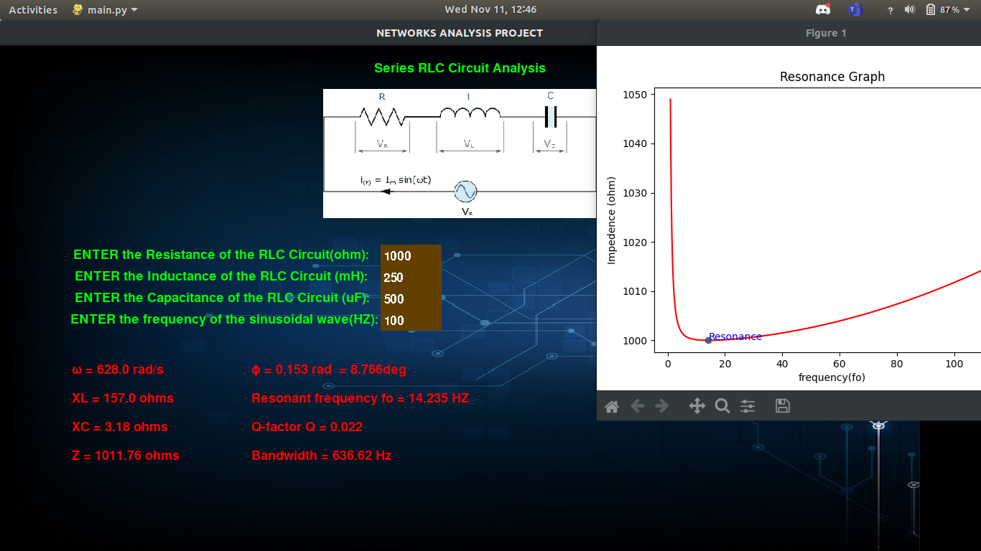

5) Code (partial for Z and ABCD):

