Parallel Programming Exercise 9–10

Author: | 張博皓 (b07505032@ntu.edu.tw)
Student ID | B07505032
Department | Engineering Science and Ocean Engineering
(If you and your team member contribute equally, you can use (co-first author), after each name.)

Problem and Proposed Approach
(Brief your problem, and give your idea or concept of how you design your program.)
Use the manager / worker method to iterate through different n. The worker is responsible of sending jobs and receiving results from the worker. The worker would reply a SUCCESS_MSG (by tag) if the checking number is a prime number, otherwise, it would return a ERROR_MSG when the test is not passed.
The manager will count the amount of the results founded and terminate workers (ps. The prime-checking process is time consuming and the worker won’t check the terminate message as long as the process is done, so the terminate message will also make the for loop break immediately in order to save time.) if the amount of results meets the set condition. (8 for this problem.)

Theoretical Analysis Model
(Try to give the time complexity of the algorithm, and analyze your program with iso-efficiency metrics)
Checking prime: sqrt(num).

Performance Benchmark
(Give your idea or concept of how you design your program.)

Table 1. The execution time
 | 1 | 2 | 3 | 4 | 5 | 6 | 7 | 8
Real | N/A | 18.14347 | 18.32257 | 18.67721 | 18.81576 | 18.89256 | 18.35982 | 18.40983
Estimate | N/A | 18.14347 | 12.09564 | 9.071733 | 7.257386 | 6.047822 | 5.183847 | 4.535867
Speedup | N/A | 1 | 0.990225 | 0.971423 | 0.96427 | 0.96035 | 0.988216 | 0.985532
Karp-flatt | N/A | 1 | 1.014807 | 1.039224 | 1.046318 | 1.049545 | 1.013912 | 1.016778
10 | 12 | 14 | 16 | 24 | 32
19.02673 | 18.9116 | 18.87658 | 18.93776 | 23.05715 | 19.61464
3.628693 | 3.023911 | 2.591924 | 2.267933 | 1.511956 | 1.133967
0.953578 | 0.959383 | 0.961163 | 0.958058 | 0.786891 | 0.924996
1.054091 | 1.046185 | 1.043515 | 1.046697 | 1.282599 | 1.083701

Figure 1. The performance of diagram
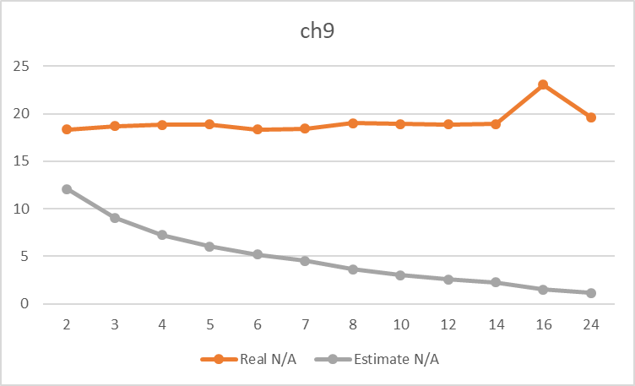

Conclusion and Discussion
(Discuss the following issues of your program
- What is the speedup respect to the number of processors used?
- How can you improve your program further more
- How does the communication and cache affect the performance of your program?
- How does the Karp-Flatt metrics and Iso-efficiency metrics reveal?
)
The speedup is not good when using manager/worker method to solve this problem, as the time always stuck at about 18 seconds.
The Karp-Flatt metrics is large but not increasing, it shows that the large fraction of the computation that is inherently sequential.
After analyzing the design of the program and have some discussion with my classmates, there are two main reasons:
- Large fraction of the sequential part (as mentioned above analyzed by Karp-Flatt) : Using the manager/worker as the method only saves a little bit of time, because the size of n is not big enough (The 8th perfect number is (2^{n}-1) 2^{n-1} , n = 31) to do it in parallel and I think the prime-checking part of code is more worth to do in parallel (maybe using Floyd's Algorithm).
- Lack of efficiency of the prime-checking part: According to the discussion with my classmates, change to a faster prime-checking algorithm will shorten the execution time, and this means the bottleneck of this program is about checking if (2^{n}-1) is a prime number. Furthermore, the 7th and 8th perfect number was founded when n=19 & n=31. At this case, 2^{n}-1 would be extremely large and cost a lot of time to do a prime check.
Appendix(optional):
(If something else you want to append in this file, like picture of life game)

