Parallel Programming Exercise 8–10

Author: | 張博皓 (b07505032@ntu.edu.tw)
Student ID | B07505032
Department | Engineering Science and Ocean Engineering
(If you and your team member contribute equally, you can use (co-first author), after each name.)

Problem and Proposed Approach
(Brief your problem, and give your idea or concept of how you design your program.)
The question wants us to perform a matrix-vector multiplication.
The solution is to modify MyMPI.py, mv3.c and use the checkerboard decomposition method.

Theoretical Analysis Model
(Try to give the time complexity of the algorithm, and analyze your program with iso-efficiency metrics)
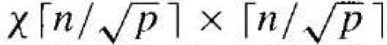
Computation time is:

Performance Benchmark
(Give your idea or concept of how you design your program.)

Table 1. The execution time
 | 1 | 2 | 3 | 4 | 5 | 6 | 7 | 8
Real | 0.398318 | 0.199112 | 0.133104 | 0.100018 | 0.08004 | 0.066701 | 0.057124 | 0.0503
Estimate | 0.398318 | 0.199159 | 0.132773 | 0.09958 | 0.079664 | 0.066386 | 0.056903 | 0.04979
Speedup | 1 | 2.000472 | 2.992532 | 3.982463 | 4.976487 | 5.971695 | 6.972866 | 7.918847
Karp-flatt | N/A | -0.00024 | 0.001248 | 0.001468 | 0.001181 | 0.000948 | 0.000649 | 0.001464
10 | 12 | 14 | 16 | 24 | 32 | 48 | 64
0.040109 | 0.033563 | 0.028772 | 0.025235 | 0.017001 | 0.013042 | 0.025871 | 0.013443
0.039832 | 0.033193 | 0.028451 | 0.024895 | 0.016597 | 0.012447 | 0.008298 | 0.006224
9.930888 | 11.86777 | 13.84395 | 15.78435 | 23.42909 | 30.54117 | 15.39631 | 29.63014
0.000773 | 0.001013 | 0.000867 | 0.000911 | 0.001059 | 0.001541 | 0.045056 | 0.018412

Figure 1. The performance of diagram
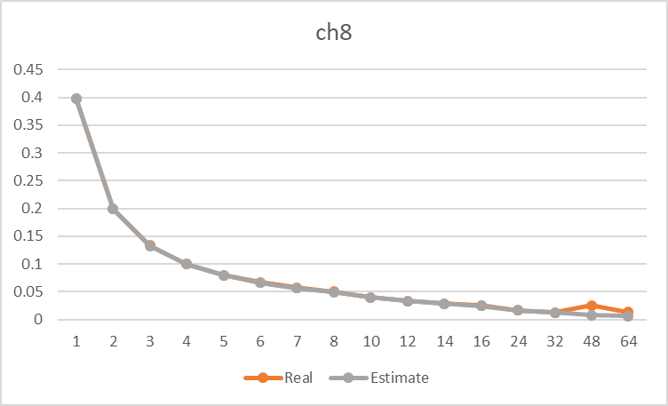

Conclusion and Discussion
(Discuss the following issues of your program
- What is the speedup respect to the number of processors used?
- How can you improve your program further more
- How does the communication and cache affect the performance of your program?
- How does the Karp-Flatt metrics and Iso-efficiency metrics reveal?
)
- The speedup remains acceptable at 2-32 processes, but doesn’t look good at 48 and 64 processes.
- The main program is modified from the source code provided by the author. The source code runs efficiently and is fully optimized.
- According to the spec sheet of the Taiwania1, one computation node contains 40 cores (processes). Maybe this is the reason of why the execution time rises when the process number is greater than 40. (because of the communication overhead.)
- The Karp-Flatt metrics remain small and stable when using 2-32 processes, but instantly grow when using 48 processes.
Appendix(optional):
(If something else you want to append in this file, like picture of life game)

