Parallel Programming Exercise Chpater 10 – 10.4

|  |  |
| --- | --- |
| **Author:** | 張瀚文([b07505027@ntu.edu.tw](mailto:b07505027@ntu.edu.tw)) |
| **Student ID** | B07505027 |
| **Department** | Engineering Science and Ocean Engineering |

(If you and your team member contribute equally, you can use (co-first author), after each name.)

# Problem and Proposed Approach

(Brief your problem, and give your idea or concept of how you design your program.)

題目要算一個立方體如果被從某個角到對角挖了一個圓柱體（軸為x = y = z）後，跟原本的體積比，還剩下多少的比例。

此問題可以用蒙地卡羅法估算：隨機取total = n^3個在立方體中的點，計算remain為有多少點不在圓柱體內（距離x = y = z不為d），則 remain / total則為答案。

隨機生成法採用獨立來源法，每個process選用不同的種子。

# Theoretical Analysis Model

(Try to give the time complexity of the algorithm, and analyze your program with iso-efficiency metrics)

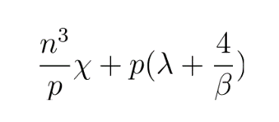計算點的個數 + Reduce p個processes

# Performance Benchmark

(Give your idea or concept of how you design your program.)

Table 1. The execution time

|  |  |  |  |  |  |  |  |
| --- | --- | --- | --- | --- | --- | --- | --- |
| **Processors** | 1 | 2 | 4 | 8 | 16 | 32 | 64 |
| **Real execution time** | 0.13848 | 0.069388 | 0.056418 | 0.025463 | 0.020974 | 0.016998 | 0.015276 |
| **Estimate execution time** | 0.1385 | 0.0692 | 0.0346 | 0.0173 | 0.0087 | 0.0043 | 0.0022 |
| **Speedup** | 1.0000 | 1.9957 | 2.4545 | 5.4385 | 6.6025 | 8.1468 | 9.0652 |
| **Karp-flatt metrics** | #DIV/0! | 0.0021 | 0.2099 | 0.0673 | 0.0949 | 0.0944 | 0.0962 |

Figure 1. The performance of diagram

# Conclusion and Discussion

(Discuss the following issues of your program

1. What is the speedup respect to the number of processors used?
2. How can you improve your program further more
3. How does the communication and cache affect the performance of your program?
4. How does the Karp-Flatt metrics and Iso-efficiency metrics reveal?
5. 與預期差不多，是很適合平行化的問題。
6. 因問題本身簡單，且目前結果又與預期相當，所以並無特別可優化之處。
7. 似乎有一點影響，但影響不太大
8. 前面的e還滿不正常的，但後面8<=p<=16時成長，到16<=p<=64時又似乎是定值，所以猜e應該是定值，溝通影響小。

# Appendix(optional):

(If something else you want to append in this file, like picture of life game)

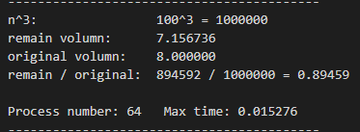p = 64時的結果