SmartTrack: An Automated Financial and Inventory Management System with Supply-Demand Analytics for Tangub Pharmacy


A Capstone Project
Presented to the Faculty of
College of Information and Communication Technology,
Northwestern Mindanao State College
of Science and Technology

In Partial Fulfillment of the Requirements
for the degree of Bachelor of Science in Information Technology

By:
Delantar, Rhoen Dale A.
Espinosa, Algen V.
Pornia, John Carlo A.

Neil Vincent Canama
Adviser

July 2026

TABLE OF CONTENTS
Chapter I 1
1.1 Project Context 1
1.2 Purpose and Description 4
1.3 Objectives 4
1.3.1 General Objective 5
1.3.2 Specific Objectives 5
1.4 Conceptual Framework 6
1.5 Statement of the Problem 7
1.6 Scope and Limitation 8
1.6.1 Limitations of the Study 8
1.6.2 Delimitation of the Study 9
1.7 Definition of Terms 10
Chapter II 13
2.1 Related Literature 13
2.2 Related Systems 15
2.2.1 mSupply 15
2.2.2 Zoho Inventory 16
2.2.3 Odoo Accounting and Inventory Modules 17
2.3 Synthesis 18
2.4 Identified Research Gaps 19
2.4.1 Lack of Integrated Inventory and Financial Management 19
2.4.2 Limited Support for Inventory Adjustments 19
2.4.3 Inadequate Expiration Date Monitoring 19
2.4.4 Limited Integration of Demand Forecasting and Inventory Replenishment Planning 20
2.4.5 Limited Adaptation to Partial Supplier Fulfillment 20
2.5 Technical Background 20
Chapter 3 23
3.1 Requirement Analysis 23
3.1.1 Project Design 23
Project Requirements 24
System Design 24
Development 24
Testing 24
Deployment 24
Review 25
3.1.2 Current Technical Situation 25
3.2 Requirements Documentation 26
3.2.1 Software and Hardware Requirements 26
3.2.2 Functional and Non-Functional Requirements 29
Functional Requirements 29
Administrator (Owner-Pharmacist) 29
Staff 30
Non-Functional Requirements 30
3.3 Design of Software, System, and Process 31
3.3.1 System Architecture 31
3.3.2 Context Diagram 32
3.3.3 Data Flow Diagram 33
3.3.4 Functional Decomposition Diagram 34
3.3.5 Entity Relationship Diagram 36
3.4 Development and Testing 38
3.4.1 Development 38
3.4.2 Testing 39
Alpha Testing 39
Beta Testing 40
3.4.3 Data Analysis Plan 44
A. Rating Scale 45
Formula for Weighted Mean: 45
3.5 Implementation Plan 46
3.6 Sample Screen Design 48
References 51

LIST OF FIGURES

Figure 1: Conceptual Framework of SmartTrack: An Automated Financial and Inventory Management System with Supply-Demand Analytics for Tangub Pharmacy 6
Figure 2: Interface of mSupply, an Open-Source Pharmaceutical Supply Chain and Inventory Management System 16
Figure 3: Interface of Zoho Inventory, a Cloud-Based Inventory Management Platform 17
Figure 4: Interface of Odoo's Integrated Accounting and Inventory Management Modules 18
Figure 5: Agile Development Cycle 23
Figure 6: Current Technical Situation 26
Figure 7: System Architecture 32
Figure 8: Context Diagram 33
Figure 9: Data Flow Diagram 34
Figure 10: Data Flow Diagram 35
Figure 11: Entity Relationship Diagram 37
Figure 12: Formula for Weighted Mean 45
Figure 13: Admin Dashboard 49
Figure 14: Inventory Management Module 49
Figure 15: Stock Alerts Module 50
Figure 16: Reports Module 50

LIST OF TABLES

Table 1: Technologies Present in the Project 20
Table 2: Hardware Requirements 27
Table 3: Software Requirements 27
Table 4: Data Dictionary 38
Table 5: Alpha Testing Activities 40
Table 6: System Evaluation for Pharmacy Administrator / Owner 42
Table 7: System Evaluation for Pharmacist (Inventory Manager) 44
Table 8: System Evaluation for Pharmacy Cashier (Staff) 45
Table 9: System Evaluation for IT Experts (Technical Evaluation) 46
Table 10: Three-Point Likert Rating Scale 47
Table 11: Likert Scale Table 48
Table 12: Implementation Plan 49

Chapter I
INTRODUCTION

1.1 Project Context
Tangub Pharmacy, established in 1999 and located at 1st Street, Tangub City, is a community pharmacy operated by a pharmacist-owner and three employees. For more than two decades, it has served as one of the primary providers of medicines and healthcare products in the locality. Despite its long years of operation, the pharmacy continues to rely on handwritten logbooks and paper-based records for inventory management and financial transaction recording. Although the pharmacy previously used a computerized system for report generation, the system eventually became non-functional, forcing the business to return to manual operations. This situation highlights the need for a reliable computerized system that can improve the efficiency, accuracy, and organization of the pharmacy's daily operations.
According to the client interviews and questionnaire described by the proponents, the pharmacy reported challenges with manual stock and financial records, delayed awareness of low stock, inconsistent recording of returns, and manual expiry checks. The owner-pharmacist reportedly estimated that the supplier delivers about 80% of requested quantities. This figure describes the reported operating context; it is not a measurement calculated by SmartTrack and should be supported by the project interview records.
The continued reliance on manual processes affects not only the pharmacy's operational efficiency but also its financial performance and quality of service. Inaccurate inventory records often result in poor replenishment decisions, while unrecorded returns, refunds, damaged products, and expired medicines contribute to inventory discrepancies and financial losses. Likewise, the omission of minor financial transactions gradually reduces the accuracy of financial reports, making it difficult for the owner to monitor business performance and make informed decisions. These operational inefficiencies also increase the administrative workload of pharmacy personnel, reducing the time available for customer service and other essential responsibilities. More importantly, stock shortages and inadequate expiration monitoring may compromise the availability and safety of medicines, directly affecting the quality of healthcare services provided to the community.
Existing literature consistently affirms the importance of automated management systems in addressing operational challenges commonly encountered by small businesses and community pharmacies. In the Philippine context, Tanaman et al. (2023) observed that small enterprises relying on manual systems frequently experience stock imbalances and delayed reporting, emphasizing the need for automated inventory management solutions. Keshari et al. (2023) further demonstrated that integrating automated forecasting and inventory monitoring improves stock accuracy and replenishment planning. Similarly, Tang et al. (2023) found that inventory forecasting models help minimize stockouts and overstocking by enabling more informed and data-driven inventory decisions, which is particularly relevant to Tangub Pharmacy's reported concern about partial deliveries. Separately, the owner-pharmacist reportedly estimated that about 80% of requested quantities are received; this figure should be corroborated by the interview records. On the financial management side, Alao et al. (2024) reported that automating financial recording minimizes manual encoding errors and improves the accuracy of financial reports. Likewise, Gallego Cossio et al. (2025) concluded that automated management systems enhance operational efficiency and support better decision-making in small businesses. Furthermore, Amosu et al. (2024) emphasized that demand forecasting models support better inventory replenishment planning by analyzing historical sales data to estimate future product demand. By providing more accurate demand estimates, these models help organizations maintain appropriate inventory levels, minimize stock shortages and overstocking, and improve inventory planning and stock management. This approach is appropriate for addressing the inventory management challenges encountered by Tangub Pharmacy.
The proposed SmartTrack system also supports the United Nations Sustainable Development Goals (SDGs), particularly SDG 3 (Good Health and Well-Being) by promoting the availability of safe and quality medicines through effective inventory management and expiration date monitoring. The study also contributes to SDG 8 (Decent Work and Economic Growth) by improving operational efficiency and reducing financial losses caused by manual processes. Furthermore, it aligns with SDG 9 (Industry, Innovation and Infrastructure) by encouraging the adoption of digital technologies to modernize inventory and financial management practices in community pharmacies (United Nations, 2015).
In response to these reported needs, this study presents SmartTrack: An Automated Financial and Inventory Management System with Supply-Demand Analytics for Tangub Pharmacy. The desktop application combines inventory and batch management, transaction recording, customer return and damage workflows, purchase-order management, alerts, reports, analytics, and role-based access. It uses received-date FIFO for stock deduction and separately applies expiry alerts and a sale-blocking rule. SMA-3 and SMA-6 estimates are displayed separately from advisory EOQ recommendations. Purchase orders and supplier fulfillment are tracked for orders recorded in SmartTrack, but fulfillment does not change the current EOQ or suggested ROP calculations.
The development of SmartTrack is carried out across two academic terms. The first phase is conducted during the Summer Term under Capstone 101 (June–July 2026), covering requirements gathering, client interviews, system analysis, and system design. The second and primary phase is implemented during the First Semester of Academic Year 2026–2027 under Capstone 102 (August–December 2026), which includes system development, implementation, unit and integration testing, user acceptance testing, system evaluation, and the preparation of the final documentation and presentation. Key milestones include the completion of the system prototype, user evaluation, and the final panel presentation. The completed system is expected to be delivered by the end of December 2026.
The study draws on client information gathered by the proponents and on the literature cited in Chapter II. Interview records and source details should be retained to support statements about the pharmacy's current workflow and supplier performance. User evaluation is planned using the instruments in Chapter III; this manuscript does not report evaluation results.

1.2 Purpose and Description
SmartTrack is a desktop-based financial and inventory management system designed for Tangub Pharmacy. It monitors stock levels against configured reorder thresholds, manages products and received batches, and supports adjustments for returns, damaged items, and other recorded inventory changes. It records batch numbers, received dates, quantities, and optional expiration dates. The system displays expiry alerts and blocks sales when the next FIFO batch is expired or is within the configured 60-day sale-blocking window. Users must review and act on alerts; expired stock is not automatically removed from inventory.
SmartTrack records sales, customer refunds, damaged-stock losses, and other supported transaction details. Its Analytics module displays SMA-3 and SMA-6 estimates and an advisory model comparison when there are enough comparable periods. Product-level EOQ recommendations use annualized historical sales and estimated unit purchase costs, not the SMA output. The module also displays an estimated restocking amount and an advisory reorder-point estimate based on a seven-day lead-time assumption and a 20% buffer. Recorded purchase orders support delivery tracking and supplier fulfillment reporting; the reported rate is not an input to the current EOQ or ROP calculations.

1.3 Objectives
This section presents the general and specific objectives that guide the development of SmartTrack: An Automated Financial and Inventory Management System with Supply-Demand Analytics for Tangub Pharmacy

1.3.1 General Objective
This study aims to design and develop SmartTrack: An Automated Financial and Inventory Management System with Supply-Demand Analytics for Tangub Pharmacy to address the operational limitations of its current manual inventory and financial record-keeping processes.

1.3.2 Specific Objectives
Specifically, this study seeks to:
Develop purchase-order functions for authorized users to prepare orders, record partial or complete deliveries as received batches, and review supplier fulfillment for orders recorded in SmartTrack;
- Develop an inventory management module that monitors stock against configured reorder thresholds, displays stock alerts, and supports product, batch, and received-stock review;
- Develop return, damage, and expiry-monitoring functions that record customer returns and refunds, allow an Inventory Manager to mark returned items as restocked or broken, display batch expiry alerts and advisory sales-velocity estimates, and block sales when the next received-date FIFO batch is expired or within the configured 60-day window;
- Develop financial functions that record sales, customer refunds, supported discounts, and damaged-stock losses, and present income summaries based on available transaction and batch-cost data;
- Implement supply-demand analytics that display SMA-3 and SMA-6 estimates and provide separate advisory EOQ recommendations using annualized historical sales and estimated unit costs. The module also presents an advisory model comparison, estimated restocking amount, and suggested ROP based on stated assumptions. Configured reorder thresholds remain the active stock-alert values, and supplier fulfillment does not change these calculations;
- Provide printable Sales, Stock Alerts, and Inventory report views, with financial summaries and supply-demand analytics available in their respective modules;
- Evaluate the system using user-acceptability questionnaires and separate technical test evidence. User ratings will measure perceived acceptability; algorithm correctness, response time, security, and forecast performance will be established only through corresponding tests. Forecast accuracy will not be inferred from user ratings.

1.4 Conceptual Framework
The conceptual framework uses the Input-Process-Output (IPO) model to show how SmartTrack transforms pharmacy records into information that supports inventory and financial operations.
The Input consists of product, batch, transaction, return, and purchase-order records, client-reported needs, and system requirements. The Process includes user authentication, stock and expiry monitoring, received-date FIFO deductions, purchase-order receipt recording, SMA-3/SMA-6 displays, separate EOQ recommendations, reporting, and evaluation. The Output is a desktop application that supports inventory and batch management, transaction and return workflows, purchase-order and delivery tracking, alerts, decision-support analytics, and printable reports. Supplier fulfillment is summarized from recorded orders but is not used as an EOQ or ROP input.
Figure 1: Conceptual Framework of SmartTrack: An Automated Financial and Inventory Management System with Supply-Demand Analytics for Tangub Pharmacy

1.5 Statement of the Problem
The project is based on operational concerns reported by Tangub Pharmacy's owner-pharmacist and staff, including reliance on paper-based records, late awareness of low stock, inconsistent recording of returns, manual expiry checks, and possible omissions in financial records. The owner-pharmacist reportedly estimated supplier fulfillment at approximately 80%; this figure requires support from the interview records and should not be presented as a system-calculated result.
Given these identified problems, this study seeks to answer the following research questions:
- How can the system monitor stock levels and generate automated low-stock alerts to prevent stockout occurrences at Tangub Pharmacy?
- How does the system record customer returns and refunds, and how are returned items processed as restocked or broken?
- How can the system monitor medicine expiration dates and generate automated notifications for products approaching their expiration dates?
- How does the system record supported sales, refunds, discounts, and damaged-stock losses, and what financial summaries can users review?
- How does the system present SMA-3 and SMA-6 estimates, separate advisory EOQ/ROP recommendations, and supplier fulfillment summaries from recorded purchase orders?
- What printable sales, stock-alert, and inventory views, and what separate financial and analytics summaries, does the system provide?
- What is the perceived acceptability of the system among its intended users in terms of functional suitability, usability, performance efficiency, reliability, and security?

1.6 Scope and Limitation
This study covers the design, development, and planned evaluation of SmartTrack, a desktop-based financial and inventory management system for Tangub Pharmacy, located at 1st Street, Tangub City.
The system covers: (1) product and batch inventory management with configured reorder thresholds; (2) sales, customer-return, refund, and damage workflows, including a pending disposition before returned goods are restocked or marked broken; (3) purchase-order preparation and recording of partial or complete deliveries; (4) stock and expiry alerts, including advisory sales-velocity estimates and a 60-day sale-blocking rule for the next FIFO batch; (5) SMA-3/SMA-6 displays and separate advisory EOQ/ROP calculations; (6) printable sales, stock-alert, and inventory views, with financial and analytics summaries in separate modules; and (7) authentication and role-based access for Admin/Owner, Admin, Inventory Manager, and Cashier. Supplier fulfillment is summarized from recorded purchase orders but is not included in EOQ or ROP calculations.
The system's inventory management covers all products sold by Tangub Pharmacy, including pharmaceutical products, over-the-counter medicines, medical supplies, and general merchandise available in the pharmacy.

1.6.1 Limitations of the Study
The study is subject to the following limitations:
- The accuracy of the demand forecasting module depends on the completeness, consistency, and accuracy of the historical sales data recorded in the system.
- Forecasts, EOQ recommendations, the replenishment-capital estimate, the model comparison, and the suggested ROP are decision-support outputs. The model comparison is advisory and is not presented as an independently validated out-of-sample accuracy result. The suggested ROP uses an assumed seven-day lead time and a 20% buffer; it is displayed alongside the configured reorder threshold, which remains the active stock-alert threshold. Final replenishment decisions remain the responsibility of the authorized pharmacy personnel. The reported supplier fulfillment rate is not incorporated quantitatively into the current calculations.
- The system is designed for desktop use at Tangub Pharmacy; it is not a cloud-synchronized, multi-branch service.
- System performance and data accessibility may be temporarily affected during power interruptions or hardware failures.
- The FIFO stock-deduction method depends on accurate recording of batch receipt dates and quantities. Expiry dates are monitored separately; FIFO and FEFO are not interchangeable in this implementation.
- The planned evaluation is limited to the intended users and technical evaluators identified in the study; findings may not represent the needs of other pharmacies.

1.6.2 Delimitation of the Study
To define the appropriate boundaries of the study, the following functional areas are deliberately excluded from the scope of SmartTrack’s development:
- Payroll processing, employee compensation, attendance monitoring, and other human resource management functions.
- Integration with the Food and Drug Administration (FDA) Philippines or other external regulatory databases.
- Direct integration with external POS terminals, barcode scanners, receipt printers, or supplier systems. Purchase orders are recorded in SmartTrack, but are shared with suppliers outside the application.
- Online sales, e-commerce transactions, customer ordering, and medicine delivery services.
- Customer relationship management (CRM), electronic medical records, prescription management, and patient health records.
- Development of advanced artificial-intelligence or machine-learning models is beyond the scope of this study. The system presents SMA-3 and SMA-6 moving-average forecasts and applies EOQ to annualized historical sales and estimated cost inputs; it does not use the SMA forecast directly as the EOQ demand input.
- Multi-branch inventory management, cloud synchronization across multiple pharmacy locations, and remote access features.
These delimitations were established based on the operational priorities identified during the client interview and the scope appropriate for an undergraduate capstone project.

1.7 Definition of Terms
For clarity and common understanding, the following terms are defined as they are used in this study.
Agile (Scrum). An iterative software development methodology that organizes project activities into short development cycles called sprints, enabling continuous development, testing, feedback, and improvement throughout the system development process.
Data Analytics. The process of collecting, organizing, analyzing, and interpreting historical sales and inventory data to identify trends and support inventory planning and decision-making.
Demand Forecasting. The process of estimating future demand from historical sales. SmartTrack presents SMA-3 and SMA-6 monthly moving-average estimates as decision-support information.
Desktop-Based System. A software application installed and operated on a desktop or laptop computer. In this study, SmartTrack is deployed on the pharmacy's desktop computer to support daily inventory and financial management operations.
Economic Order Quantity (EOQ). An advisory order-size estimate calculated from annualized historical sales, estimated unit purchase cost, a fixed ₱120 ordering-cost assumption, and a 20% annual holding rate. It does not use the displayed SMA forecast as its demand input.
Electron. A framework used to build cross-platform desktop applications using web technologies such as HTML, CSS, and JavaScript. In this study, it is used to package SmartTrack as a desktop-based application.
Expiration Date Monitoring. Recording batch expiry dates, displaying expiry alerts, and blocking a sale when the next received-date FIFO batch is expired or within the configured 60-day sale-blocking window. Expired stock is not automatically removed.
Financial Management Module. The SmartTrack functions for recording and reviewing sales, refunds, supported discounts, damaged-stock losses, and available cost-backed income summaries. The system does not provide a complete operating-expense ledger.
First-In, First-Out (FIFO). An inventory method in which the oldest received batch is deducted first. SmartTrack orders batch deductions by received date. Expiry monitoring is handled separately, so this FIFO implementation should not be described as First-Expired, First-Out (FEFO).
Forecast Estimate. A historical-sales-based SMA-3 or SMA-6 estimate displayed for decision support. It is not a separate report in the Reports module.
Inventory Adjustment. A recorded change to stock, such as a damaged-stock entry or a processed customer-return disposition. A return remains pending until an Inventory Manager marks it restocked or broken.
Inventory Management. The process of monitoring, controlling, and maintaining stock levels to ensure the availability of products. In this study, it refers to the automated inventory management functions provided by SmartTrack.
PHP API Backend. SmartTrack uses PHP API endpoints to validate requests, apply business rules, and read or update records in the MySQL database. The current project does not use the Laravel framework.
Session and Bearer-Token Authentication. SmartTrack supports browser sessions and bearer tokens for authenticated API requests. The current project does not use Laravel Sanctum.
Low Stock Alert. An automated notification generated when the quantity of a product reaches or falls below a predefined inventory threshold, reminding authorized users to replenish stock.
MySQL. An open-source relational database management system used to store and manage the system's inventory records, financial records, supplier information, user accounts, sales transactions, and other operational data.
Return and Refund Tracking. Recording a customer return linked to an original sale and recording its refund amount. The returned item remains pending until an Inventory Manager marks it restocked or broken; recording a refund does not itself put the item back into stock.
Recharts. A React-based charting library used to create interactive charts and graphs for visualizing inventory levels, sales trends, financial summaries, and demand forecasting results. In this study, it is used to present reports and statistical information in a clear and visual format to support decision-making.
React.js. A JavaScript library used to build the user interface of SmartTrack. In this study, it is used to develop the desktop application's front-end components.
Role-Based Access Control (RBAC). A security mechanism that restricts system functions according to assigned roles. SmartTrack defines Admin/Owner, Admin, Inventory Manager, and Cashier roles.
Simple Moving Average (SMA). A forecasting method that calculates average sales over a specified number of previous periods. SmartTrack displays SMA-3 and SMA-6 estimates as decision-support information; its product-level EOQ recommendations are calculated separately from annualized historical sales.
Stock Level Monitoring. Reviewing current batch quantities against configured reorder thresholds. Stock quantities change through recorded sales, receipts, and processed inventory adjustments.
Stockout. A condition in which the available quantity of a product becomes insufficient or unavailable to meet customer demand.
Supplier Fulfillment Rate. The quantity received divided by the quantity ordered across purchase orders recorded in SmartTrack. It is a historical quantity metric, not a delivery-time score, and does not currently change EOQ or ROP calculations.
User Acceptance Testing (UAT). The final testing phase in which the intended users evaluate the developed system to determine whether it satisfies the required functionality, usability, and reliability before implementation.

Chapter II
13
REVIEW OF RELATED LITERATURE

2.1 Related Literature
The increasing reliance of small enterprises on accurate inventory and financial records has led to a growing body of research advocating the automation of traditionally manual business processes. Manual record-keeping, particularly in retail and pharmacy settings, continues to expose businesses to stock discrepancies, delayed reporting, financial inaccuracies, and operational inefficiencies. Jaju et al. (2023) investigated inventory control practices in a pharmacy store in Eastern India and found that stockouts, medicine expiration, and supplier-related issues were among the major challenges affecting pharmaceutical inventory management. The study emphasized the importance of systematic inventory monitoring and demand planning in reducing inventory-related problems. Similarly, Tanaman et al. (2023) observed that many small enterprises in the Philippines that rely on manual inventory systems experience stock imbalances, delayed reporting, and inefficient inventory control. The authors recommended the implementation of automated inventory management systems to improve operational efficiency and inventory accuracy.
Automated financial management systems have likewise been recognized for improving the accuracy and reliability of business records. Zhao et al. (2022) reported that computerized accounting systems significantly reduce manual encoding errors while improving the timeliness and accuracy of financial reporting compared to traditional manual bookkeeping practices. Likewise, Alao et al. (2024) concluded that automated financial recording enhances the quality of financial information by minimizing omissions and generating real-time financial summaries, allowing business owners to make more informed financial decisions. These findings support the development of SmartTrack's financial management module, which aims to automate transaction recording and reduce errors commonly encountered in manual financial documentation.
Accurate demand forecasting has become an essential component of inventory planning, particularly for businesses that experience fluctuating customer demand and supplier constraints. Tang et al. (2023) emphasized that forecasting historical sales trends enables organizations to estimate future inventory requirements more effectively, reducing both stock shortages and excessive inventory levels. Demand forecasting provides businesses with quantitative information that supports more efficient inventory replenishment decisions and improves inventory availability. Likewise, Amosu et al. (2024) highlighted that historical sales analysis serves as an effective basis for forecasting future product demand, enabling organizations to establish inventory plans that better match customer purchasing behavior. These findings support the implementation of the Simple Moving Average (SMA) forecasting algorithm in SmartTrack to estimate future medicine demand using historical sales records.
Inventory replenishment decisions also depend on selecting an appropriate ordering strategy that minimizes inventory costs while maintaining sufficient stock levels. Khakbaz et al. (2024) describe the Economic Order Quantity (EOQ) model as an inventory-control technique for determining order quantities and balancing ordering and holding costs. These findings provide a theoretical basis for SmartTrack's advisory EOQ function. Separately, the owner-pharmacist reportedly estimates that about 80% of requested quantities are received; this client-reported figure requires support from interview records and is not a result of the cited study or a calculation produced by SmartTrack.
Proper stock-issuance and expiry-monitoring methods are important in pharmacy operations because medicines have expiration dates. SmartTrack deducts inventory using First-In, First-Out (FIFO) order based on batch receipt date and separately monitors expiry dates. Because FIFO is not the same as FEFO, the study describes these behaviors separately and does not claim that the current implementation always issues the batch with the earliest expiration date first.
Several local studies have likewise emphasized the importance of integrating inventory and financial management within a single computerized system. Bernabe et al. (2022) found that effective inventory management practices significantly contribute to improved financial performance among retail enterprises by reducing inventory losses and improving stock availability. Similarly, Toroba et al. (2025) reported a significant relationship between inventory control practices and business profitability among retail establishments in Davao Oriental. These findings indicate that inventory management and financial management should not be treated as separate business functions but rather as interconnected processes that collectively influence organizational performance.
Local system development studies further support the implementation of integrated management systems for pharmacy operations. Teleron (2022), in the development of a Pharmacy Management Information System, demonstrated that automating pharmacy inventory monitoring, sales recording, accounting, and financial management significantly improved inventory accuracy, transaction processing efficiency, and report generation. Likewise, Cabangbang et al. (2024) evaluated an automated point-of-sale system and found that automating inventory and sales recording reduced manual errors while improving transaction efficiency and overall system usability. These studies reinforce the development of SmartTrack by demonstrating that integrating inventory management, financial recording, forecasting, inventory control, and reporting within a single desktop-based system can significantly improve operational efficiency and support better decision-making in pharmacy operations.

2.2 Related Systems
The review of related systems provides an overview of existing inventory and financial management systems that share functional similarities with the proposed study. Examining these systems enables the researchers to identify their features, strengths, and limitations, which serve as references in developing SmartTrack: An Automated Financial and Inventory Management System with Supply-Demand Analytics for Tangub Pharmacy. The selected systems were chosen because they provide functionalities such as inventory management, financial recording, stock monitoring, and report generation that are relevant to the objectives of this study.

2.2.1 mSupply
mSupply is an open-source pharmaceutical supply chain and inventory management system widely used by hospitals, pharmacies, and public health organizations to manage medicine inventories, supplier transactions, and stock distribution. The system provides features such as inventory monitoring, purchase ordering, stock transfers, expiration date tracking, and inventory reporting, enabling healthcare facilities to improve medicine availability and reduce stock losses caused by expired products.
Similar to SmartTrack, mSupply provides inventory management, stock monitoring, supplier management, and expiration tracking. SmartTrack is scoped to the workflows implemented for Tangub Pharmacy, including transaction and financial records, batch-level FIFO stock deduction, expiry alerts, and SMA/EOQ decision support. Comparisons in this section are limited to features verified from the systems' available documentation.

2.2.2 Zoho Inventory
Zoho Inventory is an inventory management system designed to help businesses monitor stock levels, manage purchase and sales orders, and generate inventory reports. The system includes features such as real-time inventory tracking, automated reorder point notifications, barcode support, order management, and inventory reporting. It enables businesses to maintain accurate inventory records while improving inventory visibility and operational efficiency.
Similar to SmartTrack, Zoho Inventory provides inventory monitoring, low-stock notifications, and reporting. SmartTrack is tailored to Tangub Pharmacy's recorded requirements, including medicine batch and expiry monitoring, FIFO stock deduction, transaction and financial recording, and SMA/EOQ decision support. Comparisons in this section are limited to features verified from the systems' available documentation.

2.2.3 Odoo Accounting and Inventory Modules
Odoo is an enterprise resource planning (ERP) system that integrates inventory management and accounting into a unified platform. Its Inventory and Accounting modules enable businesses to manage stock movements, purchase orders, sales transactions, financial records, and business reports. The system also supports inventory valuation, warehouse management, invoicing, and financial reporting within a centralized environment.
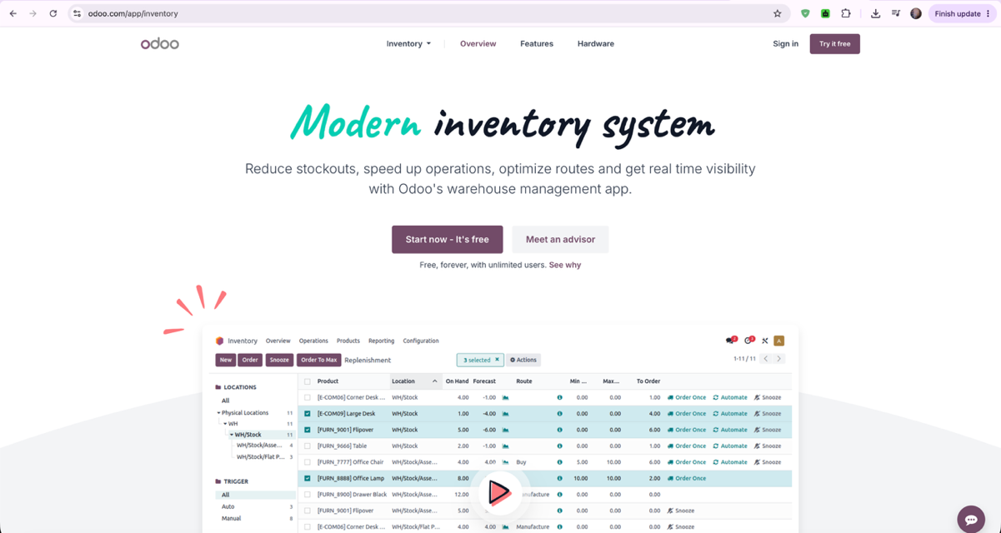
Similar to the proposed SmartTrack system, Odoo integrates inventory management and financial management into a single platform and generates inventory and financial reports. However, Odoo is a comprehensive ERP solution intended for businesses with broader operational requirements and typically requires extensive customization before deployment. It does not specifically support pharmacy-focused functions such as medicine expiration monitoring, inventory adjustments for returned, refunded, damaged, and expired products, First-In, First-Out (FIFO) inventory implementation, or inventory replenishment planning using the Simple Moving Average (SMA) forecasting algorithm together with the Economic Order Quantity (EOQ) model. SmartTrack is specifically developed to address these operational requirements of Tangub Pharmacy while providing a simpler and more focused desktop-based solution.
Figure 4: Interface of Odoo's Integrated Accounting and Inventory Management Modules

2.3 Synthesis
The reviewed related literature and systems demonstrate that automated inventory and financial management systems significantly improve operational efficiency, inventory accuracy, financial record management, and business decision-making. Existing studies consistently emphasize that automating inventory monitoring, financial transaction recording, and report generation reduces manual errors, minimizes stock discrepancies, and enhances overall operational performance. Likewise, the reviewed systems, including mSupply, Zoho Inventory, and Odoo, provide valuable functionalities such as inventory tracking, stock monitoring, financial recording, and report generation that support efficient business operations.
Despite these capabilities, the reviewed systems do not fully address the specific operational requirements of Tangub Pharmacy. Most are designed either for large healthcare institutions or general business environments and lack the integration of pharmacy-specific functions such as automated inventory adjustments for returned, refunded, damaged, and expired products, medicine expiration monitoring, First-In, First-Out (FIFO) inventory implementation, and inventory replenishment planning using demand forecasting techniques together with the Economic Order Quantity (EOQ) model. Furthermore, the reviewed studies generally focus on inventory management or financial management independently rather than integrating these functions into a single desktop-based system tailored for a small community pharmacy.
These identified gaps served as the basis for the development of SmartTrack: An Automated Financial and Inventory Management System with Supply-Demand Analytics for Tangub Pharmacy. The proposed system integrates inventory management, financial management, inventory adjustments, expiration monitoring, demand forecasting using the Simple Moving Average (SMA) algorithm, Economic Order Quantity (EOQ)-based reorder recommendations, First-In, First-Out (FIFO) inventory implementation, and automated report generation into a single desktop-based platform specifically designed to address the operational needs of Tangub Pharmacy.

2.4 Identified Research Gaps

2.4.1 Lack of Integrated Inventory and Financial Management
Most existing studies and systems focus on inventory management or financial management independently. Few integrate both functions into a single desktop-based system specifically designed for the operational needs of small community pharmacies.

2.4.2 Limited Support for Inventory Adjustments
Return workflows differ across inventory systems. SmartTrack records the customer return and refund, then requires an Inventory Manager to choose whether the returned item is restocked or marked broken. This explicit disposition avoids treating every returned item as immediately saleable stock.

2.4.3 Inadequate Expiration Date Monitoring
Although several pharmacy management systems provide inventory tracking, many lack proactive expiration monitoring with automated notifications that help pharmacy personnel identify medicines approaching their expiration dates and reduce medicine wastage.

2.4.4 Limited Integration of Demand Forecasting and Inventory Replenishment Planning
Many inventory systems rely on historical reports or fixed reorder points without incorporating demand forecasting techniques and inventory replenishment models. Few systems integrate historical sales analysis using the Simple Moving Average (SMA) forecasting algorithm together with the Economic Order Quantity (EOQ) model to support more informed inventory replenishment decisions for small community pharmacies.

2.4.5 Limited Use of Supplier Fulfillment in Replenishment Calculations
Supplier fulfillment can vary, so order records can help a pharmacy review the quantity requested and received. SmartTrack records these quantities and summarizes fulfillment for purchase orders created in the system. The current EOQ and suggested ROP calculations do not use that fulfillment rate; incorporating supplier performance into replenishment calculations remains outside the implemented model.

2.5 Technical Background
The technical background presents the technologies, software, and tools utilized in developing the proposed SmartTrack: An Automated Financial and Inventory Management System with Supply-Demand Analytics for Tangub Pharmacy. These technologies were selected based on their ability to support the system's functional and technical requirements while ensuring efficiency, security, maintainability, and ease of use.
Table 1: Technologies Present in the Project
Component | Description
PHP API Backend | Native PHP API endpoints implement request validation, application business rules, database operations, and reporting for SmartTrack.
React.js | A JavaScript library used to develop the graphical user interface (GUI) of the desktop application, providing an interactive and responsive user experience for inventory management, financial recording, forecasting, and report generation.
Electron | A framework used to package the React.js application into a desktop application that can be installed and executed on the pharmacy's computer, allowing SmartTrack to operate as a desktop-based system.
Tailwind CSS | A utility-first CSS framework used to style the React interface and responsive layouts.
MySQL Database Management System | Stores inventory, sales, user, batch, return, purchase-order, receipt, notification, and supporting records. Printable report views are generated from stored data; the system does not store generated report files as a separate report entity.
Session and Bearer-Token Authentication | The PHP API supports authenticated browser sessions and bearer tokens for API requests; the project does not use Laravel Sanctum.
Role-Based Access Control (RBAC) | Restricts application functions according to the implemented Admin/Owner, Admin, Inventory Manager, and Cashier roles.
Simple Moving Average (SMA) Forecasting Algorithm | Displays SMA-3 and SMA-6 estimates from monthly historical sales as decision-support information.
Economic Order Quantity (EOQ) Model | Calculates advisory order quantities using annualized historical sales, estimated unit cost, a fixed ₱120 ordering-cost assumption, and a 20% annual holding rate; it does not directly use the displayed SMA forecast as D.
First-In, First-Out (FIFO) | Deducts stock from the oldest received batch first. Expiry alerts and sale blocking are handled separately; FIFO is not described as FEFO.
Recharts | A React-based charting library used to generate interactive data visualizations such as inventory levels, sales trends, financial summaries, and demand forecasting results. In SmartTrack, it is used to present graphical reports that help users analyze business data and support decision-making.

Chapter III
METHODOLOGY

3.1 Requirement Analysis

3.1.1 Project Design
The methodology used in the development of SmartTrack serves as an organized framework that defines the tasks, outputs, and processes required at each stage of the system development lifecycle. It provides a structured yet flexible approach by dividing the project into manageable phases. Agile is a widely used methodology that emphasizes stakeholder involvement, adaptive planning, and iterative development (Tetteh, 2024), and was adopted by the researchers for the development of SmartTrack.
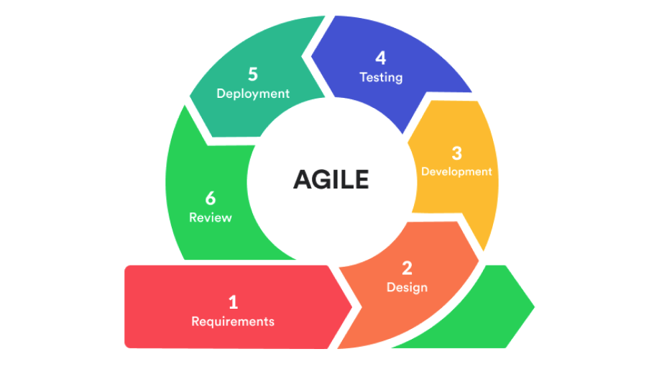
Figure 5: Agile Development Cycle

Agile system development focuses on continuous improvement through short development cycles and regular feedback. It allows the researchers to refine the system based on the identified needs of Tangub Pharmacy and to ensure that the final output remains consistent with the objectives of the study. This approach prioritizes working software, client feedback, and gradual enhancement throughout the development process.

Project Requirements
During this phase, the researchers conducted client interviews, administered structured questionnaires, and performed follow-up interviews with the owner-pharmacist of Tangub Pharmacy, Mr. Paterno B. Amamio Jr., to identify the current problems in the pharmacy's inventory and financial management processes and determine the requirements of the proposed system. The information gathered served as the basis for the system's design and development.

System Design
During this phase, the researchers developed initial prototypes and drafts of the system design, including the database schema, system architecture, and user interface layout for the desktop-based application. These were presented to the client for feedback and refinement.

Development
During this phase, the system modules, namely inventory management, financial management, inventory adjustment and monitoring, and supply-demand analytics, were built incrementally based on the client's requirements. The researchers held regular meetings with the adviser and, where possible, the client to gather feedback and improve the system.

Testing
Testing is planned to verify the implemented workflows and calculations against defined inputs and expected results. Test cases and their observed outcomes will be reported after the tests are completed.

Deployment
Deployment is planned after the system has passed the required tests and the deployment configuration has been approved. The application will be installed on the designated pharmacy computer, configured with the MySQL database, and introduced to authorized users. The manuscript should report actual deployment only when it has been confirmed.

Review
User acceptance testing is planned with the owner-pharmacist and staff after the test build is ready. Feedback will be used to assess acceptability and identify changes. Results will be reported only after the evaluation has been conducted.

3.1.2 Current Technical Situation
According to the project interviews described by the proponents, Tangub Pharmacy has relied on paper-based records for some inventory and financial activities. Staff reportedly encounter delayed stock awareness, manual expiry checks, and inconsistent recording of some returns. The owner-pharmacist reportedly estimated supplier fulfillment at about 80% of requested quantities. These are client-reported conditions and should be corroborated by the interview records; SmartTrack does not calculate this baseline from its purchase-order history.
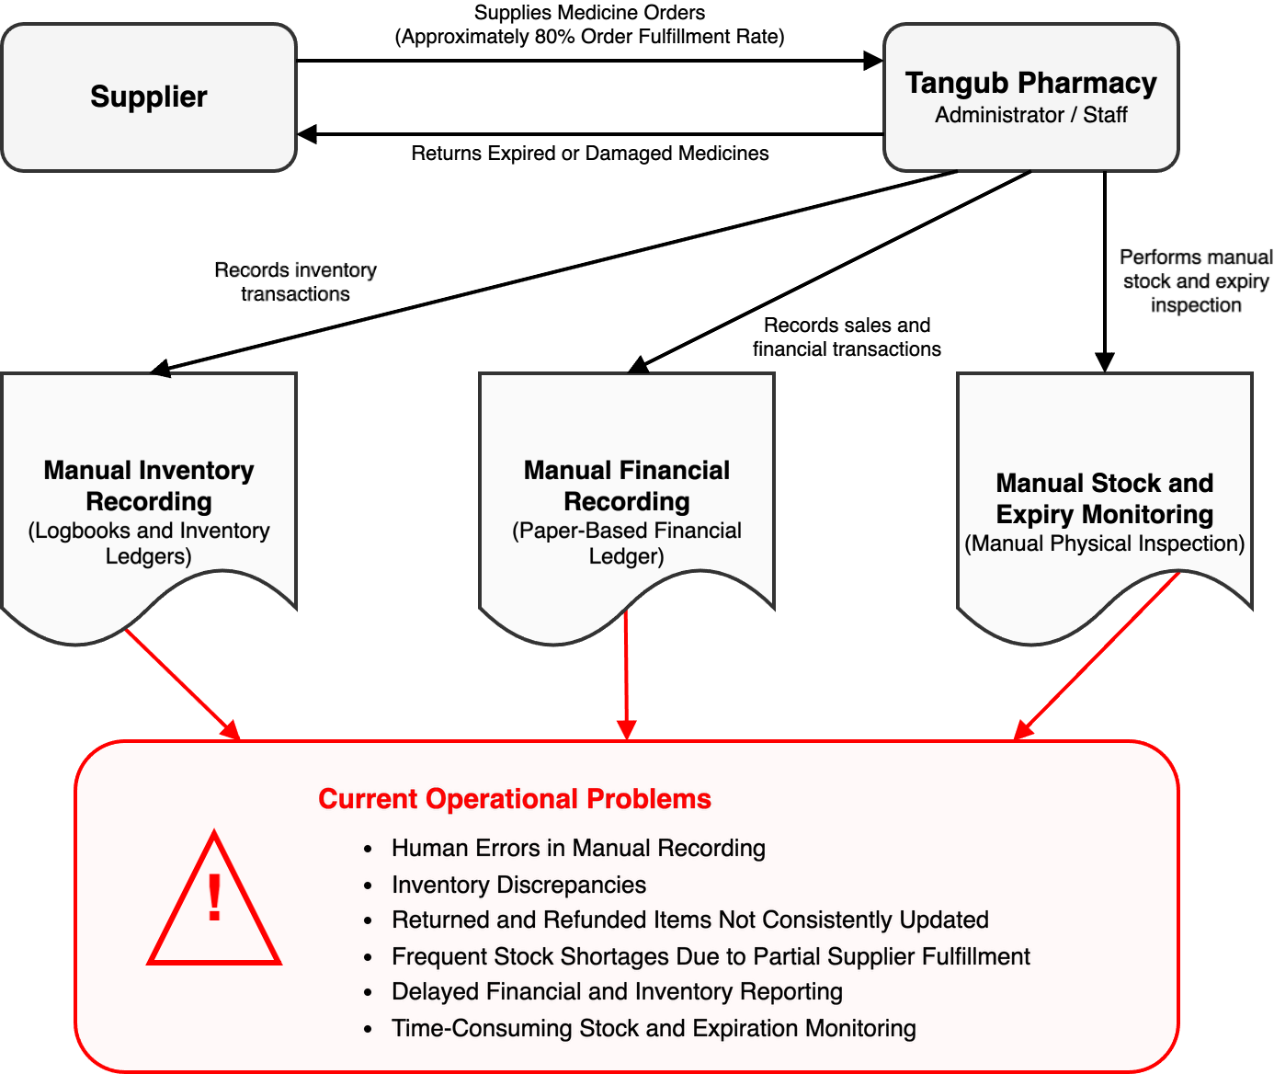
Figure 6: Current Technical Situation

3.2 Requirements Documentation
The requirements gathered for SmartTrack: An Automated Financial and Inventory Management System with Supply-Demand Analytics for Tangub Pharmacy were documented in structured formats to ensure that the system's features and functions aligned with user needs and the objectives of the project. This section presents the software and hardware requirements that served as the foundation for the system's design and development.

3.2.1 Software and Hardware Requirements
Table 2: Hardware Requirements
Components | Description
Desktop Computer | A computer used for system development, testing, and deployment of the desktop-based application. Ideally, it should have at least an Intel Core i5 processor or equivalent, 8GB RAM, and SSD storage for efficient compilation and operation.
Mouse | A handheld pointing device used to interact with the computer interface, allowing users to move the cursor and click, drag, or scroll as needed.
Stable Power Supply / UPS | Used to support uninterrupted operation of the desktop computer and help protect the system from sudden power interruptions during use.

Table 3: Software Requirements
Components | Description
Windows 10/11 | The operating system used to run the desktop application, development tools, and system testing environment.
Visual Studio Code | A lightweight but powerful code editor used for writing and debugging the system's frontend and backend code, with support for extensions and version control integration.
PHP | The server-side programming language used in developing the system's backend logic and processing functions.
PHP API Backend | Native PHP API endpoints implement request validation, application business rules, database operations, and reporting for SmartTrack.
Session and Bearer-Token Authentication | The PHP API supports authenticated browser sessions and bearer tokens for API requests; the project does not use Laravel Sanctum.
MySQL | Stores inventory, financial transaction, supplier, user, batch, return, purchase-order, receipt, and historical sales data. Printable report views are generated from stored records.
JavaScript | A programming language used to support dynamic functions, interface interactions, and responsive system behavior within the desktop application.
React.js | A JavaScript library used to develop the graphical user interface (GUI) of SmartTrack. It provides an interactive and responsive user interface that is packaged into a desktop application using Electron.
Electron | A desktop application framework used to package the React.js application into an installable desktop application that runs on Windows. It enables SmartTrack to operate as a desktop-based system while utilizing web technologies.
Tailwind CSS | A utility-first CSS framework used to style the React interface and responsive layouts.
Recharts | A React-based charting library used to generate graphical reports and data visualizations such as inventory levels, sales trends, financial summaries, and forecasting results.
Simple Moving Average (SMA) Module | Displays three-month and six-month moving-average estimates from recorded monthly sales.
Economic Order Quantity (EOQ) Module | Computes advisory order quantities from annualized historical sales and estimated unit costs using the application's stated cost assumptions.

3.2.2 Functional and Non-Functional Requirements

Functional Requirements

Administrator (Owner-Pharmacist)
Admin/Owner and Admin users oversee management functions, while access to specific pages and actions depends on the assigned system role. Admin/Owner has the highest level of account and system access.
- Inventory Management: The system allows the Administrator to add, update, and monitor real-time inventory levels, with automated low-stock notifications generated once predefined reorder thresholds are reached.
- Financial Transaction Recording: The system automatically records sales, purchases, expenses, and other financial transactions, ensuring complete, accurate, and organized financial records.
- Return and Refund Tracking: The system allows the Administrator to log returned or refunded items, automatically updating the corresponding inventory records to eliminate discrepancies.
- Expiration Date Monitoring: The system tracks the expiration dates of medicines and generates automated notifications for products approaching their expiration dates to support timely inventory management and medicine safety.
- Supply-Demand Analytics: The system displays monthly demand and SMA-3/SMA-6 moving-average estimates. Product-level EOQ recommendations use annualized historical product sales and estimated unit costs; the displayed SMA forecasts are not directly passed into the EOQ calculation. The output is advisory, and the reported supplier fulfillment rate is not a calculation input.
- FIFO Inventory Processing and Expiry Monitoring: Sales deduct quantities from batches in received-date order (FIFO). Expiration dates are monitored separately, and the system blocks a sale when the next FIFO batch is expired or within the 60-day sale-blocking window. This process is not described as FEFO.
- Report Generation: The system generates inventory, financial, sales, forecast, and expiration reports that provide accurate and timely information to support inventory planning and management decision-making.

Staff
The Inventory Manager handles inventory, purchase orders, delivery receipts, stock alerts, and return dispositions. Cashiers handle sales and may record customer-return requests; they do not manage purchase orders or process inventory dispositions.
- Transaction Encoding: Staff can encode daily sales, purchases, stock receipts, returns, refunds, and inventory updates to maintain accurate inventory and financial records.
- Stock and Expiration Viewing: Staff can view current stock levels and expiration alerts to assist in day-to-day pharmacy operations.
- Inventory Status Monitoring: Staff can monitor product movement and stock availability to help maintain accurate records and support replenishment activities.

Non-Functional Requirements
- Usability: The system should have a simple, organized, and easy-to-understand interface suitable for pharmacy personnel with basic computer skills.
- Reliability: The system should operate accurately and consistently without frequent errors, data loss, or system crashes.
- Performance: The system should process transactions, generate reports, and update inventory records within an acceptable response time.
- Security: The system should restrict access based on user roles and protect sensitive inventory and financial data from unauthorized access.
- Maintainability: The system should be easy to update, fix, and enhance when necessary.
      - Data Accuracy: The system should maintain accurate and synchronized inventory, financial, and report records based on user inputs and system computations.
      - Availability: The system should be accessible whenever needed during pharmacy operations on the designated desktop computer.

3.3 Design of Software, System, and Process

3.3.1 System Architecture
SmartTrack uses a React interface packaged with Electron, a native PHP API, and a MySQL database. The API supports session and bearer-token authentication, applies role checks and request validation, and processes inventory, transaction, return, and purchase-order operations. Sales deduct stock in received-date FIFO order; expiry monitoring and sale blocking are separate rules. Analytics displays SMA-3/SMA-6 estimates and separate advisory EOQ/ROP values. Purchase-order records support delivery and fulfillment reporting, but supplier fulfillment is not a calculation input.
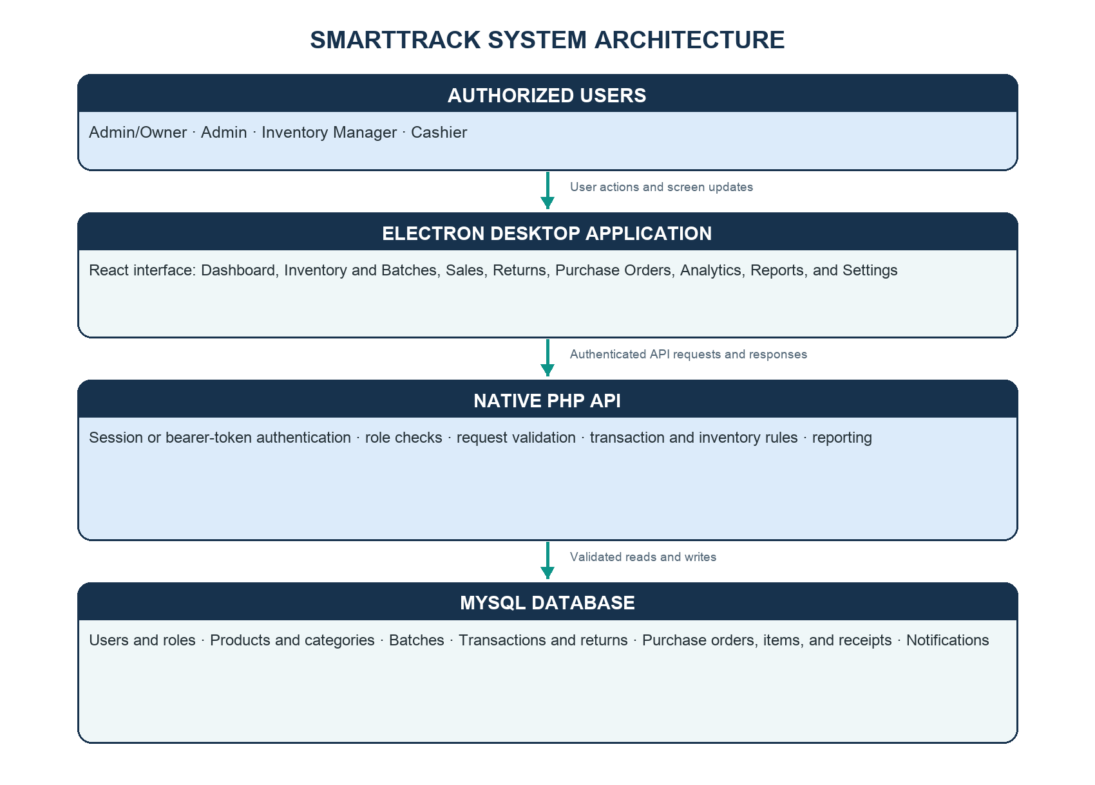
Figure 7: System Architecture

3.3.2 Context Diagram
Authorized users access SmartTrack through the Electron desktop application according to their assigned roles. The client sends requests to the native PHP API, which validates and processes them against MySQL. Authorized users enter purchase orders and delivery details in SmartTrack; the system does not connect directly to a supplier's platform. The Analytics module displays SMA-3/SMA-6 estimates, advisory EOQ/ROP values, and recorded supplier fulfillment. The configured reorder threshold remains the active stock-alert trigger.
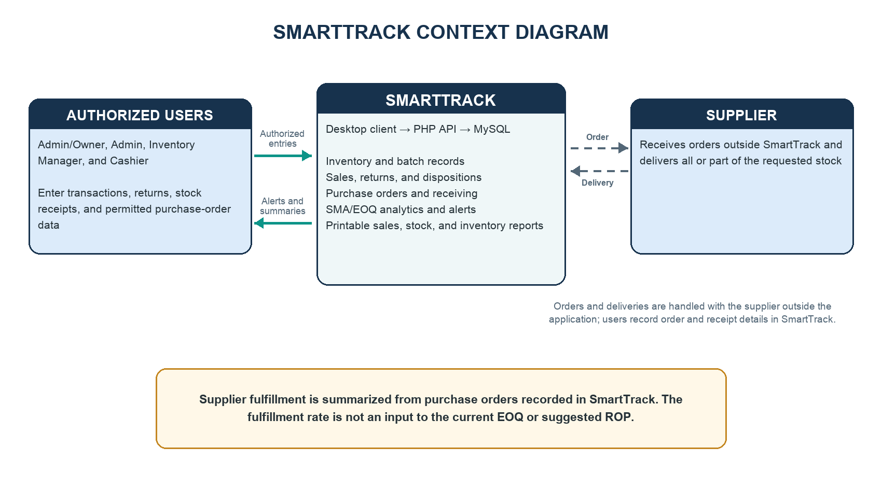
Figure 8: Context Diagram

3.3.3 Data Flow Diagram
The data flow begins when a user authenticates through the application. Users submit permitted sales, returns, inventory changes, purchase orders, and delivery receipts through the React/Electron client. The PHP API validates requests, applies role and business rules, and reads or updates MySQL records. Sales use received-date FIFO batch deductions; expiry checks separately block sales of the next FIFO batch when expired or within 60 days. The application displays historical sales with SMA-3/SMA-6 estimates, while EOQ/ROP remain separate advisory calculations. Supplier fulfillment is summarized from tracked orders and is not used by those calculations.
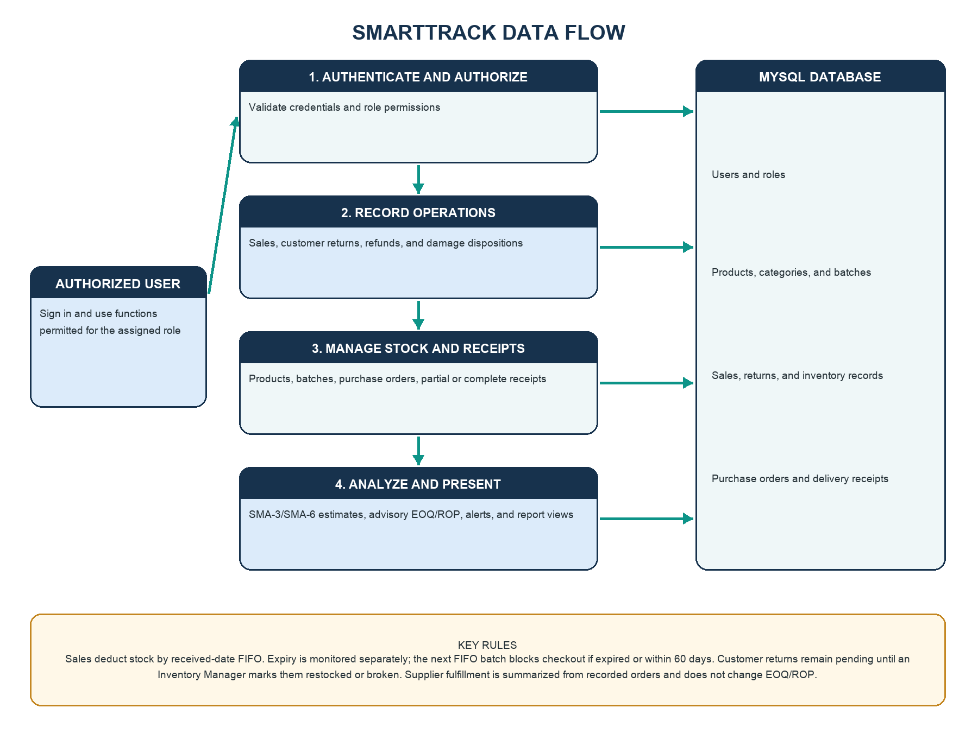
Figure 9: Data Flow Diagram

3.3.4 Functional Decomposition Diagram
The functional decomposition covers authentication and role-based access; product, batch, and reorder-threshold management; sales, customer returns, refunds, and damage dispositions; purchase-order preparation and delivery receipts; SMA-3/SMA-6 displays and separate advisory EOQ/ROP calculations; and stock/expiry alerts and report views. Only an Inventory Manager can process a pending customer return as restocked or broken.
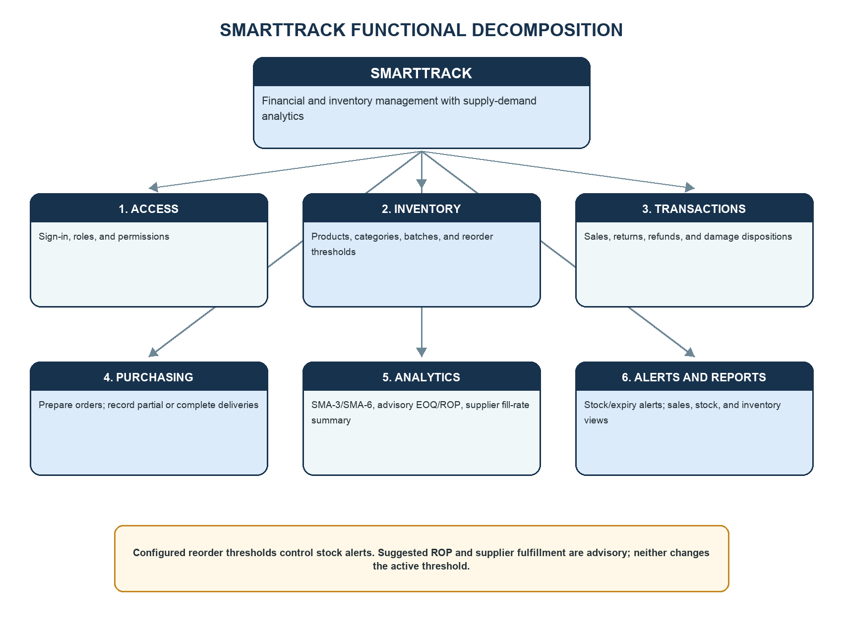
Figure 10: Functional Decomposition Diagram

3.3.5 Entity Relationship Diagram
The core database includes users, products, categories and their mapping table, product batches, transactions and batch-consumption records, customer-return/damage records, and purchase orders with order items and receipt records. Product batches reference products; purchase-order items reference orders and products; receipts reference order items and products; and return records reference products. The ERD shows selected current entities and relationships rather than an exhaustive schema.

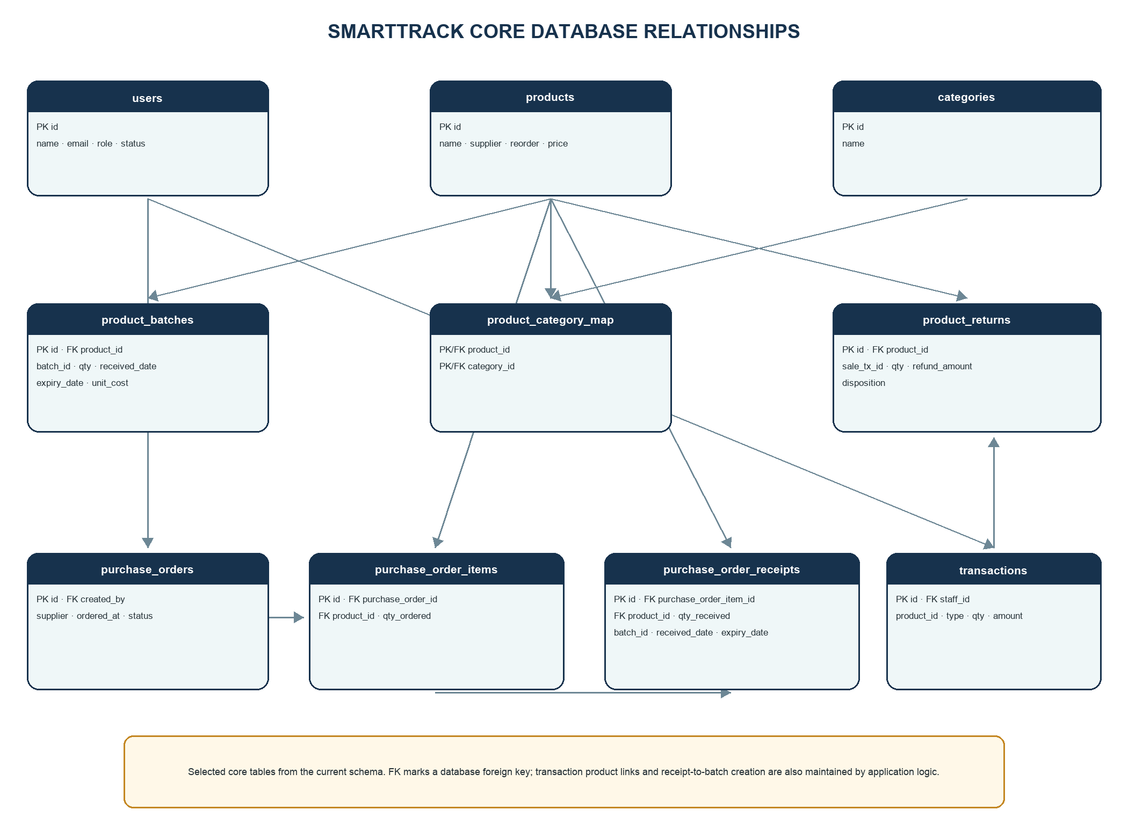
Figure 11: Entity Relationship Diagram (Core Tables)

3.3.6 Data Dictionary
The data dictionary below summarizes selected fields from the current SmartTrack MySQL schema. Product expiry, receipt dates, and purchase costs are recorded at batch level. Supplier names are stored on products and purchase orders. Purchase orders, line items, and receipts support partial-delivery tracking; return and damage dispositions are stored in product_returns. This is a core-entity summary, not an exhaustive field listing.
Table 4: Data Dictionary
Entity Name | Field Name | Field Type | Key | Description
users | id | VARCHAR(10) | PK | Unique user identifier
 | name | VARCHAR(120) |  | User display name
 | email | VARCHAR(120) | UNIQUE | Login email
 | role | ENUM |  | admin/owner, admin, inventory_manager, or cashier
 | status | ENUM |  | active or inactive account state
products | id | INT UNSIGNED | PK | Unique product identifier
 | name | VARCHAR(150) |  | Product name
 | barcode | VARCHAR(64) |  | Optional product barcode value
 | supplier | VARCHAR(120) |  | Supplier name stored on product record
 | reorder | INT |  | Configured reorder threshold in packs
 | price | DECIMAL(10,2) |  | VAT-inclusive selling price
 | status | ENUM |  | Computed stock status
product_batches | id | INT | PK | Unique batch-row identifier
 | product_id | INT UNSIGNED | FK | Related product
 | batch_id | VARCHAR(30) |  | Batch identifier
 | qty | INT |  | Remaining quantity in base units
 | expiry_date | DATE NULL |  | Batch expiration date, when applicable
 | received_date | DATE |  | Date used for FIFO received-order deduction
 | batch_total_cost | DECIMAL(12,2) NULL |  | Recorded total supplier cost for the batch
 | unit_cost | DECIMAL(10,4) NULL |  | Recorded unit purchase cost
transactions | id | VARCHAR(20) | PK | Unique transaction identifier
 | product_id | INT UNSIGNED NULL | FK | Related product, when applicable
 | type | ENUM |  | sale, return, or adjustment
 | qty | INT |  | Transaction quantity in base units
 | amount | DECIMAL(12,2) |  | Transaction amount
 | staff_id | VARCHAR(20) NULL | FK | Associated staff account, when available
 | transacted_at | DATETIME |  | Transaction date and time
product_returns | id | VARCHAR(20) | PK | Unique return or broken-stock record
 | product_id | INT UNSIGNED | FK | Related product
 | record_type | ENUM |  | return or broken
 | qty | INT |  | Quantity in base units
 | refund_amount | DECIMAL(12,2) |  | Recorded customer refund amount
 | loss_amount | DECIMAL(12,2) NULL |  | Recorded loss amount when cost is available
 | disposition | ENUM |  | pending, restocked, or broken
 | expiry_date | DATE NULL |  | Related batch expiry date, when available
purchase_orders | id | BIGINT UNSIGNED | PK | Unique purchase-order identifier
 | supplier | VARCHAR(120) |  | Supplier name recorded for the order
 | ordered_at | DATE |  | Date the purchase order was placed
 | status | ENUM |  | ordered, partially_received, received, or cancelled
purchase_order_items | id | BIGINT UNSIGNED | PK | Unique purchase-order line identifier
 | purchase_order_id | BIGINT UNSIGNED | FK | Related purchase order
 | product_id | INT UNSIGNED | FK | Product requested on the order line
 | qty_ordered | INT UNSIGNED |  | Quantity requested
purchase_order_receipts | id | BIGINT UNSIGNED | PK | Unique receipt identifier
 | purchase_order_item_id | BIGINT UNSIGNED | FK | Related purchase-order line
 | product_id | INT UNSIGNED | FK | Product received
 | qty_received | INT UNSIGNED |  | Quantity recorded for this delivery
 | batch_id / received_date | VARCHAR / DATE |  | Batch reference and date used for received-stock records
 | expiry_date / batch_total_cost | DATE / DECIMAL |  | Optional expiry and recorded total batch cost

3.3.7 Data Processing and Calculation Methods
SmartTrack uses product, batch, transaction, return, and purchase-order data for stock monitoring, historical-sales analysis, advisory reorder calculations, and expiry alerts. The calculations below distinguish implemented behavior from assumptions. Supplier fulfillment is reported from orders recorded in the system but is not used as an EOQ or ROP input.

3.3.7.1 Simple Moving Average (SMA-3 and SMA-6) for Medicine Demand Analysis
SmartTrack displays simple moving-average estimates over three-month and six-month windows. For a selected window, the average is calculated from available monthly sales totals. The two outputs provide short- and longer-window views of historical demand. The in-app historical error comparison is advisory and has not been validated as an independent out-of-sample accuracy measure.
Formula:
SMA-3: F(t) = (A(t-1) + A(t-2) + A(t-3)) / 3
SMA-6: F(t) = (A(t-1) + A(t-2) + A(t-3) + A(t-4) + A(t-5) + A(t-6)) / 6
Where F(t) is the moving-average estimate and A(t-k) is recorded sales for an earlier month. The backend fills missing months between the first and last month with recorded sales using zero-demand values. Months before the first recorded sale and after the last recorded sale are not added as observations. SMA-3 and SMA-6 use their respective historical windows; when there is not enough history, the interface indicates that additional periods are needed.
Example Computation:
Suppose Tangub Pharmacy recorded monthly sales for Paracetamol 500mg as follows: July (At-3) = 1,200 tablets, August (At-2) = 1,350 tablets, and September (At-1) = 1,290 tablets. The forecasted demand for October is calculated as:
F_October = (1,200 + 1,350 + 1,290) / 3 = 3,840 / 3 = 1,280 tablets
The example illustrates the SMA-3 arithmetic. SmartTrack also presents SMA-6. Forecast displays are decision-support estimates; the current EOQ calculation uses annualized historical sales rather than passing the SMA forecast into the EOQ formula.

3.3.7.2 Economic Order Quantity (EOQ) Recommendation
SmartTrack displays an EOQ-based recommended quantity for products with stock alerts. The estimate balances ordering and holding-cost assumptions, but it should be interpreted as decision support because order cost, holding rate, unit cost, and annual demand are estimated or fixed inputs.
Formula:
EOQ = √((2 × D × S) / H)
Where: EOQ is the estimated order quantity in base units; D is annualized historical product sales (not the SMA forecast); S is the fixed ordering-cost assumption of ₱120 per order; C is estimated unit purchase cost; and I is the annual holding rate of 20%, so H = C × I. Batch unit cost is used when available; otherwise the application estimates cost from 70% of selling price, with a fallback value when price is unavailable. The displayed product recommendation is the greater of the computed EOQ and the configured reorder quantity expressed in base units.
Illustrative example: suppose a product has annualized historical sales of 12,000 units, estimated unit purchase cost C = ₱3.00, fixed ordering cost S = ₱120, and annual holding rate I = 20%. Then H = ₱3.00 × 0.20 = ₱0.60 per unit per year.
EOQ = √((2 × 12,000 × 120) / 0.60) = √(2,880,000 / 0.60) = √4,800,000 ≈ 2,191 units
The illustrative EOQ is approximately 2,191 units before the application applies its configured-reorder-quantity floor. SmartTrack also presents an estimated replenishment-capital summary by multiplying each displayed recommended quantity by its estimated unit cost. This is an estimate for the alerted products, not a complete procurement budget or a supplier-fulfillment adjustment.

3.3.7.3 Configured Reorder Threshold and Advisory Suggested ROP
The configured reorder threshold remains the value used by SmartTrack's stock-status and alert logic. The Analytics calculation inspector separately displays a suggested ROP for decision support; this estimate does not overwrite the configured threshold and is not the active alert trigger.
Formula:
Suggested ROP = (Estimated Daily Demand × Assumed Lead Time) + Safety Buffer
For the displayed estimate, daily demand is annualized historical demand divided by 365; assumed lead time is fixed at seven days; and the safety buffer is 20% of the lead-time demand. This simplified buffer is not calculated from observed maximum demand or supplier-delay history.
Illustrative computation: if annualized demand is 1,095 units, estimated daily demand is 1,095 / 365 = 3 units. With the stated seven-day assumption, lead-time demand is 3 × 7 = 21 units, and the 20% buffer is 4.2 units.
Suggested ROP = 21 + 4.2 = 25.2, or approximately 25 units after rounding. The calculation inspector displays this suggestion beside the product's configured reorder quantity; the configured value continues to control stock alerts.
The seven-day lead time and 20% buffer are assumptions in the current interface, not supplier-specific measurements. Pharmacy personnel retain authority over the configured threshold and purchasing decision.

3.3.7.4 Expiry Monitoring and Demand-Velocity Advisory
SmartTrack displays expiry classifications for batches and provides an advisory estimate for products expiring within the alert windows. The velocity estimate uses sales recorded during the preceding 90 days to calculate average daily demand and simulates that demand against current stock in FIFO receipt order up to the nearest expiry date.
Formula:
Estimated units remaining at expiry = remaining quantity in the nearest-expiry batch group after projected 90-day sales velocity is applied over the days remaining
The estimate is heuristic decision support, not a guarantee of future sales or a validated expiry-loss forecast. The application separately labels expired, within-30-day, and within-90-day products. Sale blocking is applied to the next FIFO batch when expired or within 60 days of expiry; therefore alert windows and sale-blocking rules should not be conflated.
Example: if the nearest-expiry batch group contains 40 units, the batch expires in 20 days, and recent sales average 1 unit per day, the advisory estimate is 40 − (1 × 20) = 20 units potentially remaining at expiry, subject to FIFO ordering and actual future demand.

3.3.7.5 Financial and Statutory Pharmacy Tax Computations
SmartTrack records financial details for supported transactions and presents income summaries based on available sales and batch-cost data. The sales interface supports a customer discount and VAT-exemption flow for the selected customer-ID category. The implementation currently offers Senior Citizen, PWD, and Other Qualified ID selections. This description documents application behavior; the accepted categories and formula should be reviewed against current authoritative requirements before the manuscript claims statutory compliance.
Formulas:
Gross Revenue = Σ (Quantity Sold × Unit Selling Price)
Cost of Goods Sold (COGS) = Σ (Quantity Sold × Unit Cost Price)
Gross Profit = Gross Revenue - COGS
Gross Margin (%) = (Gross Profit / Gross Revenue) × 100
Statutory Senior Citizen and PWD 20% Discount with 12% VAT Exemption:
VAT-Exempt Base Price = Retail Selling Price / 1.12
Discount Amount (20%) = VAT-Exempt Base Price × 0.20
Discounted Selling Price = VAT-Exempt Base Price × 0.80
Example Computation:
Suppose a qualified senior citizen purchases Losartan 50mg with a regular retail price of PHP 15.00 per tablet:
VAT-Exempt Base Price = 15.00 / 1.12 = PHP 13.3929
Discounted Price = 13.3929 × 0.80 = PHP 10.71 per tablet
The customer pays PHP 10.71 per tablet, saving PHP 4.29 per tablet, ensuring accurate statutory discount compliance while maintaining complete transaction audit trails.

3.4 Development and Testing

3.4.1 Development
SmartTrack is implemented as a React application packaged with Electron, backed by native PHP API endpoints and a MySQL database. Implemented functions include product and batch management, sales and transaction records, customer returns and damage dispositions, purchase-order creation and receiving, stock and expiry alerts, SMA-3/SMA-6 displays, advisory EOQ/ROP information, reporting, and role-based access. The system uses Tailwind CSS and session or bearer-token authentication; it does not use Laravel or Laravel Sanctum. Testing and user-evaluation results are not stated here because they must be reported after the corresponding activities are completed.

3.4.2 Alpha and User Testing Plan

Alpha Testing
Alpha testing is planned to verify role permissions, product and batch updates, received-date FIFO deductions, customer-return dispositions, purchase-order receiving, expiry alerts and sale blocking, SMA-3/SMA-6 calculations, EOQ assumptions, advisory ROP behavior, reports, and transaction recording. Known inputs and expected outputs should be used for algorithm checks. The questionnaire below records evaluator feedback; it is not a pass/fail test log. Functional test cases and observed results should be documented separately after testing.
Table 5: Alpha Testing Evaluation Questionnaire

Criteria | Evaluation Statements | 5 | 4 | 3 | 2 | 1
Functional Suitability | 1. The system accurately records and updates inventory quantities using FIFO logic.
Functional Suitability | 2. The SMA-3 forecast and EOQ reorder calculations produce correct results based on the entered data.
Functional Suitability | 3. The system monitors product expiration dates and displays appropriate alerts.
Functional Suitability | 4. Customer returns and refunds are recorded; stock changes only after the Inventory Manager processes the item as restocked or broken.
Performance Efficiency | 5. The desktop application responds promptly during data entry and searching.
Performance Efficiency | 6. Reports and transaction summaries load within a reasonable time.
Usability | 7. The interface is organized and easy to navigate.
Usability | 8. Input validation and confirmation messages help prevent data entry errors.
Reliability | 9. The system operates without unexpected errors during testing.
Reliability | 10. Inventory balances and financial records remain consistent after transactions.
Security | 11. Staff accounts are restricted from accessing Administrator-only functions.
Security | 12. The system properly authenticates users and restricts unauthorized access.

Beta Testing
Beta testing will be conducted with the owner-pharmacist and pharmacy staff after the test build is ready. Participants will evaluate the functions they actually use, including sales and financial records, inventory batches, stock and expiry alerts, forecast displays, EOQ recommendations, returns and damage dispositions, and reports. This evaluation will assess usability and acceptability; it will not by itself establish forecast accuracy or prove reductions in stockouts or expiry losses.
Table 6: System Evaluation for Pharmacy Administrator / Owner
System Title: SmartTrack: An Automated Financial and Inventory Management System with Supply-Demand Analytics for Tangub Pharmacy
Evaluator's Name (Optional): ____________________ Date: ____________
Direction: Please read each statement carefully and place a check mark (✓) in the appropriate column to indicate your assessment of the system. Evaluate only the functions you have used or observed.
Rating Scale: Very Acceptable (3), Acceptable (2), Not Acceptable (1)
No. | Evaluation Statement | Very Acceptable (3) | Acceptable (2) | Not Acceptable (1)
A | Functional Suitability – Assesses whether the system provides the functions needed for pharmacy administration.
1 | The system provides the necessary administrative functions for overseeing pharmacy operations. | ☐ | ☐ | ☐
2 | The system allows me to manage user accounts, roles (Admin/Owner, Admin, Inventory Manager, and Cashier), and account permissions. | ☐ | ☐ | ☐
3 | The system provides financial summaries and sales information to help review revenue and available profit measures. | ☐ | ☐ | ☐
4 | The dashboard summarizes stock status, sales performance, and top-selling products. | ☐ | ☐ | ☐
5 | The system allows configuration of pharmacy operational settings, tax rates, and discount rules. | ☐ | ☐ | ☐
B | Usability – Assesses how easy the pharmacy administrative functions are to understand and use.
6 | The administrative dashboard and navigation interface are easy to understand. | ☐ | ☐ | ☐
7 | I can easily find and review sales summaries, revenue totals, and transaction histories. | ☐ | ☐ | ☐
8 | Managing user accounts and system configuration settings is easy. | ☐ | ☐ | ☐
9 | Financial reports and analytics graphs are presented clearly. | ☐ | ☐ | ☐
10 | The system dashboard organizes vital pharmacy business indicators effectively. | ☐ | ☐ | ☐
C | Performance Efficiency – Assesses whether the system responds within a reasonable time during administrative tasks.
11 | The dashboard analytics and summary charts load within a reasonable time. | ☐ | ☐ | ☐
12 | Generating detailed financial and sales reports responds within a reasonable time. | ☐ | ☐ | ☐
13 | User management actions (creating, editing, deactivating accounts) process within a reasonable time. | ☐ | ☐ | ☐
14 | Filtering transaction histories by date or category executes within a reasonable time. | ☐ | ☐ | ☐
15 | The system remains fast and responsive while handling large amounts of historical sales data. | ☐ | ☐ | ☐
D | Reliability – Assesses whether the system consistently performs administrative functions and maintains correct records.
16 | The system consistently performs its administrative and monitoring functions. | ☐ | ☐ | ☐
17 | The system computes financial totals, taxes, and net revenues accurately. | ☐ | ☐ | ☐
18 | The system maintains user roles and login security without unauthorized permission escalation. | ☐ | ☐ | ☐
19 | The system stores transaction records and restricts data-changing actions according to assigned permissions. | ☐ | ☐ | ☐
20 | The system completes administrative tasks and report generation without unexpected errors. | ☐ | ☐ | ☐

Table 7: System Evaluation for Pharmacist (Inventory Manager)
System Title: SmartTrack: An Automated Financial and Inventory Management System with Supply-Demand Analytics for Tangub Pharmacy
Evaluator's Name (Optional): ____________________ Date: ____________
Direction: Please read each statement carefully and place a check mark (✓) in the appropriate column to indicate your assessment of the system. Evaluate only the functions you have used or observed.
Rating Scale: Very Acceptable (3), Acceptable (2), Not Acceptable (1)
No. | Evaluation Statement | Very Acceptable (3) | Acceptable (2) | Not Acceptable (1)
A | Functional Suitability – Assesses whether the system provides the functions needed for medicine inventory and stock management.
1 | The system provides the necessary functions for managing medicine inventory and stock levels. | ☐ | ☐ | ☐
2 | The system provides real-time stock alert notifications (Critical, Low, Out-of-Stock) for timely reordering. | ☐ | ☐ | ☐
3 | The system records batch expiration dates and displays alerts for expired, within-30-day, and within-90-day products. | ☐ | ☐ | ☐
4 | The system allows me to manage medicine batches, reorder points, and suppliers. | ☐ | ☐ | ☐
5 | The system allows authorized users to review reorder recommendations and record received stock batches. | ☐ | ☐ | ☐
B | Usability – Assesses how easy the inventory and medicine management functions are to understand and use.
6 | The inventory and stock alert interface is easy to understand. | ☐ | ☐ | ☐
7 | I can search, filter, and view products by product name or category. | ☐ | ☐ | ☐
8 | Updating stock quantities, batch numbers, and expiry dates is straightforward. | ☐ | ☐ | ☐
9 | Stock level indicators (critical, low, moderate) and reorder alerts are visually clear. | ☐ | ☐ | ☐
10 | I can manage inventory tasks and restock entries without unnecessary steps. | ☐ | ☐ | ☐
C | Performance Efficiency – Assesses whether the system responds within a reasonable time during inventory operations.
11 | The medicine inventory list and stock quantities load within a reasonable time. | ☐ | ☐ | ☐
12 | Stock alert notifications update within a reasonable time when stock levels change. | ☐ | ☐ | ☐
13 | Searching for a product by name or entering its barcode responds within a reasonable time. | ☐ | ☐ | ☐
14 | Saving new medicine batches or editing product details processes without delays. | ☐ | ☐ | ☐
15 | The system remains responsive while sorting and filtering large product catalogs. | ☐ | ☐ | ☐
D | Reliability – Assesses whether the system consistently maintains correct stock counts and expiration records.
16 | The system consistently performs its inventory tracking and alert functions. | ☐ | ☐ | ☐
17 | The system saves medicine details, batch numbers, and expiry dates accurately. | ☐ | ☐ | ☐
18 | The system updates available stock balances correctly whenever restocking occurs. | ☐ | ☐ | ☐
19 | The system displays expiry alerts and an advisory sales-velocity estimate for batches nearing expiry. | ☐ | ☐ | ☐
20 | The system completes routine inventory management tasks without unexpected errors. | ☐ | ☐ | ☐

Table 8: System Evaluation for Pharmacy Cashier (Staff)
System Title: SmartTrack: An Automated Financial and Inventory Management System with Supply-Demand Analytics for Tangub Pharmacy
Evaluator's Name (Optional): ____________________ Date: ____________
Direction: Please read each statement carefully and place a check mark (✓) in the appropriate column to indicate your assessment of the system. Evaluate only the functions you have used or observed.
Rating Scale: Very Acceptable (3), Acceptable (2), Not Acceptable (1)
No. | Evaluation Statement | Very Acceptable (3) | Acceptable (2) | Not Acceptable (1)
A | Functional Suitability – Assesses whether the system provides the functions needed for processing sales and customer checkout.
1 | The system provides the necessary functions for assisting with daily sales and checkout operations. | ☐ | ☐ | ☐
2 | The system allows product lookup by name and supports entry of a product's barcode value. | ☐ | ☐ | ☐
3 | The system computes item subtotals, applied discounts (e.g., Senior/PWD), taxes, and change accurately. | ☐ | ☐ | ☐
4 | The checkout interface provides a transaction receipt for a completed sale. | ☐ | ☐ | ☐
5 | The system allows me to quickly verify medicine availability and unit prices when assisting customers. | ☐ | ☐ | ☐
B | Usability – Assesses how easy the point-of-sale (POS) and cashier functions are to understand and use.
6 | The cashier point-of-sale (POS) interface is easy to understand. | ☐ | ☐ | ☐
7 | The product search and barcode-entry controls are clearly placed and easy to use. | ☐ | ☐ | ☐
8 | The buttons and controls for quantity adjustment, discounts, and payment are clear and intuitive. | ☐ | ☐ | ☐
9 | Cart items, prices, and change calculations are displayed clearly to prevent cashier mistakes. | ☐ | ☐ | ☐
10 | I can complete customer checkout transactions quickly without unnecessary steps. | ☐ | ☐ | ☐
C | Performance Efficiency – Assesses whether the system responds within a reasonable time during sales transactions.
11 | The POS sales interface loads immediately upon logging in. | ☐ | ☐ | ☐
12 | Product lookup and barcode entry respond within a reasonable time. | ☐ | ☐ | ☐
13 | Subtotal, discount, and change calculations update instantly as items are added. | ☐ | ☐ | ☐
14 | Completing and recording a sales transaction responds within a reasonable time. | ☐ | ☐ | ☐
15 | The system remains responsive and fluid even during peak customer rush hours. | ☐ | ☐ | ☐
D | Reliability – Assesses whether the system processes sales accurately and handles transactions without errors.
16 | The system consistently performs cashier and checkout functions. | ☐ | ☐ | ☐
17 | The system accurately deducts purchased medicine quantities from the inventory upon transaction completion. | ☐ | ☐ | ☐
18 | The system records payment amounts, tendered cash, and change correctly. | ☐ | ☐ | ☐
19 | The system generates accurate, non-duplicating receipt transaction numbers. | ☐ | ☐ | ☐
20 | The system completes routine cashiering tasks without unexpected freezes or errors. | ☐ | ☐ | ☐

Table 9: System Evaluation for IT Experts (Technical Evaluation)
System Title: SmartTrack: An Automated Financial and Inventory Management System with Supply-Demand Analytics for Tangub Pharmacy
Evaluator's Name (Optional): ____________________ Date: ____________
Direction: Please read each statement carefully and place a check mark (✓) in the appropriate column to indicate your assessment of the system. Evaluate only the functions you have used or observed.
Rating Scale: Very Acceptable (3), Acceptable (2), Not Acceptable (1)
No. | Evaluation Statement | Very Acceptable (3) | Acceptable (2) | Not Acceptable (1)
A | Functional Suitability – Assesses software completeness, algorithmic correctness, and business rule implementation.
1 | The automated inventory tracking and stock alert algorithms operate with functional correctness. | ☐ | ☐ | ☐
2 | The system provides comprehensive CRUD operations across products, batches, transactions, and user accounts. | ☐ | ☐ | ☐
3 | The system enforces business logic rules (e.g., preventing checkout of out-of-stock items, received-date FIFO batch deduction and expiry blocking). | ☐ | ☐ | ☐
4 | The system correctly implements role-based access control (RBAC) across distinct user tiers. | ☐ | ☐ | ☐
5 | The system provides accurate reporting and analytical computations. | ☐ | ☐ | ☐
B | Usability & UI/UX – Assesses user interface design standards, ergonomics, and visual hierarchy.
6 | The user interface adheres to modern design principles, consistent layout grids, and visual hierarchy. | ☐ | ☐ | ☐
7 | System notifications, stock alert badges, and confirmation dialogs provide clear user feedback. | ☐ | ☐ | ☐
8 | Form controls, error handling messages, and input validations are descriptive and prevent user mistakes. | ☐ | ☐ | ☐
9 | Navigation between modules (POS, Inventory, Alerts, Analytics) is seamless and intuitive. | ☐ | ☐ | ☐
10 | The UI typography, contrast ratios, and interactive elements ensure ergonomic usability. | ☐ | ☐ | ☐
C | Performance Efficiency – Assesses computational responsiveness, network throughput, and resource utilization.
11 | Client-side page rendering and component hydration execute with minimal latency. | ☐ | ☐ | ☐
12 | Database-backed requests meet the response-time target defined in the approved performance test plan. | ☐ | ☐ | ☐
13 | Product lookup and inventory queries respond without freezing the interface during defined tests. | ☐ | ☐ | ☐
14 | Asset delivery, bundle size, and DOM updates are optimized for low resource consumption. | ☐ | ☐ | ☐
15 | The database schema is properly normalized and indexed for high transaction throughput. | ☐ | ☐ | ☐
D | Reliability & Security – Assesses fault tolerance, data integrity, and system security safeguards.
16 | Defined transaction tests maintain consistent stock records, including under the tested concurrent-sales conditions. | ☐ | ☐ | ☐
17 | The system implements secure session management and authentication token handling. | ☐ | ☐ | ☐
18 | The database enforces the documented foreign-key relationships for users, products, batches, purchase orders, receipts, and returns. | ☐ | ☐ | ☐
19 | The application presents clear outcomes for tested connection, validation, and input errors. | ☐ | ☐ | ☐
20 | The application remains stable during the defined test sessions without unexpected errors. | ☐ | ☐ | ☐

3.4.3 Data Analysis Plan
The system evaluation will use questionnaires for the Pharmacy Administrator/Owner, Inventory Manager, Cashier, and external IT experts. The user-acceptability instruments use a three-point scale. The separate technical checklist uses its own rating columns and will be analyzed independently rather than combined with user-acceptability scores. User ratings assess perceived acceptability; they do not substitute for functional test results, response-time measurements, or an out-of-sample forecast-accuracy evaluation.

A. Rating Scale
A three-point Likert scale adapted from Jacoby and Matell (1971) will be used to evaluate the acceptability of the developed system. Each statement in the evaluation questionnaire will be rated using the following scale:
Table 10: Three-Point Likert Rating Scale
Score | Verbal Interpretation
3 | Very Acceptable
2 | Acceptable
1 | Not Acceptable

The proponents will use the Weighted Mean (WM) to determine the overall evaluation of the system based on the respondents' ratings.

Formula for Weighted Mean:
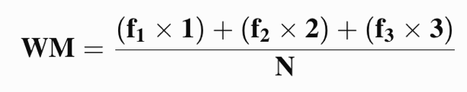
Figure 12: Formula for Weighted Mean
Where:
● f1 = frequency of "Not Acceptable"
● f2 = frequency of "Acceptable"
● f3 = frequency of "Very Acceptable"
● n = total number of respondents

The three-point Likert scale will be weighted as follows: Very Acceptable (3), Acceptable (2), Not Acceptable (1). The following decision rule will be used:
Table 11: Likert Scale Table
Range of the Weighted Mean | Points | Interpretation
2.34 – 3.00 | 3 | Very Acceptable – The system's functions are fully understood by the users and effectively meet the intended requirements and expectations.
1.67 – 2.33 | 2 | Acceptable – The system's functions are generally understood and operate satisfactorily but require minor improvements.
1.00 – 1.66 | 1 | Not Acceptable – The system's functions do not adequately meet user expectations and require major improvements.

The proponents will compute the weighted mean for each user-acceptability criterion and interpret results using Table 11. The overall evaluation covers functional suitability, usability, performance efficiency, reliability, and security. Technical performance and security conclusions will also be supported by the corresponding test evidence rather than inferred solely from user-acceptability scores.

3.5 Implementation Plan
The implementation plan summarizes the planned activities, participants, and estimated durations for developing, testing, and deploying SmartTrack. The durations are estimates; completed activities and actual dates should be confirmed before final submission.
Table 12: Implementation Plan
Strategy | Activities |  | Persons Involved | Duration
Requirements |  | Gather information about the pharmacy's current inventory and financial management processes through interviews, observations, and document review. Analyze user requirements and define the functional and non-functional requirements of the system. | Owner-Pharmacist, Staff, Developers | 1 week
Design |  | Design the database schema, system architecture, context diagram, data flow diagrams, entity relationship diagram, user interface for the desktop application, and the supply-demand analytics workflow based on the approved system requirements. | Developers | 3 weeks
Development |  | Develop the PHP API and React/Electron desktop application; implement inventory and batch management, sales and returns, purchase-order creation and receiving, stock and expiry monitoring, SMA forecasting, advisory EOQ/ROP calculations, reports, and data visualizations. | Developers | 2 months
Testing |  | Run planned alpha tests with defined inputs and expected outputs, then conduct user evaluation after the test build is ready. Record test cases and observed results separately from questionnaire ratings. | Developers, Owner-Pharmacist, Staff | 2 weeks
Deployment |  | After testing and approval, configure the MySQL database, install the desktop application on the designated pharmacy computer, create or verify user accounts, and orient authorized users. Record the actual deployment date only after installation. | Developers, Owner-Pharmacist | 1 week
Review |  | Conduct planned user acceptance testing, gather feedback from the owner-pharmacist and staff, analyze the results, and document any revisions before final turnover. | Developers, Owner-Pharmacist, Staff | 1 week

3.6 Sample Screen Design
This section presents selected interface examples from the SmartTrack build. The displayed dates and values are illustrative sample data, not study results; replace the screenshots if the final interface has changed.

Figure 13: Admin Dashboard
This figure presents the SmartTrack dashboard and its summarized operational indicators for the Administrator/Owner.
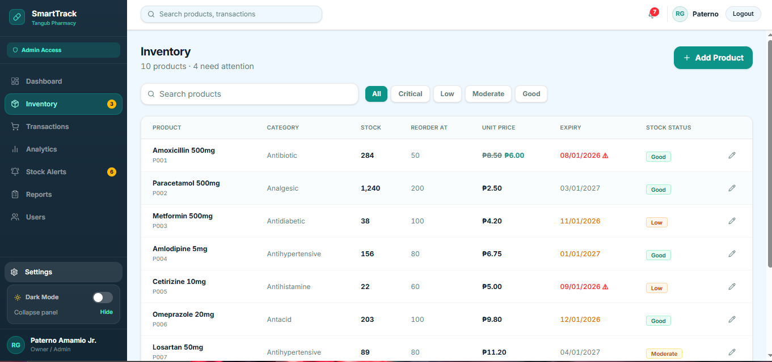
Figure 14: Inventory Management Module

This figure presents the Inventory module, where users review product records, stock status, reorder thresholds, and batch information available in the application.
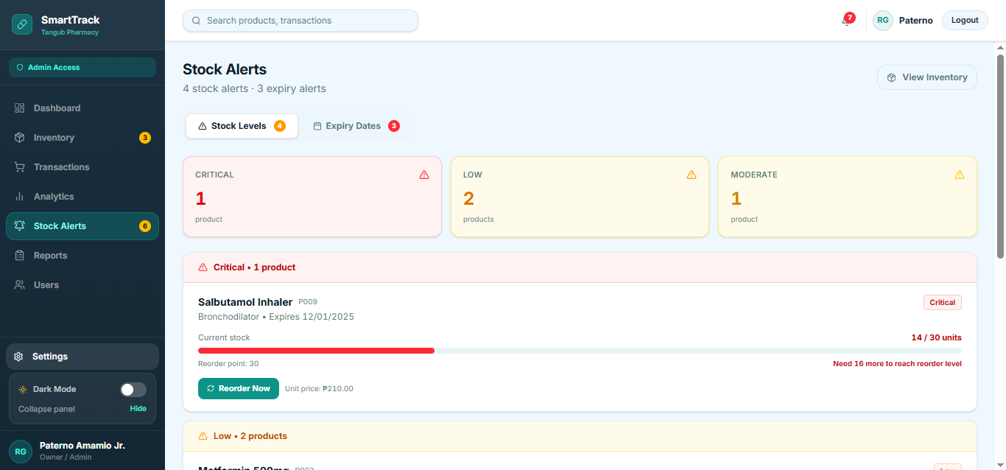
Figure 15: Stock Alerts Module

This figure shows the Stock Alerts module, which presents stock-status and expiry alerts. Expiry-velocity estimates are advisory projections based on recent sales; they do not guarantee sell-through or automatically dispose of stock.
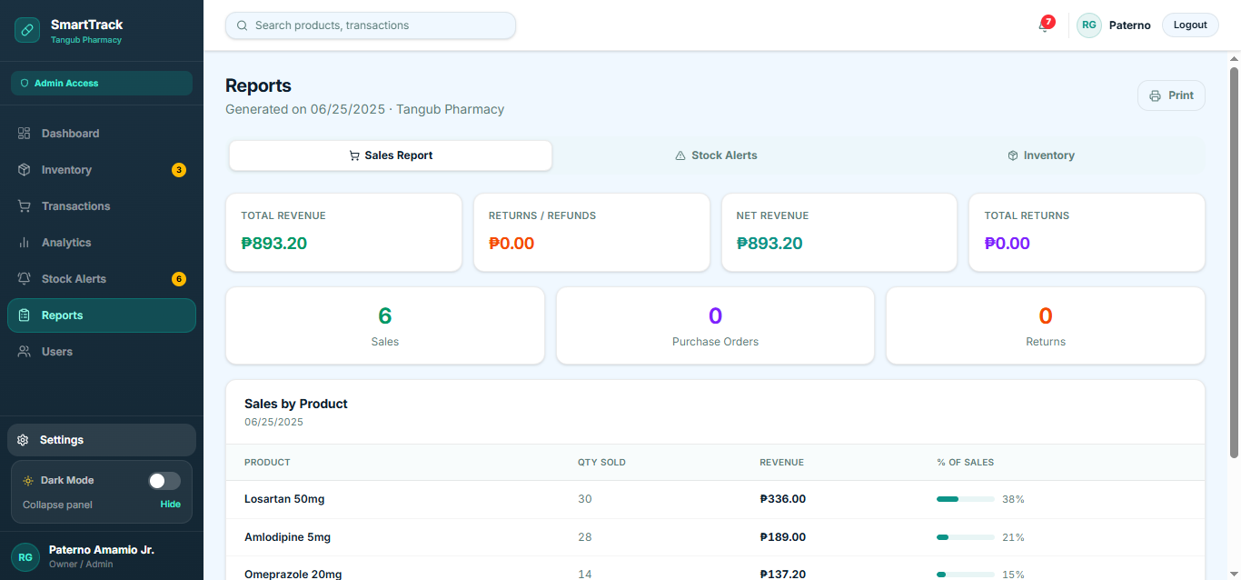
Figure 16: Reports Module

The Reports module provides Sales, Stock Alerts, and Inventory views with print functionality. Financial summaries and supply-demand analytics are presented in their own modules.

References
Alao, O. B., Dudu, O. F., Alonge, E. O., & Eze, C. E. (2024). Automation in financial reporting: A conceptual framework for efficiency and accuracy in U.S. corporations. Global Journal of Advanced Research and Reviews, 2(2), 040–050. https://doi.org/10.58175/gjarr.2024.2.2.0057
Amosu, O. R., Kumar, P., Ogunsuji, Y. M., Oni, S., & Faworaja, O. (2024). AI-driven demand forecasting: Enhancing inventory management and customer satisfaction. World Journal of Advanced Research and Reviews, 23(2), 708–719. https://doi.org/10.30574/wjarr.2024.23.2.2394
Bernabe, P. A. R., Dela Cruz, D. V., Moraga, G. J. H., & Ruiz, S. R. G. (2022). Inventory management practices and perceived financial performance of retail enterprises: An assessment. Baliuag University. https://buresearch.baliuagu.edu.ph/storage/01K6NBZQY7888PM0C3SY53DW6B.pdf
Cabangbang, N. J. A., Gardose, L. L., Guarin, A. M. C., Medequillo, E. J., Melgo, R. M. C., Monte, B., Raz, B. A., & Vasquez, R. L. (2024). Point-of-sale of CTU-Danao Campus canteen: Usability study. International Research Journal of Progressive Education and Science, 7(2). https://ijrp.sfo3.cdn.digitaloceanspaces.com/journal/7784/1001721520257817.pdf
Gallego Cossio, L. C., Hernández Aros, L., Perdomo, D. R., Villalba, L. J., & Rodríguez Barrero, M. S. (2025). Financial and administrative management models for digital ventures: A literature review. Journal of Risk and Financial Management, 18(4), 214. https://doi.org/10.3390/jrfm18040214
Jacoby, J., & Matell, M. S. (1971). Three-point Likert scales are good enough. Journal of Marketing Research, 8(4), 495–500. https://doi.org/10.2307/3150242
Jaju, R., Varshney, S., Gupta, P., Bihani, P., & Karim, H. M. R. (2023). Inventory control mechanism of the pharmacy store of a recently established national institute in Eastern India: A cross-sectional, investigative analysis. Cureus, 15(11), e49632. https://pmc.ncbi.nlm.nih.gov/articles/PMC10755685/
Keshari, S., Kundu, A. K., & Gawali, P. (2023). Improving production and inventory forecasting with big data analytics. International Research Journal of Engineering and Technology, 10(2), 569–573. https://www.irjet.net/archives/V10/i2/IRJET-V10I283.pdf
Khakbaz, A., Alfares, H. K., Amirteimoori, A., & Tirkolaee, E. B. (2024). A novel cross-docking EOQ-based model to optimize a multi-item multi-supplier multi-retailer inventory management system. Annals of Operations Research, 341, 217–243. https://doi.org/10.1007/s10479-023-05790-9
Mpamugo, E., & Ansa, G. (2024). Enhancing network security in mobile applications with role-based access control. Journal of Information Systems and Informatics, 6(3), 1872–1899. https://doi.org/10.51519/journalisi.v6i3.863
mSupply Foundation. (n.d.). mSupply. https://msupply.org.nz/
Odoo S.A. (n.d.). Odoo. https://www.odoo.com/
Putra, F. P. E., Sugi, A., Holipah, & Mufidah, K. (2025). Comparative literature study of CodeIgniter and Laravel framework performance in website creation. Jurnal Informasi dan Teknologi, 48–55. https://doi.org/10.60083/jidt.vi0.617
Tan, Y., Gu, L., Xu, S., & Li, M. (2024). Supply chain inventory management from the perspective of "cloud supply chain": A data-driven approach. Mathematics, 12(4), 573. https://doi.org/10.3390/math12040573
Tanaman, M. T., Baylosis, J. L. A., Abiles, B. J. A., Catungal, M. L. P., & Encarnacion, P. C. (2023). Web-based inventory management system for a small business enterprise in Pagadian City, Philippines. International Journal of Science and Applied Information Technology, 12(5), 44–48. https://doi.org/10.30534/ijsait/2023/021252023
Tang, Y. M., Chau, K. Y., Lau, Y., & Zheng, Z. (2023). Data-intensive inventory forecasting with artificial intelligence models for cross-border e-commerce service automation. Applied Sciences, 13(5), 3051. https://doi.org/10.3390/app13053051
Teleron, J. I. (2022). Operations research design and implementation of pharmacy management information system. International Research Journal of Advanced Engineering and Science, 7(2), 318–325. https://irjaes.com/wp-content/uploads/2022/05/IRJAES-V7N2P285Y22.pdf
Tetteh, S. G. (2024). Empirical study of agile software development methodologies: A comparative analysis. Asian Journal of Research in Computer Science, 17(5), 30–42. https://doi.org/10.9734/ajrcos/2024/v17i5436
Toroba, A. O., Gregori, R. A., Baraas, C. V., Impas, C. B., Martinez, D. J., & Cervantes, J. S. (2025). The influence of inventory management practices on financial performance among retail businesses. South Asian Journal of Social Studies and Economics, 22(8), 24–43. https://journalsajsse.com/index.php/SAJSSE/article/view/1099/2422
Zhao, J., Wang, F., Zhang, X., & Sun, K. (2022). Informatization of accounting systems in small- and medium-sized enterprises based on artificial intelligence-enabled cloud computing. Computational Intelligence and Neuroscience, 2022, 6089195. https://pmc.ncbi.nlm.nih.gov/articles/PMC9391122/
Zoho Corporation. (n.d.). Zoho Inventory. https://www.zoho.com/inventory/

