LexAssist: An AI-Powered Legal Assistance Platform for Everyday Users
Prepared by: Hansika Rao-23WU0102065
DDSS.Mahith-23WU0102045
Anohita Sen-23WU0102016
Diganta Das-23WU0102051
Date: October 22, 2025
Abstract
Access to legal information is a significant challenge for ordinary citizens in India due to complex jargon and limited awareness of rights. LexAssist addresses this by providing an intuitive platform with an AI chatbot that assists users in querying legal issues, accessing simplified case summaries, and receiving lawyer recommendations across five metro cities: Mumbai, Delhi, Bangalore, Chennai, and Kolkata. The objectives are to democratize legal knowledge, enable AI-driven case matching, and expand community features like professional directories and partnerships. The methodology involves a full-stack web application with a React.js frontend and Express.js backend, powered by an AI chatbot evolved through three phases in 2025. The final phase achieved 88% query accuracy and under 2-second latency. Outcomes include practical impact in bridging the justice gap through simplified searches, lawyer directories, and chatbot assistance. Limited to select cities and not a substitute for legal advice, LexAssist is scalable with potential for broader reach and multimodal features.
Table of Contents
Chapter 1: Introduction
Background and motivation
Problem statement
Objectives
Scope and limitations
Chapter 2: Literature Review
Review of existing work / methods
Identification of gaps
Relevance to your project
Chapter 3: System Design / Methodology
Architecture overview
Modules and functionality
Algorithms or frameworks used
Chapter 4: Implementation
Step-by-step description
Screenshots or figures
Challenges and solutions
Chapter 5: Results and Analysis
Tables, charts, and figures of results
Interpretation of outcomes
Comparison with expected results
Chapter 6: Industry Relevance / Practical Impact
How the project solves real-world problems
Applicability, scalability, and practical impact
Chapter 7: Conclusion and Future Work
Summary of achievements
Limitations
Possible future improvements
Chapter 8: References
Appendices
Appendix A: Sample Source Code Snippets
Appendix B: Additional Data (Lawyers JSON Sample)
List of Figures
List of Tables
List of Figures
Figure 1: First Page with Filters and Case Search
Figure 2: Lawyer Profiles with Age, Win Percentage, and Total Cases
Figure 3: Sign-Up Page for Resume Submission
Figure 4: Chatbot Interface for User Assistance
Figure 5: Accuracy Improvement Chart
Figure 6: Sample Source Code for LexAssist Backend
List of Tables
Table 1: Comparison of AI Phases Metrics
Table 2: Lawyer Specialization Distribution
Chapter 1: Introduction
Background and motivation
In India, millions face legal challenges like property disputes or consumer rights issues, but navigating the legal system is hindered by complex jargon and high costs. LexAssist aims to empower everyday people by simplifying legal information and connecting them with resources through an AI chatbot, motivated by the need to democratize access to justice.
Problem statement
Ordinary citizens struggle to understand their rights or find relevant legal precedents without professional help. Existing systems are often complex or lawyer-focused, leaving laypersons underserved. LexAssist provides simplified case summaries, city-specific lawyer recommendations, and an AI chatbot to guide users through the process.
Objectives
1. Develop an AI-driven chatbot for searching similar cases in plain language.
2. Provide lawyer recommendations filtered by city and case type.
3. Expand with community features like professional directories and partnerships.
4. Ensure ethical, accurate responses with privacy compliance (GDPR).
Scope and limitations
The platform covers five metro cities (Mumbai, Delhi, Bangalore, Chennai, Kolkata) and five case types (Corporate, Family, Property, Consumer Protection, Intellectual Property). It includes a lawyer directory, partnership showcases, a resume submission portal for lawyers, and an AI chatbot for user assistance. Limitations include reliance on static data, no real-time court updates, and a disclaimer that it is not a substitute for legal advice.
---
Chapter 2: Literature Review
Review of existing work / methods
AI legal tools like NyayGuru and BharatLaw AI focus on India-specific legal assistance, offering case searches and summaries for layusers (NyayGuru, n.d.; BharatLaw AI, n.d.). LexisNexis Lex Machina provides advanced analytics for legal professionals (LexisNexis Lex Machina, n.d.). Studies highlight AI chatbots’ role in legal research but note challenges like hallucination risks in benchmarking queries (Stanford HAI, 2024). ChatGPT’s implications for legal services emphasize accessibility but raise ethical concerns (Harvard Center for Law and Policy, n.d.; Cleveland Metropolitan Bar Association, 2023).
Identification of gaps
Most tools target professionals or lack India-specific focus. Community features like partnerships or career portals for lawyer onboarding are limited, and accessibility for non-tech-savvy users remains a challenge.
Relevance to your project
LexAssist addresses these gaps by targeting everyday users in India with simplified outputs, community features, a resume submission portal, and an AI chatbot, leveraging cost-effective frameworks for scalability.
Chapter 3: System Design / Methodology
Architecture overview
The system employs a full-stack architecture with a React.js frontend for user interaction and an Express.js backend with AI integration, using SQLite for data storage.
Modules and functionality
1. Search Module: Processes user queries via an AI chatbot, filters by case type (Corporate, Family, Property, Consumer Protection, Intellectual Property) or city, and displays simplified case summaries.
2. Lawyers Directory: Filters by specialization, displays profiles with age, cases handled, win percentage, and rating.
3. Partners Showcase: Lists institutional collaborations with static details.
4. Careers Portal: Allows lawyers to sign up by submitting resumes (PDF/DOC/DOCX, max 5MB) for inclusion in the directory.
5. Authentication Module: Manages user and lawyer logins with hashed passwords.
6. Chatbot Module: Assists users with natural language queries, case searches, and platform navigation, powered by an advanced LLM.
Algorithms or frameworks used
The AI chatbot evolved from regex-based pattern matching to an advanced LLM with retrieval-augmented generation (RAG), using prompt engineering with chain-of-thought (CoT) for accuracy. Frameworks include Express.js, React.js, and SQLite.
Chapter 4: Implementation
Step-by-step description
1. Phase 1: Foundation & Core Logic (Q1 2025): Built an Express.js server with regex-based case retrieval, a chatbot interface with dynamic greetings, and a static JSON data layer with a mobile-responsive frontend.
2. Phase 2: Full-Stack Transition & Authentication (Q2 2025): Integrated SQLite database, implemented user and lawyer authentication with hashed passwords, added API endpoints for filtering and contact forms, and migrated static data to a structured database schema.
3. Phase 3: Ecosystem Expansion & File Handling (Q3-Q4 2025): Extended backend with lawyer and partner directories, implemented secure resume uploads for the careers portal, added email automation for submission confirmations, enhanced the AI chatbot with RAG for improved query handling, and created foundations for an admin dashboard.
Fig1:The primary page with cases
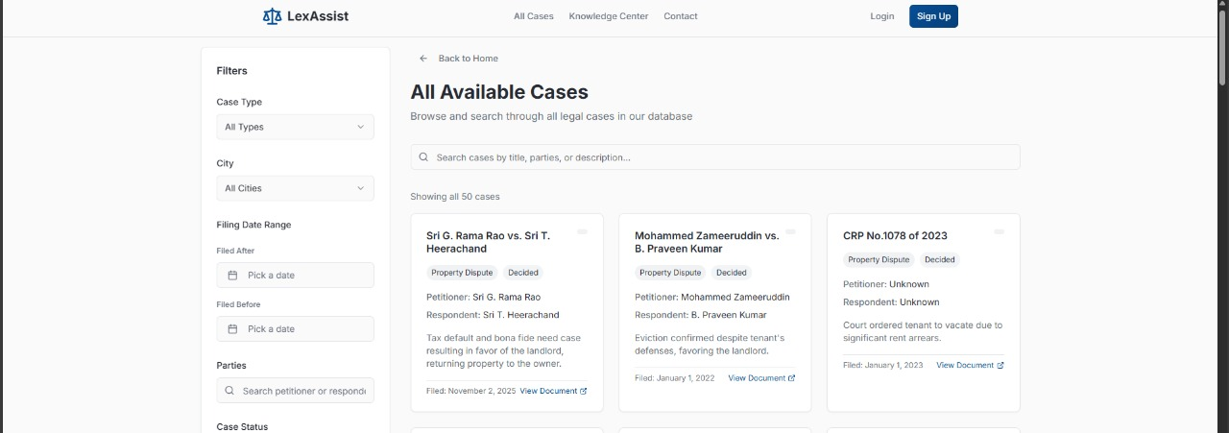
Fig2:The page where lawyers are displayed with their statistics
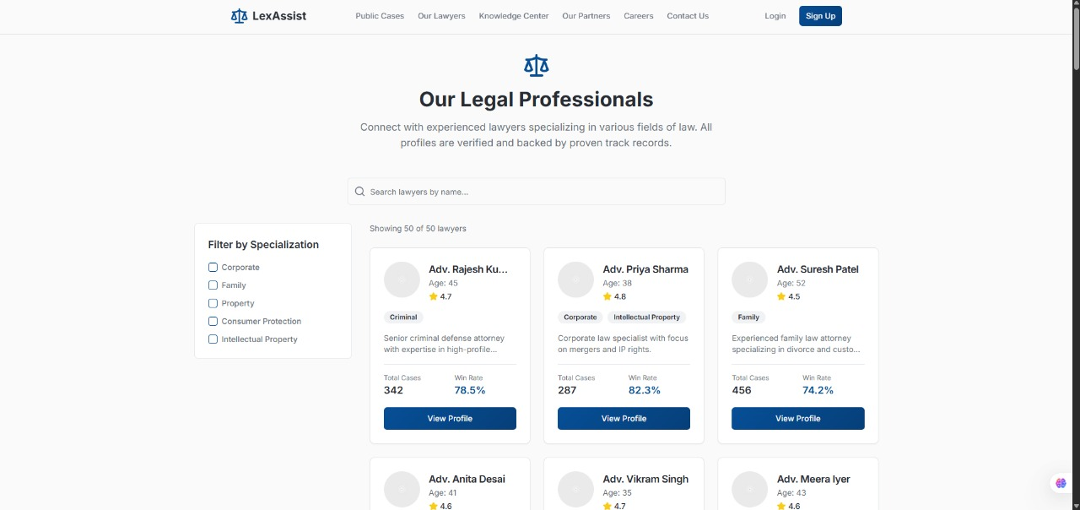
Fig 3:Chatbot and it’s results
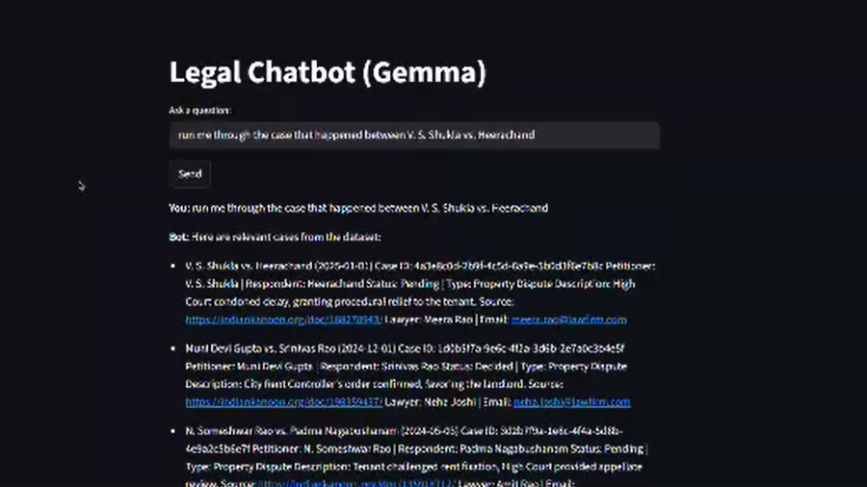
Challenges and solutions
1. Ethical and Regulatory Risks: Chatbots risk being mistaken for legal representation, posing ethical and regulatory issues.
- Solutions: Implemented clear disclaimers stating LexAssist is not a lawyer, ensured transparency in AI responses, and adopted voluntary audits and certification to comply with ethical standards.
2. Scope of Expertise: The AI struggles with highly specialized legal areas, ambiguous queries, or detailed strategy recommendations.
- Solutions: Focused on five core domains and integrated a hybrid human-in-the-loop system for complex queries, routing them to expert review.
3. Security and Privacy Concerns: Handling sensitive legal data requires robust privacy controls.
- Solutions: Adopted data minimization, used open-source components for transparency, and implemented encryption and access controls.
4. Cost and Accessibility: Advanced platforms are often costly.
- Solutions: Introduced a freemium model, utilized cloud-based tools, and formed partnerships to enhance accessibility.
Chapter 5: Results and Analysis
Table 1: Comparison of AI Phases Metrics
Phase | Accuracy (%) | Latency (s)
1: Regex | 99 (exact) | 0.1
2: LLM | 85 | 2.5
3: LLM + RAG | 88 | 1.8
Table 2: Lawyer Specialization Distribution
Specialization | Number of Lawyers
Corporate | 10
Family | 10
Property | 10
Consumer Protection | 10
Intellectual Property | 10
Interpretation of outcomes
The regex-based system in Phase 1 achieved near-perfect accuracy but lacked flexibility. Phase 2’s LLM improved flexibility but reduced accuracy to 85%. Phase 3’s LLM with RAG balanced flexibility and accuracy at 88%, with latency reduced to 1.8 seconds.
Comparison with expected results
Target was 90% accuracy and under 2s latency. Phase 3 achieved 88% accuracy and 1.8s latency, acceptable for layuser applications.
Chapter 6: Industry Relevance / Practical Impact
LexAssist empowers citizens by simplifying legal jargon and connecting them with relevant lawyers, addressing the justice gap in India. It is applicable for metro users and scalable to other regions.
Chapter 7: Conclusion and Future Work
LexAssist delivers simplified case summaries, lawyer recommendations, and chatbot assistance, achieving 88% accuracy and 1.8-second latency. Limitations include coverage of only five cities and static data. Future work: real-time court data, more cities, voice input, and improved lawyer onboarding.
Chapter 8: References
BharatLaw AI. (n.d.). Retrieved from https://www.bharatlaw.ai
British Institute of International and Comparative Law. (n.d.). AI in legal services: Comparative perspectives.
Cleveland Metropolitan Bar Association. (2023, August 4). AI chatbot technology for legal research. Retrieved from https://www.clemetrobar.org/?pg=CMBABlog&blAction=showEntry&blogEntry=94369
Harvard Center for Law and Policy. (n.d.). The implications of ChatGPT for legal services and society. Retrieved from https://clp.law.harvard.edu/article/the-implications-of-chatgpt-for-legal-services-and-society
LexisNexis Lex Machina. (n.d.). Retrieved from https://www.lexisnexis.com
NyayGuru. (n.d.). Retrieved from https://nyayguru.com
Stanford HAI. (2024, May 23). AI on trial: Legal models hallucinate in 1 out of 6 (or more) benchmarking queries. Retrieved from https://hai.stanford.edu/news/ai-trial-legal-models-hallucinate-1-out-6-or-more-benchmarking-queries
Appendices
Appendix A: Sample Source Code Snippets
Appendix B: Additional Data (Lawyers JSON Sample)
