Folder Structure

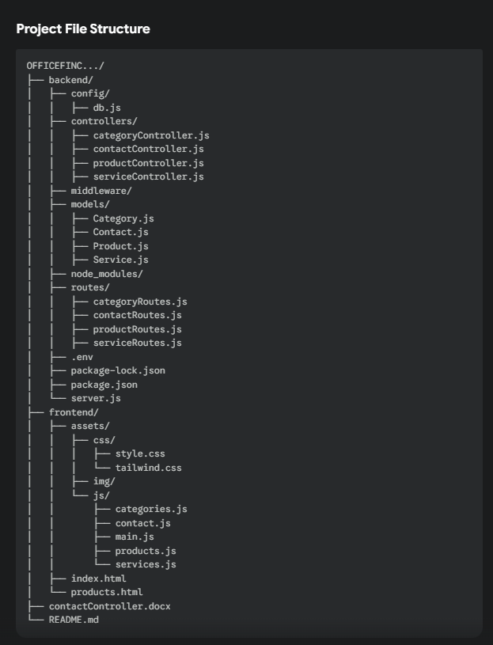

controllers

- categoryController.js

import Category from '../models/Category.js';

// Sample data to seed the database
const sampleCategories = [
{
title: 'PAPER',
name: 'Printing Media',
description:
'A4, Legal, recycled stock, custom letterheads, and high-volume specialty papers.',
imageUrl: 'assets/img/products/product-paper.jpg',
colorTheme: 'orange',
// --- NEW FIELD ADDED ---
subCategories: [
'A4 Copy Paper',
'Legal & Letter Paper',
'Photo Paper',
'Cardstock & Specialty',
],
},
{
title: 'INK & TONER',
name: 'Printer Cartridges',
description:
'OEM and compatible toner/ink for all major printer brands with fast delivery options.',
imageUrl: 'assets/img/products/product-ink.jpg',
colorTheme: 'purple',
// --- NEW FIELD ADDED ---
subCategories: [
'HP Ink & Toner',
'Canon Ink & Toner',
'Epson Ink & Toner',
'Brother Ink & Toner',
],
},
{
title: 'FURNITURE',
name: 'Ergonomics & Seating',
description:
'Desks, ergonomic chairs, standing desk converters, and full office buildouts.',
imageUrl: 'assets/img/products/product-chair.jpg',
colorTheme: 'orange',
// --- NEW FIELD ADDED ---
subCategories: [
'Ergonomic Office Chairs',
'Standing Desks',
'Filing Cabinets',
'Conference Tables',
],
},
{
title: 'TECH GEAR',
name: 'Accessories & Peripherals',
description:
'Keyboards, mice, monitors, and networking gear to keep your office connected.',
imageUrl: 'assets/img/products/product-tech.jpg',
colorTheme: 'purple',
// --- NEW FIELD ADDED ---
subCategories: [
'Keyboards & Mice',
'Monitors & Stands',
'Cables & Adapters',
'Networking Gear',
],
},
];

// Controller to get all categories
export const getCategories = async (req, res) => {
try {
// Check if there are any categories in the database
const count = await Category.countDocuments();

// If no categories, seed the database
if (count === 0) {
console.log('No categories found. Seeding database...');
await Category.insertMany(sampleCategories);
console.log('Database seeded with categories successfully.');
}

// Fetch all categories (either the newly seeded ones or existing ones)
const categories = await Category.find({});
res.status(200).json(categories);
} catch (error) {
console.error('Error fetching categories:', error);
res.status(500).json({ message: 'Server error fetching categories' });
}
};

- contactController.js

import Contact from '../models/Contact.js';

// Save contact message with phone field
export const saveContact = async (req, res) => {
try {
const { name, email, phone, message } = req.body;

if (!name || !email || !message) {
return res.status(400).json({
success: false,
message: 'Name, email, and message are required.',
});
}

const newContact = new Contact({ name, email, phone, message });
await newContact.save();

res.status(201).json({
success: true,
message: 'Message saved successfully!',
});
} catch (err) {
console.error('Save contact error:', err.message);
res.status(500).json({
success: false,
message: 'Error saving message: ' + err.message,
});
}
};
- productController.js

import Product from '../models/Product.js';

// Sample data to seed the database
const sampleProducts = [
// --- Office & Breakroom Products ---
{
name: 'Premium A4 Copy Paper',
description: '500 sheets of high-quality 80gsm paper.',
imageUrl: 'assets/img/products/product-paper.jpg',
category: 'Office & Breakroom',
supplyType: 'Printing Media', // <-- NEW FIELD ADDED
},
{
name: 'Ergonomic Mesh Office Chair',
description: 'Breathable mesh back with lumbar support.',
imageUrl: 'assets/img/products/product-chair.jpg',
category: 'Office & Breakroom',
supplyType: 'Ergonomics & Seating', // <-- NEW FIELD ADDED
},
{
name: 'Gourmet Coffee Pods (100 Pack)',
description: 'A rich, dark roast blend for all compatible brewers.',
imageUrl: 'assets/img/products/product-coffee.jpg',
category: 'Office & Breakroom',
supplyType: 'Printing Media', // <-- Note: This is a placeholder. We can make a "Breakroom" supplyType later.
},
{
name: 'Magnetic Dry Erase Whiteboard',
description: '48" x 36" board with aluminum frame.',
imageUrl: 'assets/img/products/product-whiteboard.jpg',
category: 'Office & Breakroom',
supplyType: 'Printing Media', // <-- Note: This is a placeholder. We can make an "Office Supplies" supplyType later.
},
// --- IT & Electronics Products ---
{
name: 'Wireless Keyboard and Mouse Combo',
description: 'Full-size keyboard and ergonomic mouse with a single USB receiver.',
imageUrl: 'assets/img/products/product-tech.jpg',
category: 'IT & Electronics',
supplyType: 'Accessories & Peripherals', // <-- NEW FIELD ADDED
},
{
name: '24-inch 1080p LED Monitor',
description: 'Full HD monitor with HDMI and VGA ports.',
imageUrl: 'assets/img/products/product-monitor.jpg',
category: 'IT & Electronics',
supplyType: 'Accessories & Peripherals', // <-- NEW FIELD ADDED
},
{
name: 'High-Yield Black Toner Cartridge',
description: 'Compatible with HP LaserJet Pro M404 series.',
imageUrl: 'assets/img/products/product-ink.jpg',
category: 'IT & Electronics',
supplyType: 'Printer Cartridges', // <-- NEW FIELD ADDED
},
// --- Janitorial & Safety Products ---
{
name: 'Heavy-Duty Janitorial Cart',
description: 'Yellow cart with 3 shelves and vinyl bag.',
imageUrl: 'assets/img/products/product-janitorial.jpg',
category: 'Janitorial & Safety',
supplyType: 'Accessories & Peripherals', // <-- Note: This is a placeholder. We can make a "Cleaning" supplyType later.
},
{
name: 'Industrial Hard Hat (White)',
description: 'ANSI Z89.1 certified safety helmet.',
imageUrl: 'assets/img/products/product-safety.jpg',
category: 'Janitorial & Safety',
supplyType: 'Accessories & Peripherals', // <-- Note: This is a placeholder. We can make a "Safety" supplyType later.
},
{
name: 'First Aid Kit (200-Piece)',
description: 'OSHA compliant kit for up to 50 people.',
imageUrl: 'assets/img/products/product-firstaid.jpg',
category: 'Janitorial & Safety',
supplyType: 'Accessories & Peripherals', // <-- Note: This is a placeholder. We can make a "Safety" supplyType later.
},
];

// Controller to get all products, with filtering
export const getProducts = async (req, res) => {
try {
// --- SEEDER LOGIC ---
const count = await Product.countDocuments();
if (count === 0) {
console.log('No products found. Seeding database with sample products...');
// We must make sure the new `supplyType` field is included
const productsWithSupplyType = sampleProducts.map(p => ({
...p,
supplyType: p.supplyType || 'General' // Add a default just in case
}));
await Product.insertMany(productsWithSupplyType);
console.log('Database seeded successfully.');
}

// --- FILTERING LOGIC (NOW UPDATED) ---
let filter = {};

// Check if the URL has a 'category' query
if (req.query.category) {
filter.category = req.query.category;
}

// --- THIS IS THE NEW CODE ---
// Check if the URL also has a 'supplyType' query
if (req.query.supplyType) {
filter.supplyType = req.query.supplyType;
}
// --- END OF NEW CODE ---

// Find products based on the filter (which might be empty or have one or both keys)
const products = await Product.find(filter);

res.status(200).json(products);

} catch (error) {
console.error('Error fetching products:', error);
res.status(500).json({ message: 'Server error fetching products' });
}
};

- serviceController.js

import Service from '../models/Service.js';

// Define the data from your plan. We'll add this if the DB is empty.
const seedData = [
{
mainCategory: 'Office & Breakroom',
description:
'Everything from stationery and printing paper to coffee, snacks, and organizational tools. Reliable restocking and inventory management.',
icon: 'pencil', // Corresponds to the icon in your HTML
subCategories: ['Office Supplies', 'Furniture', 'Breakroom Items'],
},
{
mainCategory: 'IT & Electronics',
description:
'Bulk procurement of monitors, cables, peripherals, and custom IT hardware bundles. Direct shipping and setup logistics.',
icon: 'laptop', // Corresponds to the icon in your HTML
subCategories: [
'Computer Accessories',
'Networking Devices',
'Printers & Scanners',
],
},
{
mainCategory: 'Janitorial & Safety',
description:
'Bulk cleaning supplies, sanitizers, safety equipment, and restroom essentials. Ensuring a healthy and compliant workplace environment.',
icon: 'cleaning', // Corresponds to the icon in your HTML
subCategories: ['Cleaning Equipment', 'Safety Gear', 'Emergency Tools'],
},
];

// This function will get all services
export const getAllServices = async (req, res) => {
try {
// Check if there is any data.
const count = await Service.countDocuments();

// If no data, insert the seed data.
if (count === 0) {
console.log('No services found. Seeding database...');
await Service.insertMany(seedData);
}

// Now, find all services (including the new seed data if it was just added)
const services = await Service.find();
res.status(200).json({ success: true, data: services });
} catch (err) {
console.error('Error in getAllServices:', err.message);
res
.status(500)
.json({ success: false, message: 'Server Error: ' + err.message });
}
};

models

- Category.js

import mongoose from 'mongoose';

const categorySchema = new mongoose.Schema({
title: { type: String, required: true },
name: { type: String, required: true },
description: { type: String, required: true },
imageUrl: { type: String, required: true },
colorTheme: { type: String, required: true },
// --- NEW FIELD ADDED ---
// This follows the exact same pattern as your Service.js model
subCategories: { type: [String], default: [] },
});

export default mongoose.model('Category', categorySchema);

- Contact.js

import mongoose from 'mongoose';

// This is the correct structure for your Mongoose model
const contactSchema = new mongoose.Schema({
name: {
type: String,
required: true,
},
email: {
type: String,
required: true,
},
phone: {
type: String,
required: false, // Set to false, as it's optional
},
message: {
type: String,
required: true,
},
createdAt: {
type: Date,
default: Date.now,
},
});

export default mongoose.model('Contact', contactSchema);

- Product.js

import mongoose from 'mongoose';

const productSchema = new mongoose.Schema({
name: { type: String, required: true },
description: { type: String, required: true },
imageUrl: { type: String, required: true },
// This is the main service category (e.g., "Office & Breakroom")
category: { type: String, required: true },

// --- NEW FIELD ADDED ---
// This is the specific supply type (e.g., "Printing Media")
supplyType: { type: String, required: true },
}, {
timestamps: true // Adds createdAt and updatedAt timestamps
});

export default mongoose.model('Product', productSchema);

- Service.js

import mongoose from 'mongoose';

const serviceSchema = new mongoose.Schema({
mainCategory: {
type: String,
required: true,
},
description: {
type: String,
required: true,
},
// We'll store an icon name to tell the frontend what to display
icon: {
type: String,
required: true,
},
// The array of strings for your sub-categories
subCategories: {
type: [String],
default: [],
},
});

export default mongoose.model('Service', serviceSchema);

routes

- categoryRoutes.js

import express from 'express';
import { getCategories } from '../controllers/categoryController.js';

const router = express.Router();

// Route for GET /api/categories
router.get('/', getCategories);

export default router;

- contactRoutes.js

import express from "express";
import { saveContact } from "../controllers/contactController.js";
const router = express.Router();

router.post("/", saveContact);

export default router;

- productRoutes.js

import express from 'express';
import { getProducts } from '../controllers/productController.js';

const router = express.Router();

// This one route handles BOTH:
// 1. GET /api/products (which gets all products)
// 2. GET /api/products?category=... (which gets filtered products)
router.get('/', getProducts);

export default router;

- serviceRoutes.js

import express from 'express';
import { getAllServices } from '../controllers/serviceController.js';

const router = express.Router();

// When a GET request comes to '/', use the getAllServices function
router.get('/', getAllServices);

export default router;

- server.js

import express from 'express';
import dotenv from 'dotenv';
import cors from 'cors';
import mongoose from 'mongoose';
import path from 'path';
import { fileURLToPath } from 'url';
import { dirname } from 'path';

// Import all routes
import contactRoutes from './routes/contactRoutes.js';
import serviceRoutes from './routes/serviceRoutes.js';
import productRoutes from './routes/productRoutes.js';
import categoryRoutes from './routes/categoryRoutes.js';

dotenv.config();

const app = express();

// Middleware
app.use(cors());
app.use(express.json());

// MongoDB connection
mongoose
.connect(process.env.MONGO_URI)
.then(() => console.log('MongoDB Connected'))
.catch((err) => console.log(err));

// API Routes
app.use('/api/contact', contactRoutes);
app.use('/api/services', serviceRoutes);
app.use('/api/products', productRoutes);
app.use('/api/categories', categoryRoutes);

// ----------------------------------------------------------------
// ✅ STATIC FRONTEND SERVING FIX (this solves "File Not Found")
// ----------------------------------------------------------------
const __filename = fileURLToPath(import.meta.url);
const __dirname = dirname(__filename);

// Serve all files from the frontend folder
app.use(express.static(path.join(__dirname, '../frontend')));

// Optional: make sure routes like /categories.html and /products.html load
app.get('/*.html', (req, res) => {
res.sendFile(path.join(__dirname, '../frontend', req.path));
});

// Fallback route: if someone just opens "/", serve index.html
app.get('/', (req, res) => {
res.sendFile(path.join(__dirname, '../frontend', 'index.html'));
});
// ----------------------------------------------------------------

const PORT = process.env.PORT || 5000;

app.listen(PORT, () => console.log(`Server running on port ${PORT}`));

