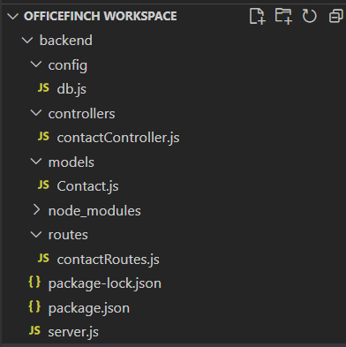

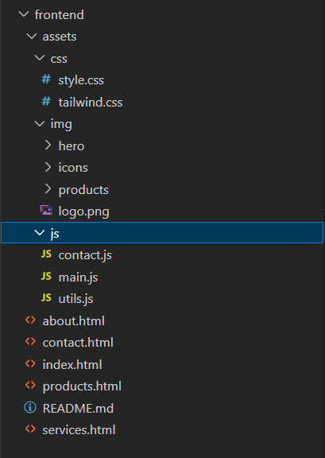
- contactController.js

import Contact from "../models/Contact.js";

export const saveContact = async (req, res) => {
try {
const { name, email, message } = req.body;
const contact = new Contact({ name, email, message });
await contact.save();
res.status(201).json({ success: true, message: "Message saved successfully!" });
} catch (err) {
res.status(500).json({ success: false, message: err.message });
}
};

- Contact.js
- import mongoose from "mongoose";

- const contactSchema = new mongoose.Schema({
- name: { type: String, required: true },
- email: { type: String, required: true },
- message: { type: String, required: true },
- createdAt: { type: Date, default: Date.now },
- });

- export default mongoose.model("Contact", contactSchema);

- contactRoutes.js

import express from "express";
import { saveContact } from "../controllers/contactController.js";
const router = express.Router();

router.post("/", saveContact);

export default router;

- server.js

import express from "express";
import dotenv from "dotenv";
import cors from "cors";
import mongoose from "mongoose";
import contactRoutes from "./routes/contactRoutes.js";

dotenv.config();
const app = express();
app.use(cors());
app.use(express.json());

// MongoDB connection
mongoose.connect(process.env.MONGO_URI)
.then(() => console.log("MongoDB Connected"))
.catch((err) => console.log(err));

// API Routes
app.use("/api/contact", contactRoutes);

const PORT = process.env.PORT || 5000;
app.listen(PORT, () => console.log(`Server running on port ${PORT}`));

