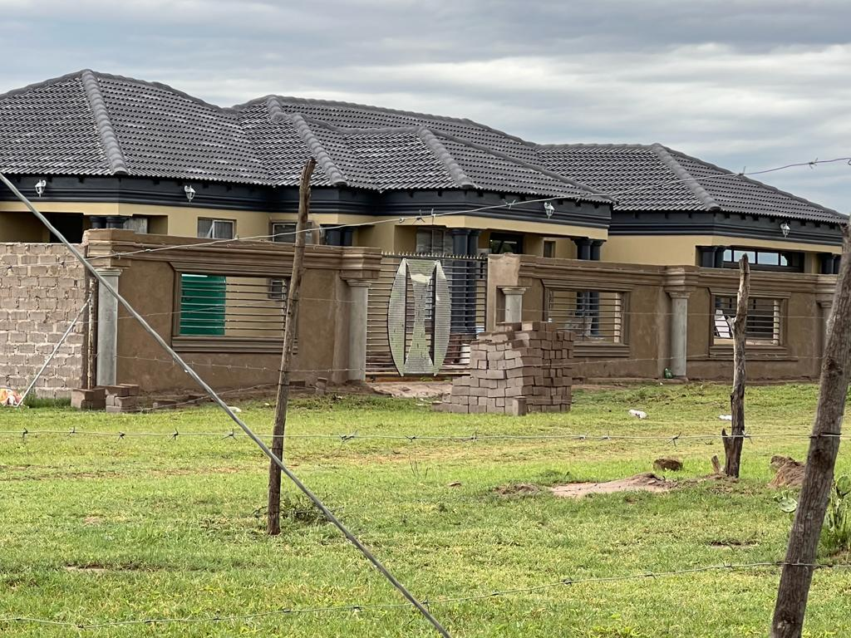 The first the was built in my presence. I got to see the building process , the challenges the builder face on site as well a the amount of work that is put into building the house. It felt good to see something I had designed turn into a beautiful house. That was the when I realised that there is no greater feeling then seeing my designs become real.

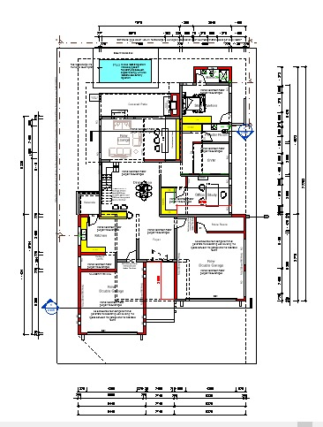Floor Plan Detail – Detailing of a house extension where the client to add a garage and also make a few changes to the house. There was an existing floorplan. I redesigned and made the above changes. The plan was then checked by Mr Thabiso Matenchi.

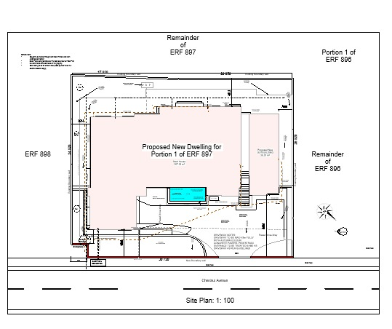

Site plan – This is a site plan describing and showing details of where everything on the yard will be positioned. It also shows the ERF of the surrounding Houses giving an idea of where the proposed will be and how other houses are surrounded. I have added building lines so that the builders will know how much space the allowed to use as well as adding dimensions to show builders exactly where the dwelling should be situated.

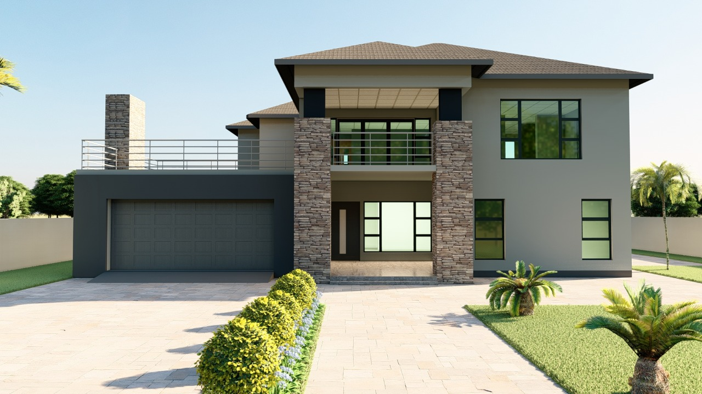

Design – This house was Designed by me in 2021. Here I was still learning and exploring how to design using the software Revit. This where I leant to explore my creative side. I believe I have grown and learnt a lot since then I have gotten out of my comfort zone not only designing from my view but also understanding that my style may not be what my client prefer hence I see it not as a challenge but as an opportunity to leave my comfort zone. An example being the image below:

`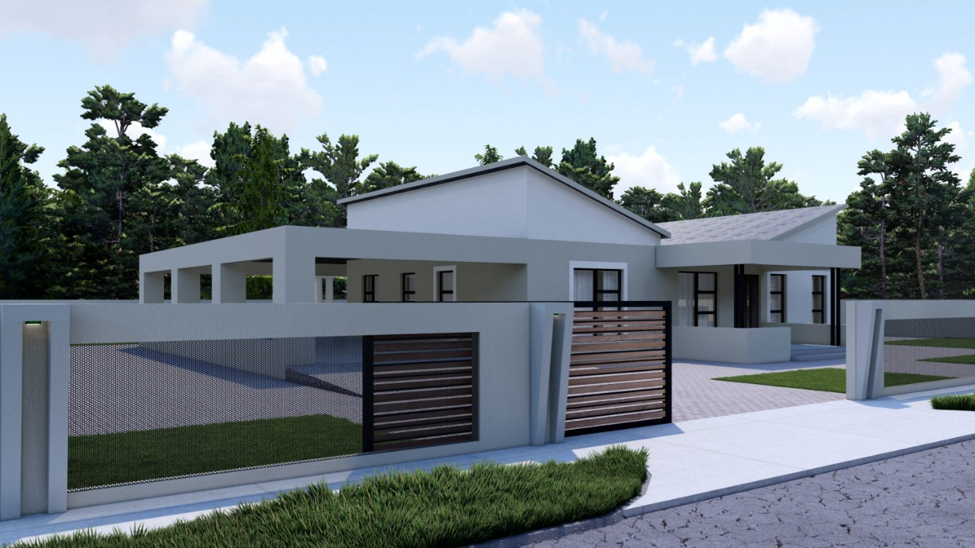

This was designed by me in March 2025. The client wanted a simple 3 bedroom house plan with a butterfly roof. The plan includes a shelter like structure that fits 4 cars.