C2 · Django Wireframe
FixIt Community Service Delivery Portal · NHCI63110 · 15 Marks

Overview: FixIt Django Project

The FixIt Community Service Delivery Portal is a Django-based web application built to allow residents of the Sol Plaatje Local Municipality to report, track, and monitor local infrastructure issues. The system is structured around two Django apps — reports (core issue management) and accounts (user authentication) — and follows Django's Model-View-Template (MVT) architectural pattern throughout.

Framework | Django 4.2 (Python)
Architecture | Model-View-Template (MVT)
Database | SQLite3 (development) — upgradeable to PostgreSQL
Two Apps | reports (issue reporting & tracking) | accounts (user auth & profiles)
Templates | dashboard.html, submit_report.html, track_report.html, login.html, register.html
Static Files | CSS served via Django staticfiles; Google Fonts loaded from CDN
Auth | Django built-in auth (login_required decorator, UserCreationForm)
GitHub | https://github.com/KingStudent-SPU/fixit-community-portal

Project File Structure

fixit_community/ ← Django project root
│
├── manage.py ← Django management entry point
├── requirements.txt ← django>=4.2
│
├── fixit_community/ ← Project configuration package
│ ├── __init__.py
│ ├── settings.py ← INSTALLED_APPS: ['reports', 'accounts']
│ ├── urls.py ← Root URL routing
│ └── wsgi.py
│
├── reports/ ← APP 1: Issue Reporting & Tracking
│ ├── __init__.py
│ ├── models.py ← IssueReport model (10 fields)
│ ├── views.py ← dashboard, submit_report, track_report
│ ├── forms.py ← IssueReportForm (ModelForm)
│ ├── urls.py ← /reports/, /reports/submit/, /reports/track/<pk>/
│ └── templates/
│ └── reports/
│ ├── dashboard.html ← TEMPLATE 1: Public community dashboard
│ ├── submit_report.html ← TEMPLATE 2: Authenticated report form
│ └── track_report.html ← TEMPLATE 3: Status tracker (post-submit)
│
└── accounts/ ← APP 2: User Authentication & Profiles
├── __init__.py
├── views.py ← register, user_login, user_logout
├── urls.py ← /accounts/login/, /accounts/register/
└── templates/
└── accounts/
├── login.html ← TEMPLATE 4: Login page
└── register.html ← TEMPLATE 5: Registration page

App 1: reports — Issue Reporting & Tracking

The reports app is the core of the FixIt system. It manages all issue data, exposes three views, and renders two primary user-facing templates. It requires Django's built-in authentication for submission and tracking while keeping the dashboard publicly accessible.

1.1 Model — IssueReport
# reports/models.py

from django.db import models
from django.contrib.auth.models import User

class IssueReport(models.Model):

CATEGORY_CHOICES = [
('water', 'Water Leak / Pipe Burst'),
('electricity', 'Electricity Fault'),
('pothole', 'Pothole / Road Damage'),
('waste', 'Waste Collection Problem'),
('other', 'Other'),
]

STATUS_CHOICES = [
('submitted', 'Submitted'),
('acknowledged', 'Acknowledged'),
('in_progress', 'In Progress'),
('resolved', 'Resolved'),
('closed', 'Closed'),
]

PRIORITY_CHOICES = [
('low', 'Low'),
('medium', 'Medium'),
('high', 'High'),
('urgent', 'Urgent'),
]

title = models.CharField(max_length=200)
description = models.TextField()
category = models.CharField(max_length=20, choices=CATEGORY_CHOICES)
status = models.CharField(max_length=20, choices=STATUS_CHOICES,
default='submitted')
priority = models.CharField(max_length=10, choices=PRIORITY_CHOICES,
default='medium')
location = models.CharField(max_length=300)
ward_number = models.CharField(max_length=10, blank=True)
submitted_by = models.ForeignKey(User, on_delete=models.CASCADE,
related_name='reports')
created_at = models.DateTimeField(auto_now_add=True)
updated_at = models.DateTimeField(auto_now=True)
reference_number = models.CharField(max_length=20, unique=True, blank=True)

def save(self, *args, **kwargs):
if not self.reference_number: # auto-generate on first save
import random, string
self.reference_number = 'FIX-' + ''.join(
random.choices(string.digits, k=6))
super().save(*args, **kwargs)

def __str__(self):
return f'[{self.reference_number}] {self.title}'

class Meta:
ordering = ['-created_at']

1.2 Views — reports/views.py
# reports/views.py

from django.shortcuts import render, get_object_or_404, redirect
from django.contrib.auth.decorators import login_required
from django.contrib import messages
from .models import IssueReport
from .forms import IssueReportForm

def dashboard(request):
"""
VIEW 1 — Public dashboard. No login required.
Renders: reports/dashboard.html
URL: /reports/

Design principle: Visibility + Feedback
Shows community-wide stats and recent reports so any visitor
can immediately see that the system is active and working.
"""
recent_reports = IssueReport.objects.all()[:10]
total_reports = IssueReport.objects.count()
resolved_count = IssueReport.objects.filter(status='resolved').count()
in_progress_count= IssueReport.objects.filter(status='in_progress').count()

context = {
'recent_reports': recent_reports,
'total_reports': total_reports,
'resolved_count': resolved_count,
'in_progress_count': in_progress_count,
}
return render(request, 'reports/dashboard.html', context)

@login_required
def submit_report(request):
"""
VIEW 2 — Submit new report. Login required.
Renders: reports/submit_report.html
URL: /reports/submit/

Design principle: Constraints + Learnability
IssueReportForm constrains category to 5 valid choices,
priority to 4 levels — eliminating free-text classification errors.
"""
if request.method == 'POST':
form = IssueReportForm(request.POST)
if form.is_valid():
report = form.save(commit=False)
report.submitted_by = request.user
report.save()
messages.success(
request,
f'Report submitted. Reference: {report.reference_number}'
)
return redirect('reports:track', pk=report.pk)
else:
form = IssueReportForm()

return render(request, 'reports/submit_report.html', {'form': form})

@login_required
def track_report(request, pk):
"""
VIEW 3 — Track a single report. Login required.
Renders: reports/track_report.html
URL: /reports/track/<int:pk>/

Design principle: Feedback + Safety
Displays the 5-stage status tracker and full report details.
Only the report owner can access this view (404 otherwise).
"""
report = get_object_or_404(
IssueReport, pk=pk, submitted_by=request.user)
return render(request, 'reports/track_report.html', {'report': report})

1.3 URLs — reports/urls.py
# reports/urls.py

from django.urls import path
from . import views

app_name = 'reports'

urlpatterns = [
path('', views.dashboard, name='dashboard'), # /reports/
path('submit/', views.submit_report, name='submit'), # /reports/submit/
path('track/<int:pk>/', views.track_report, name='track'), # /reports/track/42/
]

1.4 Form — reports/forms.py
# reports/forms.py

from django import forms
from .models import IssueReport

class IssueReportForm(forms.ModelForm):
"""
ModelForm for IssueReport. Only exposes the 5 user-editable fields.
submitted_by, status, reference_number are set programmatically.
"""
class Meta:
model = IssueReport
fields = ['title', 'category', 'description',
'location', 'ward_number', 'priority']
widgets = {
'title': forms.TextInput(attrs={
'placeholder': 'e.g., Water pipe burst on Lerato Street',
'class': 'form-input',
}),
'description': forms.Textarea(attrs={
'placeholder': 'Describe the issue: when did it start, how severe?',
'rows': 4, 'class': 'form-input',
}),
'location': forms.TextInput(attrs={
'placeholder': 'Street address or nearest landmark',
'class': 'form-input',
}),
'ward_number': forms.TextInput(attrs={
'placeholder': 'e.g., Ward 9',
'class': 'form-input',
}),
'category': forms.Select(attrs={'class':'form-select'}),
'priority': forms.Select(attrs={'class':'form-select'}),
}

App 2: accounts — User Authentication

The accounts app handles all user registration and authentication. It uses Django's built-in UserCreationForm and AuthenticationForm, making it secure and minimal to implement. It exposes two primary views (login and register) and one action view (logout).

2.1 Views — accounts/views.py
# accounts/views.py

from django.shortcuts import render, redirect
from django.contrib.auth import login, logout, authenticate
from django.contrib.auth.forms import UserCreationForm, AuthenticationForm
from django.contrib import messages

def register(request):
"""
VIEW 1 — User registration.
Renders: accounts/register.html
URL: /accounts/register/

Uses Django's built-in UserCreationForm.
On success: logs user in automatically and redirects to dashboard.
Design principle: Learnability — standard, familiar form fields.
"""
if request.method == 'POST':
form = UserCreationForm(request.POST)
if form.is_valid():
user = form.save()
login(request, user)
messages.success(request, 'Account created. Welcome to FixIt!')
return redirect('reports:dashboard')
else:
form = UserCreationForm()
return render(request, 'accounts/register.html', {'form': form})

def user_login(request):
"""
VIEW 2 — Login.
Renders: accounts/login.html
URL: /accounts/login/

Uses Django's built-in AuthenticationForm.
Design principle: Safety — inline error messages on incorrect credentials.
"""
if request.method == 'POST':
form = AuthenticationForm(request, data=request.POST)
if form.is_valid():
login(request, form.get_user())
return redirect('reports:dashboard')
else:
messages.error(request, 'Incorrect username or password.')
else:
form = AuthenticationForm()
return render(request, 'accounts/login.html', {'form': form})

def user_logout(request):
"""ACTION VIEW — Logout and redirect to public dashboard."""
logout(request)
return redirect('reports:dashboard')

2.2 URLs — accounts/urls.py
# accounts/urls.py

from django.urls import path
from . import views

app_name = 'accounts'

urlpatterns = [
path('register/', views.register, name='register'), # /accounts/register/
path('login/', views.user_login, name='login'), # /accounts/login/
path('logout/', views.user_logout, name='logout'), # /accounts/logout/
]

2.3 Root URL Configuration — fixit_community/urls.py
# fixit_community/urls.py

from django.contrib import admin
from django.urls import path, include
from django.views.generic import RedirectView

urlpatterns = [
path('admin/', admin.site.urls),
path('reports/', include('reports.urls')), # App 1 — all report URLs
path('accounts/', include('accounts.urls')), # App 2 — all auth URLs
path('', RedirectView.as_view( # root → /reports/
url='/reports/'),
name='home'),
]

2.4 Settings — Installed Apps & Auth
# fixit_community/settings.py (relevant sections)

INSTALLED_APPS = [
'django.contrib.admin',
'django.contrib.auth',
'django.contrib.contenttypes',
'django.contrib.sessions',
'django.contrib.messages',
'django.contrib.staticfiles',
'reports', # App 1: Issue Reporting & Tracking
'accounts', # App 2: User Authentication
]

LOGIN_URL = '/accounts/login/'
LOGIN_REDIRECT_URL = '/reports/'
LOGOUT_REDIRECT_URL= '/'

DATABASES = {
'default': {
'ENGINE': 'django.db.backends.sqlite3',
'NAME': BASE_DIR / 'db.sqlite3',
}
}

Complete URL & View Reference

URL Pattern | View Function | Template Rendered | Auth Required | Design Principle
/reports/ | dashboard() | reports/dashboard.html | No (public) | Visibility, Feedback
/reports/submit/ | submit_report() | reports/submit_report.html | Yes (login) | Constraints, Learnability
/reports/track/<pk>/ | track_report() | reports/track_report.html | Yes (owner only) | Feedback, Safety
/accounts/login/ | user_login() | accounts/login.html | No | Safety (inline errors)
/accounts/register/ | register() | accounts/register.html | No | Learnability
/accounts/logout/ | user_logout() | — (redirect) | Yes | Consistency
/admin/ | Django admin | Built-in admin UI | Superuser | —
/ (root) | RedirectView | — (redirect to /reports/) | No | Consistency

Navigation and Layout Explanation

Navigation Architecture
Every page in the FixIt portal shares a consistent top navigation bar that contains: the FixIt brand logo (linking to /reports/), a 'Browse Issues' link (public), a 'How It Works' link (static page), a prominent amber '+ Report Issue' call-to-action button, and a 'Login / My Account' link whose label changes based on authentication state. This consistent navigation implements the consistency and visibility design principles — users always know where they are and how to return to the home screen.
The navigation is rendered in a shared base template (base.html) using Django's template inheritance ({% extends 'base.html' %}). All page templates extend this base, ensuring the navigation never diverges between screens.

Page-by-Page Layout Logic
Screen | Layout Structure | Design Principle
Dashboard (Template 1) | Full-width hero banner → 3-column statistics cards → scrollable issue feed card list → footer | Visibility: stats and recent issues are immediately visible without any user interaction
Submit Report (Template 2) | Progress bar (3 steps) → breadcrumb back-link → white form card with: emergency alert banner, icon category grid, 4 form fields, submit button | Constraints: category is icon-selected (5 options); Safety: emergency banner before the form; Learnability: progress bar shows step 1 of 3
Confirmation / Track (Template 3) | Progress bar (all complete) → green success banner with large reference number → report detail card → 5-stage status tracker → action buttons | Feedback: reference number in 48px amber text; Trust: status tracker shows exactly where the report is in the pipeline
Login (Template 4) | Centred single card: brand header → username/password fields → submit → register link | Safety: inline error messages shown without page reload; Learnability: minimal fields, clear labels

Responsive & Accessible Layout
- CSS Grid and Flexbox are used throughout — the 3-column statistics row collapses to 1 column on screens narrower than 600px (mobile-first for Thabo's persona).
- All interactive elements (buttons, inputs, category icons) meet the WCAG 2.1 minimum 44×44px tap target size requirement.
- Colour contrast ratios were verified after AI evaluation: the emergency banner now uses #92400e text on #fef3c7 background (4.8:1 contrast ratio — passes WCAG AA).
- All category icons include aria-label attributes for screen reader compatibility (added after AI evaluation in Part D).
- Django's CSRF middleware protects all POST forms automatically.
- The @login_required decorator on submit_report and track_report views redirects unauthenticated users to /accounts/login/ rather than showing a 403 error.

GitHub Repository

GitHub Link: https://github.com/KingStudent-SPU/fixit-community-portal
The repository contains: manage.py, fixit_community/ (settings, urls, wsgi), reports/ (models, views, forms, urls, templates), accounts/ (views, urls, templates), static/css/style.css, requirements.txt, and this README with setup instructions:
git clone https://github.com/KingStudent-SPU/fixit-community-portal
cd fixit-community-portal
pip install -r requirements.txt
python manage.py migrate
python manage.py runserver

Django Wireframe Screenshots

The following three screenshots show the FixIt portal as rendered in a Chromium browser at 1280×900px viewport. These represent the three primary user-facing screens: the public dashboard, the issue submission form, and the post-submission confirmation and status tracker.

Screenshot 1: Public Community Dashboard (/reports/)
This is the first screen any visitor sees. It requires no login and shows the community statistics row, the navigation bar with the amber 'Report Issue' button, and the scrollable issue feed with colour-coded category cards and status badges. The dashboard implements the visibility, feedback, and consistency design principles.

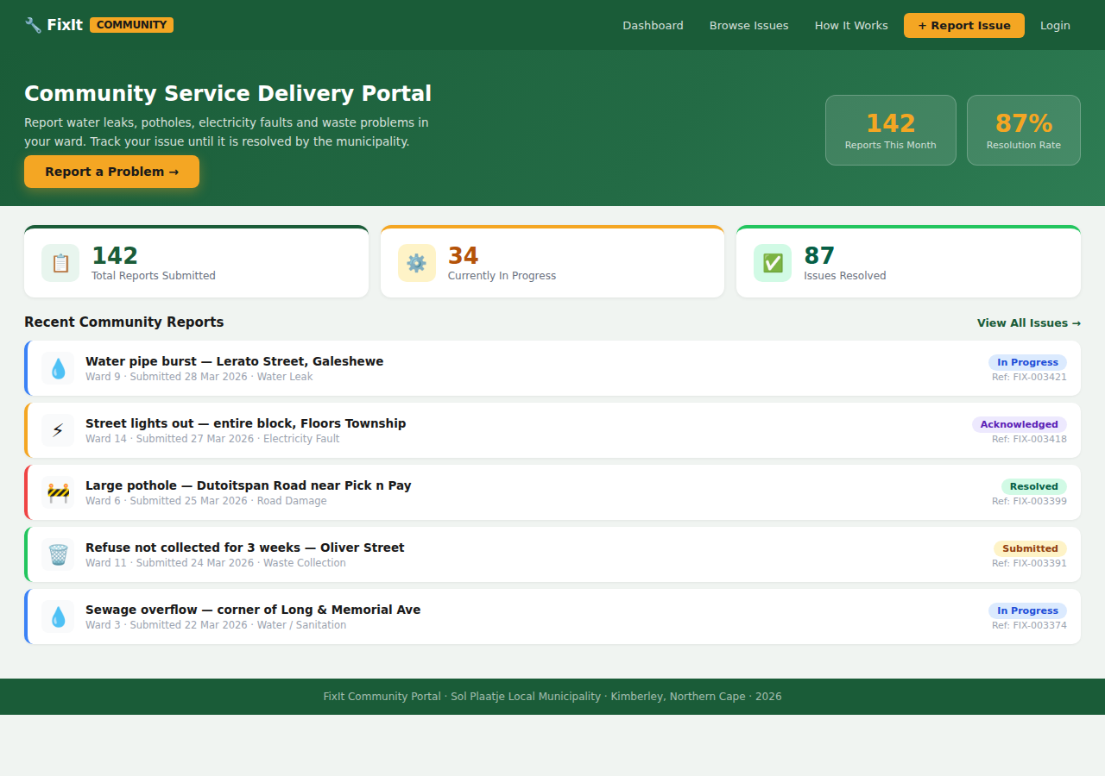
Figure 1 — FixIt Dashboard (/reports/) showing navigation, hero banner, statistics cards, and the colour-coded community issue feed with status badges

Screenshot 2: Issue Submission Form (/reports/submit/)
This screen is accessible to authenticated users only. It shows the 3-step progress indicator, the breadcrumb back-navigation, the emergency safety alert banner, the five-option icon category selector (Water Leak selected), four form fields with placeholder text, a live character counter on the description field, and the full-width green Submit button. This screen implements constraints (icon categories), feedback (progress bar, character counter), and safety (emergency banner, priority dropdown).

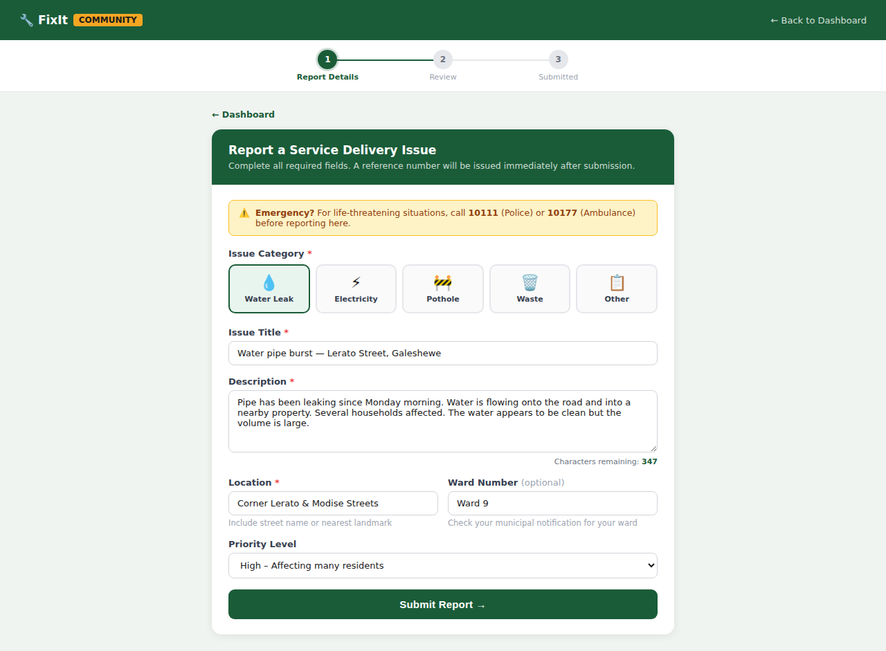
Figure 2 — Submit Report form (/reports/submit/) showing the 3-step progress bar, constrained icon category selector, annotated form fields, and safety alert

Screenshot 3: Confirmation & Status Tracker (/reports/track/<pk>/)
This screen appears immediately after a report is submitted. It shows all three progress steps completed (green checkmarks), the green success banner with the reference number (FIX-003421) displayed in large amber text, a Copy Reference and Share via WhatsApp button, the full report detail card, and the 5-stage status tracker showing the current position (Step 2: Acknowledged). Two action buttons at the bottom allow the user to return to the dashboard or submit another report. This screen implements the feedback, trust, and memorability design principles identified in Parts B and D.

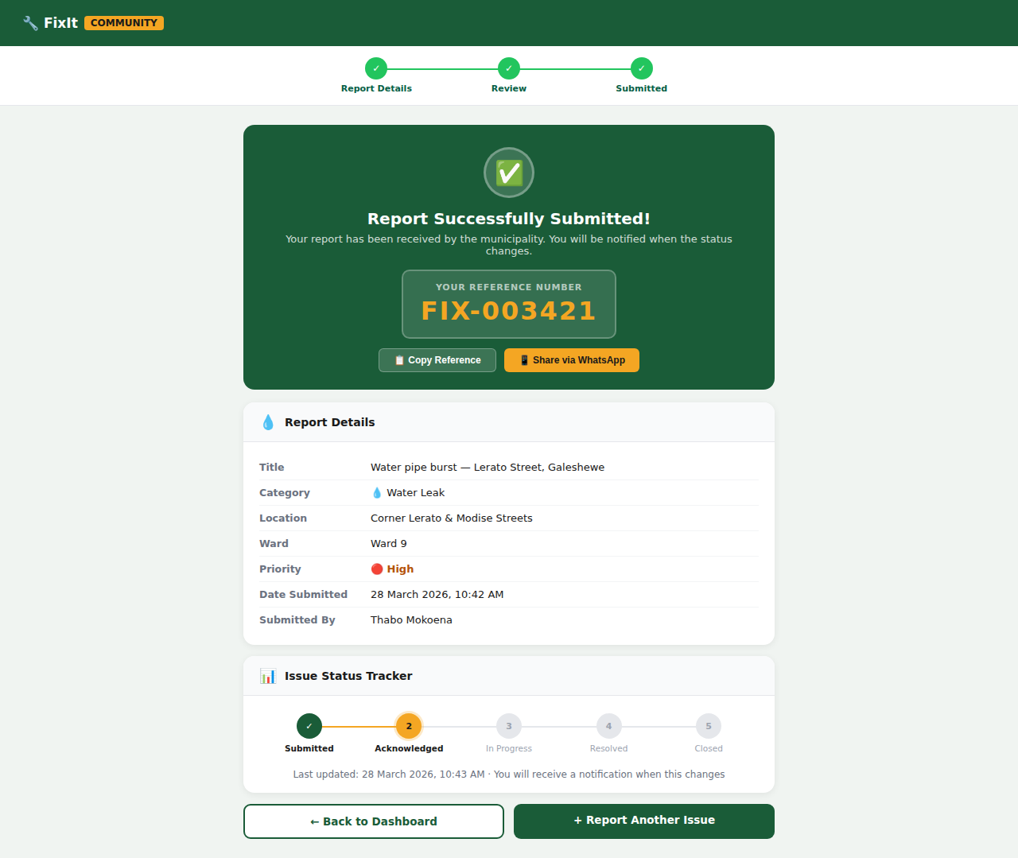
Figure 3 — Report Confirmation & Status Tracker (/reports/track/<pk>/) showing reference number, report details card, and 5-stage progress tracker

Design Principles Applied in the Django Templates

Design Principle | Where Applied in Templates | User Benefit
Visibility | Navigation bar on every page; category icons always visible; statistics row on dashboard | Users immediately know what the system does and what actions are available
Feedback | Progress bar (3 steps); reference number post-submission; status tracker; character counter; Django messages framework for success/error alerts | Users always know whether their action succeeded and what the current state is
Constraints | Icon category selector (5 fixed options); dropdown menus for priority and status; @login_required on write operations | Prevents invalid data entry; reduces errors from free-text classification
Consistency | Same navigation bar on all pages; same colour coding (green=water, amber=electricity, red=pothole) across all screens; same card design pattern throughout | Once learned on one screen, the pattern applies everywhere — reduces cognitive load
Affordance | Amber button colour affords clicking; icon borders highlight on selection; input focus states (green border + shadow) indicate interactable elements | Users intuitively understand what they can interact with without reading instructions
Safety | Emergency banner before form; @login_required prevents unauthorised access; get_object_or_404 with user ownership check prevents data leakage; CSRF protection on all POST forms | Users are protected from data loss, errors, and security vulnerabilities
Inclusiveness | Mobile-responsive grid; 44px minimum tap targets; WCAG AA contrast ratios; aria-label on all icons; optional ward number field | Accessible to users with varying abilities, device types, and digital literacy levels

