Less track closed. More trains running.
RBC: AI that plans railway maintenance for every team at once
94 | 105 hours
fewer track closures in one week | of track time given back to trains

- Smart India Hackathon · SIH26027 · Ministry of Railways
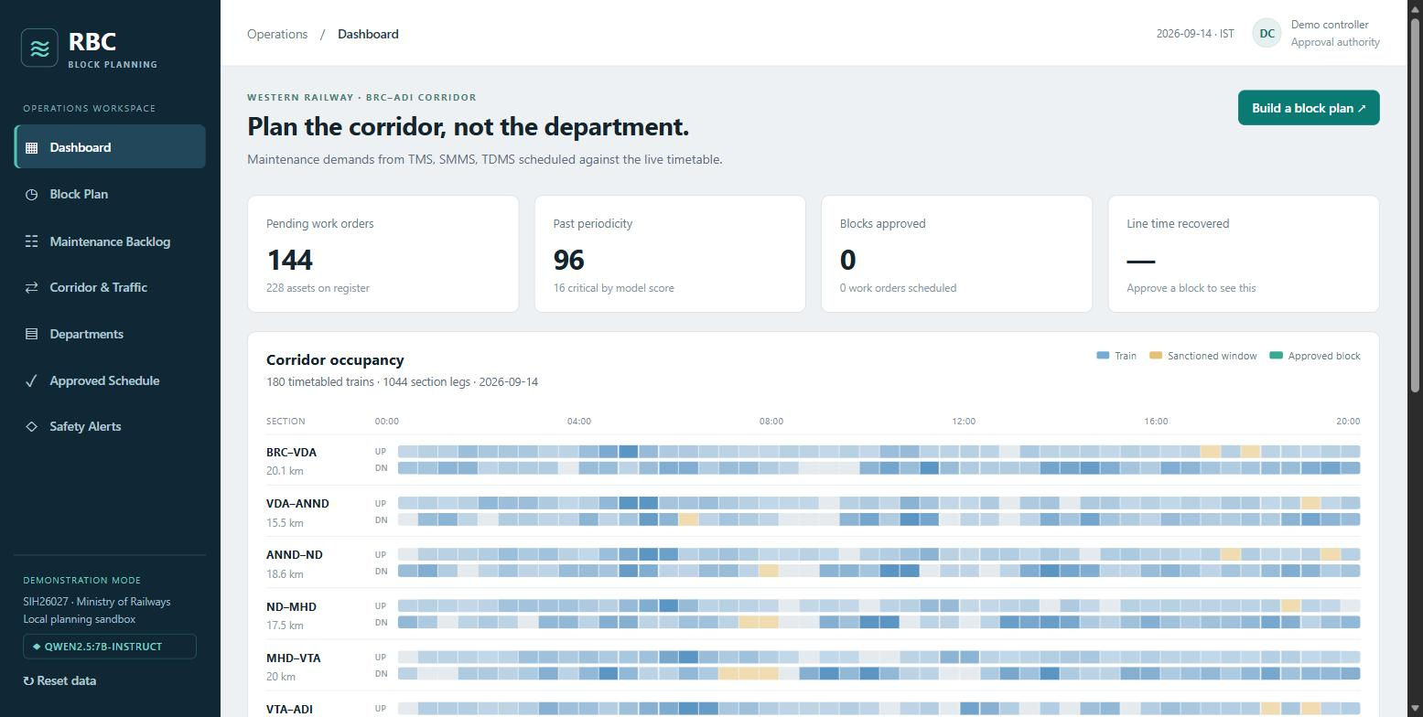

The problem: the same track is closed again and again
Three maintenance teams each plan their own work, alone.
3 | 50 min
teams planning separately: track, signals, overhead power | just to make the power line safe, before any work starts

- Each team asks for its own track closure, often on the same stretch, on the same day
- Every closure repeats the safety setup, and every minute closed is a minute trains cannot run
- Nobody sees the full picture: what is overdue, what might break, which time slot is free

Our idea: one plan for all teams
Put all the work together, then fit it into the fewest closures.
0.25 sec
to plan a full week of work

- 1. Collect every pending job from all three teams
- 2. AI ranks them: what is most overdue and most likely to fail goes first
- 3. Group jobs on the same stretch into one closure, at the time that disturbs the fewest trains
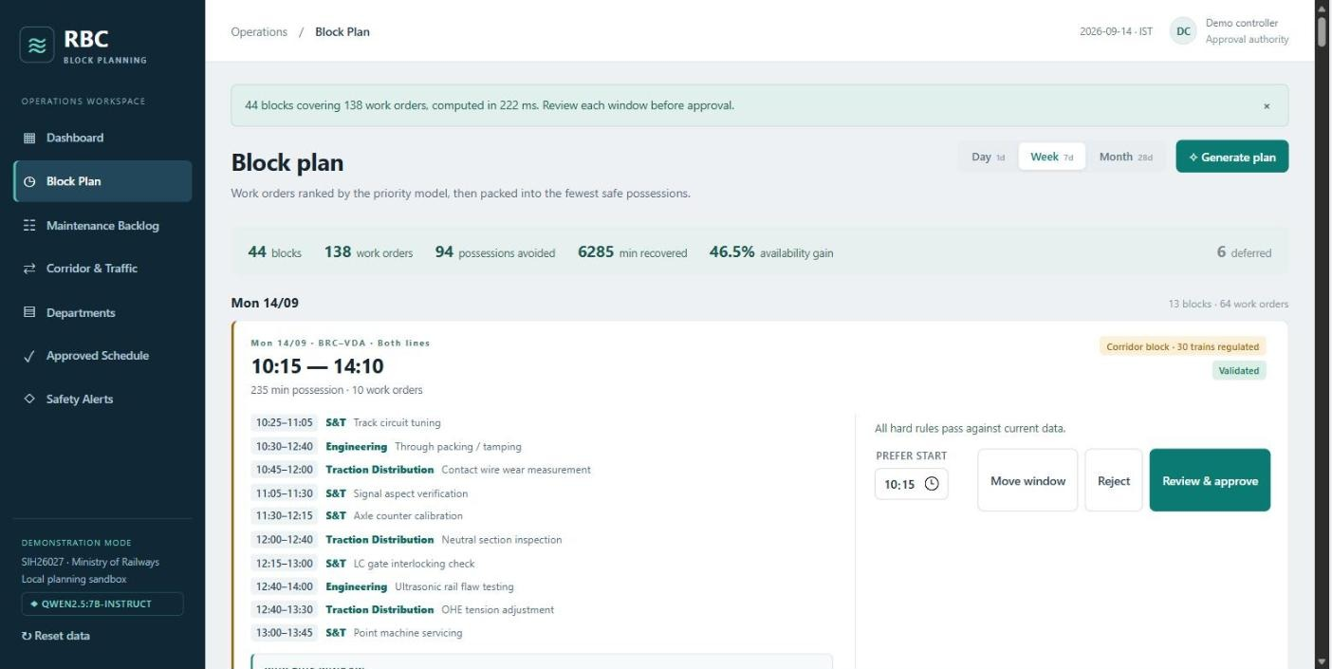

The impact in one week
Compared with planning every job separately, on a real Western Railway line.
94 | 105 hours | 138 of 144 | 46.5%
fewer track closures | of track time back to trains (6,285 min) | maintenance jobs planned | less track time lost to maintenance

- In a single day, the saving is even bigger: 60% less track time lost

One example: 10 jobs, 3 teams, 1 closure
Instead of 10 separate closures on the same stretch.
615 min | 1×
less track closed than doing the jobs separately | safety setup, instead of 10 times

- Teams work side by side in the same time window
- The app shows exactly why it picked this slot, and how many trains it affects
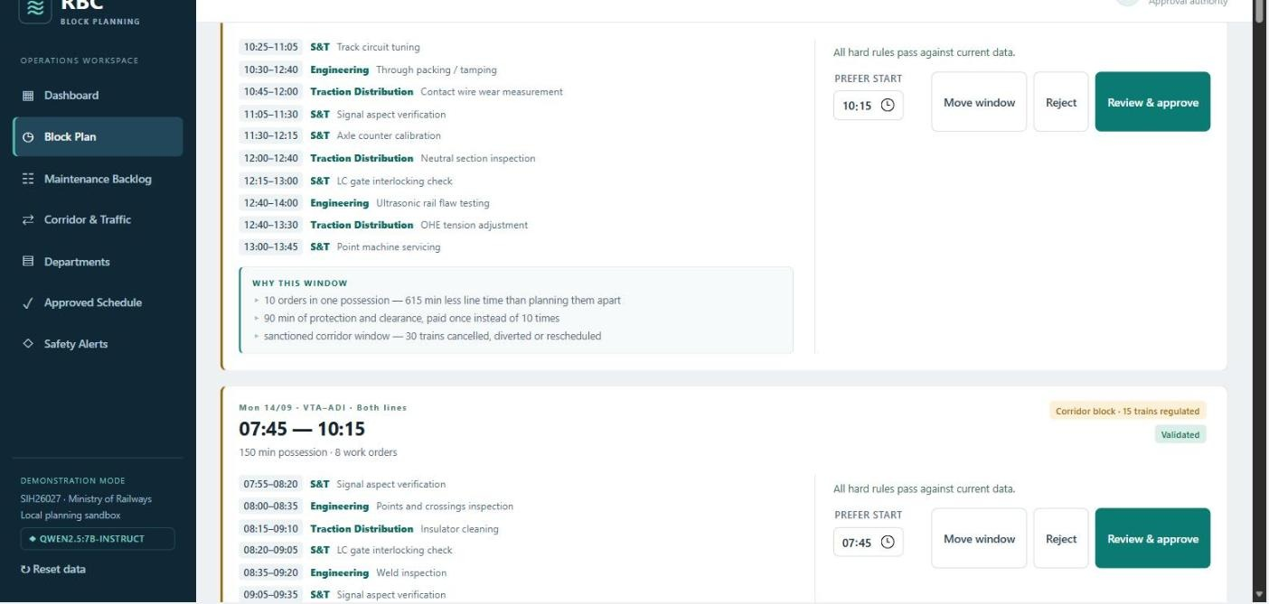

Built on real trains, not made-up data
Vadodara to Ahmedabad: 100 km, 180 real trains every day.
42 min | 6 trains
the longest gap between trains when both tracks are closed | the fewest affected by the best planned slot

- The line is so busy that work cannot simply wait for a gap
- So the app finds the time slot that disturbs the fewest trains, and shows that cost up front
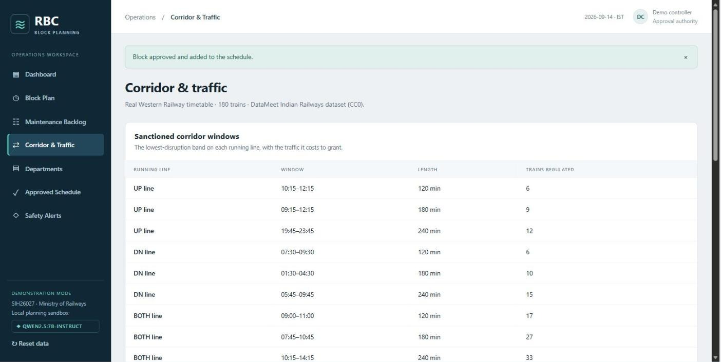

AI you can trust, because it explains itself
Click "Why?" on any job to see exactly what made it urgent.
77% | Almost 3×
of the time the AI picks the same time slot a planner chose | better than just taking the first free slot (28%)

- Predicts which parts are likely to fail before the next check
- Ranks jobs by how late they are, how risky they are, and how bad a failure would be
- No black box: every score is broken down into its reasons
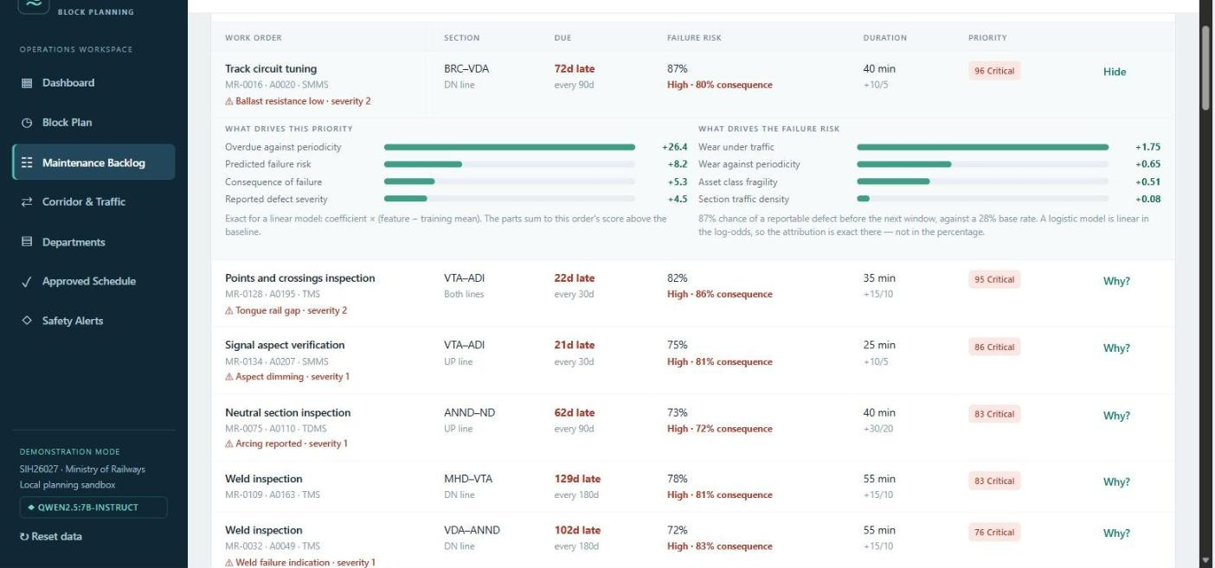

Safety first: AI suggests, people decide
Nothing is scheduled until a named controller approves it.
100%
of approvals re-checked against safety rules first

- Before approval, the app shows the cost clearly, like "this affects 30 trains"
- If a train runs late, an emergency comes in, or a closure is cancelled, the plan is checked again
- Every decision is recorded with who approved it and when
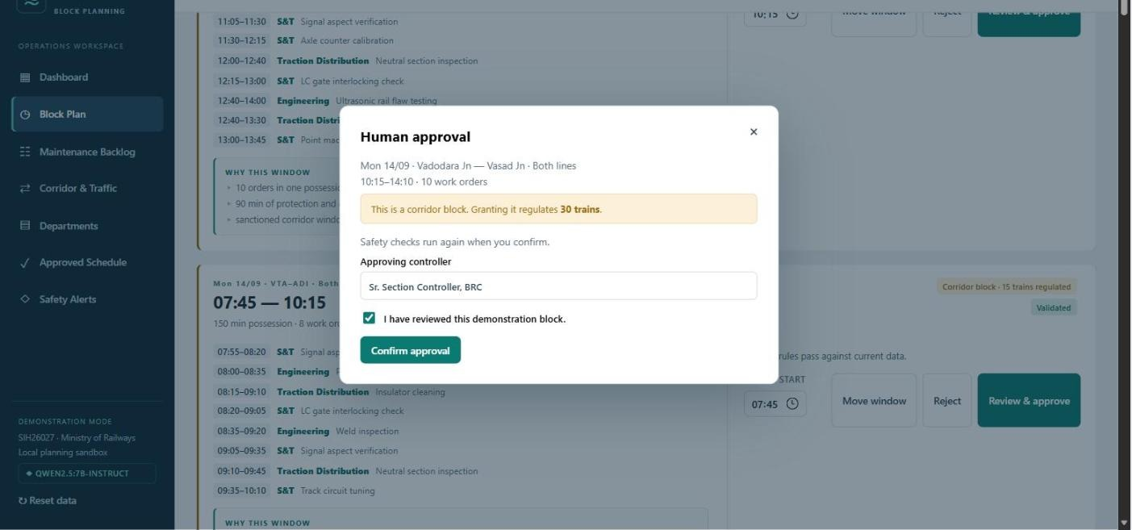
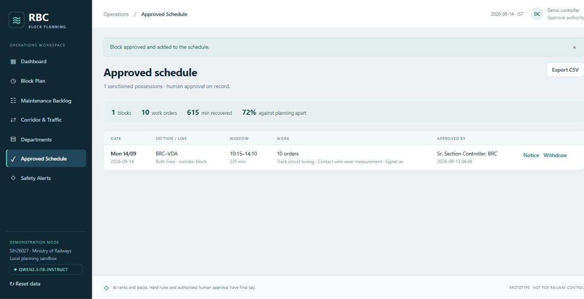

A built-in assistant that speaks plain language
Runs on the laptop itself. No internet needed, and no data leaves the machine.
- Type a note like "rail crack near km 42 on the up line" and it fills in the job form for you
- Ask "why was this job delayed?" and it answers from the plan, or says it does not know
- It only helps with words. Planning and safety decisions stay with the system and people.
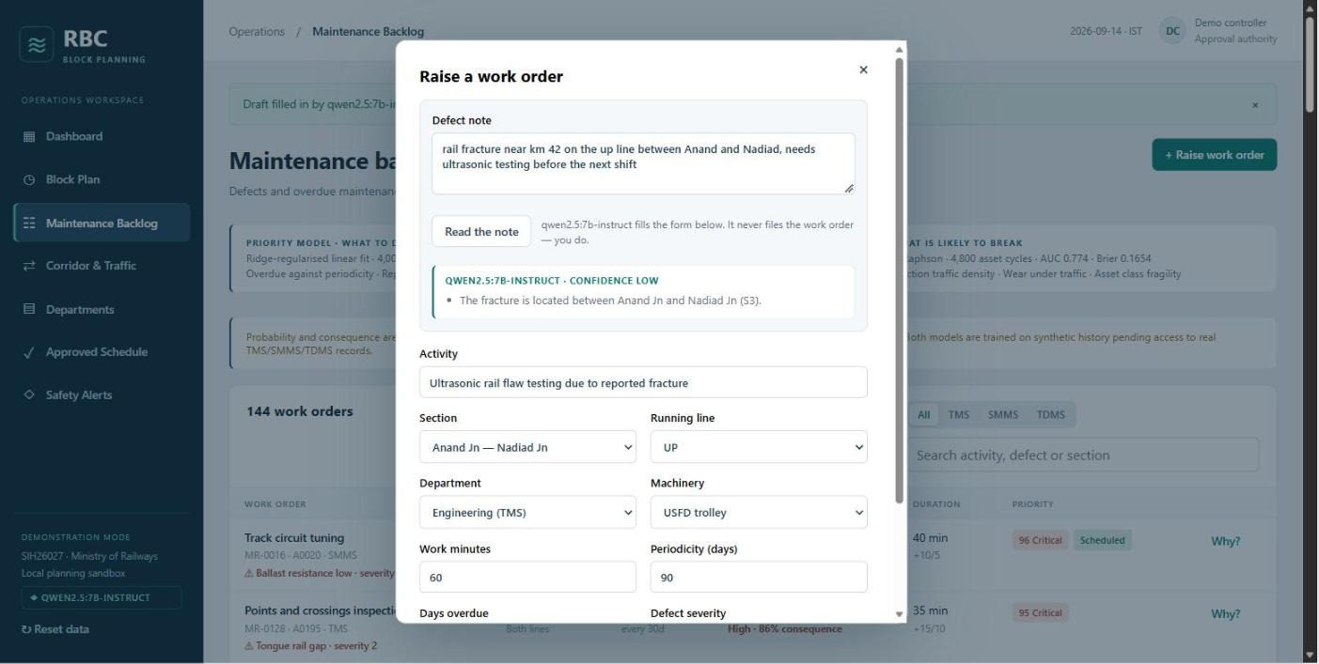
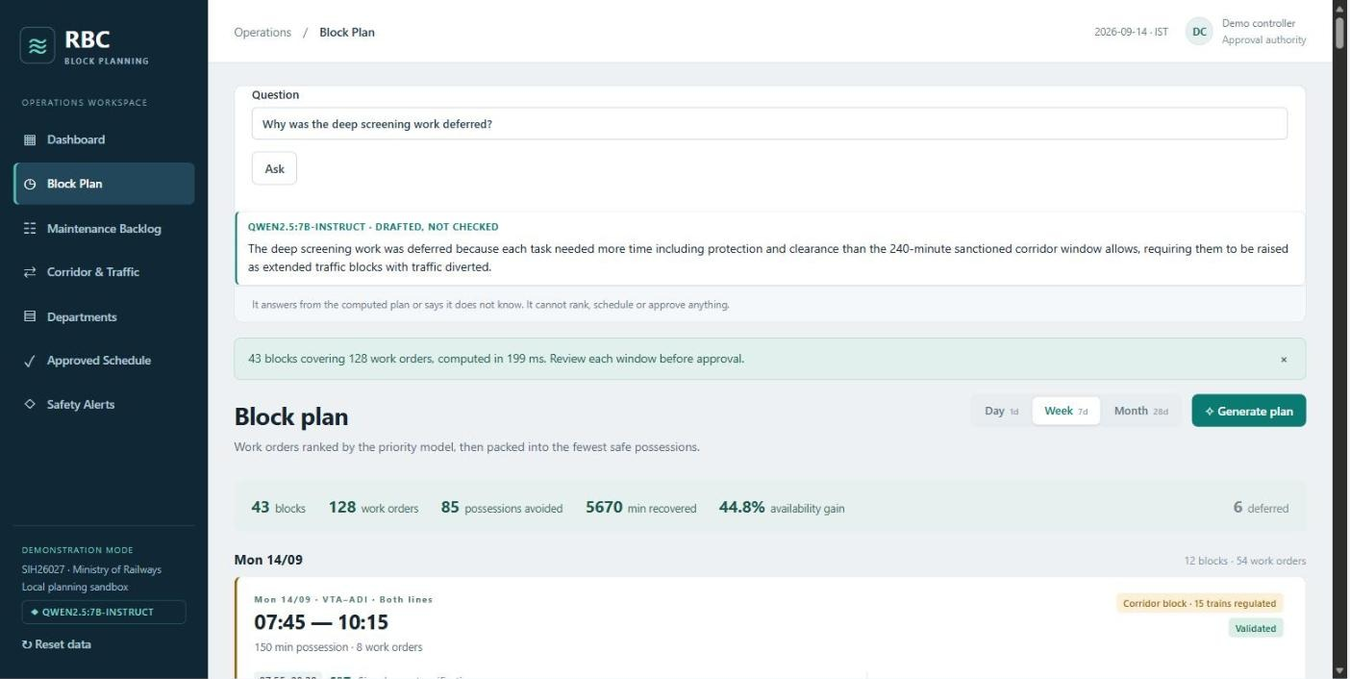

Ready for a real railway division
More trains on time, safer tracks, and less wasted time for maintenance teams.
58 | 0
automated tests passing | internet, logins or paid services needed

- Uses real train timings today. Maintenance records are sample data, because real records are not public.
- Built to plug in real records from one division and retrain automatically
- Next step: a pilot on one real division

