Module 6 Exercise Solutions
The exercise problems in Module 6 provide practice using the Crow’s Foot notation. You are encouraged to use the ER Assistant or other drawing tool to complete the exercise problems in module 6. If you want to use the ER Assistant, I encourage you to watch at least the first part of the software demonstration about the ER Assistant, available in module 7.
- Draw an ERD containing Student and Paper entity types connected by a 1-M relationship. The Student entity type should have attributes for StdNo (primary key), StdFirstName, StdLastName, StdAdmitSemester, StdAdmitYear, and StdEnrollStatus (full or part-time). The Paper entity type should have attributes for PaperNo (primary key), PaperTitle, PaperSubmitDate, PaperAccepted (yes or no), and PaperType (first, second,
proposal, or dissertation). Add a 1-M relationship from Student to Paper.
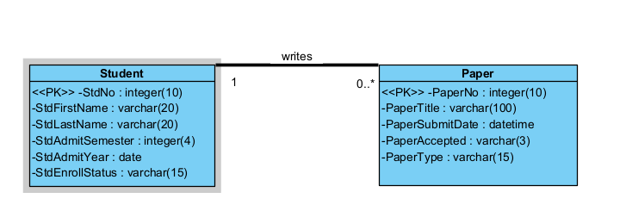
- Extend the ERD from problem 1 with an Evaluator entity type and an M-N relationship between Paper and Evaluator. The Evaluator entity type should have attributes for EvalNo (primary key), EvalFirstName, EvalLastName, EvalEmail, and EvalOffice. The M-N relationship should have attributes for EvalDate, EvalLitReview (1 to 5 rating), EvalProbId (1 to 5 rating), EvalTechWriting (1 to 5 rating), EvalModelDev (1 to 5 rating), EvalOverall (1 to 5 rating), and EvalComments.
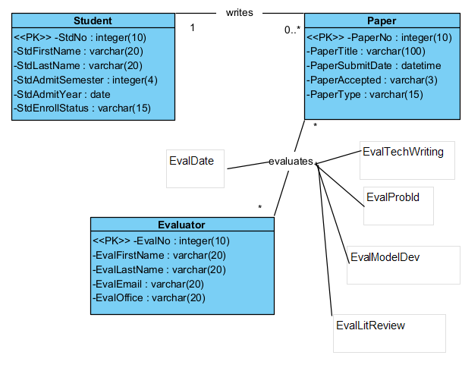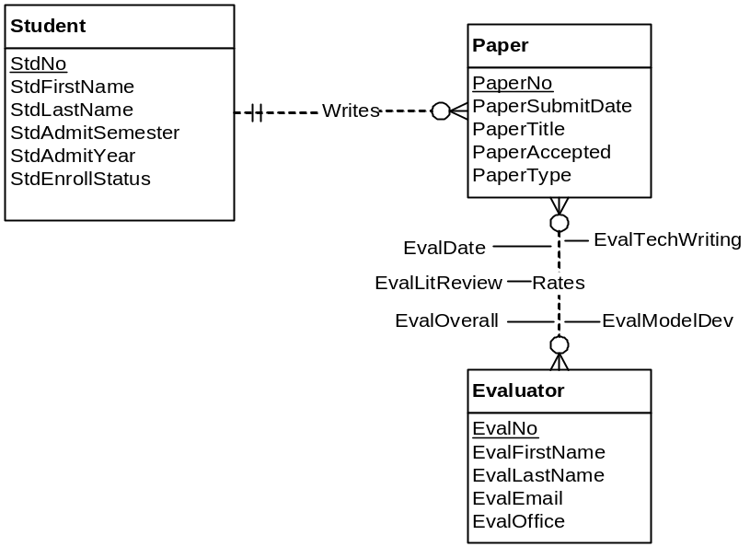
- Transform the M-N relationship from problem 2 into an associative entity type and identifying relationships.
