A Mini Project Report on

**“Document Scanner with Air Drawing using Computer Vision”**

Submitted in partial fulfillment of the requirement for the Sixth Semester

**Bachelor of Engineering**

In

**Computer Science and Engineering**

**Visvesvaraya Technological University, Belgaum**

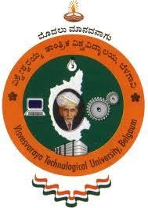

Submitted by

##### Rhuthu Hegde[1DS18CS731]

##### Under the guidance of

##### Prof. Navyashree T M

##### Assistant Professor,

##### Dept. of CSE, DSCE

##### 

2020-2021

**Department of Computer Science and Engineering,**

**DAYANANDA SAGAR COLLEGE OFENGINEERING**

**BANGALORE – 560078**