Fedex Dataset
project charter
Version <1.0>
<09/dd/2023>

VERSION HISTORY
[Provide information on how the development and distribution of the Project Charter Template up to the final point of approval was controlled and tracked. Use the table below to provide the version number, the author implementing the version, the date of the version, the name of the person approving the version, the date that particular version was approved, and a brief description of the reason for creating the revised version.]
Version # | Implemented  By | Revision  Date | Approved  By | Approval  Date | Reason
1.0 | Saibindu Domala | <mm/dd/yy> | <name> | <mm/dd/yy> | <reason>
UP Template Version: 11/30/06
Introduction

Purpose of Project Charter
[Provide the purpose of the project charter.]
The Fedex Dataset project charter documents and tracks the necessary information required by decision maker(s) to approve the project for funding. The project charter should include the needs, scope, justification, and resource commitment as well as the project’s sponsor(s) decision to proceed or not to proceed with the project. It is created during the Initiating Phase of the project.
The intended audience of the Fedex Analysis project charter is the project sponsor and senior leadership.

project And Product Overview
FedEx Corporation is a multinational conglomerate holding company based in Memphis, Tennessee, that provides transportation, e-commerce, and business services. Data cleaning is supposed to perform on the dataset. The estimated duration of the data cleaning is 1 month.

Justification

Business Need
FedEx, a global courier leader, is dedicated to ensuring on-time deliveries. By leveraging data analysis, FedEx aims to optimize operations, enhance customer satisfaction, make data-driven decisions, achieve cost efficiency, and stay competitive in the dynamic logistics industry. The goal is to provide a seamless delivery experience, exceeding customer expectations, and maintaining a culture of continuous improvement.

Business Impact
Effective data analysis and modeling on the FedEx dataset will:
- Improve On-time Deliveries: Enhance FedEx's ability to meet delivery commitments, reducing delays and boosting customer satisfaction.
- Operational Efficiency: Optimize resource allocation, routing, and scheduling to reduce costs and increase profitability.
- Data-Driven Decisions: Enable informed decision-making to respond quickly to market changes and adapt to customer needs.
- Competitive Advantage: Stay ahead in the competitive logistics sector by delivering reliable and timely services.
- Cost Savings: Identify areas for cost reduction and resource optimization, leading to increased profitability.
- Customer Retention: Deliver superior service, retaining and attracting more customers in an increasingly competitive market.

Scope

Objectives
The objectives of the FedEx are as follows:
- To Improve On-time Delivery: Ensure timely package delivery.
- To Optimize Operations: Enhance logistics efficiency.
- To Boost Customer Satisfaction: Prioritize customer needs.
- To Data-Driven Decisions: Use data for proactive decisions.
- To Stay Competitive: Maintain a competitive edge.
- To Cost Efficiency: Reduce operational costs.

High-Level Requirements

Req. # | I Requirement Description
1. | Data Set
2. | Data Description

Major Deliverables
The following table presents the major deliverables that the project’s product, service or result must meet in order for the project objectives to be satisfied.
Major Deliverable | I Deliverable Description
Clean Data | The clean dataset can be used to train module.
Trained Module | The trained module is used to forcast and predict.

Boundaries
This project does not encompass any modifications to infrastructure, business processes, legal frameworks, hardware upgrades, customer interfaces, or employee training. The focus is strictly on data-related tasks, analysis, and model development for delivery status prediction.

Duration

Timeline

10/05
12/05
02/06
05/06
System Development
Completed
Developed Prototype
Requirements Analysis
Completed
Project Plan Completed

Executive Milestones
The table below lists the high-level Executive Milestones of the project and their estimated completion timeframe.
Executive Milestones | Estimated Completion Timeframe
Project Planned Version1
Version 2

budget Estimate

Funding Source
[Example: grant, terrorism budget, or operational budget.]

Estimate
This section provides a summary of estimated spending to meet the objectives of the <Project Name> project as described in this project charter. This summary of spending is preliminary, and should reflect costs for the entire investment lifecycle. It is intended to present probable funding requirements and to assist in obtaining budgeting support.
[For CPIC major/tactical projects complete and attach the required sections of the OMB Exhibit 300 located at http://intranet.cdc.gov/cpic/. For all other projects, provide a summary of the project’s expected spending below.]

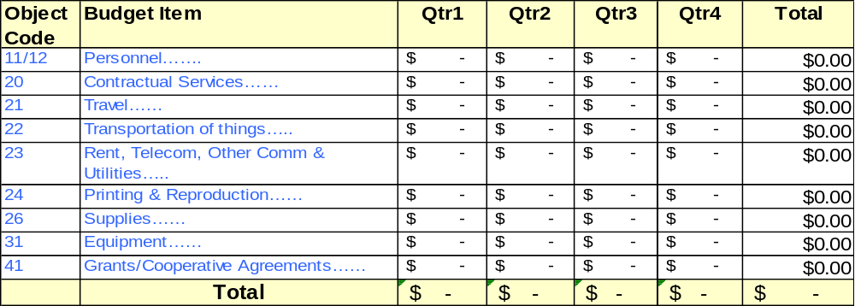

High-Level Alternatives Analysis
[Example: Alternatives to developing a custom system may have included looking at existing COTS products or reusing an existing system.]
- [Provide a statement summarizing the factors considered.]
- [Provide a statement summarizing the factors considered.]

Assumptions, Constraints And Risks

Assumptions
[Example: The system is being developed to capture data from public health partners. One assumption is that data is entered electronically into the system.]
This section identifies the statements believed to be true and from which a conclusion was drawn to define this project charter.
- [Insert description of the first assumption.]
- [Insert description of the second assumption.]

Constraints
[Example: There might be time constraints on developing a system that is used to track data of highly infectious diseases like SARS.]
This section identifies any limitation that must be taken into consideration prior to the initiation of the project.
- [Insert description of the first constraint.]
- [Insert description of the second constraint.]

Risks
[Example: The risk of accessibility or unavailability of public health partners for obtaining requirements to develop a data collection system may delay project deliverables. A possible mitigation strategy might be to schedule requirement sessions with the partners as early as possible. List the risks that the project sponsor should be aware of before making a decision on funding the project, including risks of not funding the project.]
Risk | Mitigation

Project Organization

Roles and Responsibilities
[Depending on your project organization, you may modify the roles and responsibilities listed in the table below.]
This section describes the key roles supporting the project.
Name & Organization | Project Role | Project Responsibilities
<Name>  <Org> | Project Sponsor | Person responsible for acting as the project’s champion and providing direction and support to the team. In the context of this document, this person approves the request for funding, approves the project scope represented in this document, and sets the priority of the project relative to other projects in his/her area of responsibility.
<Name>  <Org> | Government Monitor | Government employee who provides the interface between the project team and the project sponsor. Additionally, they will serve as the single focal point of contact for the Project Manager to manage CDC’s day-to-day interests. This person must have adequate business and project knowledge in order to make informed decisions.  In the case where a contract is involved, the role of a Government Monitor will often be fulfilled by a Contracting Officer and a Project Officer.
<Name>  <Org> | Contracting Officer | Person who has the authority to enter into, terminate, or change a contractual agreement on behalf of the Government. This person bears the legal responsibility for the contract.
<Name>  <Org> | Project Officer | A program representative responsible for coordinating with acquisition officials on projects for which contract support is contemplated. This representative is responsible for technical monitoring and evaluation of the contractor's performance after award.
<Name>  <Org> | Project Manager (This could include a Contractor Project Manager or an FTE Project Manager) | Person who performs the day-to-day management of the project and has specific accountability for managing the project within the approved constraints of scope, quality, time and cost, to deliver the specified requirements, deliverables and customer satisfaction.
<Name>  <Org> | Business Steward | Person in management, often the Branch Chief or Division Director, who is responsible for the project in its entirety.
<Name>  <Org> | Technical Steward | Person who is responsible for the technical day-to-day aspects of the system including the details of system development. The Technical Steward is responsible for providing technical direction to the project.
<Name>  <Org> | Security Steward | Person who is responsible for playing the lead role for maintaining the project’s information security.

Stakeholders (Internal and External)
[Examples of stakeholders include an epidemiologist performing a behavioral research project and people in the field collecting data using a software application (the proposed project) to collect the data required for a behavioral research project.]

project Charter approval
The undersigned acknowledge they have reviewed the project charter and authorize and fund the <Project Name> project. Changes to this project charter will be coordinated with and approved by the undersigned or their designated representatives.
[List the individuals whose signatures are desired. Examples of such individuals are Business Steward, Project Manager or Project Sponsor. Add additional lines for signature as necessary. Although signatures are desired, they are not always required to move forward with the practices outlined within this document.]

Signature: |  | Date:
Print Name:
Title:
Role:

Signature: |  | Date:
Print Name:
Title:
Role:

Signature: |  | Date:
Print Name:
Title:
Role:

