**Seatwork No. 6**

**Module 6: Introduction to Vector Space**

**1 Theoretical Question (Multiple Choice with options from A to D)**

* is a quantity that has both magnitude and direction, represented by means of an arrow or directed line segment emanating from a reference point O.

1. **vector – correct answer**
2. column
3. row
4. vectors in Rn

**1 Problem Solving Vector Addition**

* (9,3, -5,10) + (4,-3,4,9)

= (9+4, 3+(-3), -5+4, 10+9 ) = (13, 0, -1. 19) – final answer

**Module 7: Rank and Nullity of a Matrix**

**1 Theoretical Question (Multiple Choice with options from A to D)**

* Matrices have the same row space. If an m×n matrix  
  A is row equivalent to an m×n matrix B,then the row space of A is  
  equal to the row space of B.

1. **Row-equivalent - correct answer**
2. space of a matrix
3. nonzero row vectors
4. Column space of A

Ref M7 Page 10

**1 Problem Solving Vector Addition**

**Verify the rank and nullity theorem for the matrix**

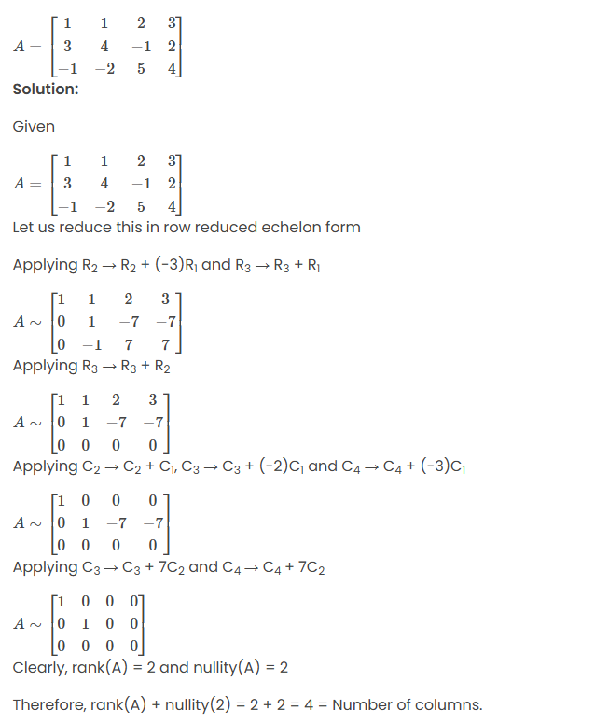

**Ref of questions: https://byjus.com/maths/rank-and-nullity/**