**BOOK INVENTORY SYSTEM**

**Code -**

|  |
| --- |
| #include<iostream>  #include<string.h>  #include<stdlib.h>  using namespace std;  class book {  private:  char *author,*title,*publisher;  float *price;  int *stock;  public:  book() {  author= new char[20];  title=new char[20];  publisher=new char[20];  price= new float;  stock=new int;  }  void feeddata();  void editdata();  void showdata();  int search(char[],char[]);  void buybook();    };  void book::feeddata() {  cin.ignore();  cout<<"\nEnter Author Name: "; cin.getline(author,20);  cout<<"Enter Title Name: "; cin.getline(title,20);  cout<<"Enter Publisher Name: "; cin.getline(publisher,20);  cout<<"Enter Price: "; cin>>*price;  cout<<"Enter Stock Position: "; cin>>*stock;    }  void book::editdata() {    cout<<"\nEnter Author Name: "; cin.getline(author,20);  cout<<"Enter Title Name: "; cin.getline(title,20);  cout<<"Enter Publisher Name: "; cin.getline(publisher,20);  cout<<"Enter Price: "; cin>>*price;  cout<<"Enter Stock Position: "; cin>>*stock;  }  void book::showdata()  {  cout<<"\nAuthor Name: "<<author;  cout<<"\nTitle Name: "<<title;  cout<<"\nPublisher Name: "<<publisher;  cout<<"\nPrice: "<<*price;  cout<<"\nStock Position: "<<*stock;  }  int book::search(char tbuy[20],char abuy[20] ) {  if(strcmp(tbuy,title)==0 && strcmp(abuy,author)==0)  return 1;  else return 0;  }  void book::buybook() {  int count;  cout<<"\nEnter Number Of Books to buy: ";  cin>>count;  if(count<=*stock) {  *stock=*stock-count;  cout<<"\nBooks Bought Sucessfully";  cout<<"\nAmount: Rs. "<<(*price)*count;  }  else  cout<<"\nRequired Copies not in Stock";  }  int main() {  book *B[20];  int i=0,r,t,choice;  char titlebuy[20],authorbuy[20];  while(1) {  cout<<"\n\n\t\tMENU"  <<"\n1. Entry of New Book"  <<"\n2. Buy Book"  <<"\n3. Search For Book"  <<"\n4. Edit Details Of Book"  <<"\n5. Exit"  <<"\n\nEnter your Choice: ";  cin>>choice;    switch(choice) {  case 1: B[i] = new book;  B[i]->feeddata();  i++; break;    case 2: cin.ignore();  cout<<"\nEnter Title Of Book: "; cin.getline(titlebuy,20);  cout<<"Enter Author Of Book: "; cin.getline(authorbuy,20);  for(t=0;t<i;t++) {  if(B[t]->search(titlebuy,authorbuy)) {  B[t]->buybook();  break;  }  }  if(t==1)  cout<<"\nThis Book is Not in Stock";    break;  case 3: cin.ignore();  cout<<"\nEnter Title Of Book: "; cin.getline(titlebuy,20);  cout<<"Enter Author Of Book: "; cin.getline(authorbuy,20);    for(t=0;t<i;t++) {  if(B[t]->search(titlebuy,authorbuy)) {  cout<<"\nBook Found Successfully";  B[t]->showdata();  break;  }  }  if(t==i)  cout<<"\nThis Book is Not in Stock";  break;    case 4: cin.ignore();  cout<<"\nEnter Title Of Book: "; cin.getline(titlebuy,20);  cout<<"Enter Author Of Book: "; cin.getline(authorbuy,20);    for(t=0;t<i;t++) {  if(B[t]->search(titlebuy,authorbuy)) {  cout<<"\nBook Found Successfully";  B[t]->editdata();  break;  }  }  if(t==i)  cout<<"\nThis Book is Not in Stock";  break;    case 5: exit(0);  default: cout<<"\nInvalid Choice Entered";  }  }  return 0;  } |

**Output –**

* Menu

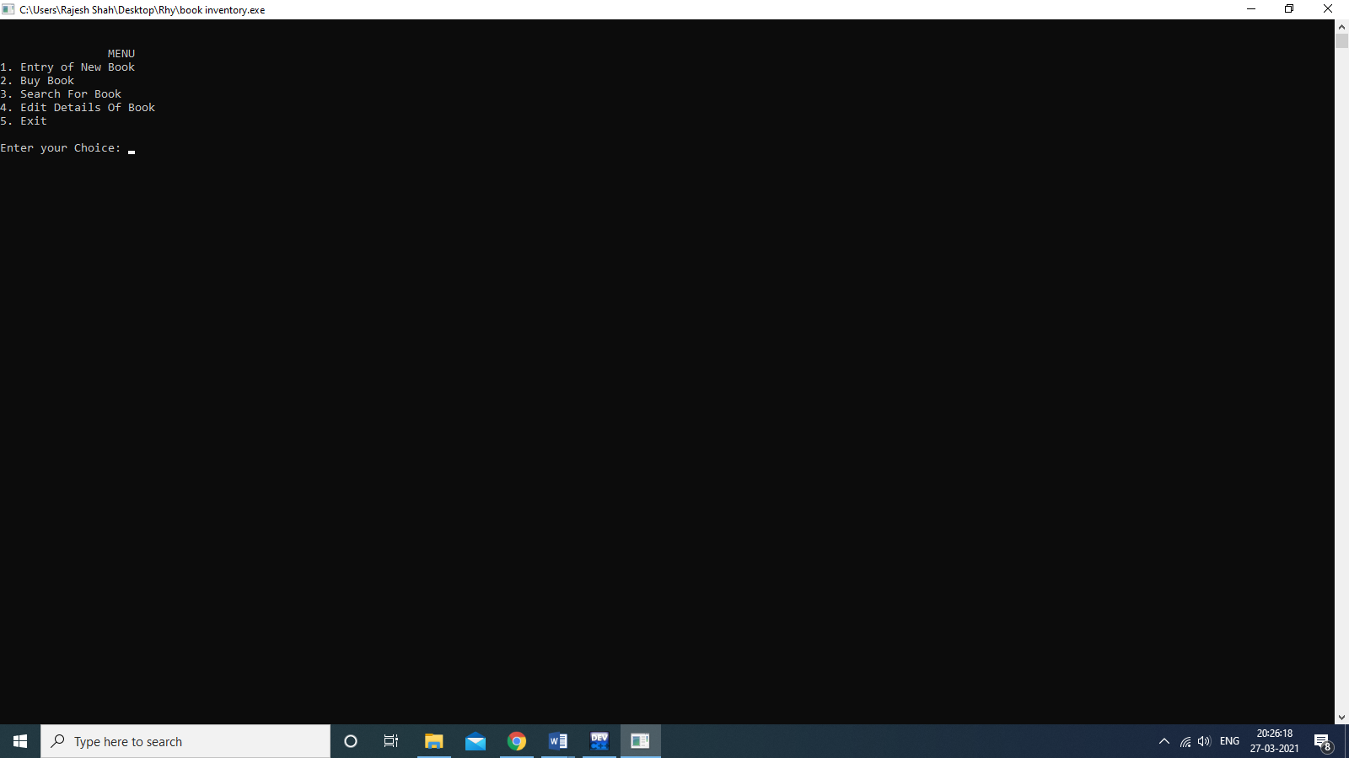

* Entry of New Book

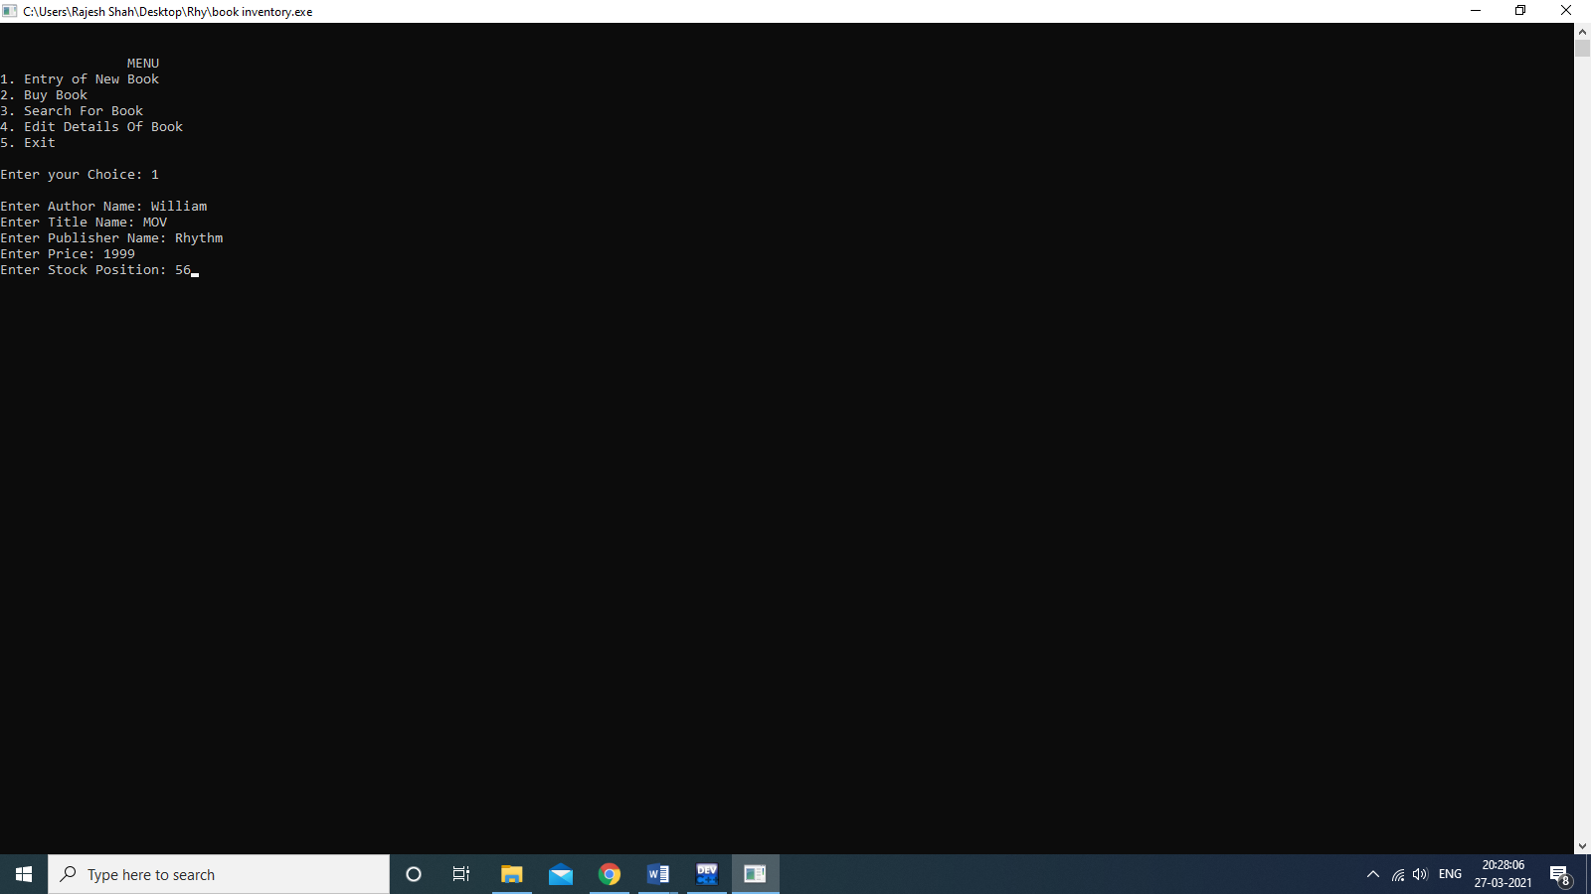

* Buy Book

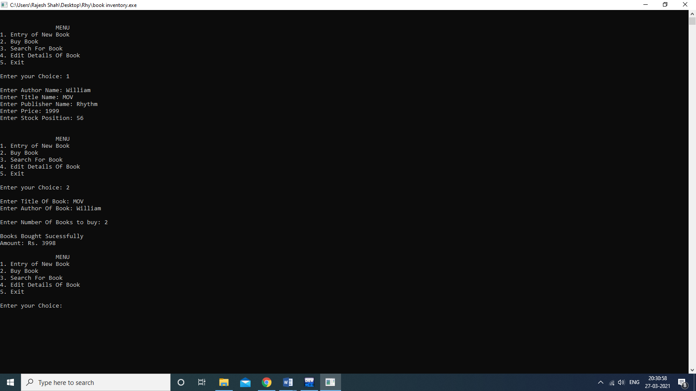

* Search For Book

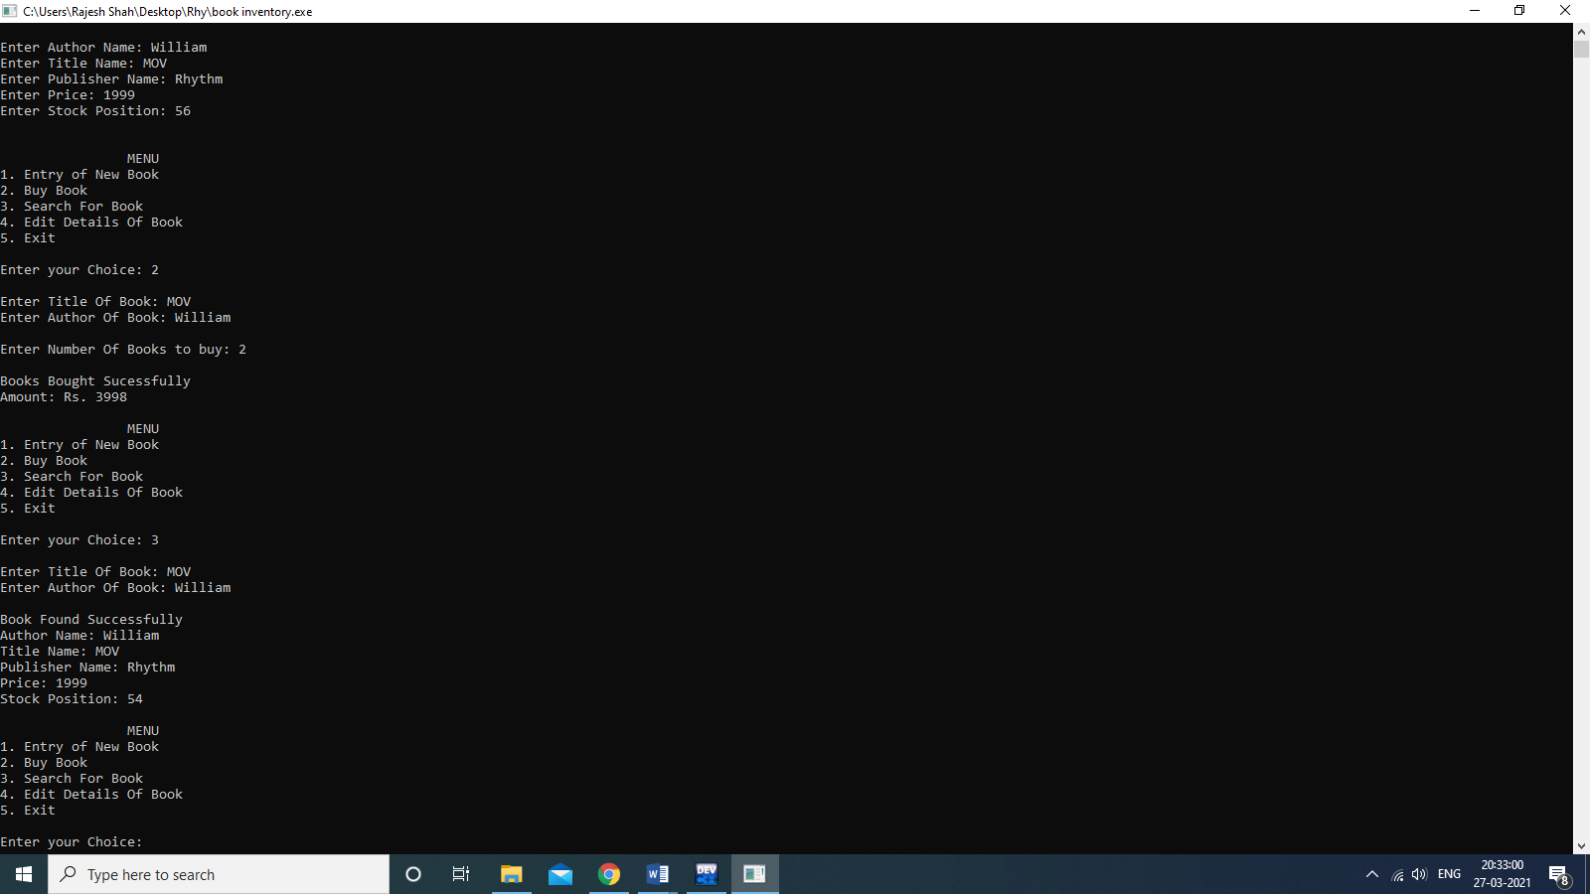

* Edit Details of Book

