Practical 12: Classes and methods in python

1. Design a class that store the information of student and display the same
2. Create a class called Numbers, which has a single class attribute called m, and a constructor which takes the parameters x and y (these should all be numbers).

i. Write a method called add which returns the sum of the attributes x andy.

ii. Write a class method called multiply, which takes a single number parameter a and returns the product of a and m.

iii. Write a static method called subtract, which takes two number parameters, b and c, and returns b -c.

iV. Write a method called value which returns a tuple containing the values of x and y and write a deleter for manipulating the values of x and y.

Code:

|  |
| --- |
| class student:      """Design a class that store the information of student and display the same"""      @classmethod      def __init__(self, name):          self.name = name      @classmethod      def disp(self):          print("The student name is: ", self.name)  class Numbers:      """Class called Numbers, which has a single class attribute called m,          and a constructor which takes the parameters x and y          (these should all be numbers)"""      m = 50      @classmethod      def __init__(self, x, y):          """ Constructor for initializing the x and y members"""          self.x = x          self.y = y      @classmethod      def add(self):          """Write a method called add which returns              the sum of the attributes x and y."""          return self.x+self.y      @classmethod      def multipy(self, num):          """Write a class method called multiply, which takes a single number              parameter a and returns the product of a and m."""          return self.m * num      @staticmethod      def sub(x, y):          """ Write a static method called subtract,              which takes two number parameters, b              and c, and returns b -c. """          return x - y      @classmethod      def value(self):          """Write a method called value which returns a             tuple containing the values of x and y and write a             deleter for manipulating the values of x and y."""          x = (1,2,3,4)          y = (1,3,5,7)          z = x+y          print(z)          del z          print(z)  stud1 = student("OM")  stud1.disp()  num1 = Numbers(10, 20)  print(num1.add())  print(num1.multipy(5))  print(Numbers.sub(10,4))  num1.value() |

Output:

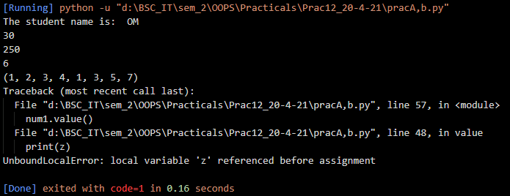

1. Aim: Implement the concept of inheritance using python.

Code:

|  |
| --- |
| # Implement the concept of inheritance using python.  class base1:      def printBase1(self):          print("This is base1 class print statement.")  class base2:      def printBase2(self):          print("This is base2 class print statement.")  class childOne(base1):      def printChildOne(self):          super().printBase1()          print("This is child one class print statement.")  class childTwo(base1, base2):      def printChildTwo(self):          super().printBase1()          super().printBase2()          print("This is child two class print statement.")    C1 = childOne()  C2 = childTwo()  C1.printChildOne()  print()  C2.printChildTwo() |

Output:

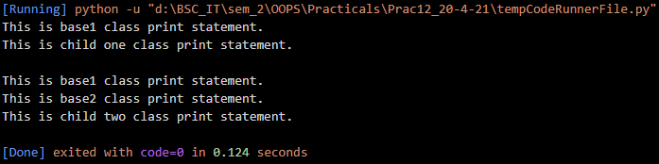

Write-Up:

