NAME:- RHYTHM SHAH UID:- 20BIT053

**O – Board Game**

This game only works on one rule - Last to play loses!

In this project I have used AI Minimax Algorithm. Whenever the human player plays something the only thing AI does is copy the move and mirror it unless it is the last row to solve. If it’s the last row to play then the algorithm will copy Human player’s move-1 piece. Hence, it leaves Human no choice but to play the last move.

The Code for this algorithm is attached below

Screenshots:

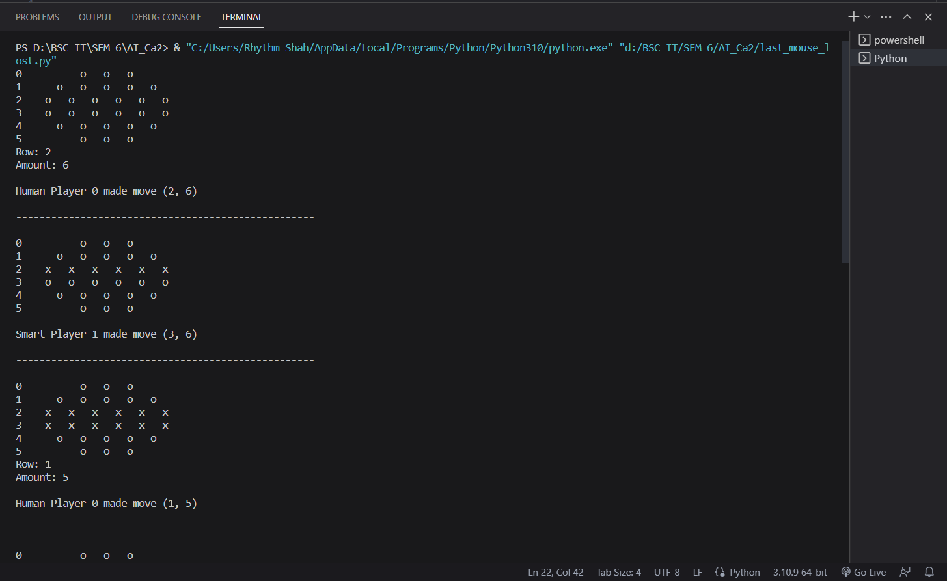

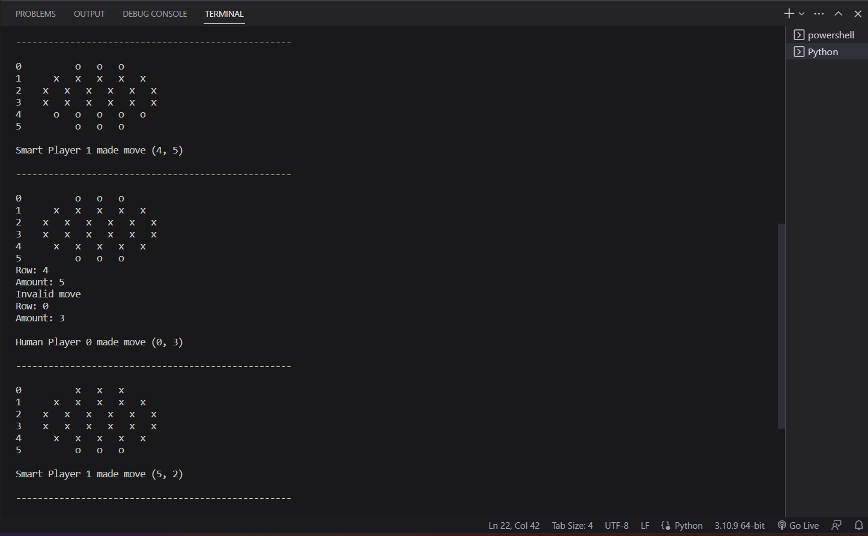

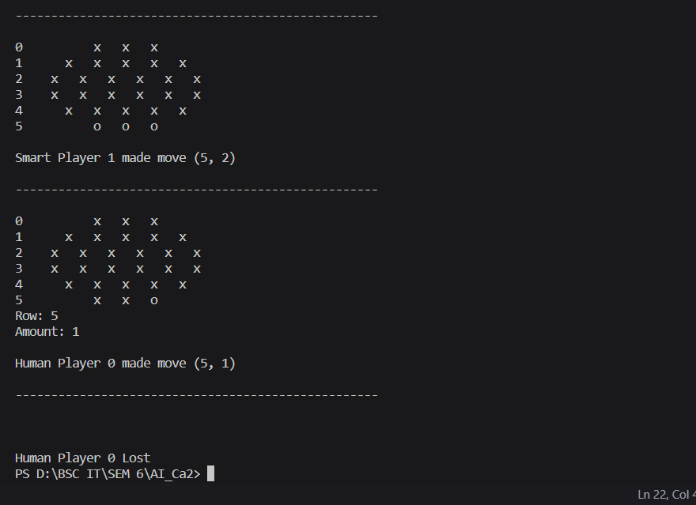

1. Board

|  |
| --- |
| 1. *from* math *import* floor *as* fl 2. class Board: 3. def __init__(*self*): 4. self.b = [['o', 'o', 'o'], ['o', 'o', 'o', 'o', 'o'], ['o', 'o', 'o', 'o', 'o', 'o'], 5. ['o', 'o', 'o', 'o', 'o', 'o'], ['o', 'o', 'o', 'o', 'o'], ['o', 'o', 'o']] 6. def update_b(*self*, *r*, *a*): 7. i = 0 8. *while* i < len(self.b[r]) and a > 0: 9. *if* self.b[r][i] == 'o': 10. self.b[r][i] = 'x' 11. a -= 1 12. i += 1 13. def spot_avail(*self*, *r*): 14. s = 0 15. *for* i *in* range(len(self.b[r])-1, -1, -1): 16. *if* self.b[r][i] == 'x': 17. *break* 18. s += 1 19. *return* s 20. def row_empty(*self*, *r*): 21. *for* i *in* range(len(self.b[r])-1, -1, -1): 22. *if* self.b[r][i] == 'o': 23. *return* False 24. *return* True 25. def draw(*self*): 26. *for* i *in* range(len(self.b)): 27. print(str(i) + ' '*(int(fl((i-2.5)**2)+4)), *end*='') 28. *for* c *in* self.b[i]: 29. print(c, *end*='   ') 30. print() 31. def g_o(*self*): 32. *for* i *in* self.b: 33. *for* c *in* range(len(i)-1, -1, -1): 34. *if* i[c] == 'o': 35. *return* False 36. *else*: 37. *break* 38. *return* True 39. def __len__(*self*): 40. *return* len(self.b) 41. def num_row(*self*): 42. temp_l = [] 43. *for* i *in* range(len(self.b)): 44. s = 0 45. *for* c *in* range(len(self.b[i])-1, -1, -1): 46. *if* self.b[i][c] == 'o': 47. s += 1 48. *else*: 49. *break* 50. temp_l.append(s) 51. *return* temp_l 52. def diff(*self*, *r1*, *r2*): 53. r10 = 0 54. r20 = 0 55. *for* i *in* range(0, len(self.b[r1])): 56. *if* self.b[r1][i] == 'o': 57. r10 += 1 58. *if* self.b[r2][i] == 'o': 59. r20 += 1 60. *if* r10 > r20: 61. *return* (r1, r10 - r20) 62. *else*: 63. *return* (r2, r20 - r10) |

2. Player.py

|  |
| --- |
| *from* random *import* randint *as* rand  *import* collections *as* col  class Player:      def __init__(*self*, *board*):          self.board = board      def move(*self*):  *raise* NotImplementedError  class RandomPlayer(Player):      def move(*self*):          r = rand(0, 5)  *while* self.board.row_empty(r):              r = rand(0, 5)  *return* (r, rand(1, self.board.spot_avail(r)) + 1)      def __str__(*self*):  *return* 'Random Player'  class HumanPlayer(Player):      def move(*self*):  *try*:              pr = int(input('Row: '))              pa = int(input('Amount: '))  *except* ValueError:              pr = -1              pa = -1  *while* pr > 5 or self.board.row_empty(pr) or pa <= 0 or pr < 0:              print('Invalid move')  *try*:                  pr = int(input('Row: '))                  pa = int(input('Amount: '))  *except* ValueError:                  pr = -1                  pa = -1  *return* (pr, pa)      def __str__(*self*):  *return* 'Human Player'  class SmartPlayer(Player):      def __init__(*self*, *board*, *pn*):          Player.__init__(self, board)          self.pn = pn      def _rmove(*self*):          r = rand(0, 5)  *while* self.board.row_empty(r):              r = rand(0, 5)  *return* (r, rand(1, self.board.spot_avail(r)))      def move(*self*):          cur_b = col.Counter(self.board.num_row())  *if* cur_b in [{0: 2, 1: 4}, {0: 2, 1: 3, 2: 1}, {0: 2, 1: 3, 3: 1}, {0: 2, 1: 3, 4: 1}, {0: 2, 1: 3, 5: 1}, {0: 2, 1: 3, 6: 1}, {1: 6}, {1: 5, 2: 1}, {1: 5, 3: 1}, {1: 5, 4: 1}, {1: 5, 5: 1}, {1: 5, 6: 1}, {0: 4, 1: 2}, {0: 4, 1: 1, 2: 1}, {0: 4, 1: 1, 3: 1}, {0: 4, 1: 1, 4: 1}, {0: 4, 1: 1, 5: 1}, {0: 4, 1: 1, 6: 1}]:              m = 0              r = 0  *for* i *in* range(len(self.board)):  *if* self.board.spot_avail(i) > m:                      m = self.board.spot_avail(i)                      r = i  *return* (r, m)  *elif* cur_b in [{0: 1, 1: 4, 2: 1}, {0: 1, 1: 4, 3: 1}, {0: 1, 1: 4, 4: 1}, {0: 1, 1: 4, 5: 1}, {0: 1, 1: 4, 6: 1}, {0: 3, 1: 2, 2: 1}, {0: 3, 1: 2, 3: 1}, {0: 3, 1: 2, 4: 1}, {0: 3, 1: 2, 5: 1}, {0: 3, 1: 2, 6: 1}, {0: 5, 2: 1}, {0: 5, 3: 1}, {0: 5, 4: 1}, {0: 5, 5: 1}, {0: 5, 6: 1}]:              m = 0              r = 0  *for* i *in* range(len(self.board)):  *if* self.board.spot_avail(i) > m:                      m = self.board.spot_avail(i)                      r = i  *return* (r, m - 1)  *else*:  *if* self.board.b[0] != self.board.b[5]:  *return* self.board.diff(0, 5)  *if* self.board.b[1] != self.board.b[4]:  *return* self.board.diff(1, 4)  *if* self.board.b[2] != self.board.b[3]:  *return* self.board.diff(2, 3)  *else*:  *return* self._rmove()      def __str__(*self*):  *return* 'Smart Player' |

3. AI-SmartPlayer.py

|  |
| --- |
| *from* sys *import* maxsize  class Node:      def __init__(*self*, *depth*, *pnum*, *board*, *move*=(0, 0), *val*=0):          self.depth = depth          self.pnum = pnum          self.board = board          self.val = val          self.move = move          self.children = []          self.create_children()      def create_children(*self*):  *if* self.depth < 0 or self.val != 0:  *return*  *# This is much messier than before but cuts down tree size because of the symmetry of the board*  *if* self.board.b[0] == self.board.b[5]:  *if* self.board.b[1] == self.board.b[4]:  *if* self.board.b[2] == self.board.b[3]:  *for* r *in* range(3):  *if* not self.board.row_empty(r):  *for* a *in* range(self.board.spot_avail(r)):                                  tempb = self.board.dupe()                                  tempb.update_b(r, a+1)                                  self.children.append(Node(self.depth - 1, -1*self.pnum, tempb, (r, a+1), self.real_val(self.board)))  *else*:  *for* r *in* range(4):  *if* not self.board.row_empty(r):  *for* a *in* range(self.board.spot_avail(r)):                                  tempb = self.board.dupe()                                  tempb.update_b(r, a+1)                                  self.children.append(Node(self.depth - 1, -1*self.pnum, tempb, (r, a+1), self.real_val(self.board)))  *else*:  *if* self.board.b[2] == self.board.b[3]:  *for* r *in* [0, 1, 2, 4]:  *if* not self.board.row_empty(r):  *for* a *in* range(self.board.spot_avail(r)):                                  tempb = self.board.dupe()                                  tempb.update_b(r, a+1)                                  self.children.append(Node(self.depth - 1, -1*self.pnum, tempb, (r, a+1), self.real_val(self.board)))  *else*:  *for* r *in* [0, 1, 2, 3, 4]:  *if* not self.board.row_empty(r):  *for* a *in* range(self.board.spot_avail(r)):                                  tempb = self.board.dupe()                                  tempb.update_b(r, a+1)                                  self.children.append(Node(self.depth - 1, -1*self.pnum, tempb, (r, a+1), self.real_val(self.board)))  *else*:  *if* self.board.b[1] == self.board.b[4]:  *if* self.board.b[2] == self.board.b[3]:  *for* r *in* [0, 1, 2, 5]:  *if* not self.board.row_empty(r):  *for* a *in* range(self.board.spot_avail(r)):                                  tempb = self.board.dupe()                                  tempb.update_b(r, a+1)                                  self.children.append(Node(self.depth - 1, -1*self.pnum, tempb, (r, a+1), self.real_val(self.board)))  *else*:  *for* r *in* [0, 1, 2, 3, 5]:  *if* not self.board.row_empty(r):  *for* a *in* range(self.board.spot_avail(r)):                                  tempb = self.board.dupe()                                  tempb.update_b(r, a+1)                                  self.children.append(Node(self.depth - 1, -1*self.pnum, tempb, (r, a+1), self.real_val(self.board)))  *else*:  *if* self.board.b[2] == self.board.b[3]:  *for* r *in* [0, 1, 2, 4, 5]:  *if* not self.board.row_empty(r):  *for* a *in* range(self.board.spot_avail(r)):                                  tempb = self.board.dupe()                                  tempb.update_b(r, a+1)                                  self.children.append(Node(self.depth - 1, -1*self.pnum, tempb, (r, a+1), self.real_val(self.board)))  *else*:  *for* r *in* range(6):  *if* not self.board.row_empty(r):  *for* a *in* range(self.board.spot_avail(r)):                                  tempb = self.board.dupe()                                  tempb.update_b(r, a+1)                                  self.children.append(Node(self.depth - 1, -1*self.pnum, tempb, (r, a+1), self.real_val(self.board)))  *# if self.depth >= 0 and self.val == 0:*  *#   for r in range(6):*  *#       if not self.board.row_empty(r):*  *#           for a in range(self.board.spot_avail(r)):*  *#               tempb = self.board.dupe()*  *#               tempb.update_b(r, a+1)*  *#               self.children.append(Node(self.depth - 1, -1*self.pnum, tempb, (r, a+1), self.RealVal(self.board)))*      def real_val(*self*, *b*):  *if* b.g_o():  *return* maxsize * -1 * self.pnum  *elif* b.one_left() or b.win_board():  *return* maxsize * self.pnum  *return* 0  def min_max(*node*, *depth*, *pnum*):  *if* (depth == 0) or (abs(node.val) == maxsize):  *return* node.val      best_val = maxsize * -pnum  *for* child *in* node.children:          val = min_max(child, depth - 1, -1 * pnum)  *if* abs(maxsize * pnum - val) < abs(maxsize * pnum - best_val):              best_val = val  *# if bestV == maxsize*pnum:*  *#   break*  *return* best_val  def good_depth(*b*):      l = b.num_row()      s = 0  *for* i *in* l:          s += i  *if* s > 20:  *return* 0      r = 0  *for* i *in* l:  *if* i > 0:              r += 1  *if* r > 4 and s > 15:  *return* 2  *if* r > 3 and s > 10:  *return* 4  *if* r > 3:  *return* 6  *return* 8 |

4. Game.py

|  |
| --- |
| *from* board *import* Board  *from* player *import* HumanPlayer, RandomPlayer, SmartPlayer  class Game:      def __init__(*self*):          self.b = Board()      def make_move(*self*, *r*, *a*):          self.b.update_b(r, a)      def draw_board(*self*):          self.b.draw()      def game_over(*self*):  *return* self.b.g_o()      def run_game(*self*, *num_h*, *num_r*, *num_s*):          t = 0          l = []  *for* i *in* range(num_h):              l.append(HumanPlayer(self.b))              t += 2  *for* i *in* range(num_r):              l.append(RandomPlayer(self.b))              t += 2  *for* i *in* range(num_s):              l.append(SmartPlayer(self.b, -1 + t))              t += 2  *while* not self.game_over():  *for* playr *in* l:                  self.draw_board()                  plm = playr.move()                  self.make_move(plm[0], plm[1])                  print('\n' + str(playr) + ' ' + str(l.index(playr)) + ' made move (' + str(plm[0]) + ', ' + str(plm[1]) + ')\n\n---------------------------------------------------\n')  *if* self.game_over():                      print('\n\n' + str(playr) + ' ' + str(l.index(playr)) + ' Lost')  *return* l.index(playr)  *if* __name__ == '__main__':      g = Game()      g.run_game(1, 0, 1) |