Lab-1

Theme: Connect Customers with Service Professionals

Project Abstract:
Work Buddy is a centralized web-based marketplace designed to streamline the connection between urban households and skilled local professionals. By replacing manual, unverified service logs with an automated booking and scheduling system, the platform provides a transparent environment for service discovery and professional management. The system utilizes a role-based interface to allow customers to book services based on availability while enabling professionals to manage their job workflows effectively.

Questionnaire: (Asked to Client)
- What are the maximum number of users that can login at a time?
- What are the services you need to include?
- Do you want any specific type of login interface (in terms of admin, customer and service professionals)?
- Do you want to add AI Assistance for customer help?
- Do you want a mobile application or a desktop website?
- Do you want to add 2 step verification system through otp to registered mobile number while log in?
- Which mode of payment you want to add (UPI, Net banking, Credit/Debit card…)?
- Do you want to add location of service professionals nearby?
- Do you want to add any subscription mode?
- Do you want to add rating option for service professional?
- Do you want to add an option for any recovery mobile number or email?

Task Board Screenshot Simulation:
- Backlog: Database design
- In Progress: Gathering Requirements
- Testing: None
- Done: Project Abstract

Lab-2: Requirement Analysis

1. Functional Requirements:
- The system shall allow Customers and Service Professionals to register/login using Phone Number with OTP verification.
- The system shall provide a "Switch to Professional" toggle for verified users to manage their services.
- The system shall maintain three distinct access levels: Customer, Service Professional, and System Admin.
- The system shall allow Service Professionals to upload identity proof and certifications for admin verification.
- The system shall allow Customers to save and name multiple service locations (Home, Office, Parents) using GPS.
- The system shall support secure Biometric Authentication (Face/Fingerprint) for returning users on mobile.
- The system shall allow Service Professionals to define their "Work Zone" by setting a maximum travel radius.
- The system shall allow Service Professionals to set and update their daily availability or working hours.
- The system shall allow users to manage their personal profile (Name, Email, Profile Picture, and Contact details).
- The system shall distinguish services into categories (e.g., Home Repairs, Personal Care, Appliance Service).
- The system shall allow the Admin to dynamically add, edit, or deactivate service categories.
- The system shall provide a search bar with auto suggestions for service types and their specific keywords.
- The system shall display "Recommended Services" based on the user's past booking history.
- The system shall display "Trending Services" based on current regional demand or seasonal trends.
- The system shall provide detailed service pages showing complete breakdown of base pricing.
- The system shall allow users to filter Service Professionals based on rating, experience, or price.
- The system shall allow Customers to view the profile and previous customer reviews of a Service Professional.
- The system shall allow Customers to select specific date and time slots for service.
- The system shall automatically block time slots on a Service Professional’s calendar once a booking is confirmed.
- The system shall support "Urgent Booking" for urgent repairs.
- The system shall allow Customers to schedule recurring services (e.g., "Weekly House Cleaning").
- The system shall enable Customers to add voice notes or photos to a booking to explain the issue better.
- The system shall allow Service Professionals to "Accept" or "Decline" a service request.
- The system shall provide a "Reschedule" option for Customers up to 2 hours before the service time.
- The system shall automatically reassign a request to another Service Professional if the first one declines.
- The system shall send real-time push notifications for booking confirmations and professional arrival.
- The system shall support in app messaging/calling between the Customer and the assigned Service Professional.
- The system shall provide live GPS tracking of the Service Professional.
- The system shall require the Service Professional to be within a 100m distance to "Start" the job.
- The system shall implement an OTP based Start mechanism, where the customer provides a code to begin work.
- The system shall allow the Service Professional to add "Material Costs" to the bill, subject to Customer approval.
- The system shall enable in-app messaging between the Customer and the assigned Service Professional.
- The system shall allow to classify an undergoing service as (initiated, in progress, completed).
- The system shall enable the Service Professional to upload "Job Completion" photos before closing the task.
- The system shall support multiple payment gateways including UPI, Credit/Debit cards, and Net Banking.
- The system shall provide a "Pay After Service" option.
- The system shall hold digital payments in an Apps Account until the service is verified as finished.
- The system shall automatically calculate and deduct a platform convenience fee from the total bill.
- The system shall generate an automated E Invoice (PDF) and send it to the Customer via email/WhatsApp.
- The system shall provide a lifetime Earnings Dashboard for Service Professionals to track daily income.
- The system shall allow Customers to provide a 1-5 star rating and detailed feedback for the service.
- The system shall allow Service Professionals to rate Customers also.
- The system shall allow the admin to suspend Service Professionals whose average rating falls below a threshold.
- The system shall provide a Support system for handling disputes, cancellations, and refund requests.
- The system shall provide a "Wallet" feature for users to manage refunds and promotional credits.
- The system shall automatically apply valid promotional coupons at the checkout screen.
- The system shall allow Customers to add a "Tip" for the Service Professional after the job is completed.
- The system shall provide a detailed transaction history for all payments made by the Customer.
- The system shall allow users to "Report" a review for being fraudulent or inaccurate.
- The system shall allow the Admin to set global or regional pricing for service categories.
- The system shall allow the Admin to manage "Refer and Earn" program parameters.
- The system shall allow Service Professionals to view their upcoming schedule in a calendar view.
- The system shall send automated reminders 30 minutes before the scheduled service time.
- The system shall allow the Admin to set "Surge Pricing" during periods of extremely high demand.
- The system shall verify the professional's insurance status during the registration phase.
- The system shall automatically suggest "Add-on" services during the checkout process based on the selected service.
- The system shall allow users to change the app language to at least 3 regional languages.
- The system shall provide a "Dark Mode" interface toggle for the mobile application.

2. Non-functional Requirements:

- Performance:
- Response Time: The system shall load the homepage and service listings in under 2 seconds.
- Latency: Results for service searches shall appear within 500ms of the query.
- Concurrency: The system shall support up to 1,000 simultaneous booking requests without crashing.

- Security:
- The system shall ensure that personal phone numbers are never visible during in app calls.
- Passwords must be stored using SHA-256 encryption.
- The system shall strictly restrict Admin only features from Customer/Professional accounts.

- Availability:
- The system shall maintain an availability of 99.9%
- If the payment gateway fails, the system should allow users to complete bookings via Cash.
- In case of a server crash, the system shall recover and be operational within 30 minutes.

- Scalability:
- The database shall be designed to store up to 1 million user records without performance loss.

- Usability:
- The UI must adapt to screen sizes from 4-inch phones to 24-inch monitors.
- The app shall allow users find a service in 2 clicks or less.
- Cross-Platform: The web interface shall support all modern browsers (Chrome, Safari, Firefox, Edge).

3. Product backlog:

- As a User, I want to register and login via Mobile OTP, so that I can securely access my account without needing to remember a password.
- ⁠As a Customer, I want to search and filter professionals by rating and category, so that I can find a highly rated expert who fits my specific budget.
- ⁠As a Customer, I want to pick a specific date and time slot, so that I can ensure the service happens only when I am available at the location.
- ⁠As a Service Professional, I want to Accept or Decline job requests in real time, so that I can maintain control over my daily work schedule.
- ⁠As a Service Professional, I want to view my Earnings Dashboard and Ratings, so that I can track my financial growth and improve my service quality based on feedback.
- ⁠As a Customer, I want to receive a pdf invoice of the service, so that I can keep a documented record of my transactions.
- ⁠As a Service Professional, I want to set my work radius, so that I only get requests from nearby areas.

Lab-3: Class Design
1. List of Classes
- User
- Admin
- Customer
- ServiceProfessional
- PreferenceManager
- AuthService
- APIHandler
- AuditLogger
- KYCManager
- PolicyManager
- RegionalManager
- CategoryManager
- ServiceCatalog
- SearchEngine
- RecommendationEngine
- ReferralSystem
- CustomerHistory
- BookingManager
- BookingScheduler
- ServiceAreaValidator
- DynamicPricing
- RequestHandler
- ReassignEngine
- StatusManager
- LiveTracker
- NoteHandler
- OTPAuthenticator
- PrivacyVault
- NotificationDispatcher
- ChatSystem
- TaxCalculator
- MaterialCostManager
- WalletSystem
- PaymentProcessor
- InvoiceGenerator
- EarningsDashboard
- FeedbackEngine
- ServiceHistory
- DisputeArbitrator
- SuspensionManager
- SupportTicketSystem
- PromotionManager

2. Class Responsibilities (CRC Approach)
1. Class User (Abstract)
- Attributes: userId, name, email, phoneNumber, passwordHash, role, preferredLanguage
- Methods: login(), logout(), updateProfile(), switchRole(), raiseSupportTicket()
2. Class Admin
- Attributes: adminId, permissionLevel
- Methods: manageCategories(), suspendUser(), viewAuditLogs(), reviewKYC()
3. Class Customer
- Attributes: customerId, referralCode, savedAddresses
- Methods: bookService(), rateService(), viewHistory(), initiateChat()
4. Class ServiceProfessional
- Attributes: proId, specialization, workRadius, availabilityStatus, rating
- Methods: acceptBooking(), declineBooking(), updateAvailability(), viewEarnings()
5. Class PreferenceManager
- Attributes: prefId, isDarkMode, notificationSettings
- Methods: toggleTheme(), updatePreferences()
6. Class AuthService
- Attributes: authId, tokenValidity, biometricData
- Methods: authenticateUser(), generateToken(), validateBiometrics()
7. Class APIHandler
- Attributes: endpointUrl, timeoutDuration, connectionStatus
- Methods: sendRequest(), syncData(), handleResponse()
8. Class AuditLogger
- Attributes: logId, actionType, timestamp
- Methods: logAction(), exportLogs(), filterLogs()
9. Class KYCManager
- Attributes: documentId, documentType, verificationStatus
- Methods: uploadDocument(), verifyDocument(), rejectDocument()
10. Class PolicyManager
- Attributes: policyId, regionCode, termsText
- Methods: getTerms(), updatePolicy(), validateCompliance()
11. Class RegionalManager
- Attributes: regionId, currencyCode, taxRate, languageCode
- Methods: setRegion(), updateTaxRules(), switchLanguage()
12. Class CategoryManager
- Attributes: categoryId, categoryName, serviceType
- Methods: addCategory(), updateCategory(), deactivateCategory()
13. Class ServiceCatalog
- Attributes: catalogId, basePrices, linkedAddOns
- Methods: listServices(), getServiceDetails(), updateBasePrice()
14. Class SearchEngine
- Attributes: searchId, keywords, filters
- Methods: searchServices(), filterByPrice(), filterByRating()
15. Class RecommendationEngine
- Attributes: algorithmVersion, userPreferenceData
- Methods: analyzeHistory(), getRecommendations()
16. Class ReferralSystem
- Attributes: referralCode, rewardAmount
- Methods: generateCode(), validateReferral(), creditReward()
17. Class CustomerHistory
- Attributes: historyId, pastBookingsList
- Methods: addToHistory(), viewHistory(), repeatBooking()
18. Class BookingManager
- Attributes: bookingId, status, recurrenceType, rescheduleLimit
- Methods: createBooking(), cancelBooking(), rescheduleBooking(), updateBookingStatus()
19. Class BookingScheduler
- Attributes: scheduleId, timeSlots, calendarDate
- Methods: checkAvailability(), blockSlot(), scheduleRecurringSlots()
20. ServiceAreaValidator
- Attributes: allowedRadius, gpsCoordinates
- Methods: validateLocation(), checkServiceability()
21. UrgentDispatcher
- Attributes: dispatchId, urgencyLevel
- Methods: findNearestPro(), broadcastRequest()
22. DynamicPricing
- Attributes: surgeFactor, demandLevel
- Methods: calculateSurge(), getFinalPrice()
23. RequestHandler
- Attributes: requestId, timeoutDuration
- Methods: displayRequest(), handleAccept(), handleDecline()
24. ReassignEngine
- Attributes: attemptCount, rejectionReason
- Methods: findNextPro(), escalateRequest()
25. StatusManager
- Attributes: currentStatus, completionRules
- Methods: updateStatus(), validateTransition()
26. LiveTracker
- Attributes: trackerId, currentLat, currentLong
- Methods: updateLocation(), shareLocation(), calculateETA()
27. NoteHandler
- Attributes: noteId, mediaAttachments
- Methods: addNote(), uploadPhoto(), getNotes()
28. OTPAuthenticator
- Attributes: otpCode, expirationTime
- Methods: generateStartCode(), verifyCode(), resendCode()
29. PrivacyVault
- Attributes: virtualNumber, sessionKey
- Methods: maskNumber(), connectCall(), terminateSession()
30. NotificationDispatcher
- Attributes: templateId, recipientList
- Methods: sendPushNotification(), sendSMS(), scheduleNotification()
31. TaxCalculator
- Attributes: taxPercentage, totalTaxAmount
- Methods: calculateTax(), generateTaxBreakdown()
32. MaterialCostManager
- Attributes: materialId, costAmount, approvalStatus
- Methods: addMaterialCost(), requestApproval()
33. PromotionManager
- Attributes: promoCode, discountType, expiryDate
- Methods: validateCoupon(), applyDiscount(), deactivateCoupon()
34. WalletSystem
- Attributes: walletId, balance, currency
- Methods: addMoney(), deductMoney(), viewTransactionHistory()
35. PaymentProcessor
- Attributes: transactionId, paymentMethod, gatewayStatus
- Methods: chargeCustomer(), refundAmount(), processAutoPay()
36. InvoiceGenerator
- Attributes: invoiceNo, invoiceDate, totalAmount
- Methods: generatePDF(), emailInvoice()
37. EarningsDashboard
- Attributes: totalEarnings, pendingPayout
- Methods: calculateDailyIncome(), generateStatement(), viewTrends()
38. FeedbackEngine
- Attributes: rating, comment, flagCount
- Methods: submitReview(), analyzeSentiment(), flagReview()
39. ServiceHistory
- Attributes: recordId, technicalLogs
- Methods: archiveBooking(), retrieveLog()
40. DisputeArbitrator
- Attributes: disputeId, resolutionStatus
- Methods: openDispute(), resolveDispute(), issueRefundOrder()
41. SuspensionManager
- Attributes: suspendId, ratingThreshold
- Methods: checkSuspension(), banUser(), revokeBan()
42. ChatSystem
- Attributes: chatId, messageContent
- Methods: sendMessage(), getChatHistory(), archiveChat()
43. SupportTicketSystem
- Attributes: ticketId, priorityLevel
- Methods: createTicket(), assignToAgent(), closeTicket()
3. Class Diagram Output
Inheritance
- User is inherited by Admin, Customer, and ServiceProfessional.
Composition (Strong Ownership)
- User is composed of PreferenceManager.
- Customer is composed of CustomerHistory.
- ServiceProfessional is composed of EarningsDashboard.
- BookingManager is composed of StatusManager, LiveTracker, NoteHandler, OTPAuthenticator.
- CategoryManager is composed of ServiceCatalog.
- AuditLogger is composed of User (logs actions of).
Association
- User is associated with AuthService, SupportTicketSystem.
- Admin is associated with AuditLogger, KYCManager, CategoryManager, PromotionManager.
- Customer is associated with SearchEngine, RecommendationEngine, ReferralSystem, BookingManager, ChatSystem.
- ServiceProfessional is associated with KYCManager, BookingManager, ChatSystem.
- PolicyManager is associated with RegionalManager.
- RegionalManager is associated with User.
- SearchEngine is associated with ServiceCatalog.
- RecommendationEngine is associated with CustomerHistory.
- BookingManager is associated with BookingScheduler, RequestHandler, PrivacyVault, NotificationDispatcher, TaxCalculator, FeedbackEngine, ServiceHistory.
- BookingScheduler is associated with ServiceProfessional.
- RequestHandler is associated with ServiceProfessional.
- ReassignEngine is associated with SearchEngine.
- LiveTracker is associated with Customer.
- OTPAuthenticator is associated with ServiceProfessional.
- PrivacyVault is associated with User.
- NotificationDispatcher is associated with User.
- TaxCalculator is associated with MaterialCostManager.
- MaterialCostManager is associated with PaymentProcessor.
- PaymentProcessor is associated with WalletSystem, InvoiceGenerator.
- InvoiceGenerator is associated with Customer.
- EarningsDashboard is associated with WalletSystem.
- FeedbackEngine is associated with SuspensionManager.
- SuspensionManager is associated with ServiceProfessional (Admin enforces).
- DisputeArbitrator is associated with BookingManager, WalletSystem.
- PromotionManager is associated with BookingManager, DynamicPricing.
- UrgentDispatcher is associated with ServiceProfessional.

Dependency
- User depends on APIHandler.
- BookingManager depends on ServiceAreaValidator, DynamicPricing.
- PolicyManager depends on RegionalManager.

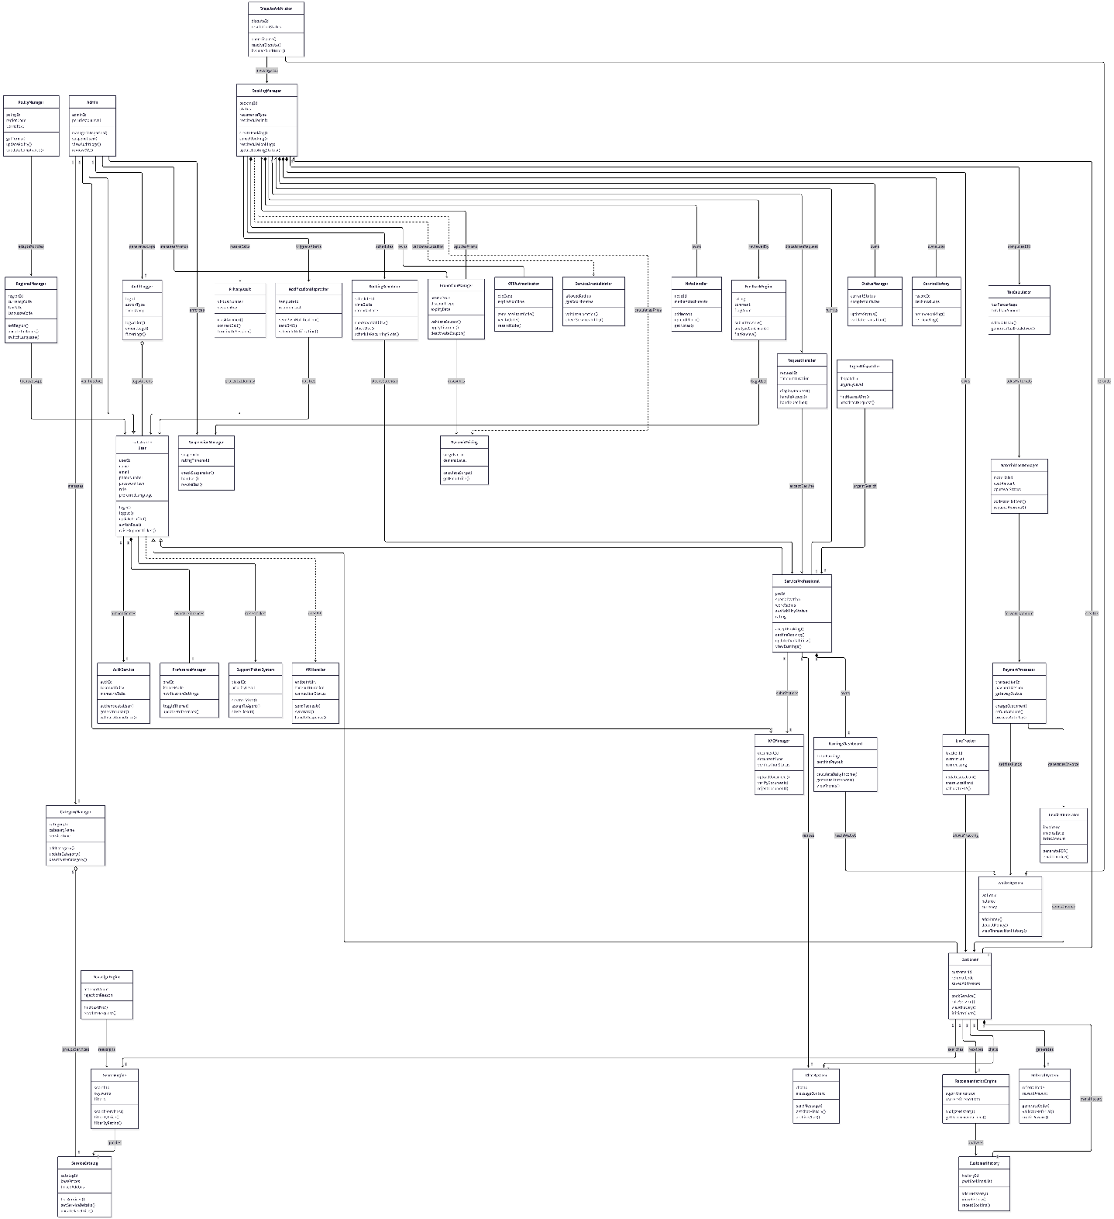
LAB 4 : Interaction Design
- Sequence Diagram

Actor: User
Step 1: User → System: Register / Login
Step 2: System → User: Login Success
Step 3: User → Service Module: Search Services
Step 4: System → User: Display Services
Step 5: User → Booking Module: Select Service & Slot
Step 6: Booking Module → System: Check Availability
Step 7: System → User: Confirm Availability
Step 8: User → Payment Module: Make Payment
Step 9: Payment Module → System: Payment Success
Step 10: System → Booking Module: Create Booking
Step 11: System → Notification Module: Send Confirmation
Step 12: Notification Module → User: Booking Confirmation
Actor: Admin & Professional flow continues similarly aligned with backend operations.

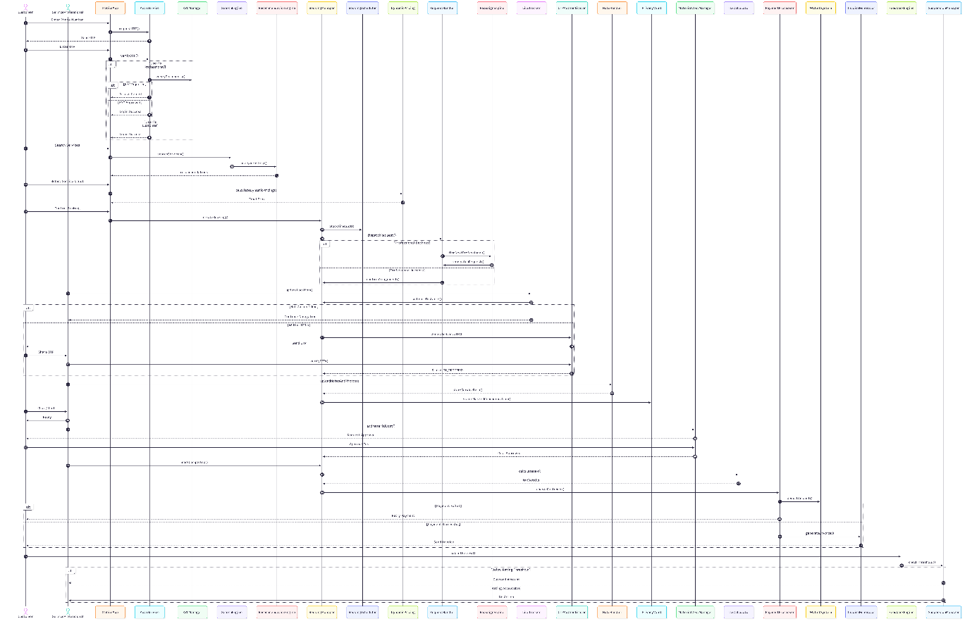

2. Activity Diagram
Start → Register/Login → Validate User
→ Search Services → Select Service
→ Check Availability → Confirm Booking
→ Make Payment → Payment Success?
→ Create Booking → Send Notification → End
Separate flows exist for Admin and Professionals managing system operations.
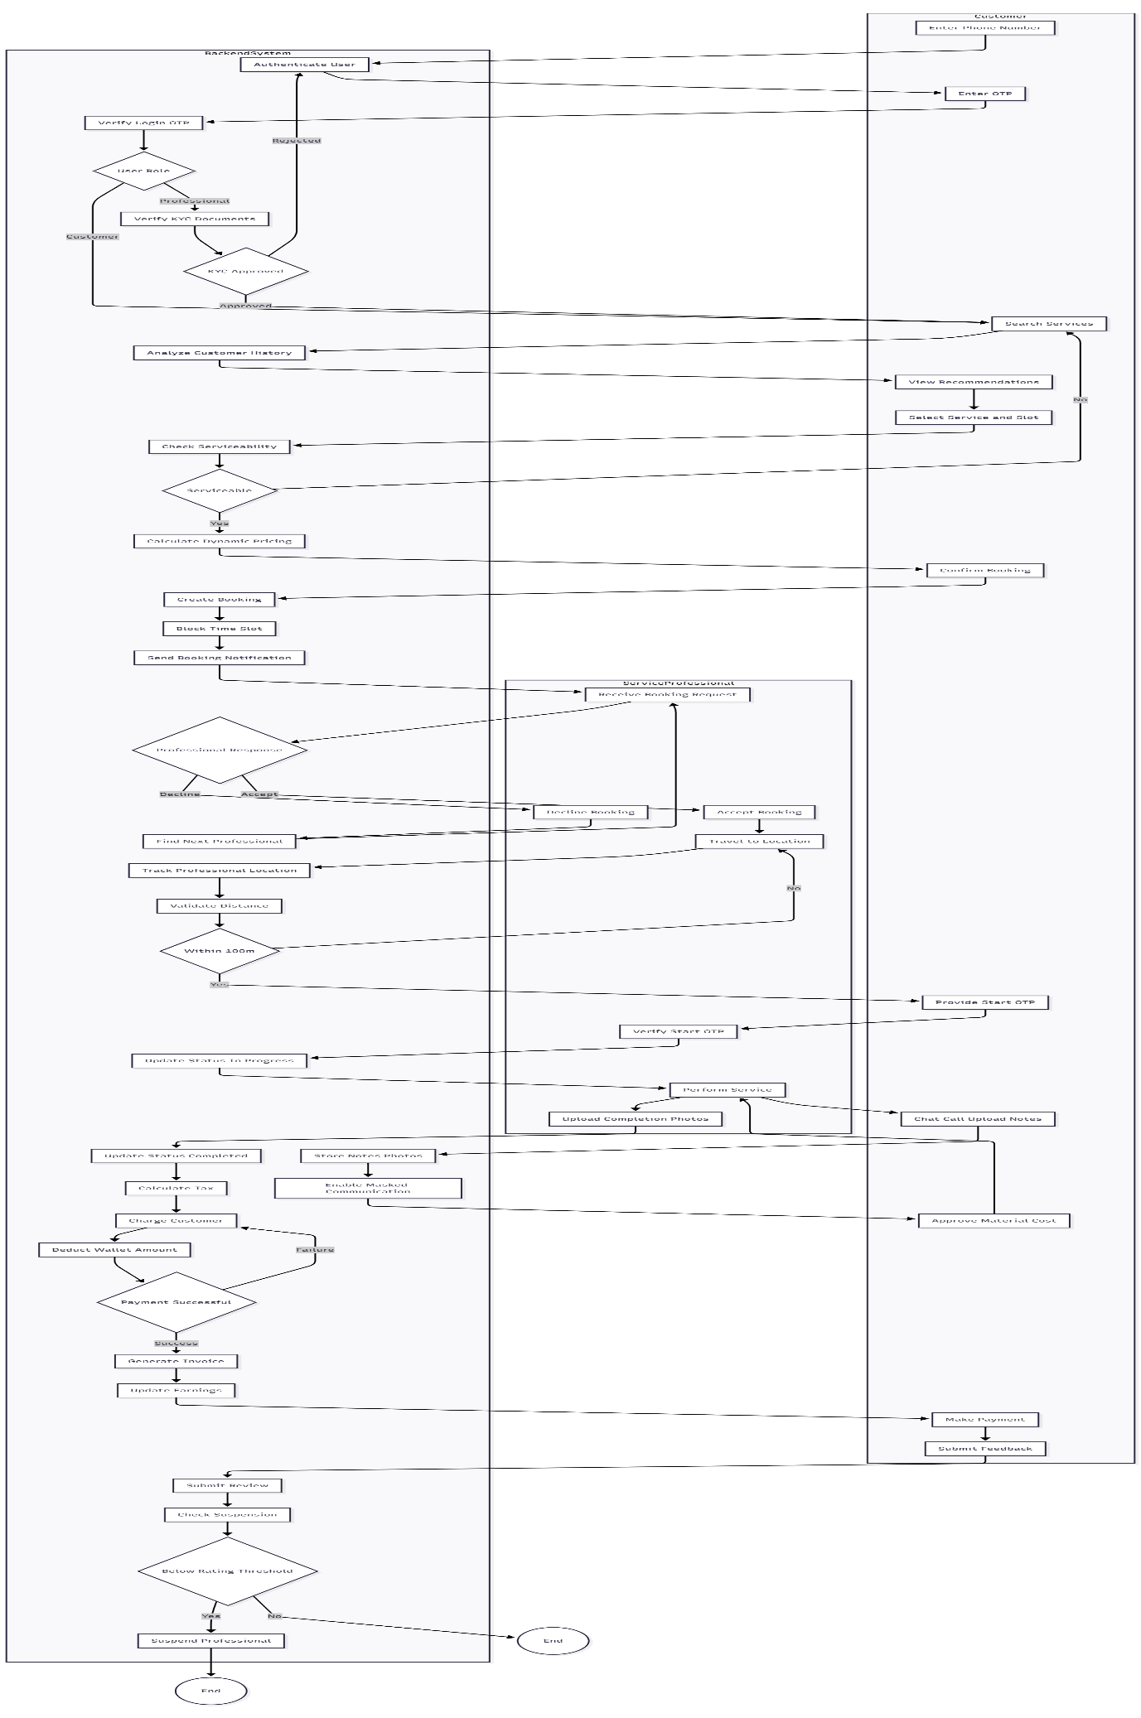
3. Use Case Diagram
Actors: Customer, Professional, Admin
Customer:
- Register, Login
- Search Services
- Book Service
- Make Payment
- View Bookings
- Give Feedback
Professional:
- Accept Booking
- Complete Service
- Update Availability
Admin:
- Manage Users
- Manage Services
- Generate Reports
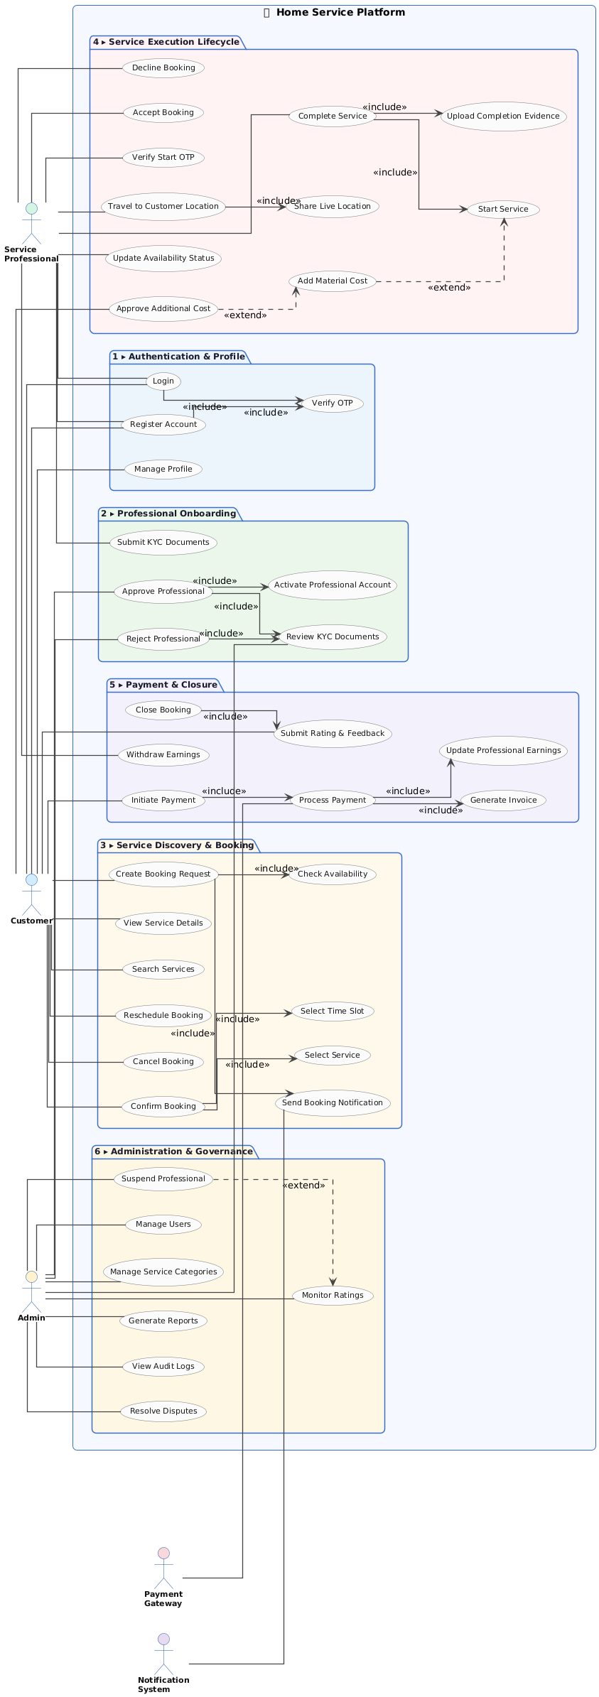

Lab 5: Architecture Design

5.1 Architecture Type
The system follows a layered architecture:
- Model: Handles business logic and database operations
- View: Frontend interface
- Controller: Handles request flow
5.2 Component Diagram
Modules:
- Authentication Module
- Service Management
- Booking System
- Payment Module
- Notification Service
- Admin Module
- Database
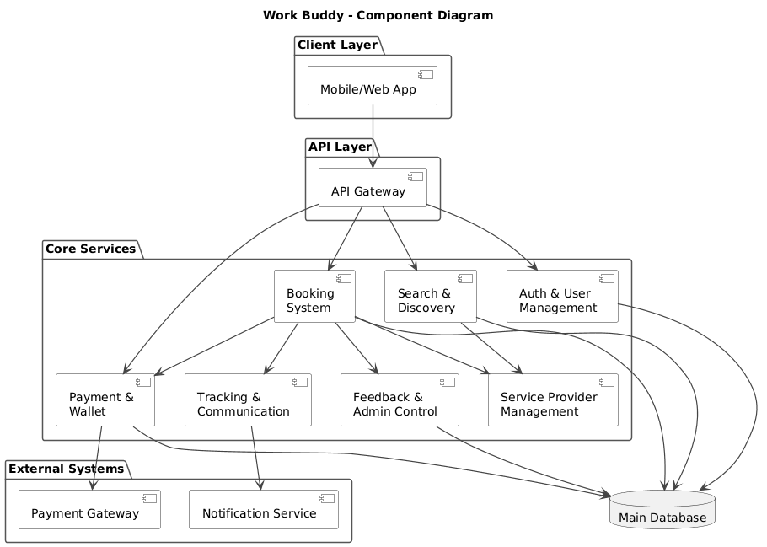

5.3 Deployment Diagram
Client Device → Application Server → Database Server
External Services:
- OTP Service
- Payment Gateway
- Notification System


