RTIS Description

This document describes the NMA Real Time Ionospheric Scintillation monitoring RTIS.

# Space weather and scintillations

The performance of GNSS systems can be severely affected by space weather. The main effects occurs when the signals pass through the enhanced electron densities in the ionosphere. One of the main effects is a delay of the signal. This can to a certain degree be mitigated by dual frequency positioning. During high solar activity, the ionosphere can be highly variable and the irregularities formed generate rapid fluctuations in the amplitude and phase of signals. This is also known as scintillations. The signal is scattered in random directions while propagating through the ionosphere causing it to interfere with itself. Amplitude scintillation may cause deep signal fades that can interfere with a user’s ability to receive GNSS signals. Phase scintillations can lead to increased phase noise, cycle slips, and even loss of lock if the phase fluctuations are too rapid for the receiver to track.



Figure 1: Auroral oval (Credit: NASA)

Equatorial latitudes and high latitude-regions are most severely affected by scintillations. Amplitude scintillations occur most commonly at equatorial latitudes in particular the regions 15 degrees north and south of equator, while phase scintillations are more common at high latitudes. At high latitudes, scintillations are associated with processes in the polar cap and auroral oval. While the low latitude scintillations have clear seasonal and daily variations the high latitude scintillations are more directly dependent on solar storms and the ionospheric activity that follows this.



Figure 2:Frequency of scintillations (P. Kintner, 2009)

The scintillations are often quantified by the scintillation indices S4 and Sigma Phi for amplitude and phase scintillations respectively.

# RTIS receivers

The Real-Time Ionospheric Scintillation Monitor (RTIS) at the NMA is capable of detecting the occurrence of both amplitude and phase scintillation by providing numerical data and maps of the S4 and σφ indexes. Currently, the NMA operates 12 Septentrio PolaRxS scintillation receivers, spread around the Norwegian mainland and the Norwegian islands in the North Sea. The receivers support multi-constellation and multi frequency measurements, so that scintillation indexes are determined for both GPS and GLONASS data. Raw data measurements necessary for determining the scintillation indexes, such as signal phase, Doppler values, signal intensity and signal-to-noise ratio are carried out using a sampling rate of 100Hz.

# Receivers

Currently 11 Septentrio PolaRxS receivers are deployed in Norway, on Iceland and on Faroe Islands. The receivers have a 100 Hz sampling rate.

The stations are listed in the table below. Additionally one receiver is located at Hønefoss for testing purposes.

|  |  |
| --- | --- |
| Site | Receiver ID |
| Tromsø | TRO2 |
| Vega | VEG2 |
| Ny-Ålesund | NYA2 |
| Kautokeino | KAU2 |
| Honningsvåg | HON2 |
| Höfn (Iceland) | HOF2 |
| Faroe Islands | FAR2 |
| Bjørnøya | BJO2 |
| Hopen | HOP2 |
| Jan Mayen | JAN2 |
| Bodø | BOD2 |

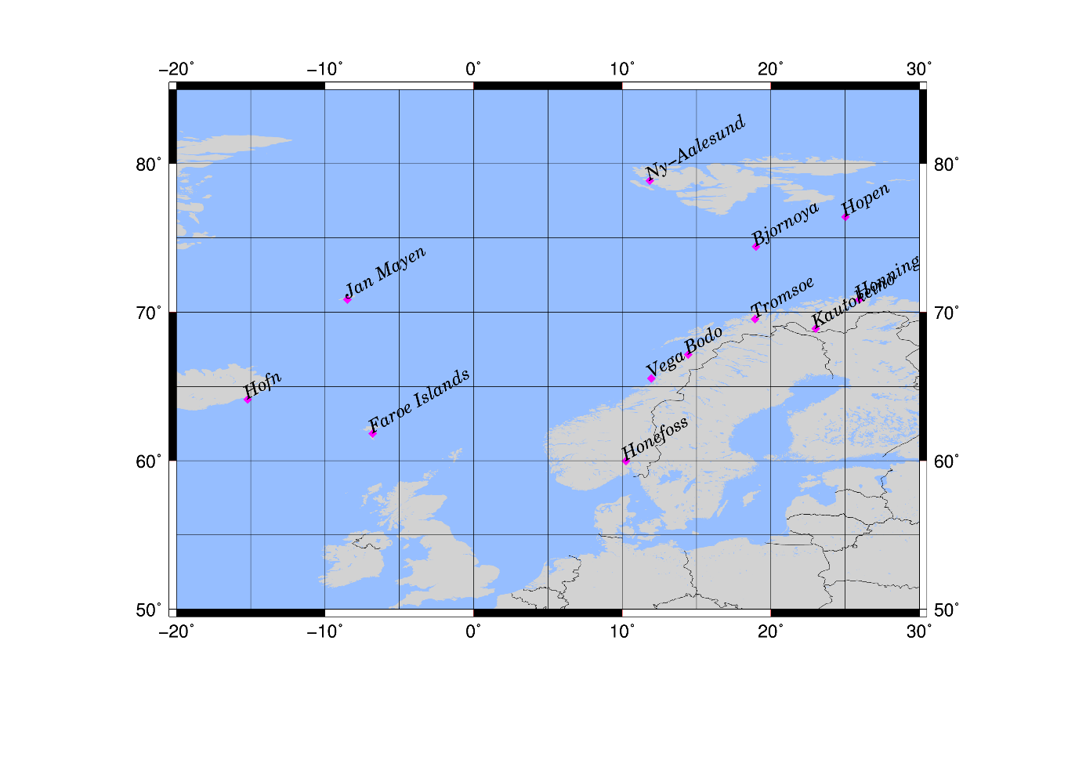

Figure 3: NMA scintillation receivers

## Operational Environment

The software is running on a Lenovo PC with a Linux Lubuntu 32bit environment. In addition, an external USB hard drive (of at least 2TB) is connected to the PC. The external hard drive is used for the raw data transport to NMA.



# RTIS Software

The RTIS software stores the raw data from the receiver and calculates the scintillation indices S4 and Sigma Phi in real time.

The software tool performs the following main tasks:

* Run a real-time streaming of SBF messages.
* Calculate the scintillation indices S4 and σφ indices in one minute resolution.
* Produce a Satref message with 1Hz observation data and send to Hønefoss
* Produce raw data files containing the parts of the SBF messages necessary for the determination of scintillation parameters.
* Produce output files containing the scintillation indices.
* Produce a Send Satref message containing the scintillation indices and send it to RTIM.

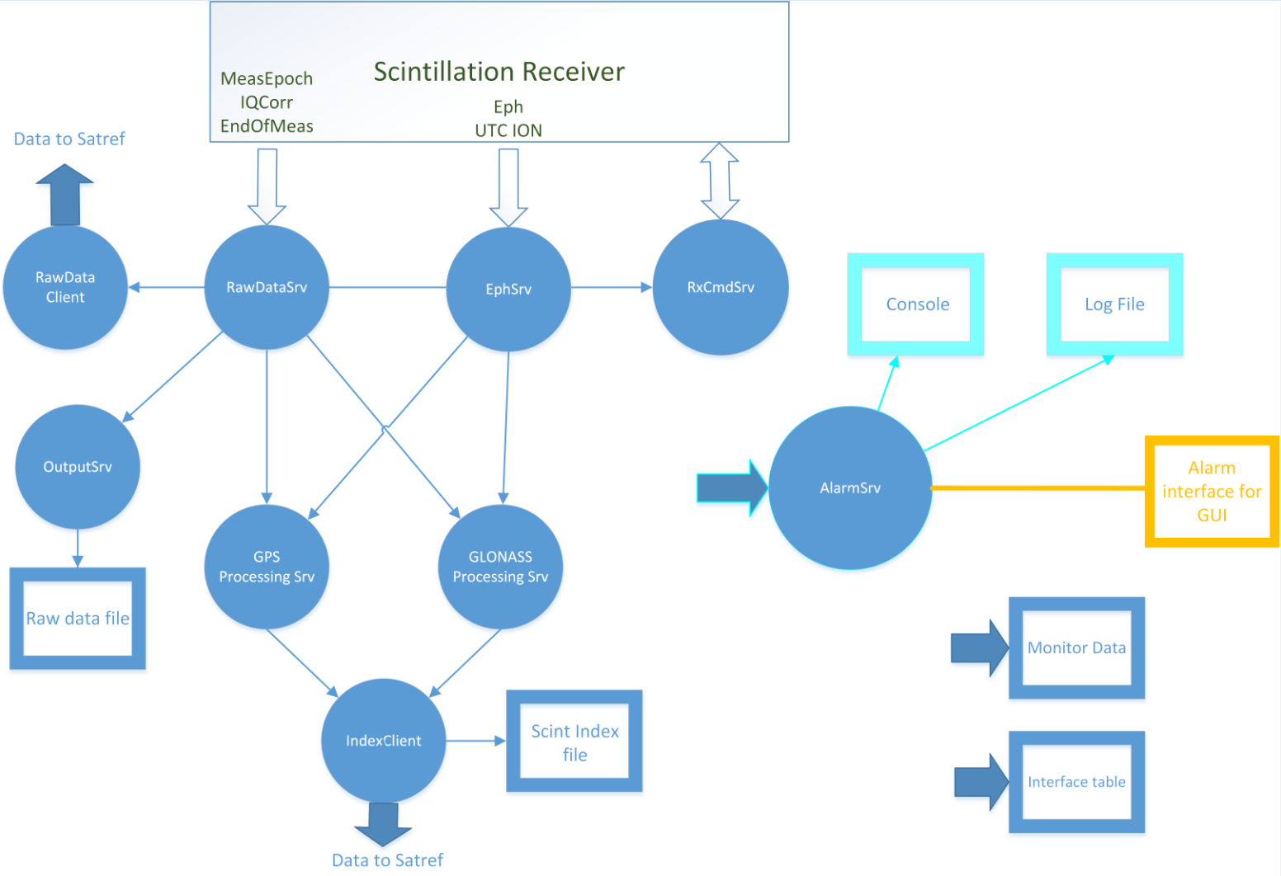

# Determination of the Scintillation Indices

Phase scintillation monitoring is accomplished by monitoring the standard deviation σφ of detrended carrier phase from signals received from satellites. The method used for detrending carrier phase passes raw 100Hz phase measurements through a sixth-order high-pass digital Butterworth filter, which removes all low frequency effects below a nominal cut-off frequency, which can be adjusted between 0.1 Hz and 0.3Hz.

The strength of amplitude scintillations is typically quantified by a metric called the S4 index. The total S4 index is the ratio of the standard deviation of the signal power to the mean signal power computed over a 60s interval. Just as for the phase measurement, the signal power must be detrended. This is done by first filtering the original intensity measurement time series with a 6th order Butterworth low pass, and then divide the by the original signal power by the filter output. Using the known signal-to-noise ratio, the effect of the ambient noise can be estimated and corrected for the final S4 index.