S-DDS Architectural Design Document

Prepared by: | Clément Drouadaine (ENSG – IGN France) | Date :
Checked by: |  | Date :
Approved by: |  | Date :
Authorised by: |  | Date :
ESA Approval |  | Date :

Documentation Information
Category : A |  |  |  | Filename:
[I: For Information] | [R: For Review] |  | [A: For Approval] | 0000.doc
Doc type : |  |  |  |  | Originator :
S/S : |  | DRD :
Doors Baseline : _ |  |  |  |  | Current document contains 33 pages,  excluding added annexes.

This page is INTENTIONALLY left blank
Change Record

Issue | Revision | Date | Change Status | Origin
1 |  |  | First version of the document

This page is INTENTIONALLY left blank
Table of Contents
1. Introduction 8
1.1. Contributions 8
1.2. References 9
1.2.1. Applicable Documents 9
1.2.2. Definitions 9
1.2.3. Acronyms 10
1.3. Document Outline 12
2. Abstract 13
3. General Description 15
3.1. Product description 15
3.2. General constrains 15
3.3. Assumptions and dependencies 15
3.4. Operational environment 15
4. Logical model 16
4.1. The NAME Model 16
4.2. Name External Interfaces 17
4.3. Mini-specification of the 18
4.3.1. Type 18
4.3.2. Purpose 18
4.3.3. Function. 18
4.3.4. Subordinates 18
4.3.5. Dependencies 18
4.3.6. Interfaces 19
4.3.7. Processing 19
4.3.8. Data 20
4.4. Mini-specification of 21
4.4.1. Type 21
4.4.2. Purpose 21
4.4.3. Function. 21
4.4.4. Subordinates 21
4.4.5. Interfaces 21
4.4.6. Processing 21
5. Interface Description 22
5.1. Internal Interfaces 22
5.1.1. NAME, Internal interface 23
5.3. External Interfaces 25
5.3.1. ???, External interface 26
6. Appendixes 27

List of Figures
Fant ingen figurlisteoppføringer.

List of Tables

Table 4-1 - 19
Table 5-1 - S-DDS External Interfaces 24
Table 5-2 - DDS_NTP Message Description 25

Introduction
This document is based on the requirements given in the RTIS GUI Statement of Work, RTIS_GUI-SOW-0001-NMA.

Contributions
Have contributed to the redaction of this document:
Company Name | Sections
ENSG | All
NMA | All

References

Applicable Documents

ID | Title | Reference | Version
 | RTIS GUI Statement of Work | RTIS_GUI-SOW-0001-NMA | 0.1

Definitions
NA

Acronyms
AD Applicable Document
AIT Assembly Integration and Tests
AIVV Assembly Integration, Verification and Validation
AJF Architecture Justification File
ALMD Additional Local Monitoring Data
ASN Abstract Syntax Notation
bit Binary digit
CCF Central Control Facility
CDR Critical Design Review
CIDL Configuration item Data List
COTS Commercial Off The Shelves
CPF Central Processing Facility
CRC Cyclic Redundancy Check
CS Check Set (CPF subsystem)
DDF Design Definition File
DJF Design Justification File
EGNOS European Geostationary Navigation Overlay Service
ESA European Space Agency
EWAN EGNOS Wide Area Network
FAR Final Acceptance Review
FEE Front End Equipment
GBAS Ground Based Augmentation System
GLONASS GLObal NAvigation Satellite System (Russian GNSS)
GNSS Global Navigation Satellite System
GPS Global Positioning System (United States GNSS)
ICD Interface Control Document
INSPIRE INterface System for the Provision In Real time of EGNOS
IPC Inter-process Communication
IRD Interface Requirement Document
ISO International Organization for Standardization
LAN Local Area Network
LSB Less Significant Bit
M&C Monitoring and Control
MCC Mission Control Centre
MIB Management Information Base
MMI Man-Machine-Interface
MRS Multi Regional System
MSB Most Significant Bit
NLES Navigation Land Earth Station
NOF Navigation Overlay Frame
NTP Network Time Protocol
PDR Preliminary Design Review
PS Processing Set (CPF subsystem)
RD Reference Document
RF Radio Frequency
RIBEX Receiver Independent Binary Exchange format
RID Review Item Discrepancy
RIMS Ranging and Integrity Monitoring Station
RINEX Receiver INdependent EXchange format
RJF Requirements Justification File
SACOS SAtref COntrol centre System
SBAS Satellite Based Augmentation System
S-CAT SPEED Catalogue
S-CCM SPEED Command, Control and Monitoring
S-COM SPEED Communications
S-DDS SPEED Data Dispatching Server
S-IDF SPEED Input Data Feeder
SiS Signal in Space
SIS2DS Signal In Space To Data Server Protocol
SiSNet Signal in Space Network
SOW Statement of work
SPEED Support Platform for EGNOS Evolutions & Demonstrations
S-PK SPEED Processing Kernel
S-PMOFF SPEED Performance Monitoring Offline
S-PMON SPEED Performance Monitoring Online
S-QK SPEED Qualification Kernel
SRD System Requirements Document
S-RDS SPEED RIMS Data Server
SRR System Requirements Review
S-SM SPEED Scenario Management
S-SWAN SPEED SiS and EWAN Emulator
S-TS SPEED Time Synchronisation
SV Satellite Vehicle
TBC To Be Confirmed
TBD To Be Defined
URD User Requirement Document
UTC Universal Time Coordinated
VLAN Virtual Local Area Network
VSAT Very Small Aperture satellite Terminal
WAN Wide Area Network

Document Outline

Abstract

This page is INTENTIONALLY left blank

General Description

Product description
The application consists of two parts. One part, GuiSrv is integrated in the RTIS SW, and is responsible for sending relevant data to the graphical interface and to carry out the commands it receives from it. The other part, GuiCli, is the web server, which manages the communications with all the RTIS installations. It also manages the graphical interface, updates it with the data it receives from the RTIS SW, and acts as a console for the operator.

General constrains

Assumptions and dependencies
To minimize development cost, a COTS, gl_Library, will be used to provide basic tasks like network communication, inter-process communication, process handling, event handling and data storage. gl_Library is a high level library, which use the API libraries delivered with the operating system.
The development of GuiSrv is based on ANSI C, while GuiCli is mainly written in HTML, PHP and JavaScript.

Operational environment
The RTIS GUI runs on LINUX system, based on the Ubuntu Operating system.

Logical model
In order to have fast data transfer from GuiSrv to GuiCli, these transfers are done via a UDP connection. It means there is no insurance the messages have been received, but there is also no slowing down in sending messages.
To communicate the other way around, GuiCli sets up a TCP connection to GuiSrv, and sends its commands via this channel. Here, the integrity of the message and the certitude that it has been received are more important than the execution delay.

Process description
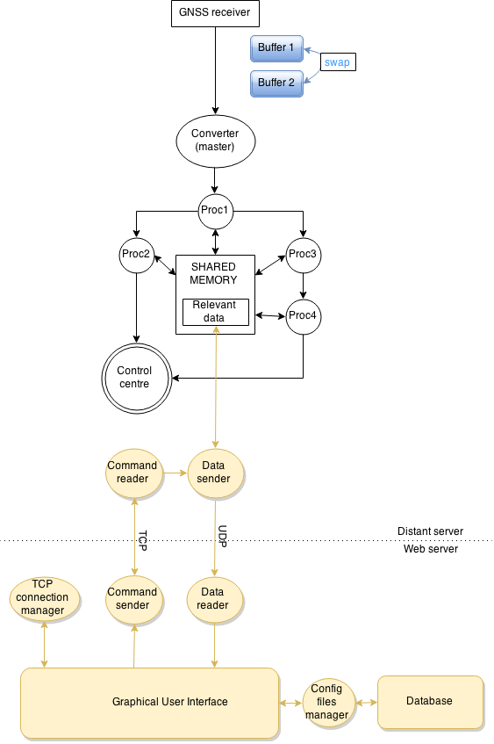
Figure 4-1 – Global Model

An overview of the system is given in Figure 4-1 – Global Model. On this figure, the external system is in black, while RTIS GUI system is in yellow.

The command reader is on the server side and, as its name suggests, reads user input from the GUI. This input comes in the form of SATREF messages, and can correspond to one of the following commands:
- reboot the application;
- replace the configuration file with the one provided;
- change the nature of the data to send and/or the frequency at which this data is being sent. This is done by modifying the input parameters of the data sender.
The commands that are read by the command reader are received by a TCP connection set by GuiCli. The other role of the command reader is to check the state of the connection, and to reset the data sender parameters to default if the connection is closed. The TCP connection can be closed as a result of a disconnection by the GUI user, but also for technical reasons if the signal is lost.

For each RTIS installation, GuiSrv uses the data sender to fetch data from the shared memory. The data to be read defaults to only a heartbeat every second telling if the process is up running or has failed, but this can be changed by the command reader. The data can be one or a combination of the following: a heartbeat, the list of the active process running on the installation, a flow of numbers that give information regarding the quality of the GNSS data that is being processed, or a list of error and information messages sent by the different process.
This data is converted to a SATREF message before being sent to GuiCli, via a UDP connection, at the specified frequency. It is to be noted that the data sender does not wait for any answer from the client. The data sender is also responsible for maintaining the UDP connection open.

On the client, the data reader is in charge of the reception of the data, its conversion to a readable format, and of displaying the converted data inside the GUI.

The command sender has the role of converting user input to orders to send into SATREF messages and to actually send them to the RTIS installation.

The TCP connection manager is in charge of opening and closing the TCP connection between GuiCli and one of the RTIS installations. It must be noted that only one TCP connection can exist at a time. To open a new one, there must not be another still open.

Finally, the database is here to store the history of the configuration files for all the stations. It is a relational database, that communicates with the GUI via the configuration files manager. The goal of this manager is both to read from and to write to the database. Whenever the user wants to send a configuration file, a check for existence of this file is made in the database. If the file does not already exist, it is then saved. The configuration file manager role is also to provide the history of the configuration files to the GUI when needed.

All of these client-side modules obviously communicate with the GUI, which is a PHP-based web page.

Name External Interfaces

Overview & mini-specification of the command reader

Type
The command reader is an independent real-time process within GuiCli.

Purpose
The purpose of the command reader is to:
- convert the commands coming from the command sender from SATREF to a more readable format;
- depending on the command, obey it by performing one of the following operations:
  - reboot the whole RTIS software;
  - change the configuration file from the RTIS software;
  - inform the data fetcher about a change in the data requirements;
- detect if the TCP connection was broken, and in this case reset the data fetcher parameters to default;
- inform the command sender about the success of performing the command.

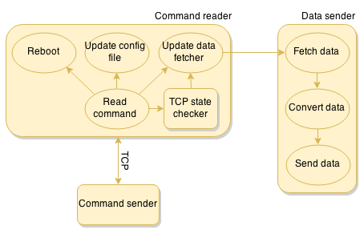
Figure X – The command reader

Function
The command reader is launched with the rest of the RTIS SW. It launches the TCP state checker when a TCP connection is established.
The command reader will process all messages and send back to the command sender a message informing it that its command has been read and done.
To reboot the RTIS SW, the command reader launches a bash script, which has to be present in the distant computer.
To inform the data sender of an update in its parameters, it first changes its configuration file, and then runs a function of the data sender to read it.

Subordinates

TCP state checker.

Dependencies
The command server has to be launched by the main process. In order for the TCP connection not to be considered closed, the command sender has to be up and running.
The bash file has to exist.

Interfaces
The ??? uses the following interfaces:
Interfaces | Description | Reference
 |  | KAP
 |  | KAP
Table 4-1 -

Processing

Data
The data that is received/sent through TCP is in form of SATREF messages.

Overview & mini-specification of the TCP state checker

Type
The TCP state checker is an independent real-time process within the command reader.

Purpose
The goal of the TCP state checker is to reset the parameters of the data sender to default if the TCP connection between the command sender and the command reader is broken. To do so, it reads the heartbeats sent by the command sender at a regular interval. If no such heartbeat is received after a certain time, the connection is considered closed, the data sender is notified to reset its parameters to default, and the TCP state checker kills itself.

Function
Whenever the command reader receives a command, it checks if the TCP state checker is running and, if not, launches it. The TCP state checker kills itself when the TCP connection is broken.

Subordinates
None.

Interfaces

Processing

Overview & mini-specification of the data sender

Type
The data sender is an independent real-time process within GuiCli.

Purpose
The goal of the data sender is to acquire specific data from the RTIS SW at a specified frequency, and to send it to the data reader via a UDP connection, in the form of a SATREF message. The data to be read can be:
- error messages coming from a dedicated UDP connection in the form of SATREF messages;
- data to be read from the shared memory of the RTIS SW, namely:
  - a heartbeat indicating if the main process is running;
  - the list of all RTIS-related processes currently running;
  - a flow of numbers quantifying the quality of the results.
Depending on the parameters it has been given by the command reader, the data sender can read one or more of these types of data. However, it always reads at least the heartbeat.
The read data is then converted into SATREF messages if needed, which are sent to the data reader via a UDP connection.

Function
The data sender is launched with the rest of the GuiCli SW.

Subordinates
None.

Interfaces

Processing

Overview & mini-specification of the data reader

Type
The data sender is an independent real-time process within GuiSrv.

Purpose
The goal of the data reader is to receive data from the data sender, to convert it to a readable format, and to display it on the GUI.

Function

Subordinates
None.

Interfaces

Processing

Overview & mini-specification of the command sender

Type
The data sender is an independent process within GuiSrv.

Purpose
The goal of the command sender is to convert input from the user on the GUI to a SATREF message, and to send it to the command reader. The commands that do not directly impact the GuiCli are not handled by this component: the configuration files manager, which is responsible for the interactions with the database, is described in 4.8; the TCP connection manager, which is responsible for the creation/destruction of the TCP connections, is described in 4.9.

Function

Subordinates
None.

Interfaces

Processing

Overview & mini-specification of the TCP connection manager

Type
The data sender is an independent process within GuiSrv.

Purpose
The goal of the TCP connection manager is to create and destroy TCP connections between the command sender and the command reader. Only one such connection can exist at a given time, thus the TCP connection manager looks for an open connection and closes it, before opening a new one.

Function

Subordinates
None.

Interfaces

Processing

Overview & mini-specification of the configuration file manager

Type
The data sender is an independent process within GuiSrv.

Purpose
The goal of the configuration file manager is to manage communications between the GUI and the database, going both ways. The database is only used to store configuration files. The idea is that whenever the user sends a configuration file to a station, this file has to be saved into the database, in order to be able to be reloaded later.
To transfer data from the GUI to the database, the user has to send a configuration file to a station. In addition to effectively sending the file, this will also call the “Check for existence” function of the configuration file module. This function will search the database for an identical configuration file. If none is found, the configuration file is a new one, and needs to be saved. The “Save” function is then called, and the configuration file stored in the database.
For communication the other way around, the GUI calls the function “Display a drop-down list” whenever the user goes to the configuration file modification page. This function queries to the database to get the list of names of the configuration files for the current station, and formats it so that it can directly be included in the HTML code as a drop-down list. Once the drop-down list is made, the user can choose one of its elements, that is to say one of the previous configuration files. Choosing an element triggers the “Prefill fields” function, which queries the database for all of the information concerning the selected configuration files, and prefills the GUI fields accordingly.

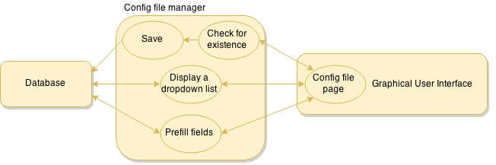
Fig X : the configuration file manager.

Function

Subordinates
None.

Dependencies
The database has to exist.

Interfaces

Processing

Interface Description

Internal Interfaces

This section describes the internal interfaces.

NAME, Internal interface

External Interfaces
This section describes the ??? external interfaces.

Input/  Output | Interface name | Description
I
O
Table 5-2 - Name External Interfaces

Name, External interface

Name | Description | Units | Range | Type | Size in bytes | Format

Table 5-3 - Name

Appendixes

