RHYS LANCASTER
W20024457
BSC COMPUTER SCIENCE
INTELIGENT SYSTEMS(KF5042)
21/08/2023

Learning-Based Algorithms with Face Detection
A Compressive Study

Rhys Lancaster(W20024457)
W20024457@northumbria.ac.uk

Abstract—Facial Detection has developed into an essential use in intelligent systems for several systems as such traffic monitoring, security monitoring, law enforcement, and personal use. This study will be detailing the present AI technology available with approaches for facial detection & recognition including CNN, Machine Learning, and KLT. The study will be going over several stages of AI systems for facial detection, such as facial features, and tracking points of a face.

Introduction (Heading 1)
In recent years, there has been an increase in the number of AI technologies within newly developed systems. These systems will be able to be incredibly efficient at processing data and analyzing data that may or may not be visible, and all of this will be consistent whether the task is difficult or not difficult. Computers are becoming intelligent and as systems progress this means that the interaction between humans and computers is becoming less theoretical & more realistic than anything at all. In this study Object detection is discussed as to what it is, what it can do, and how it is used effectively, and how efficiently it can be in face detection systems. Other AI will be discussed also as a comparison to object detection in order to show the differences and impacts of how different AIs can provide different results.
Object detection is an area where AI systems are used. Object detection functions by discovering/detecting objects in the parameters it can be specifically whether image or video. This application of AI is one of the most popular in recent times [1]. Several uses of object detection have emerged over the years and one of them is face detection, and this system has become one of the most used as it provides aid in areas such as monitoring, traffic monitoring, security on personal properties or business properties as well and the list grows even further from the provided examples. [2]. From this point, the system will begin with the AI model at this stage is completed it will begin further analysis of what it detects within the surrounding box with points when a video is displayed.

Object detection starts by working on an arbitrary image which can be detailed on what is in the image by analyzing the patterns in the images/videos. Furthermore, Object detection can move forward by rechecking the patterns but instead looking into what they can form based on similarities with the others, and as a result, it can return any discovered dimensions from what is withheld in the box identifier and display it.[3] However, the only way to achieve this successfully is without displaying errors should it fail, if no issues arise it will cease the procedure till it is resolved. If there are no issues then the last part will not matter, if all is working then you will need to think about acquiring different kinds of aspects, these aspects would be ranging from things like focusing, color, poses [4] reflections, shadows, etc. [5].

The standard process of face recognition/detection is a simple task for computers. As there is a variety of different algorithms to help this process happen & exist & function at one time. However, for this task, very few of them are considered for this task. In various papers on the web and other education centers, information detailing these types of algorithms is used for object detection.[6] the algorithms that are used are 1. Viola Jones, SMQT & snow classifier 3. Network-based Face Detection, Support Vector Jones machine face detection, and Convolutional Neural Networks with Deep Learning Attached too. In Table I below results are shown which show how precise the various algorithms can be between them and how fast an image is displayed.

Table I.

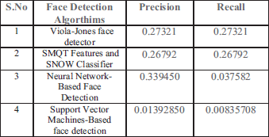

This paper is explained in a detailed report through various papers defining various pieces of AI research that concern face detection. This will allow more in-depth explanations of how face detection is adapted through multiple algorithms and how they function together to form results at the results stage. In the detailed information will be the concerns facing face detection such as legal, social & ethical issues as these will be major factors in how these systems operate effectively without outside concerns.

Literature Review
In the recent years, deep learning has evolved and is in more demand than ever, and with its popularity over the last decade the applications for it specifically in monitoring (any kind) and security are the reason for this as “with growing techniques and computer technologies emerging, biometric recognition system has gained immense popularity among the masses”. [5]. The support for this claim is supported in [7], At this point, say that a monitoring security system is set up to provide real-time images/videos projected through external screens. Face Detection is achieved by using several stages throughout the model (see Fig 1), these stages are called Harr Features, detecting harr-like features, and cascading classifiers.

Harr features are “narrowing down with the application of object detection” such as with features shown in the figure below.

Fig 3
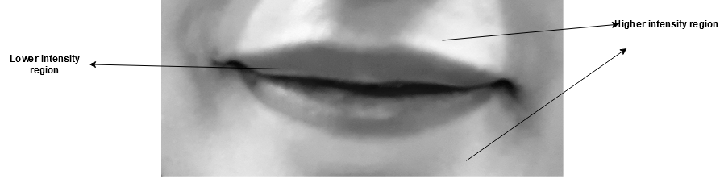
Being able to detect features like harr is seen as impossible because of how many pixels are within an image which is then why an integral image is created so that we can make some way with being able to find these features. Harr features gather little details that do not reside sorely on the central part of an image, specifically it tends to be the case of the eyes, ears, lips, and any other characteristics that may be present in the image.

Fig 2.


The last stage is about cascading classifiers and can change from a weak classifier into a robust one instead which can save time by eliminating anything that resembles what it can consider unnecessary “The cascade can be viewed as an object-specific focus-of-attention mechanism which unlike the previous approaches provides statistical guarantees that discarded regions are unlikely to contain the object of interest [15]. Studies have shown that these studies using the Viola-Jones Algorithm are being used in this study which has shown and has been claimed to have high accuracy results that enable the models to determine which images are faces and which are not and will not track them either if this was a video. It showed that showing different angles can change the success rate for the result. [9].

Fig 1.
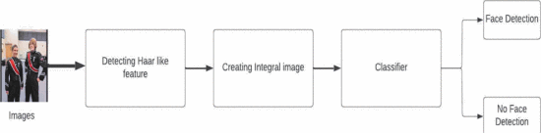

On this note, we can see that it can be difficult to implement this model/algorithm depending on which way you go about it as the image/video using Viola Jones on its own or with Kanade-Lucas-Tomasi Tracker which is able to track down a detect object and turn into key feature points, which is faster more applicable to real-time systems. This would need to be efficient to provide real-time images and real-time live monitoring systems. Technical aspects of this prove to be beneficial for this reason. Therefore, time is therefore taken to consider the ethical, social, and legal issues with concerns of people’s privacy.

- Data Privacy – One of the most important public concerns, as this is down sorely because of the information managed and kept and how the transparency of the information is used against people. It is also because any unsecured data can pose a security risk or a threat if it’s a company and it's why most companies/people will choose to host their information on a local server instead of an online one. FRT can ensure maximum protection against security issues.

- Mass Surveillance – Facial recognition can lead to huge public surveillance on an hour-to-hour and day-by-day basis, which acutely is able to compromise local people’s rights to privacy. It’s known that over the years CCTV surveillance has been effective and sufficient in helping the local law enforcement and general government in court cases and tracking down people who commit crimes. But in another case because of this people are getting recorded which is considered as violating the fundamental rights of innocent and ordinary people. When you consider the case, you can consider thinking about the consent which is never asked for first, as live recordings can be taken of people that pass a street camera daily and thought about the people on those recordings whose faces no matter the age are stored without consent for months on end in local servers.

- Data Breaches & No Support – Data breaches can happen especially when no anti-security is set up on the device in use. Furthermore, as data breaches have been happening the type of data that is leaked can be things such as “financial information”, “Medical Information”, or “Vulnerable Information” [17]. This is seen as a significant issue as people’s images/videos would be stored, could be leaked, and spread around or posted.

There are several AI technologies that exist to utilize real-time face detection & recognition. One of these is called YOLO [12] which is an “Algorithm that uses neural networks to provide real-time object detection”. The other is called RCNN is a “region-based convolutional neural network, as a type of machine learning used in vision tasks as such objection” [13]. This has proven to be very effective in giving accurate results and is also quite efficient with providing it in real time [10].

Fig 3.
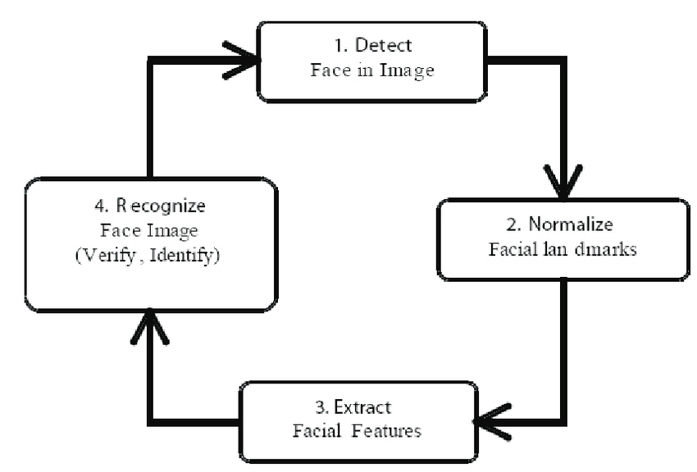

METHODS

- Deep Learning – CNN
In any experiment process, it will feature a series of critical stages. These stages will be ranging from data preparation, Evaluation of Performance, and network training. The first stage will be creating the dataset containing images & videos of people’s faces which is required to run the experiment. This model has been chosen as it has been shown to have high efficiency in object detection, this will be a characteristic as it can acquire detailed detection features.

- Dataset
To further develop the experiment, a dataset containing videos & images, in two separate folders for both scripts. The dataset for images contains several hundred images listed as XML file types are kept whereas the videos are all mp4 file types. The dataset for images & files is downloaded from Kaggle, the reason why two datasets were selected is to show the difference in accuracy between that of a video and a still image. [16].

- Pre-Processing of Data –
By training the module, after one or more datasets are acquired and at this stage preprocessing of data will commence after the collection of data is gathered. Pre-Processing data can only commence after a gathering of data is completed. After this images or videos can be modified, which in turn will give a better result to be provided as this data will then be stored in a new variable.

- Bounding Boxes
Training an object detection model, the algorithm will be able to leverage bounding boxes, this will help it to load the datasets used from the CSVs which contain images and videos with any annotations applied to the images.

- Object Detection –
The model is trained by checking the inputs of the processed data and any training decisions. Through the training phase, this model will be able to gain capacities to be relied on so that the bounding box can successfully identify where the face is and what facial features may be expressed in this image/video. In the training model will gain the capacity to predict reliably the bounding box on the coordinates of the face’s seen in the images/videos.

Results
The face detection model has been trained and conditioned using a dataset of images and a video one too and with the corresponding bounding boxes within. The performance of the model was carefully measured using different evaluations, along the lines of accuracy, and precision. The model that is run was able to achieve an accuracy of 85.4% which indicated that it was able to indicate it can detect the faces and is able to track them as well. All of these would have been within the bounding boxes to ensure as accurate of results as possible.

The chosen algorithm for this was a deep learning CNN, which has been critical in being able to obtain the images/videos and the faces within these bounding boxes. CNN has convolutional layers that can allow the model to gather different patterns and spatial correlations in the input with the images, all while all connected layers help to classify the faces.

However, there are limits to this model for face detection as the model’s efficiency is based on being dependent on the quality and the training of the dataset that is used in for the experiment. If the dataset was able to be bias or carry a lack of through samples this could jeopardize the data and accuracy result overall. Furthermore, a model's performance can get influenced by outer factors like I.E lighting or a different angle or occlusion.

Conclusion
In conclusion, the face detection & recognition system is a crucial application within intelligent systems., with the employment of AI technologies, for example, CNN, machine learning, and finally YOLO has been shown to increase significantly the accuracy of the image/video displayed. Various stages that involved an AI system for face detection & recognition, such as features, image preprocessing, and classifications have been talked about. As to ensure responsible and fair use the social, ethical, and legal implications of using face detection & recognition must be significantly considered and used carefully.

References
- Cha Zhang and Zhengyou Zhang (no date) A survey of recent advances in face detection - microsoft.com, Survery of Recent Advances in Face Detection. Available at: https://www.microsoft.com/en-us/research/wp-content/uploads/2016/02/facedetsurvey.pdf (Accessed: 04 August 2023).
- Himani S. Parekh, Darshak G. Thakore and Udesang K. Jaliya, A Survey on Object Detection and Tracking Methods International Journal of Innovative Research in Computer and Communication Engineering.
- M.-H. Yang, D. J. Kriegman and N. Ahuja, "Detecting faces in images: A survey", IEEE Trans. on PAMI, vol. 24, no. 1, pp. 34-58, 2002.I. S. Jacobs and C. P. Bean, “Fine particles, thin films and exchange anisotropy,” in Magnetism, vol. III, G. T. Rado and H. Suhl, Eds. New York: Academic, 1963, pp. 271–350.
- R. Hussin, M. Rizon, Juhari Ng, Wei Kang, R.C. Ismail and A. Kamarudin, "Digital Image Processing Techniques for Object Detection From Complex Background Image", International Symposium on Robotics and Intelligent Sensors 2012, 2012..
- N. Singla, G. Singla and N. Maggon, "Face Detection and Recognition Using Digital Image Processing: "State of the Art"," 2022 2nd International Conference on Innovative Sustainable Computational Technologies (CISCT), Dehradun, India, 2022, pp. 1-4, doi: 10.1109/CISCT55310.2022.10046441.
- Vasha v (no date) Face recognition based automated student attendance ... - researchgate. Available at: https://www.researchgate.net/publication/342758665_Face_Recognition_Based_Automated_Student_Attendance_System_using_Deep_Learning (Accessed: 07 August 2023).
- C. Luo, J. Zhuo, K. Tang, J. Zou, S. Zuo and Y. Cai, "Contrastive Research on Performance of Face Detection based on Classical and Deep Learning Algorithms," 2022 International Applied Computational Electromagnetics Society Symposium (ACES-China), Xuzhou, China, 2022, pp. 1-4, doi: 10.1109/ACES-China56081.2022.10064747.
- P. Dwisnanto, B. Teguh and B Winduratna, "Sistem Deteksi Wajah dengan Menggunakan Metode Viola-Jones", Semin. Nas. “Science Eng. Technol., pp. 1-5, 2012.
- P. Dwisnanto, B. Teguh and B Winduratna, "Sistem Deteksi Wajah dengan Menggunakan Metode Viola-Jones", Semin. Nas. “Science Eng. Technol., pp. 1-5, 2012.
- W. Yang and Z. Jiachun, "Real-time face detection based on YOLO," 2018 1st IEEE International Conference on Knowledge Innovation and Invention (ICKII), Jeju, Korea (South), 2018, pp. 221-224, doi: 10.1109/ICKII.2018.8569109.
- K. R. Gangarapu, “Ethics of Facial Recognition: Key Issues and Solutions,” learn.g2.com, Jan. 25, 2022. https://learn.g2.com/ethics-of-facial-recognition

- Grace (2021) Introduction to yolo algorithm for object detection, Section. Available at: https://www.section.io/engineering-education/introduction-to-yolo-algorithm-for-object-detection/ (Accessed: 18 August 2023).

- Odemakinde, E. (2022) Everything about mask R-CNN: A beginner’s guide, viso.ai. Available at: https://viso.ai/deep-learning/mask-r-cnn/ (Accessed: 18 August 2023).

- Khan, K. (2017) Comparison of viola-jones and Kanade-Lucas-Tomasi Face Detection Algorithms, Oriental Journal of Computer Science and Technology. Available at: https://www.computerscijournal.org/vol10no1/comparison-of-viola-jones-and-kanade-lucas-tomasi-face-detection-algorithms/ (Accessed: 18 August 2023).
- P. Viola and M. Jones, "Rapid object detection using a boosted cascade of simple features," Proceedings of the 2001 IEEE Computer Society Conference on Computer Vision and Pattern Recognition. CVPR 2001, Kauai, HI, USA, 2001, pp. I-I, doi: 10.1109/CVPR.2001.990517.
- Gupta, A. (2020) Human faces, Kaggle. Available at: https://www.kaggle.com/datasets/ashwingupta3012/human-faces (Accessed: 18 August 2023).
- What is a data breach: TIPS for data leak prevention: Imperva (2020) Learning Center. Available at: https://www.imperva.com/learn/data-security/data-breach/ (Accessed: 20 August 2023).

- https://ieeexplore.ieee.org/abstract/document/9825259M. Young, The Technical Writer's Handbook. Mill Valley, CA: University Science, 1989.

Appendix:
Github Link:

MATLAB CODE BELOW:
the_Video = VideoReader('Rhys.mp4.mp4'); % Finds and will Load the video file
the_Video1 = VideoReader('vid 1.avi');
video_Frame = readFrame(the_Video); % Indicating where to look on the video

face_Detector = vision.CascadeObjectDetector(); % Creates Object Detector to detect objects or faces on images and videos
Face_of_a_Face = step(face_Detector, video_Frame); % Creating a variable here to indicating where to focus its detection on

Frames_Detected = insertShape(video_Frame, 'Rectangle', Face_of_a_Face); % Indicating where an object has been detected so will place a shape onto the video

rectangle_to_Points = bbox2points(Face_of_a_Face(1,:)); % Draws the box around the detection

feature_Points = detectMinEigenFeatures(rgb2gray(Frames_Detected), 'ROI', Face_of_a_Face ); % Creating the pointers which will display on the users face withi

TrackingthePoints = vision.PointTracker('MaxBidirectionalError', 2);

feature_Points = feature_Points.Location;
initialize(TrackingthePoints, feature_Points, Frames_Detected);

left = 100;
bottom = 100;
width = size(Frames_Detected, 2);
height = size(Frames_Detected, 1);
Video_Player = vision.VideoPlayer('Position', [left bottom width height]);

previous_Points = feature_Points;

while hasFrame(the_Video)
video_Frame = readFrame(the_Video);
[feature_Points, isFound] = step(TrackingthePoints, video_Frame);
new_Points = feature_Points(isFound,:);
old_Points = previous_Points(isFound,:);

if size(new_Points, 1) >= 2
[transformed_Rectangle, old_Points, Points_new] = ...
estimateGeometricTransform(old_Points, new_Points, ...
'similarity', 'MaxDistance', 4);
Points_From_Rectangle = transformPointsForward(transformed_Rectangle, rectangle_to_Points);

reshaped_Rectangle = reshape(rectangle_to_Points', 1, []);
detected_Frame = insertShape(video_Frame, 'Polygon', reshaped_Rectangle, 'LineWidth', 2);

detected_Frame = insertMarker(detected_Frame, Points_new, '+', 'Color', 'White');

Points_old = Points_new;
setPoints(TrackingthePoints, previous_Points);
end
step(Video_Player, detected_Frame)

end

release(Video_Player);
DetectBody = vision.CascadeObjectDetector('BodyUpper');
DetectBody.MinSize = [ 30, 60];
DetectBody.MergeThreshold = 25;

I2 = imread('picturewicture.jpg');
bboxBody = DetectBody(I2);

IBody = insertObjectAnnotation(I2, 'rectangle', bboxBody, 'BodyUpper');
figure
imshow(IBody)
title('Showing All Upper Bodies which are detected');

clear % Will be giving us a fresh and clear workspace to begin my work from
% Now Below I will be creating a cascade Objector as which will allow us to
% detect faces from images or videos.

DetectFace = vision.CascadeObjectDetector();

% This will prompt the users to select one or more images

I = imread('picturewicture.jpg');

bbox = DetectFace(I); % Box Identifying the face inside of it
IFaces = insertObjectAnnotation(I,'rectangle', bbox, 'Faces'); % Creates the box that will appear around the overall faces
figure
imshow(IFaces)
title('Faces are Detected'); % Displays the title for the boxes and informs the user that face is detected

