

SeatTest class contains following tests set:

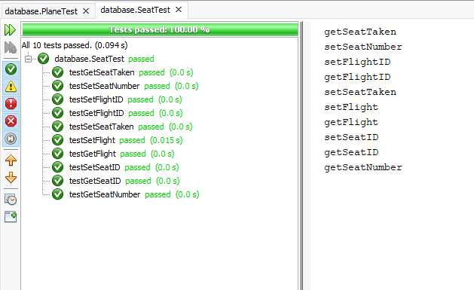

FlightHandler class contains following tests set:

