**JDBC(Api)**

* To store data permanently so to use or retrieve at any time need db.
* To connect java and mysql
* To access mysql from java or java to mysql need a need a interface called JDBC.(that helps to make uunderstand result from java to mysql and mysql to java.

JDBC API

DB

JAVA PROGRAM

* It not only connect java and mysql it also connects with oracle,mongodb(to connect with these it has each drivers)

**DRVIVER MANAGER:**

* IT connect java with sql,oracle each has separate drivers. Ecah drivers it has logic to connet with each.
* These drivers makes java to understandable by sql (java will be understand by sql)

1. **To read values in table in sql from java**
2. Connect->to connect java and sql use interface **Connectoion**(import java.sql.*) to implement this classes and interface. (we cannot able to create instantiate i.e to give **connection con=new connection** bze it is interface .So ther is a class called DriverManager where getConnection method present/already defined

Connection con=DriverManager.*getConnection*(url,username,password);// to connect with sql(all 3 r strings

1. **Statement** should be created->to execut the query(before this write the query In java) i.e to select or retrive

Statement st=con.createStatement();//used to execute query

st.executeQuery(query);//it is a method in Statement class this execute the query



2)**To insert**

1. Connection is same for all insert and other
2. Onlexecut query changes bze(it is used where only reading occurs withot any change
3. So to toUpdate in db use executeUpate()
4. After inserting in java in sql becomes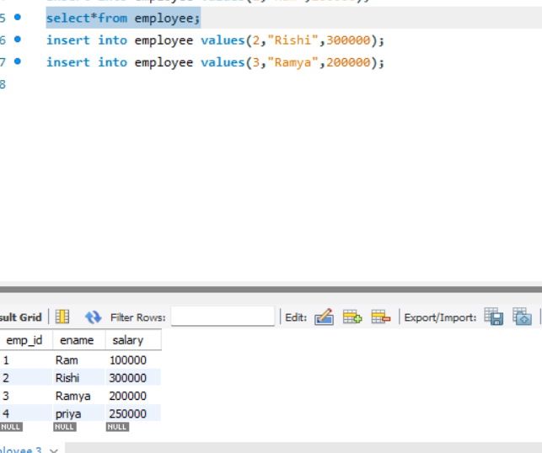

**String query="insert into employee values(4,'priya',250000)";** //QUERY->give ' ' ot string to avoid confusion in" " in Query

Connection **con=DriverManager.*getConnection*(url,username,password);**// to connect with sql(all 3 r strings

**Statement st=con.createStatement**();//used to execute query//The Statement object (st in this case) is used to execute SQL commands (like SELECT, INSERT, UPDATE, DELETE).

//statement allows you to send SQL queries to the database and handle the returned results.

**int row=st.executeUpdate(query);**//it executes the query and gives/returns the result set so create the object to result set and result int bze it doent return table it gives only the int//i.e how rows affected

//intially rs set points to attribute in the table to retrive data i.e it has only 1 data give rs.next()

**System.*out*.println("Number of rows affected: "+row);**