Project Report: Fall Season Evening Scene
Student Name: Sania Akter
Student ID: 23-50511-1
Serial :16
Section: D
Course: Computer Graphics

Table of Contents
- Title Page ..................................................................................... 1
- Introduction ................................................................................. 2
  - Project Overview: Fall Season Evening Scene
- Project Graph .............................................................................. 3
  - Coordinate Mapping and Design Blueprint
- List of Objects (with Object IDs) .............................................. 4
  - Static Visual Elements
- List of Functions to Represent Objects ..................................... 5
  - Mapping Code Logic to Visuals
- List of Animation Functions (with Animation IDs) .................... 6
  - Dynamic Movement and Interaction Logic
- Contribution Table ........................................................................ 7
  - Individual Work Breakdown (100% Contribution)
- Conclusion ................................................................................... 8

1. Introduction
The "Fall Season Evening Scene" is an interactive OpenGL-based graphical simulation. It depicts a detailed urban environment transitioning into an autumn evening. The project utilizes complex 2D primitives to build a city skyline, a park with seasonal foliage, and an animated roadway. Key features include a day-to-night toggle system, drifting clouds, falling leaf physics, and a moving vehicle. The project demonstrates the application of transformation matrices, timer-based animations, and user-input handling.

2. Project Graph
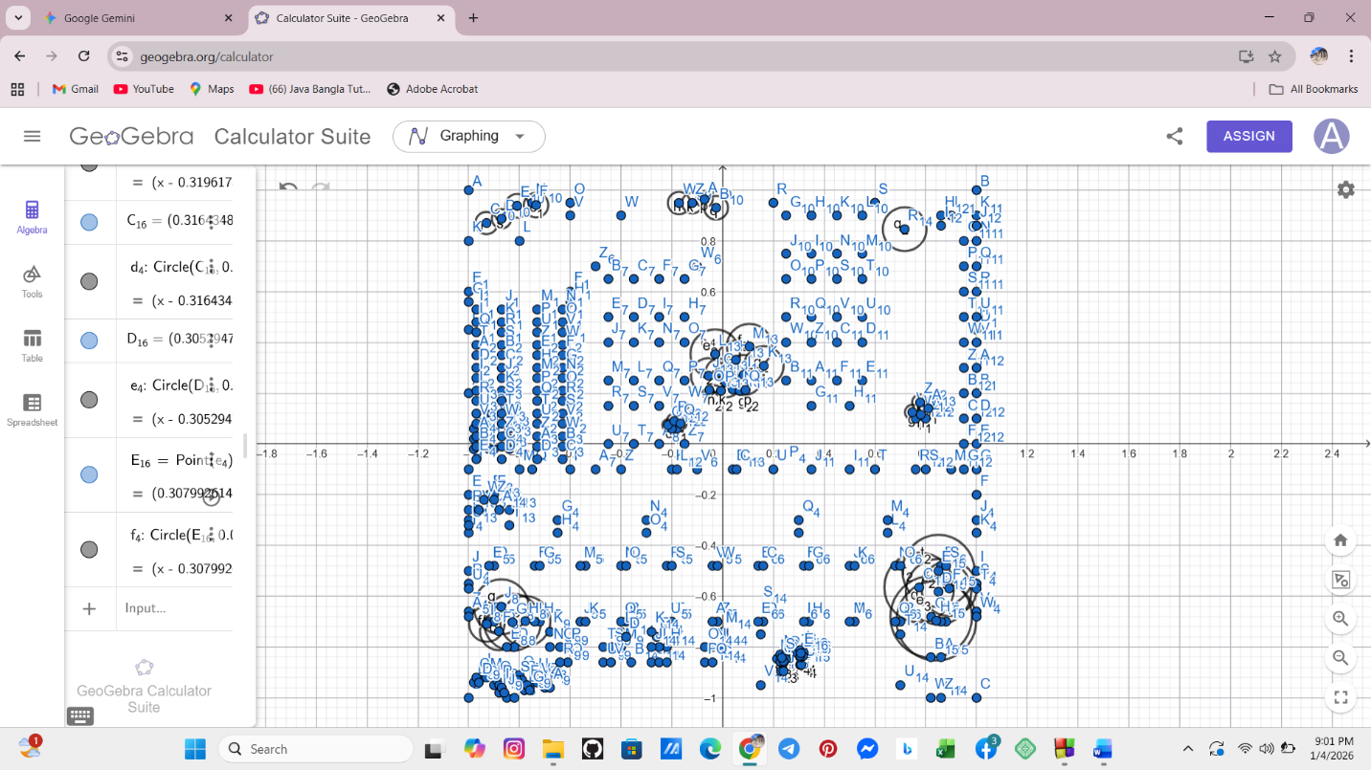
The scene is constructed on a 2D Cartesian plane using gluOrtho2D(-1, 1, -1, 1).
- Sky/Upper Atmosphere: Positioned from $y = 0.2$ to $y = 1.0$.
- Horizon/Cityscape: Buildings and sun/moon are anchored around $y = -0.1$ to $y = 0.8$.
- Ground/Roadway: The lower region from $y = -0.2$ to $y = -1.0$ contains the park, sidewalk, and road.

3. List of Objects
SL# | Object ID | Object Name
1 | OBJ_01 | City Road and Lane Markers
2 | OBJ_02 | Animated Vehicle (Car & Wheels)
3 | OBJ_03 | Skyscrapers and Building Windows
4 | OBJ_04 | Dynamic Clouds
5 | OBJ_05 | Sun and Night-mode Moon
6 | OBJ_06 | Autumn Trees & Falling Leaves
7 | OBJ_07 | Park Bench and Trash Bin
8 | OBJ_08 | Wooden Perimeter Fence
9 | OBJ_09 | Street Lamp Post
10 | OBJ_10 | Night-time Fireflies

4. List of Functions To Represent Objects
SL# | Function Name | Object_ID
1 | road(), roadborder1-3() | OBJ_01
2 | car(), wheel() | OBJ_02
3 | building1-8(), window1-14(), building3win1-7() | OBJ_03
4 | clouds(), clouds2(), clouds3() | OBJ_04
5 | sun() | OBJ_05
6 | tree4(), tree10(), fallingLeaves10(), leaves1-3() | OBJ_06
7 | banch2(), banch22(), dustbin() | OBJ_07
8 | wall1-24() | OBJ_08
9 | lampstand(), lamptop() | OBJ_09
10 | drawFireflies() | OBJ_10

5. List of Animation Functions
SL# | Animation Function | Animation Function ID
1 | updateCar() | ANIM_01 (Horizontal Translation)
2 | updateWheelRotation() | ANIM_02 (Rotational Logic)
3 | updateTree() | ANIM_03 (Leaf Falling Physics)
4 | updateClouds() | ANIM_04 (Cloud Drifting)
5 | updateFireflies() | ANIM_05 (Random Walk Algorithm)
6 | keyboard() | ANIM_06 (User Input State Toggle)

6. Contribution Table
This project was developed individually. I have handled all aspects of the design, implementation, and logic.
Member Name | Implemented Functions | Implemented Animation Functions | Percentage
Sania Akter | All functions (OBJ_01 to OBJ_10) | All logic (ANIM_01 to ANIM_06) | 100%

7. Conclusion
The project successfully achieves a balanced blend of static architectural drawing and dynamic environmental effects. By implementing various glutTimerFunc callbacks, I ensured that multiple animations (car, leaves, clouds, and fireflies) run simultaneously without performance drops. The interactive "N" and "D" keys allow for a seamless transition between day and night, demonstrating a strong grasp of state-based rendering in OpenGL.
