
AMERICAN INTERNATIONAL UNIVERSITY BANGLADESH

Name | Most. Sumaiya Habiba Nishat
ID | 23-50515-1
Section | D
Project | Spring season

Project Title:
Morning of spring season

Table of Contents:
- Title page | 1
- Table of Contents | 2
- Introduction | 3
- Graph | 3
- List of Objects | 4
- List of Functions | 5
- List of Animations | 5
- Conclusion | 6

Introduction:
Project “Morning of spring season” correctly depicts a vibrant morning scene where birds are soaring, a boat is gliding across a flowing river, and a car travels along the road, creating a lively atmosphere. It is an interactive OpenGL based project where animations such as translation and scaling were used in objects such as the rising sun, moving clouds, and blooming flowers, which increased user interactivity. The project was built using C++ with the help of GLUT Libraries to render 2D graphics to create a close depiction of a peaceful countryside landscape during the spring.

Project Graph:
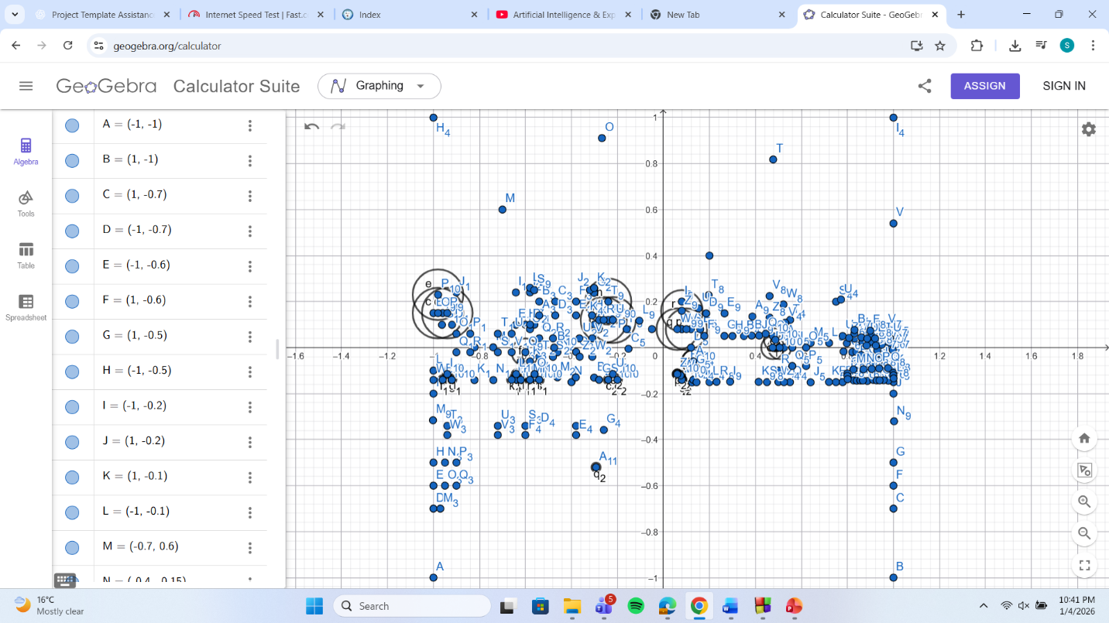

List of Objects:
SL# | Object ID | Object Name
1 | OBJ_SKY | Gradient Day Sky
2 | OBJ_SUN | Rising Sun
3 | OBJ_HILLS | Background Mountains
4 | OBJ_RIVER | Flowing River
5 | OBJ_STREAM_LINES | Moving Water Currents
6 | OBJ_BOAT | Gliding River Boat
7 | OBJ_ROAD | Road
8 | OBJ_ROAD_MARKINGS | White Road Borders / Dividers
9 | OBJ_DIVIDERS | Brown Roadside Fencing
10 | OBJ_CAR | Keyboard-Controlled Red Car
11 | OBJ_HOUSE_1 | Yellow House with Grey Roof
12 | OBJ_HOUSE_2 | Multi-story Yellow House
13 | OBJ_SMALL_HOUSE | Slanted Roof Cottage
14 | OBJ_TREE_TRUNKS | Wooden Tree Stems
15 | OBJ_TREE_LEAVES | Leaves of tree
16 | OBJ_GARDEN_TREES | Triangular Pine Trees
17 | OBJ_FENCE | Backyard Wooden Fence
18 | OBJ_BUSHES | Dark Green Shrubbery
19 | OBJ_FLOWERS | Mouse-Interactive Flowers
20 | OBJ_CLOUDS | Moving White Clouds
21 | OBJ_BIRDS | Flapping Animated Birds

List of Functions to Represent Objects:
SL# | Function Name | Object ID
1 | drawCircle() | Used for OBJ_SUN, OBJ_TREE_LEAVES, OBJ_CLOUDS, OBJ_BUSHES drawFlower()
2 | drawFlower() | OBJ_FLOWERS
3 | drawBird() | OBJ_BIRDS
4 | drawBoat() | OBJ_BOAT
5 | drawCar() | OBJ_CAR
6 | update() | Handles Animation for SUN, BOAT, CLOUDS, BIRDS, CAR
7 | display() | ALL (Main Rendering Loop)

List of Animation Functions with ID:
SL# | Animation Function | Animation Function ID
1 | update() | ANIM_TIMER
2 | mouse() | ANIM_MOUSE_BLOOM
3 | handleKeys() | ANIM_KEYBOARD_CAR
4 | update() | ANIM_SUN_RISE
5 | update() | ANIM_BOAT_GLIDE
6 | update() | ANIM_STREAM_FLOW
7 | update() | ANIM_CLOUD_DRIFT
8 | update() | ANIM_BIRD_TRAVEL
9 | update() | ANIM_BIRD_FLAP
10 | update() | ANIM_CAR_TRANSLATION

Conclusion:
This project successfully demonstrates a vibrant spring season within an interactive 2D countryside environment using GLUT OpenGL. All the core concepts of the Computer Graphics course were applied here, such as Object Design using primitives, Animation through translation and scaling, and User Interactivity via mouse and keyboard event handling. By implementing features like the blooming flower mechanics, the rising sun, and controllable vehicle movement, the project fulfills the practical goals of this course and provides a comprehensive depiction of a dynamic, animated scene.

