Lab Practice-7
Question-
Create a simple day and night scenario that will automatically change from day to night. Your scenario must have enough elements to depict a fully design a animated scenario. You must use function to represent objects and animations.

Graph
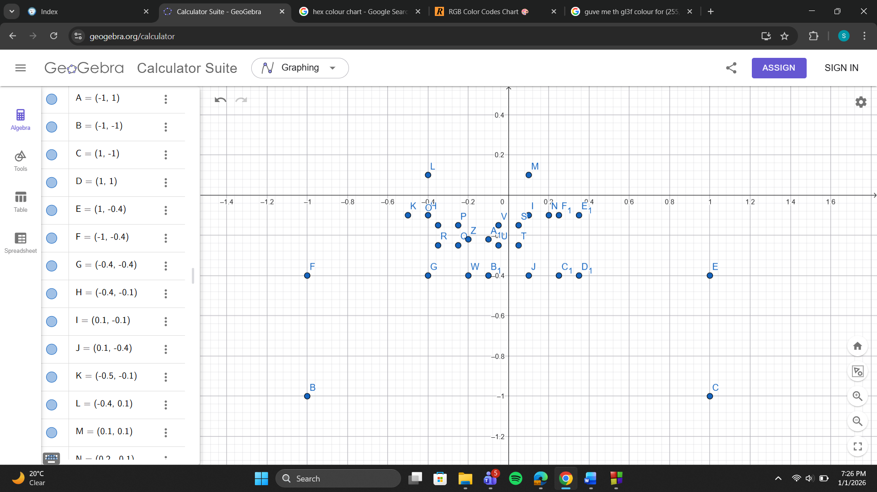
Code-
#include <GL/gl.h>
#include <GL/glut.h>
#include <math.h>

// Global variables
bool isDay = false;
float timeOfDay = 0.0f;
float cloudX = -1.2f;

// draw circles
void drawCircle(float cx, float cy, float r, int num_segments) {
glBegin(GL_POLYGON);
for (int i = 0; i < num_segments; i++) {
float theta = 2.0f * 3.1415926f * float(i) / float(num_segments);
float x = r * cosf(theta);
float y = r * sinf(theta);
glVertex2f(x + cx, y + cy);
}
glEnd();
}

void field() {
if (isDay) glColor3f(0.1f, 0.7f, 0.1f);
else glColor3f(0.05f, 0.25f, 0.05f);
glBegin(GL_QUADS);
glVertex2f(-1.0f, -1.0f);
glVertex2f(1.0f, -1.0f);
glVertex2f(1.0f, -0.4f);
glVertex2f(-1.0f, -0.4f);
glEnd();
}

void tree() {
glColor3f(0.35f, 0.2f, 0.1f); // Trunk
glBegin(GL_QUADS);
glVertex2f(0.25f, -0.4f);
glVertex2f(0.35f, -0.4f);
glVertex2f(0.35f, -0.1f);
glVertex2f(0.25f, -0.1f);
glEnd();

if (isDay) glColor3f(0.0f, 0.8f, 0.2f);
else glColor3f(0.0f, 0.4f, 0.1f);
drawCircle(0.22f, -0.05f, 0.12f, 30);
drawCircle(0.38f, -0.05f, 0.12f, 30);
drawCircle(0.30f, 0.08f, 0.12f, 30);
}

void house() {
if (isDay) glColor3f(0.85f, 0.7f, 0.5f);
else glColor3f(0.4f, 0.3f, 0.2f);
glBegin(GL_QUADS);
glVertex2f(-0.4f, -0.4f);
glVertex2f(-0.4f, -0.1f);
glVertex2f(0.1f, -0.1f);
glVertex2f(0.1f, -0.4f);
glEnd();

if (isDay) glColor3f(0.6f, 0.2f, 0.1f);
else glColor3f(0.3f, 0.1f, 0.05f);
glBegin(GL_QUADS);
glVertex2f(-0.5f, -0.1f);
glVertex2f(-0.4f, 0.1f);
glVertex2f(0.1f, 0.1f);
glVertex2f(0.2f, -0.1f);
glEnd();

glColor3f(0.3f, 0.15f, 0.05f);
glBegin(GL_QUADS);
glVertex2f(-0.2f, -0.4f);
glVertex2f(-0.05f, -0.4f);
glVertex2f(-0.05f, -0.2f);
glVertex2f(-0.2f, -0.2f);
glEnd();

if (isDay) {
glColor3f(1.0f, 0.6f, 0.2f); // for day
} else {
glColor3f(1.0f, 0.8f, 0.0f); //night
}

glBegin(GL_QUADS);
glVertex2f(-0.35f, -0.25f);
glVertex2f(-0.25f, -0.25f);
glVertex2f(-0.25f, -0.15f);
glVertex2f(-0.35f, -0.15f);
glEnd();

glBegin(GL_QUADS);
glVertex2f(-0.02f, -0.25f);
glVertex2f(0.08f, -0.25f);
glVertex2f(0.08f, -0.15f);
glVertex2f(-0.02f, -0.15f);
glEnd();

glLineWidth(6.0f);

glBegin(GL_LINES);
glColor3f(0.0f, 0.0f, 0.0f);
glVertex2f(-0.4f, -0.4f);
glVertex2f(0.1f, -0.4f);
glEnd();
}

void drawClouds() {
if (!isDay) return;
glColor3f(1.0f, 1.0f, 1.0f);
drawCircle(cloudX, 0.75f, 0.07f, 20);
drawCircle(cloudX + 0.08f, 0.78f, 0.09f, 20);
drawCircle(cloudX + 0.16f, 0.75f, 0.07f, 20);
}

void renderNightScene() {
glClearColor(0.0f, 0.05f, 0.15f, 1.0f);
glClear(GL_COLOR_BUFFER_BIT);
// Stars
glColor3f(1.0f, 1.0f, 1.0f);
glBegin(GL_POINTS);
glVertex2f(-0.8f, 0.8f);
glVertex2f(0.4f, 0.7f);
glVertex2f(-0.2f, 0.5f);
glVertex2f(0.7f, 0.9f);
glVertex2f(-0.5f, 0.3f);
glEnd();
// Moon
glColor3f(0.9f, 0.9f, 0.8f);
drawCircle(-0.6f, 0.7f, 0.1f, 40);
}

void renderDayScene() {
glClearColor(0.4f, 0.7f, 1.0f, 1.0f);
glClear(GL_COLOR_BUFFER_BIT);
// Sun
glColor3f(1.0f, 1.0f, 0.0f);
drawCircle(0.6f, 0.8f, 0.15f, 40);
drawClouds();
}

void timer(int value) {
timeOfDay += 0.005f;
cloudX += 0.004f;
if (cloudX > 1.2f) cloudX = -1.2f;
if (timeOfDay >= 1.0f) {
isDay = !isDay;
timeOfDay = 0.0f;
}
glutPostRedisplay();
glutTimerFunc(30, timer, 0);
}

void display() {
if (isDay) renderDayScene();
else renderNightScene();
field();
house();
tree();
glFlush();
}

void init() {
glMatrixMode(GL_PROJECTION);
glLoadIdentity();
gluOrtho2D(-1.0, 1.0, -1.0, 1.0);
}

int main(int argc, char** argv) {
glutInit(&argc, argv);
glutInitDisplayMode(GLUT_SINGLE | GLUT_RGB);
glutInitWindowSize(1600, 1200);
glutCreateWindow("Day and night scenerio");
init();
glutDisplayFunc(display);
glutTimerFunc(60, timer, 0);
glutMainLoop();
return 0;
}

Output Screenshot (Full Screen)-
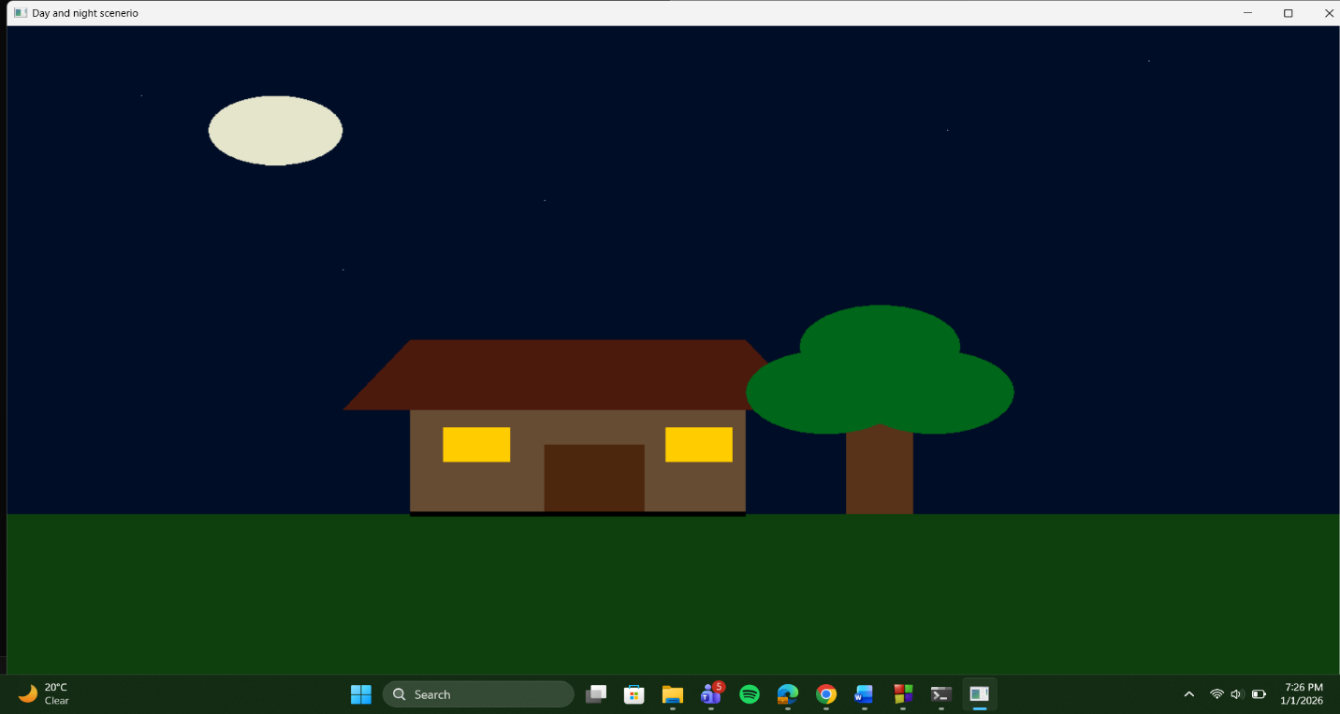

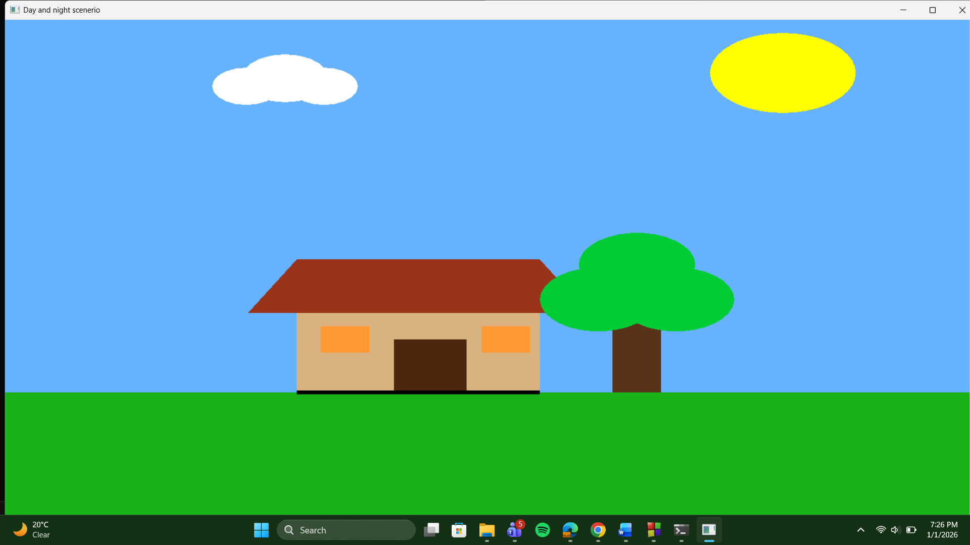

Question-
Create two scenarios. Each scenario will have its own objects, animations, mouse and keyboard interactions. Then ‘Merge’ the two scenarios into one. You must keep ways to call one scenario from another automatically and using pre-defined buttons.

Graph
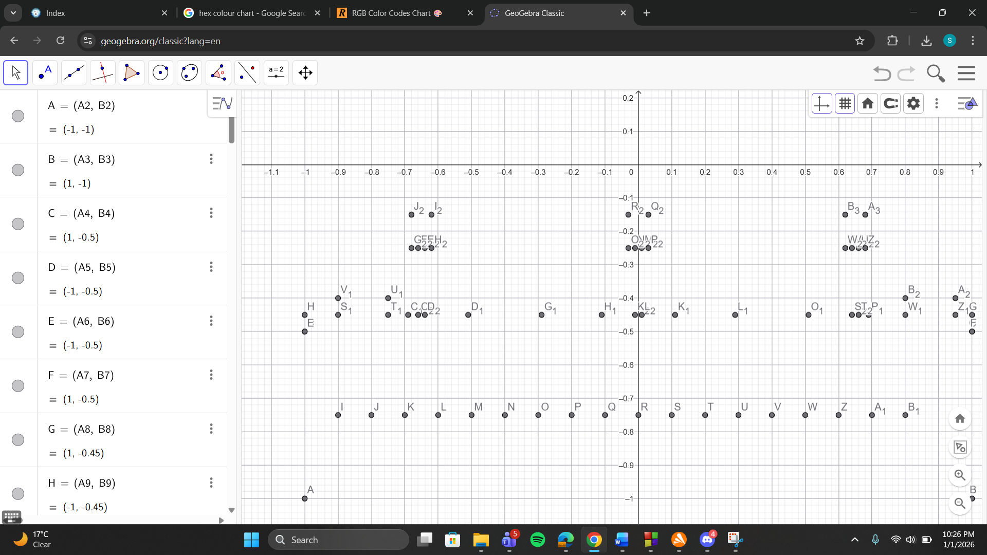

Code-
#include <GL/gl.h>
#include <GL/glut.h>
#include <math.h>
#include <iostream>

using namespace std;

int scene = 1;
float cloudX = -1.5f;
bool cloudActive = true;
bool isDay = true;
float carX1 = -1.0f;
float carX2 = 0.5f;
bool houseLightOn = true;
float buildingLightTimer = 0.0f;
bool buildingLightsOn = false;

void drawCircle(float cx, float cy, float r, int num_segments) {
glBegin(GL_POLYGON);
for (int i = 0; i < num_segments; i++) {
float theta = 2.0f * 3.1415926f * float(i) / float(num_segments);
float x = r * cosf(theta);
float y = r * sinf(theta);
glVertex2f(x + cx, y + cy);
}
glEnd();
}

void field() {
if (isDay) glColor3f(0.1f, 0.7f, 0.1f);
else glColor3f(0.05f, 0.25f, 0.05f);
glBegin(GL_QUADS);
glVertex2f(-1.0f, -1.0f);
glVertex2f(1.0f, -1.0f);
glVertex2f(1.0f, -0.4f);
glVertex2f(-1.0f, -0.4f);
glEnd();
}

void tree() {
glColor3f(0.35f, 0.2f, 0.1f);
glBegin(GL_QUADS);
glVertex2f(0.25f, -0.4f);
glVertex2f(0.35f, -0.4f);
glVertex2f(0.35f, -0.1f);
glVertex2f(0.25f, -0.1f);
glEnd();

if (isDay) glColor3f(0.0f, 0.8f, 0.2f);
else glColor3f(0.0f, 0.4f, 0.1f);
drawCircle(0.22f, -0.05f, 0.12f, 30);
drawCircle(0.38f, -0.05f, 0.12f, 30);
drawCircle(0.30f, 0.08f, 0.12f, 30);
}

void house() {
if (isDay) glColor3f(0.85f, 0.7f, 0.5f);
else glColor3f(0.4f, 0.3f, 0.2f);
glBegin(GL_QUADS);
glVertex2f(-0.4f, -0.4f);
glVertex2f(-0.4f, -0.1f);
glVertex2f(0.1f, -0.1f);
glVertex2f(0.1f, -0.4f);
glEnd();

if (isDay) glColor3f(0.6f, 0.2f, 0.1f);
else glColor3f(0.3f, 0.1f, 0.05f);
glBegin(GL_QUADS);
glVertex2f(-0.5f, -0.1f);
glVertex2f(-0.4f, 0.1f);
glVertex2f(0.1f, 0.1f);
glVertex2f(0.2f, -0.1f);
glEnd();

glColor3f(0.3f, 0.15f, 0.05f);
glBegin(GL_QUADS);
glVertex2f(-0.2f, -0.4f);
glVertex2f(-0.05f, -0.4f);
glVertex2f(-0.05f, -0.2f);
glVertex2f(-0.2f, -0.2f);
glEnd();

if (houseLightOn) {
glColor3f(1.0f, 1.0f, 0.8f);
} else {
glColor3f(0.2f, 0.2f, 0.3f);
}

glBegin(GL_QUADS);
glVertex2f(-0.35f, -0.25f);
glVertex2f(-0.25f, -0.25f);
glVertex2f(-0.25f, -0.15f);
glVertex2f(-0.35f, -0.15f);
glEnd();

glBegin(GL_QUADS);
glVertex2f(-0.02f, -0.25f);
glVertex2f(0.08f, -0.25f);
glVertex2f(0.08f, -0.15f);
glVertex2f(-0.02f, -0.15f);
glEnd();

glLineWidth(6.0f);
glBegin(GL_LINES);
glColor3f(0.0f, 0.0f, 0.0f);
glVertex2f(-0.4f, -0.4f);
glVertex2f(0.1f, -0.4f);
glEnd();
}

void drawClouds() {
if (!isDay) return;
glColor3f(1.0f, 1.0f, 1.0f);
drawCircle(cloudX, 0.75f, 0.07f, 20);
drawCircle(cloudX + 0.08f, 0.78f, 0.09f, 20);
drawCircle(cloudX + 0.16f, 0.75f, 0.07f, 20);
}

void renderNightScene() {
glClearColor(0.0f, 0.05f, 0.15f, 1.0f);
glClear(GL_COLOR_BUFFER_BIT);

glColor3f(1.0f, 1.0f, 1.0f);
glBegin(GL_POINTS);
glVertex2f(-0.8f, 0.8f);
glVertex2f(0.4f, 0.7f);
glVertex2f(-0.2f, 0.5f);
glVertex2f(0.7f, 0.9f);
glVertex2f(-0.5f, 0.3f);
glEnd();

glColor3f(0.9f, 0.9f, 0.8f);
drawCircle(-0.6f, 0.7f, 0.1f, 40);
}

void renderDayScene() {
glClearColor(0.4f, 0.7f, 1.0f, 1.0f);
glClear(GL_COLOR_BUFFER_BIT);

glColor3f(1.0f, 1.0f, 0.0f);
drawCircle(0.6f, 0.8f, 0.15f, 40);

drawClouds();
}

void drawScene1() {
if (isDay) renderDayScene();
else renderNightScene();

field();
house();
tree();
}

void cityGround() {
glColor3f(0.3f, 0.3f, 0.3f);
glBegin(GL_QUADS);
glVertex2f(-1.0f, -1.0f);
glVertex2f(1.0f, -1.0f);
glVertex2f(1.0f, -0.5f);
glVertex2f(-1.0f, -0.5f);
glEnd();

glColor3f(0.5f, 0.5f, 0.5f);
glBegin(GL_QUADS);
glVertex2f(-1.0f, -0.5f);
glVertex2f(1.0f, -0.5f);
glVertex2f(1.0f, -0.45f);
glVertex2f(-1.0f, -0.45f);
glEnd();

glColor3f(1.0f, 1.0f, 1.0f);
glLineWidth(3.0f);
glBegin(GL_LINES);
for (float i = -0.9f; i < 0.9f; i += 0.2f) {
glVertex2f(i, -0.75f);
glVertex2f(i + 0.1f, -0.75f);
}
glEnd();
}

void drawSkyscraper(float x, float y) {
glColor3f(0.35f, 0.35f, 0.4f);
glBegin(GL_QUADS);
glVertex2f(x - 0.09f, y);
glVertex2f(x + 0.09f, y);
glVertex2f(x + 0.09f, y + 0.7f);
glVertex2f(x - 0.09f, y + 0.7f);
glEnd();

if (isDay || buildingLightsOn) {
if (isDay) {
glColor3f(0.8f, 0.9f, 1.0f);
} else {
glColor3f(1.0f, 1.0f, 0.8f);
}

glBegin(GL_QUADS);
glVertex2f(x - 0.04f, y + 0.58f);
glVertex2f(x + 0.04f, y + 0.58f);
glVertex2f(x + 0.04f, y + 0.63f);
glVertex2f(x - 0.04f, y + 0.63f);
glEnd();

glBegin(GL_QUADS);
glVertex2f(x - 0.04f, y + 0.33f);
glVertex2f(x + 0.04f, y + 0.33f);
glVertex2f(x + 0.04f, y + 0.38f);
glVertex2f(x - 0.04f, y + 0.38f);
glEnd();

glBegin(GL_QUADS);
glVertex2f(x - 0.06f, y + 0.08f);
glVertex2f(x - 0.02f, y + 0.08f);
glVertex2f(x - 0.02f, y + 0.12f);
glVertex2f(x - 0.06f, y + 0.12f);
glEnd();

glBegin(GL_QUADS);
glVertex2f(x + 0.02f, y + 0.08f);
glVertex2f(x + 0.06f, y + 0.08f);
glVertex2f(x + 0.06f, y + 0.12f);
glVertex2f(x + 0.02f, y + 0.12f);
glEnd();
}

glColor3f(0.2f, 0.2f, 0.2f);
glBegin(GL_QUADS);
glVertex2f(x - 0.09f, y + 0.7f);
glVertex2f(x + 0.09f, y + 0.7f);
glVertex2f(x + 0.09f, y + 0.72f);
glVertex2f(x - 0.09f, y + 0.72f);
glEnd();
}

void drawCar1(float x, float y) {
glColor3f(1.0f, 1.0f, 0.0f);
glBegin(GL_QUADS);
glVertex2f(x - 0.12f, y);
glVertex2f(x + 0.12f, y);
glVertex2f(x + 0.12f, y + 0.06f);
glVertex2f(x - 0.12f, y + 0.06f);
glEnd();

glBegin(GL_QUADS);
glVertex2f(x - 0.1f, y + 0.06f);
glVertex2f(x + 0.1f, y + 0.06f);
glVertex2f(x + 0.08f, y + 0.1f);
glVertex2f(x - 0.08f, y + 0.1f);
glEnd();

glColor3f(0.2f, 0.4f, 0.8f);
glBegin(GL_QUADS);
glVertex2f(x - 0.09f, y + 0.06f);
glVertex2f(x - 0.01f, y + 0.06f);
glVertex2f(x - 0.01f, y + 0.095f);
glVertex2f(x - 0.07f, y + 0.095f);
glEnd();

glBegin(GL_QUADS);
glVertex2f(x + 0.01f, y + 0.06f);
glVertex2f(x + 0.09f, y + 0.06f);
glVertex2f(x + 0.07f, y + 0.095f);
glVertex2f(x + 0.01f, y + 0.095f);
glEnd();

glColor3f(0.1f, 0.1f, 0.1f);
drawCircle(x - 0.08f, y - 0.01f, 0.02f, 10);
drawCircle(x + 0.08f, y - 0.01f, 0.02f, 10);

if (!isDay) {
glColor3f(1.0f, 1.0f, 0.8f);
drawCircle(x + 0.13f, y + 0.03f, 0.01f, 8);
}

glColor3f(0.8f, 0.0f, 0.0f);
glBegin(GL_QUADS);
glVertex2f(x - 0.02f, y + 0.1f);
glVertex2f(x + 0.02f, y + 0.1f);
glVertex2f(x + 0.02f, y + 0.12f);
glVertex2f(x - 0.02f, y + 0.12f);
glEnd();
}

void drawTrafficLight(float x, float y) {
glColor3f(0.3f, 0.3f, 0.3f);
glBegin(GL_QUADS);
glVertex2f(x - 0.01f, y);
glVertex2f(x + 0.01f, y);
glVertex2f(x + 0.01f, y + 0.2f);
glVertex2f(x - 0.01f, y + 0.2f);
glEnd();

glColor3f(0.1f, 0.1f, 0.1f);
glBegin(GL_QUADS);
glVertex2f(x - 0.03f, y + 0.2f);
glVertex2f(x + 0.03f, y + 0.2f);
glVertex2f(x + 0.03f, y + 0.3f);
glVertex2f(x - 0.03f, y + 0.3f);
glEnd();

if (isDay) {
glColor3f(1.0f, 0.0f, 0.0f);
} else {
glColor3f(0.3f, 0.0f, 0.0f);
}
drawCircle(x, y + 0.28f, 0.01f, 8);

if (!isDay) {
glColor3f(0.0f, 1.0f, 0.0f);
} else {
glColor3f(0.0f, 0.3f, 0.0f);
}
drawCircle(x, y + 0.22f, 0.01f, 8);
}

void drawScene2() {
if (isDay) {
glClearColor(0.6f, 0.8f, 1.0f, 1.0f);
} else {
glClearColor(0.1f, 0.1f, 0.2f, 1.0f);
}
glClear(GL_COLOR_BUFFER_BIT);

if (isDay) {
glColor3f(1.0f, 1.0f, 0.0f);
drawCircle(0.7f, 0.7f, 0.1f, 40);

glColor3f(1.0f, 1.0f, 1.0f);
drawCircle(cloudX - 0.3f, 0.8f, 0.08f, 20);
drawCircle(cloudX - 0.2f, 0.85f, 0.1f, 20);
drawCircle(cloudX - 0.1f, 0.8f, 0.07f, 20);
} else {
glColor3f(0.9f, 0.9f, 0.8f);
drawCircle(-0.7f, 0.7f, 0.08f, 40);

glColor3f(1.0f, 1.0f, 1.0f);
glBegin(GL_POINTS);
glVertex2f(-0.9f, 0.9f);
glVertex2f(-0.6f, 0.85f);
glVertex2f(0.8f, 0.8f);
glEnd();
}

cityGround();

drawSkyscraper(-0.6f, -0.45f);
drawSkyscraper(-0.2f, -0.45f);
drawSkyscraper(0.2f, -0.45f);
drawSkyscraper(0.6f, -0.45f);

drawTrafficLight(-0.65f, -0.45f);
drawTrafficLight(0.0f, -0.45f);
drawTrafficLight(0.65f, -0.45f);

drawCar1(carX1, -0.7f);
}

void display() {
if (scene == 1) {
drawScene1();
} else {
drawScene2();
}
glutSwapBuffers();
}

void timer(int value) {
if (cloudActive) {
cloudX += 0.01f;

if (cloudX > 1.8f) {
scene = (scene == 1) ? 2 : 1;
cloudX = -1.5f;
}
}

if (scene == 2) {
carX1 += 0.01f;

if (carX1 > 1.5f) carX1 = -1.5f;

if (!isDay) {
buildingLightTimer += 0.1f;
if (buildingLightTimer > 10.0f) {
buildingLightsOn = !buildingLightsOn;
buildingLightTimer = 0.0f;
}
} else {
buildingLightsOn = false;
}
}

glutPostRedisplay();
glutTimerFunc(30, timer, 0);
}

void keyboard(unsigned char key, int x, int y) {
switch(key) {
case 'n':
case 'N':
scene = (scene == 1) ? 2 : 1;
cloudX = -1.5f;
break;
case 27:
exit(0);
break;
}
glutPostRedisplay();
}

void mouse(int button, int state, int x, int y) {
if (button == GLUT_LEFT_BUTTON && state == GLUT_DOWN) {
float glX = (x / 400.0f) - 1.0f;
float glY = 1.0f - (y / 300.0f);

if (scene == 1) {
if (isDay) {
float dx = glX - 0.6f;
float dy = glY - 0.8f;
if (dx*dx + dy*dy < 0.03f) {
isDay = !isDay;
}
} else {
float dx = glX + 0.6f;
float dy = glY - 0.7f;
if (dx*dx + dy*dy < 0.02f) {
isDay = !isDay;
}
}

if (glX >= -0.4f && glX <= 0.1f && glY >= -0.4f && glY <= -0.1f) {
houseLightOn = !houseLightOn;
}
} else if (scene == 2) {
if (isDay) {
float dx = glX - 0.7f;
float dy = glY - 0.7f;
if (dx*dx + dy*dy < 0.02f) {
isDay = !isDay;
}
} else {
float dx = glX + 0.7f;
float dy = glY - 0.7f;
if (dx*dx + dy*dy < 0.015f) {
isDay = !isDay;
}
}

for (float tx = -0.65f; tx <= 0.65f; tx += 0.65f) {
float dx = glX - tx;
float dy = glY - (-0.45f + 0.25f);
if (dx*dx + dy*dy < 0.02f) {
buildingLightsOn = !buildingLightsOn;
}
}
}
}
glutPostRedisplay();
}

void init() {
glMatrixMode(GL_PROJECTION);
gluOrtho2D(-1.0, 1.0, -1.0, 1.0);
}

int main(int argc, char** argv) {
glutInit(&argc, argv);
glutInitDisplayMode(GLUT_DOUBLE | GLUT_RGB);
glutInitWindowSize(1600, 1200);
glutInitWindowPosition(100, 100);
glutCreateWindow("merging two scenerio");

init();
glutDisplayFunc(display);
glutKeyboardFunc(keyboard);
glutMouseFunc(mouse);
glutTimerFunc(30, timer, 0);

cout << "CONTROLS:" << endl;
cout << "N - Switch between Scene 1 (Village) and Scene 2 (City)" << endl;
cout << "Mouse Click:" << endl;
cout << " Scene 1: Click sun/moon to toggle day/night" << endl;
cout << " Click house to toggle lights on/off" << endl;
cout << " Scene 2: Click sun/moon to toggle day/night" << endl;
cout << " Click traffic lights to toggle building lights" << endl;
cout << "ESC - Exit" << endl;
cout << endl;
cout << "NOTE: Cloud moves automatically between scenes" << endl;

glutMainLoop();
return 0;
}

Output Screenshot (Full Screen)-
