***Sleepy Michael***

Do you remember Michael from Midsem’s UNIX question? Once again, he seeks your assistance. Indeed, Michael's predictions about the 2008 stock market crash were accurate. Now, he aims to express gratitude to all his investors who trusted him.

He has a long file called email.txt. This file is a bit corrupted. So, your goal is to extract all valid email addresses from this text file and to display all such email addresses on a new line in lexicographic order with duplicates removed.

1. Every line has some strings separated by one or more colons. We are interested in two consecutive strings (which can be anywhere). The first one is the email id and the second one is the type of the respective person. (Only two types: “investor” and “friend”.)
2. We need to extract only those email addresses which have “investor” written just after them. (in the same line) (He does not wish to pay gratitude to his friends and relatives:))
3. For the email address to be valid, it should have a string of length > 0, then “@” and should end in “.com” or “.org”. Also, the email address should contain only a single “.” and “@” and no “:”.
4. You need to ignore all the email addresses which are starting with “michael”. (Because he does not want to mail himself.)
5. You can assume that every line has at most one such pair of email and type. But remember that this pair can be placed anywhere in the line.
6. You should complete the pattern matching part of the question only using “sed”.

You need to write your command/commands in submission.sh.

Hint: To remove the duplicates, you can use the sort command. Type “man sort” on the terminal for more details.

See the below example:

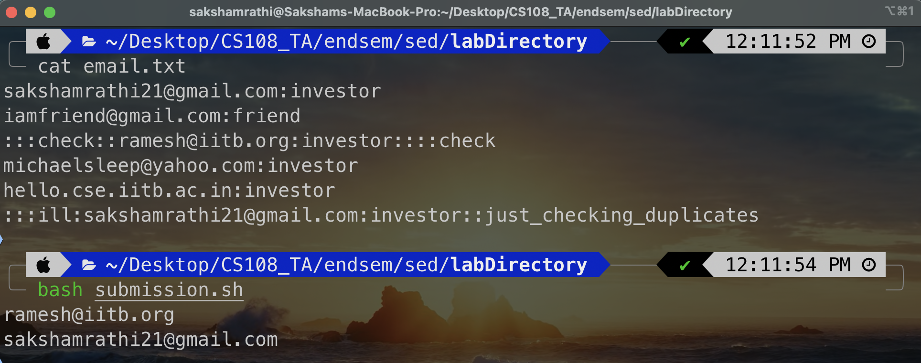

Also, please note that we will be having our own server side test cases. So, make sure you test your script thoroughly with your own test cases.

You need to submit only submission.sh